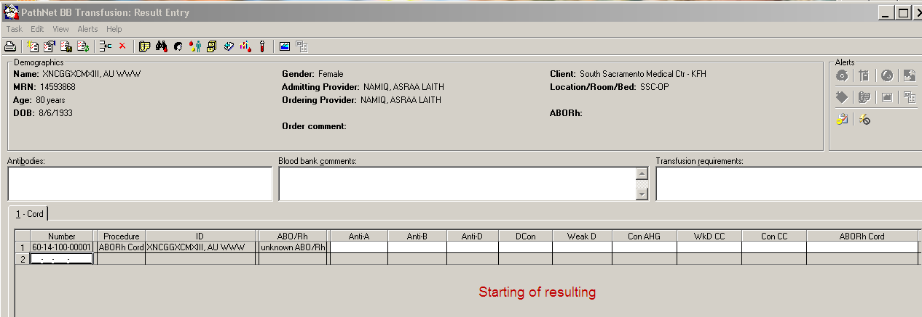

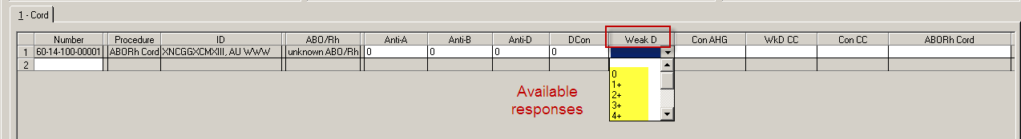

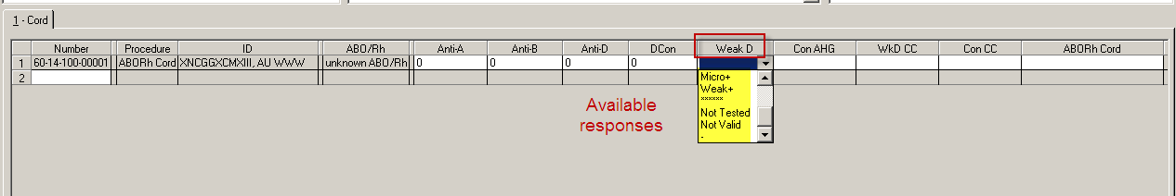

**These are the available alpha responses for Weak D that could be chosen from.**

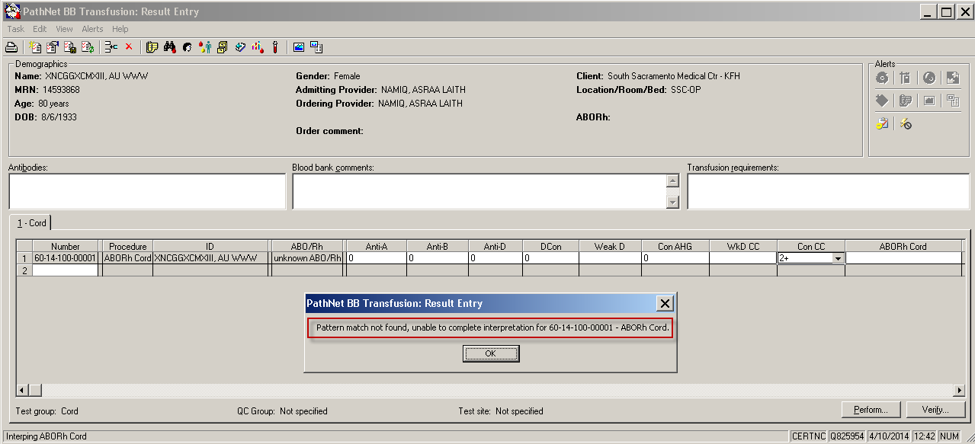

**When the result of the Weak D is left blank the message above appears when you come to the ABORh Cord interpretation.**

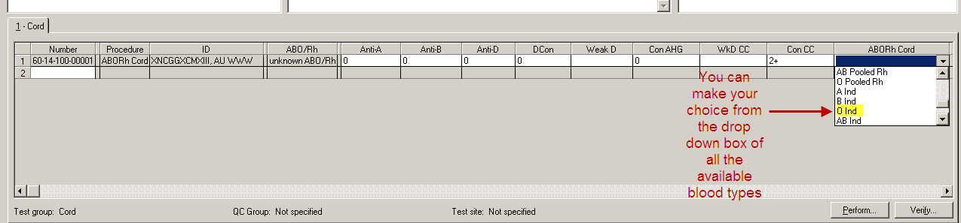

**The CLS users will have to make a choice of which blood type to use. In this case O Ind.**

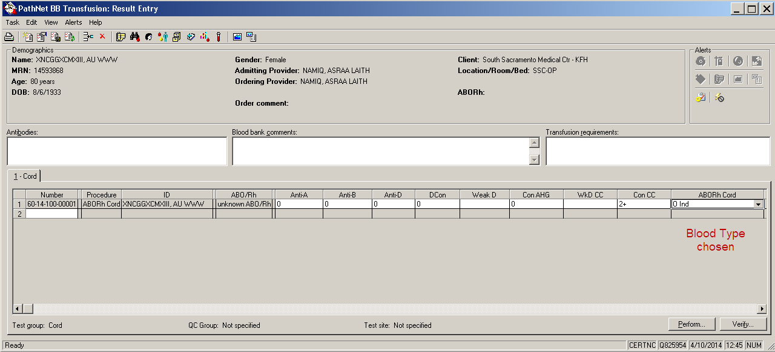

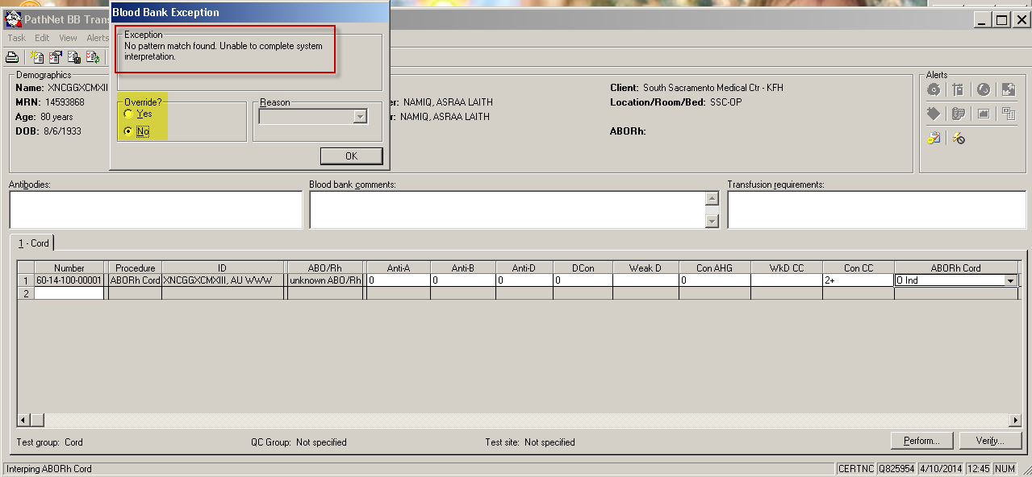

**Once you click on Verify the Blood Bank Exception box opens, and because we allow an over-ride the “Override?” Yes radio button is available.**

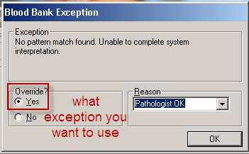

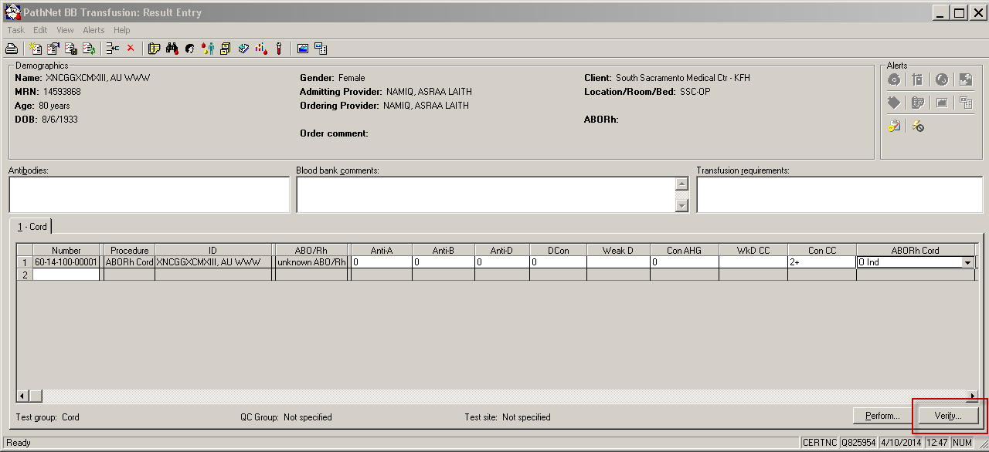

**Exception box closes and CLS can now Verify results leaving the Weak D blank.**

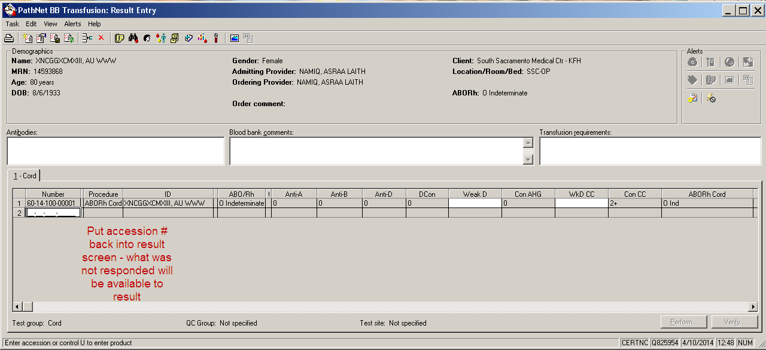

**To record now the reactions of the Weak D you can place the accession # back into BB Result Entry and those cells not responded to the first time will be available to place a result into without doing an error correction.**

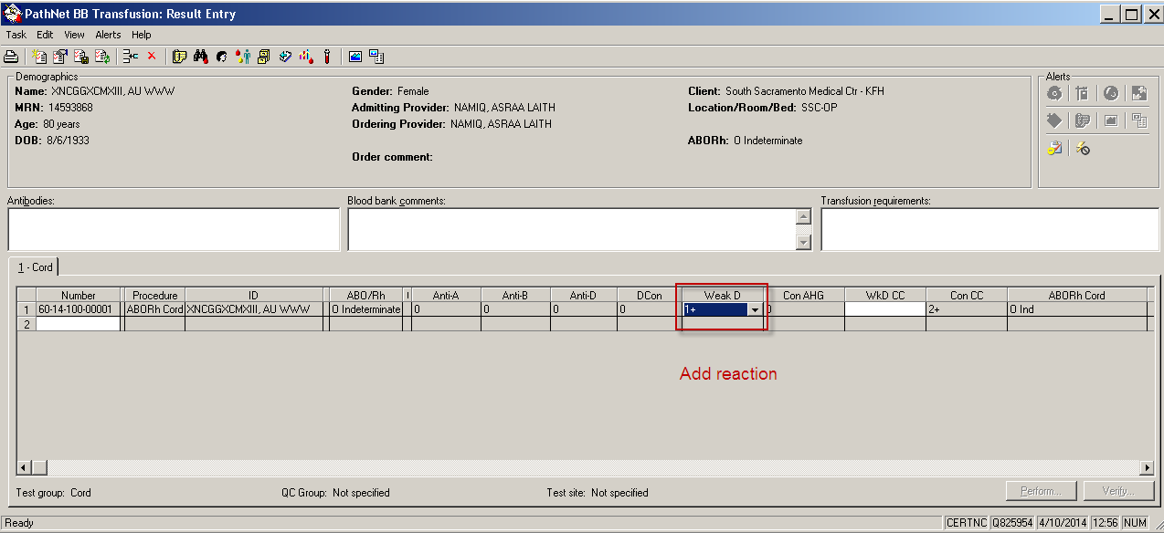

**Add your reaction for the Weak D now.**

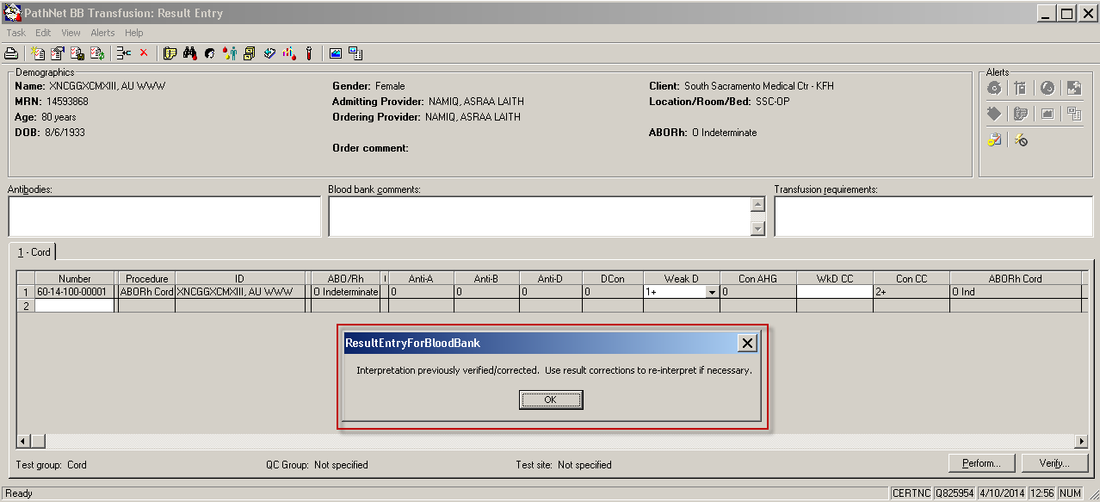

**System will warn that the Interpretation has been verified and to update will require “result correction” to update.**

**You can verify the result of the Weak D and not change the interpretation.**

**Displayed in Order Result Viewer (ORV)**

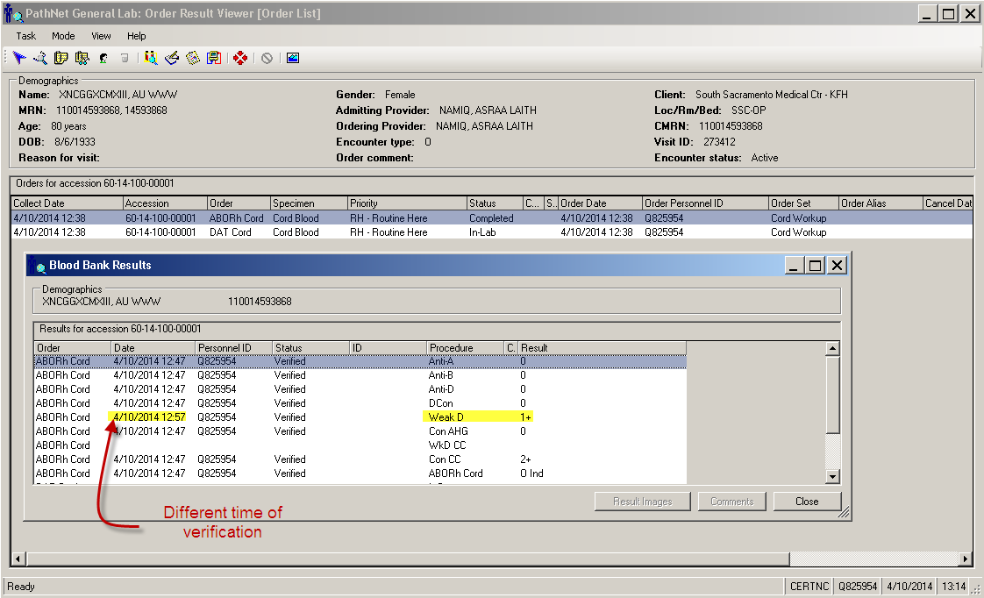

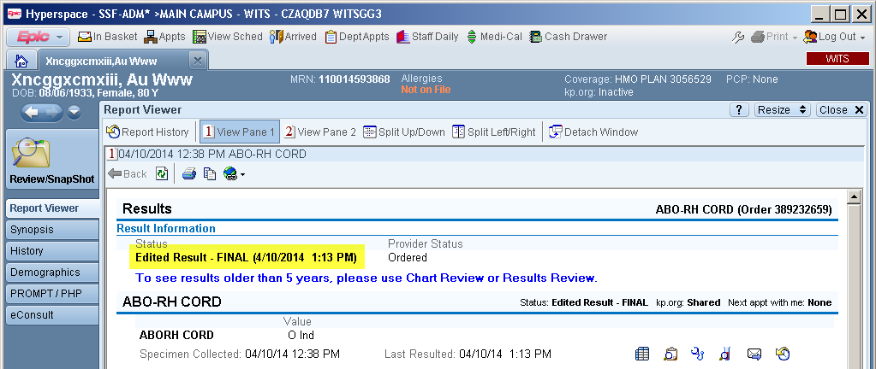

**Will show “Edited Results –Final” because the Weak D reaction was verified after the initial resulting even though the interpretation was not updated. No correction value is indicated. In the example above no result or order comments that could of displayed were used.**

**Infants / neonates that are Weak D**

**Result the Rh interpretation using the IND (indeterminate for the Rh)**

|  |  |
| --- | --- |
| SF_DU | Infant is Weak D Positive. Note: RHIG should be given to Rh Neg mother. |

**Weak D Adults**

**Result the Rh interpretation as “Neg”**

|  |  |
| --- | --- |
| SF_WKD | Weak D Positive. Due to new clinical standards, this patient is considered Rh neg and women of child bearing age are candidates for RhIg. |