**ACCESSION RESULT ENTRY**

**TROUBLESHOOTING TIPS**

***Table of Contents***

|  |  |
| --- | --- |
| **TITLE** | **PAGE** |
| Resulting with “< or >” | **2** |
| Re-Directing Samples for Local Analysis | **3** |
| Sending an Order and Specimen to Another Kaiser Lab | **6** |
| Correction of Verified Results | **9** |
| Results that do not cross the interface | **10** |
| Add-On Test | **11** |

**RESULTING WITH “< or >”**

Use the linear limit functionality to report results with proper flagging

Enter the result in the column using **only** the default **NUMERIC** to enable appropriate flagging

**DO NOT FREETEXT**

**Resulted as Free text Result entered without the use of Free text** 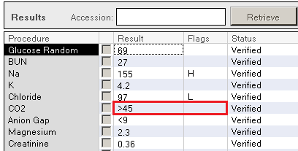 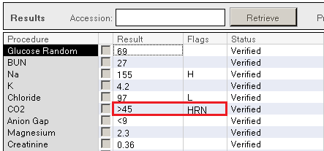

**All applicable result flag will append**

**Abnormal result flag missing**

 

**RE-DIRECTING SAMPLES FOR LOCAL ANALYSIS**

(Example: One order (PT – RO/RR), MD requesting order be done soon rather than Regional)

Sample still in Local Lab but order has been transmitted to Regional (“in transit” status)

**NO**

**YES**

**Call Regional Lab**

T

Perform TRT

**TRT:**

Determine performing location / service resource for Regional Lab:

Open Container Inquiry → Enter accession number → Select desired order in the container list → right click → select “Show Routing”

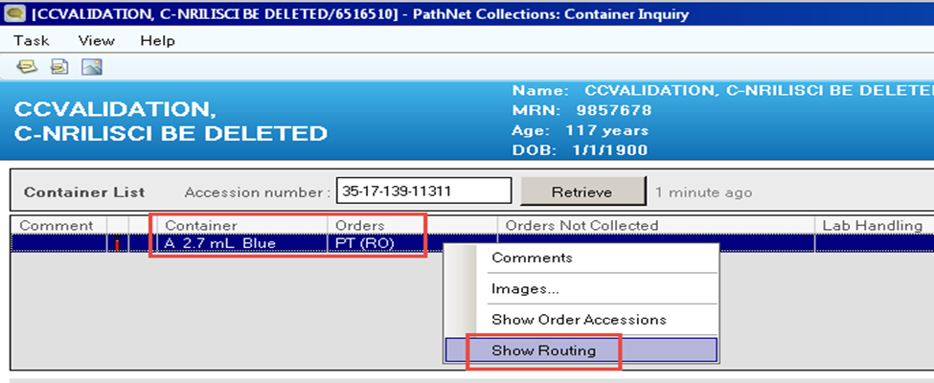

Open Pending Inquiry. In Select Pending Procedures window, type the exact Test Site and Procedure (“Order”) names as noted in the Order Routing window (you can also use the search function by clicking on the magnifying glass icon immediately next to each respective fields).

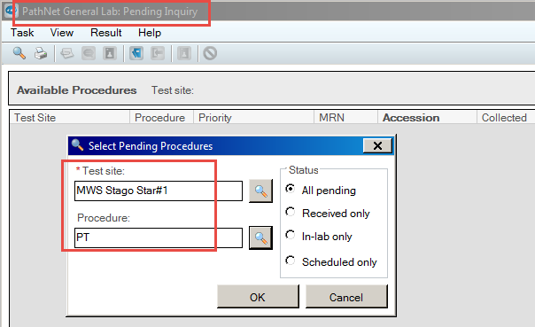NOTE: User has to be specific with test site and procedure as to avoid other procedural orders being affected.

Pending list for the defined service resource and procedure combination will display → sort display by accession by clicking on the Accession column header once. Locate order to be transferred back to local facility > click to select / highlight

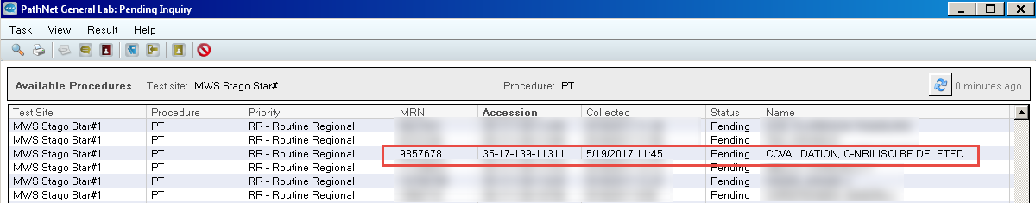

With the order / specimen highlighted, click Task → Transfer → Selected Orders →All Details

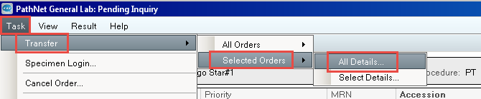

In Transfer dialog box, enter or search for the intended service resource (if unsure, please consult CLS or technical supervisor for service resource name)

Open Container Inquiry → enter accession number → select desired order in the container list → right

click, select “Show Routing.” Confirm that order now routes to the desired performing facility.

Login accession at local facility (for this example – SSF Lab Login location)

Process specimen per lab protocol

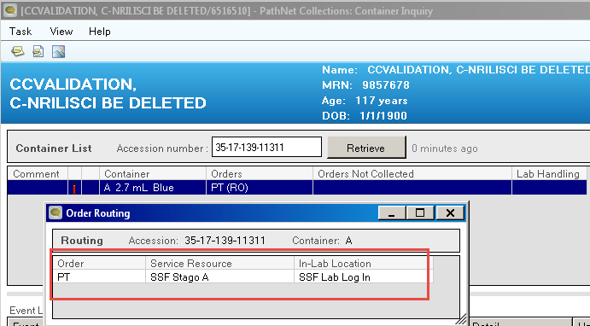

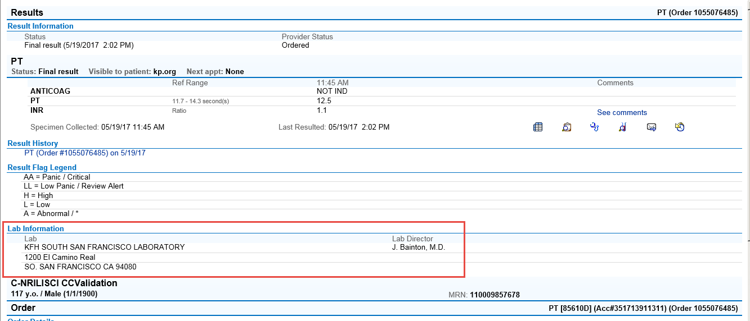Once result is verified, go to KPHC and confirm performing laboratory is posted correctly in Chart Review.

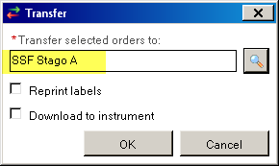

**SENDING AN ORDER AND SPECIMEN TO ANOTHER KAISER LAB**

(example: instrument down)

Ensure to contact receiving facility and notify of incoming order and specimen

Perform the following remediation to transfer order:

SENDING FACILITY

RECEIVING / PERFORMING FACILITY

Determine current performing location / service resource: Login accession at local facility.

Open Container Inquiry → Enter accession number → Process specimen per lab protocol.

Select desired order in the container list → right click →

select “Show Routing” Once result is verified, go to KPHC

and confirm that performing lab is

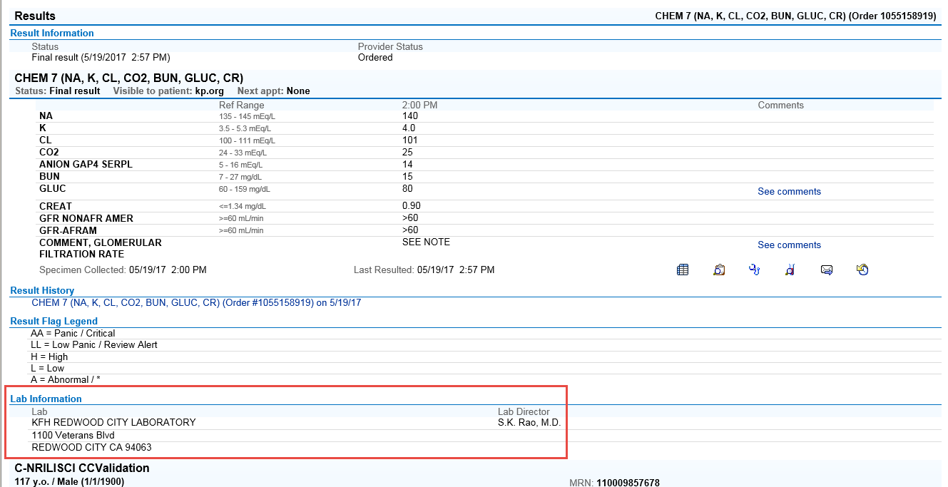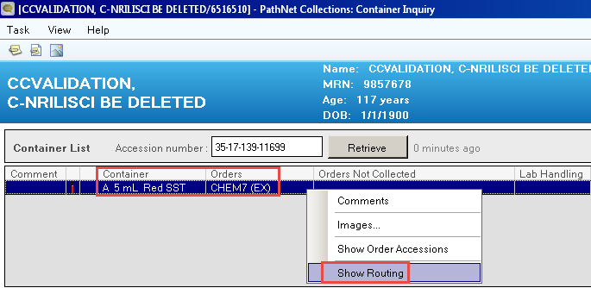 posted correctly in Chart Review.

Order Routing window opens → make note of Service Resource name

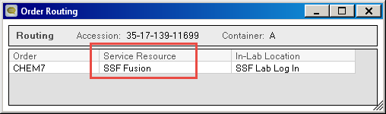(in this example, the designated service resource is “SSF Fusion”)

Open Pending Inquiry. In Select Pending Procedures window →

type the exact Test Site and Procedure (“Order”) names as noted in the

Order Routing window (you can also use the search function by clicking

on the magnifying glass icon immediately next to each respective fields)

Use Status “All Pending” → then select **OK** to initiate query.

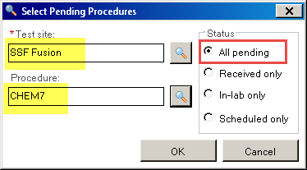

Pending list for the defined service resource and procedure combination

will display → sort display by accession by clicking on the Accession

column header once. Locate order to be transferred to the other

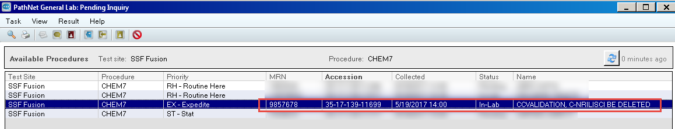 KP NCAL facility →click to select / highlight.

With the order / specimen highlighted, click Task → Transfer →

Selected Orders → All Details

In Transfer dialog box, enter or search for the intended service resource

(if unsure, please consult CLS or technical supervisor for service resource name)

– for this example order will be transferred to RWC lab’s primary chemistry analyzer

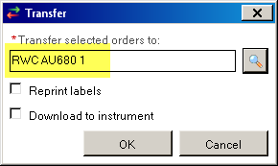(RWC AU680 1)

Open Container Inquiry → enter accession number >

select desired order in the container list > right click →

select “Show Routing.” Confirm that order now routes

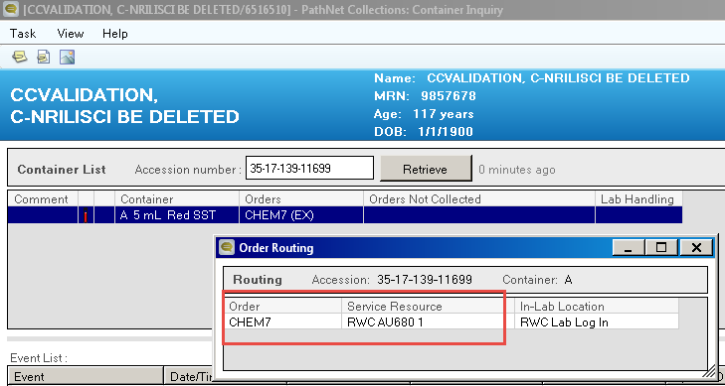to the desired performing facility.



**CORRECTION OF VERIFIED RESULTS:**

Results performed and verified at the Local Lab

If errors are outside the lab process, local Chart Accuracy Unit (CAU) team should be notified to appropriately initiate an investigation, ECR and corrective actions as appropriate.

Results performed and verified at Regional or another lab

Verified results can only be **corrected**.

Refer to your local lab Work Instruction – Accession Result Entry Correction Mode.

Tests can only be corrected where tests were performed. Correction can only be made by sending a formal request to Regional Lab Client Services or performing lab if considered a lab error.

Follow the required Chart Accuracy Unit (CAU) and Regional Lab ECR process.

**CALL PERFORMING LAB**



**DO NOT FREETEXT**

**REGIONAL LAB TESTING**

**MEDICAL CENTER TESTING**

Complete the Regional Lab Test Order Change Request and fax to Regional Lab with a copy of the add-on requisition.

Specimens already received at Regional Lab

but still **In Transit**

If the specimen is insufficient/inadequate, the requesting provider will be notified.

Ask Regional Lab to locate the specimen when the specimen box arrives

Outpatient specimens already sent to Regional Lab but still **In Transit**

If the specimen is insufficient/inadequate, the requesting provider will be notified.

Locate the specimen to determine if there is adequate volume to perform an add test(s) on to the appropriate accession number.

Outpatient specimen not yet sent to Regional Lab

Print the Cerner Millennium label.

Receive the accession number in Millennium using Specimen Login keeping the original collection date/time and add an order note that order was added to original specimen with Accession # XX-XX-XXX-XXXXX

Use the NEW accession number for the add on obtained from Order Result Viewer (ORV)

An order is placed and released in HC as 'Collect Now' frequency

Nursing unit calls lab to determine if a test can be added

Inpatients, ME, STAT, PW, and other locally performed tests

**ADD-ON TESTS**