**EXAMPLES OF ECR:**

**Case #1: DONE BY LOCAL LAB ON RESULTS RELEASED AND VERIFIED AT REGIONAL OR ANOTHER LAB:**

**CBC (RO) – routed to MWS**

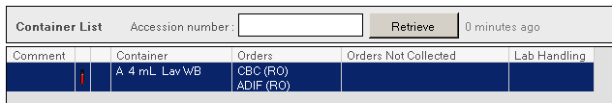

**Specimen was received in MWS**

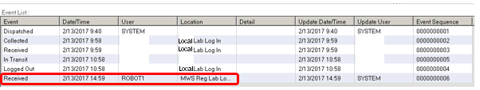

**Local CLS performed ECR by cancelling test results verified by MWS**

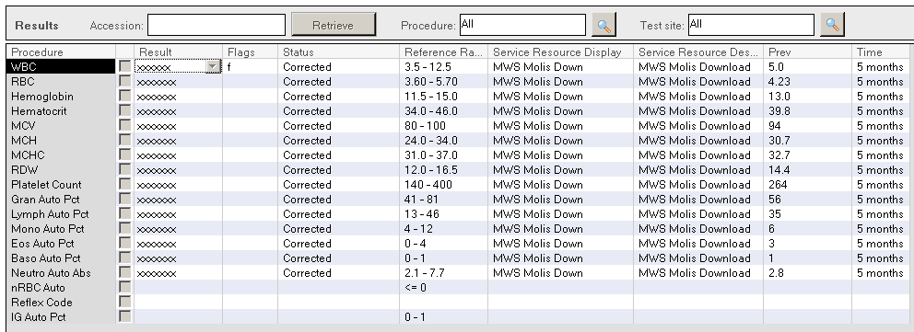

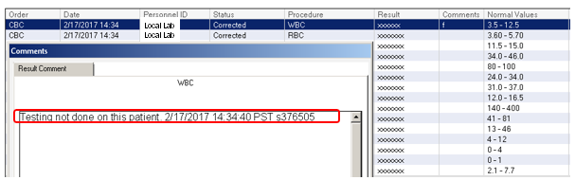

***ASSESSMENT:***

* **Correction of verified results should be done by the performing lab.**
* **CALL PERFORMING LAB.**

**Case #2: Platelet ECR on a CBC done at MWS**

**CBC (RO) – routed to MWS**

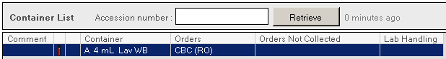

**Specimen was received in MWS**

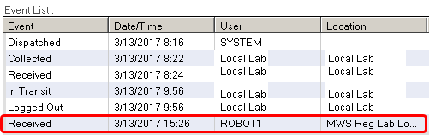

**Local CLS performed ECR on test results verified by MWS**

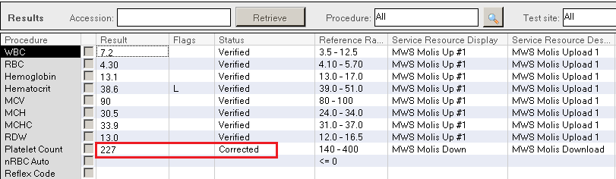

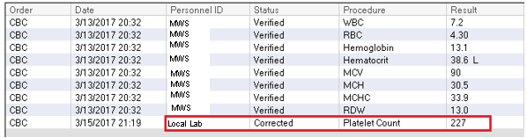

***Assessment:***

***Local CLS did not customize view to show Service Resource/Test Site while resulting under ARE (Accession Result Entry).***