

***Kaiser Permanente Medical Center, San Francisco  
Northern California Region***

****************************************** ******************************************

THIS DOCUMENT CONTAINS CONFIDENTIAL INFORMATION. Its use is restricted to employees with a need to know and third parties with a need to know and who have signed a non-disclosure agreement.

|  |  |
| --- | --- |
|  | **Work Instruction** |

|  |  |  |
| --- | --- | --- |
| **Title:** | **Lantronix Servers Support** | **WI Number** SFOWI-1351  **Revision:** 2 |

|  |  |  |
| --- | --- | --- |
| **Department:**  Lab Information System  **Area:**  2425 Geary Blvd SFO Hospital Lab | ***Approved & Released Work Instruction*** | **Implementation Date:** 04/06/2018 |

|  |  |
| --- | --- |
| **Type of Document:**  Work Instruction | **Review Period -** 340 **Days** |

Lantronix Server Support

**Principle:**

End User Support guide for the Lantronix Server Boxes.

**Procedure:**

Follow normal process for requesting that the interface server (CareAware) be cycled.

1. Call the Corona Help Desk and open a ticket with AD CDA LAB CN.

Note: DO NOT choose Clinical Technology, this group will not be able to cycle any servers for you.

2. Request interface server (CareAware) to be cycled for instrument, this should be SFO then the instrument name. Example: SFO AU 680 A.

3. Note INC # for future reference if needed.

**Incident Response**

1. AD CDA LAB CN support will call the laboratory to verify which instrument is not transmitting results.

2. AD CDA LAB CN support will cycle the CareAware server and check with end users if instrument is now transmitting result to Millennium.

3. Results transmitting

a. Yes – no further action is needed and AD CDA LAB CN will close the INC ticket.

b. No

i. AD CDA LAB CN will ping device to check that the device can be pinged, that is it can be seen on the network.

ii. End user may be asked to power cycle the device. Power cycling is to unplug the power supply for the device for 10 seconds followed by plugging the power supply back in. Check the following on the device:

The unit contains the following LEDS

• Power

• 10/100 Mb Link

• 10/100 Activity

• Diagnostics

• Status Channel 1

Simultaneously lit red and green LEDS means something is wrong.

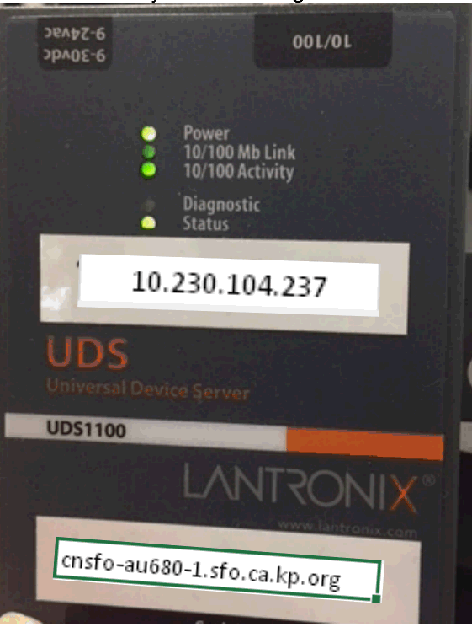

iii. At the same time check that the ethernet cables are plugged and not loose.

iv. Results transmitting

a.) Yes – no further action is needed and AD CDA LAB CN will close the INC Ticket.

b.) No –

i.) INC Ticket will be reassigned to Royce Digital who will be available 24/7 for support of these devices.

ii.) Royce Digital will call or actual come on site and trouble shoot the device to see what the issue is.

iii.) If Lantronix Server Box needs to be replaced there are spare ones in the Manager’s Office.

**References:**

Lantronix UDS1100 2011 Copyright Quick Start Guide.

**Associated Documents:**

External Documents

Associated Quality System Documents - None

**Document Revision History:**

|  |  |  |
| --- | --- | --- |
| **Revision:** 2 | **Date Created:** 03/29/2018  **Date of Last Revision:** 04/06/2018 | **Last Approval Date:** 04/06/2018 |

|  |  |
| --- | --- |
| **Document Author:**  Filipina S Perucho/CA/KAIPERM |  |

**Reason for Change:**

|  |  |  |  |
| --- | --- | --- | --- |
| **Revision:** | **Sec/Para Changed** | **Change Made:** | **Date** |
| 1 | N/A | Initial Issue of Document | 03/29/2018 |
|  |  |  |  |
|  |  |  |  |
|  |  |  |  |

**Approvals:**

|  |  |
| --- | --- |
| **Name:** Eric Suba/CA/KAIPERM  **Title:** Chief of Pathology; CLIA Director | Apr 6, 2018 09:19:08 AM PDT - Approved by: Eric Suba/CA/KAIPERM |