**Platelet Inventory Management**

1. **Number of Platelets to Order for CVOR the Next Day**

|  |  |
| --- | --- |
| Number of CVOR cases that starts **before noon**  (Do not count TAVR cases in CVOR5) | Number of Platelets to Order  (2 platelets per case + 1 extra) |
| 1 | 3 |
| 2 | 5 |
| 3 | 7 |
| IRR | 2 per case – include in total above |
| Rh Neg F<50 yrs | 2 per case – include in total above |

**NOTE:** Do Not Order Rh Neg platelets for non-CVOR patients. Request stock to be delivered after midnight if there are at least 2 platelets that are good after midnight in the Platelet Agitator.

1. **Platelet Replenishment During Surgery Hours**

**Order replenishment platelets** **immediately**:

1. When down to 1 unassigned platelet – Order 1 unit STAT
2. When there are more than one ongoing CVOR and one CVOR case requests 4 platelets without advance order – Order 2 platelets STAT if no extra units to accommodate 2 units per CVOR case
3. When platelet is requested for non-CVOR patient e.g. CVICU, ICU, L&D, INF CTR, etc. – Order the same number of units requested, 1 to 1 replacement, if the platelets stocked that day was only adequate for CVOR and no extra units.

Example: 5 platelets for 2 CVOR cases but 1 unit requested by CVICU – order 1 unit STAT

1. When any patient is bleeding – Order 2 units STAT if no extra platelets in stock
2. When MTP is initiated - Order 2 units STAT if no extra platelets in stock
3. **Platelets for ‘To-Follow’ Afternoon CVOR**

**At** **11am Monday-Friday:**

Day Shift checks Platelet Inventory and order additional units if needed ensuring 2 platelets for each CVOR case + 1 extra.

1. **Short-dated Platelets which Cannot be Credited**

**All Shifts** - At the time of receipt, place **'Short Dated Use First'** sticker on platelets that will expire the next day (i.e. platelets that will not be credited if expired unused).

**All Shifts** – If you receive an order for imminent transfusion, switch out assigned **'Short Dated Use First'** platelets if any and use for your patient.

**Swing Shift** – When performing platelet inventory, place **‘Short Dated Use First’** sticker on platelets expiring the next day that will not be credited if expired unused.

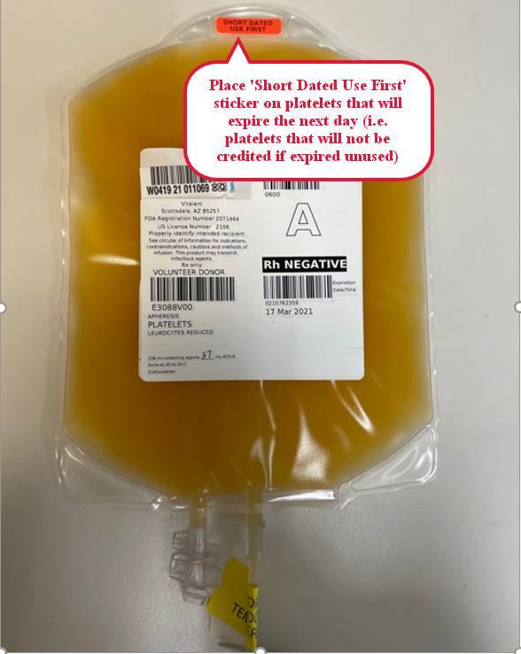

1. **Excess Platelets Management**

**After conclusion of surgery:**

Swing Shift checks Platelet Inventory and transfer extra units to another KP facility.

1. Call KP facility in the following order to inquire if and how many platelets we can transfer:
   1. KP SCL (8401-6310)
   2. KP OAK (8492-6081)
   3. KP SSF (8436-2203)
   4. KP RWC (8424-2420)
   5. KP SLN (8524-4244)
   6. KP SRF (8441-2065)

**NOTE:** If there is no answer, call Operator and ask to be connected to the Blood Bank of that facility.

1. Transfer Platelets in Millennium using Final Disposition module. Add Product Comment ‘Transferred from KPSF’.
2. Transfer Platelets in Vitalant Customer Portal if sending to affiliated KP facilities, SSF, RWC and SRF. Use [***Transfer Document*(BS 5150)**](https://www.vitalant.org/Doc-Control-(1)/BS_5150_R5.aspx)  form for all other KP facilities (except for facilities supplied by ARC) printed from <https://hospitals.vitalant.org/For-Customers/Printable-Forms.aspx> . Fax completed form to Vitalant.

KP facilities supplied by ARC: SCL, SJO, OAK, SLN, RCH, FRE.

1. Pack platelets in Vitalant Platelet Transport Box and add a note ‘Please send back box via Reg Lab courier’. Call UltraX STAT @ 1-800-882-1000 Acct# 7559 to transport the platelets. Other courier services can be used if UltraX is unavailable.