New Platelet Products Coming Starting in August 2021 (week of 8/8/21)

Vitalant has begun implementation of their compliance plan with FDA’s Final Guidance [“Bacterial Risk Control Strategies for Blood Collection Establishments and Transfusion Services to Enhance the Safety and Availability of Platelets for Transfusion”](https://urldefense.com/v3/__https:/www.fda.gov/regulatory-information/search-fda-guidance-documents/bacterial-risk-control-strategies-blood-collection-establishments-and-transfusion-services-enhance__;!!BZ50a36bapWJ!76dcKU9VhXLXvJxMu6CH48T2aZlKaUQ89o3lSoTvdrrLgawnMYxv41dLv9A0SQ$).

To comply with FDA’s Bacterial Risk Mitigation Guidance, Vitalant will have three platelet product types:

To comply with FDA’s Bacterial Risk Mitigation Guidance, Vitalant will have three platelet product types:

1. LVDS 36-hour/5-day (36 hour Large Volume Delayed Sampling – 5 day outdate) – Have the same appearance as current conventional platelets
2. LVDS 48-hour/7-day (48 hour Large Volume Delayed Sampling – 7 day outdate) – Have the same appearance as current conventional platelets
3. PRT Platelets (Pathogen Reduced or Psoralen Treated – 5 day outdate for now) – Platelet bag is longer by 2.8 inches. PRT platelets are acceptable for patients requiring irradiated products, and as an alternative to CMV seronegative or CMV Safe product attributes (AABB standard 5.19.4.1 for irradiation of blood products considers the FDA approved method of pathogen reduction equivalent to irradiation).

LVDS, PRT and conventional platelets can be used interchangeably for treatment of hemostasis.

Please Note that LVDS platelets are similar to conventional platelets (what we have now). LVDS platelets are leukoreduced (CMV safe) and can be CMV Neg if tested so. LVDS platelets must be irradiated if patient requires it. The strategy of large volume delayed sampling involves taking larger sample volumes from each platelet unit and inoculating aerobic and anaerobic culture media 36-48 hours after collection, rather than the 24-hour interval for conventional platelets. The increased sample volume of at least 16 mL per unit, and additional incubation time prior to sampling results in increased bacterial detection.

PRT Platelets have been treated photochemically with psoralen (the specific psoralen used is known as amotosalen) and UVA illumination to reduce pathogens (bacteria, virus, parasite) and T-cells (reduces risk of TA-GVHD). PRT platelets can be dispensed as an alternative to irradiated and/or CMV negative (or CMV safe) platelets. Psoralen treated platelets are leukoreduced during the apheresis collection process. The PRT system that Vitalant uses is manufactured by Cerus Intercept and the platelets may sometimes be called Intercept treated platelets. For more information, check out <https://intercept-usa.com/what-is-intercept/how-intercept-works/>

**Starting in August**, we may receive a combination of different platelet product types i.e. conventional, LVDS 36-hour/5-day, LVDS 48-hour/7-day and PRT Platelets (PRT platelets will be on standing order 3 units/weekday) .

Vitalant’s implementation plan includes:

* Rolling implementation across Vitalant service areas of 7-Day Large Volume Delayed Sampling (no sooner than 48 hours after collection) platelet products (LVDS 48-hour/7-day)
* **NOTE:** Vitalant is rapidly working to have all locations obtain LVDS 48-hour/7-day licensure at time of implementation. LVDS 36-hour/5-day will only be offered by Vitalant should licensure for any locations be delayed.
* Ongoing availability of Pathogen Reduction Technology (PRT) platelets
* **NOTE:** As Vitalant implements LVDS 48-hour/7-day on a rolling basis across service areas, there may be a short period where your facility receives a combination of **conventional** (i.e., the single donor platelet product you have historically received from Vitalant), **LVDS** (36-hour/**5-day** and/or 48-hour/**7-day**, depending on licensure timing) and **PRT** products. As we become fully implemented, conventional products will no longer be available.
* You will receive an additional **notification via paper insert in your blood product shipping containers 7 days prior to the cutover** in the regional blood center that primarily serves your organization, as well as **a reminder a day before you should expect to receive your first LVDS 48-hour/7-day platelets**. – **Please inform Supervisor/In-Charge CLS and manager when you receive the notification and reminder.**

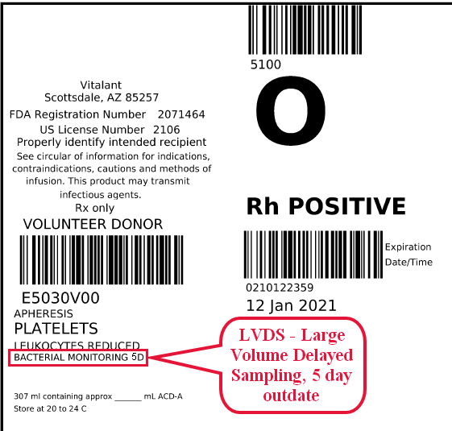

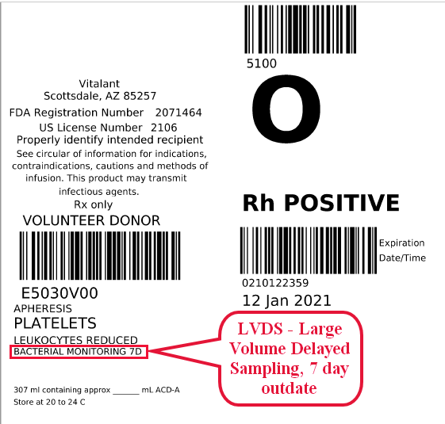

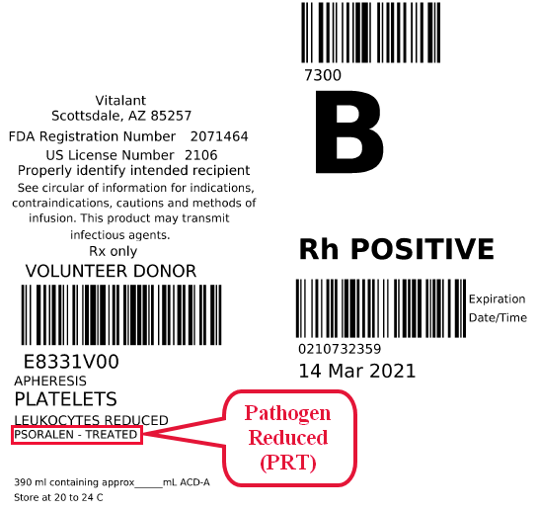

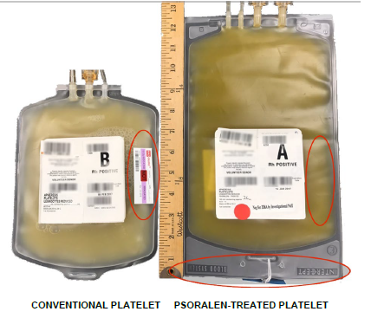

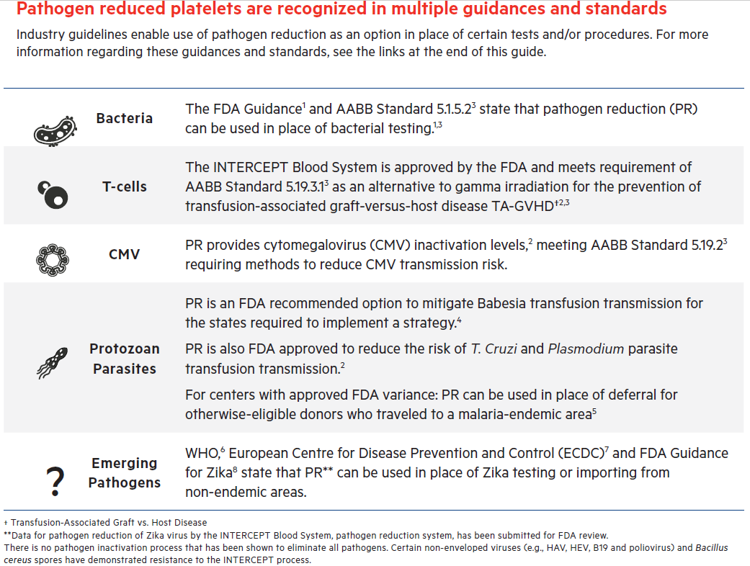

• Contraindications for PRT platelets:

1. Patients with a history of hypersensitivity reactions to amotosalen or other psoralens
   1. PRT platelets have been approved in Europe since 2002 and in the United

States since 2014.

* 1. No cases of psoralen or amotosalen hypersensitivity have been reported

after millions of PRT transfusions.

1. Neonatal patients treated with phototherapy devices that emit a peak energy

wavelength less than 425 nm, or have a lower bound of the emission bandwidth less

than 375 nm

1. The American Academy of Pediatrics-Clinical Practice Guidelines

recommend a spectrum between 430-490 nm for intensive phototherapy;

which is outside of the bounds of the listed PRT contraindication. None of the

neonatal phototherapy devices currently approved for market in the U.S. emit

a peak wavelength below 425 nm, and/or a lower bound of the emission

bandwidth less than 375 nm.

1. No photosensitivity reactions have been reported in neonates undergoing

phototherapy who have received PRT platelets.

• The contraindications for PRT platelets are generally not applicable for the vast

majority of patients.