EMERGENCY RELEASE with Trauma ID or NO Current Encounter

NOTE: Please refer to the Emergency Release SOP for details. NO Prepare Order needed.

- Click on Dispense and Assign Products icon .

- When the patient is using a trauma number or has No Current Encounter, click on the Emergency Release icon on top menu bar.

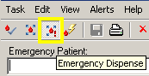

- Type the assigned Trauma Name and Trauma# or Patient’s actual Name and MR# as freetext in the Emergency Patient box. Caution: This freetext mode does not crosscheck with patient’s historical information if there is any in the Millennium database. Patient’s demographics will not populate.

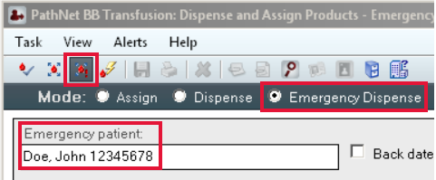

- Scan the unit# of the uncrossmatched ‘O Neg’ or ‘O Pos’ RBC into the space below the Product Number. When the Blood Bank Exception window below opens, click on ‘Yes’ to override and select ‘Emergency’ as the reason for unmatched group and type. (Emergency patients may not have a blood type). Click ‘OK’.

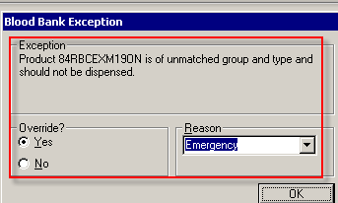

- Continue scanning all the uncrossmatched RBC units, then click the ‘Save’ icon on top menu bar. Enter the appropriate information in the window below when it pops up. See next page.
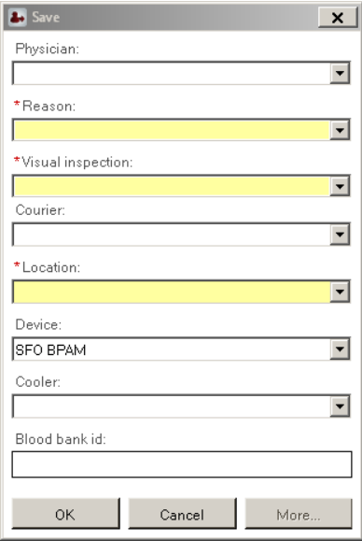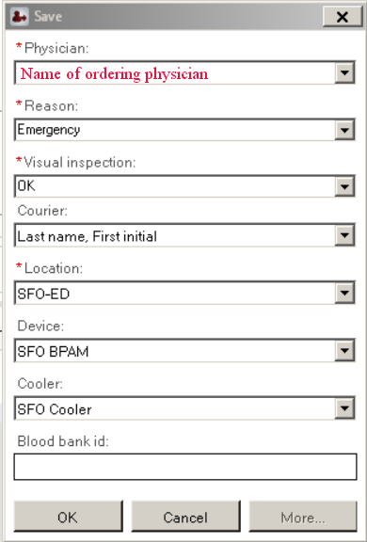

- Physician: Enter physician’s last name, first name or select from drop down menu.

- Reason: Select Emergency.

- Visual Inspection: The only accepted response in this field is OK. If any other response is entered, the system will not allow the product to be dispensed.

- Courier: Enter runner’s last name, initial of first name and OR# when dispensing to SX.
- Location: The appropriate location will auto populate if the correct encounter had been selected. Otherwise, type ‘SFO-‘ and enter. Select from the drop down menu.
- Device: Device will autopopulate with ‘SFO BPAM’ for IP and ‘SFO Ambulatory’ for OP.
- Cooler: Enter ‘SFO Cooler’ or ‘SFO Surgery’ when appropriate. 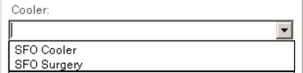

- Click OK when done.

NOTE: For products that are dispensed emergently or without a Prepare Order to a patient, the user will receive a warning that no outbound message will be sent. The end result is that the patient and product information will not be transmitted to BPAM.
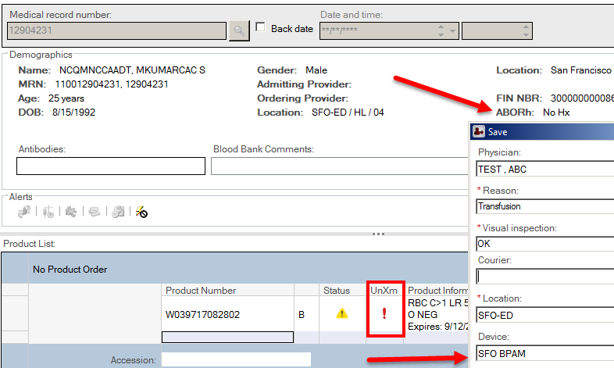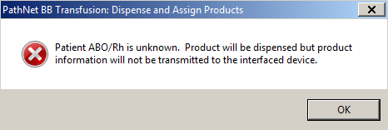

NOTE: Millennium considers a device or a cooler a viable storage device, like a refrigerator, and will exempt those units from being marked as transfused when the daily Final Disposition report is run.

NOTE: Once a product has been dispensed to a patient in Emergency Dispense mode and the patient is registered in the system and has been given an MRN, the patient’s record must be updated to reflect the use of the emergency dispensed product. This action is performed in the Correct Inventory application and links the product to the patient for accurate disposition.

- See next page to link the emergently dispensed products with the correct MR#.

Update Emergency Dispense Information (Correct Inventory) 
- Click on the ‘Correct Inventory’ icon.
- Click the Emergency Dispense tab in the ‘Correct Inventory’ window.
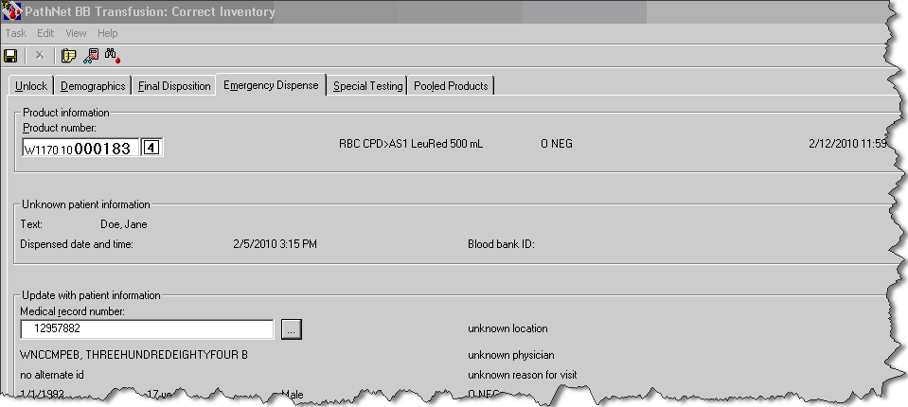

- Click the Product Number field and scan in the product number.

NOTE: After an appropriate product has been entered, free-text patient name or identifier information that was entered at the time of the emergency dispense is displayed in the Unknown patient information area.

- Click the Medical record number field and enter the patient’s MR# and select the appropriate encounter; patient’s demographic information displays.
- Click the ‘Save’ icon.
- Select Reason from the predefined list or enter a free-text comment in the Comments box.
- Click OK; changes are saved.
- Check PPI to make sure the products are associated correctly with the patient.

NOTE: Post-transfusion compatibility testing should be performed according to protocol. The system will warn you that product is currently Dispensed. By clicking ‘Yes’, the system will allow you to enter results. Once results are entered, when the user clicks Verify, the system will warn the user that the product will remain in a Dispensed state. When the user clicks ‘OK’, the system will document in the product history that the product was crossmatched.

