**PeriOp BPAM Process starting 2/13/23**

Go LIVE for Golden Gate area is 2/13/23.

Starting 2/13/23, BPAM (Blood Product Administration Module in KPHC) will be used by Anesthesia to document transfusion during surgery.

In order for blood products to be scanned into BPAM, Blood Bank needs appropriate Inpatient Prepare Orders, e.g. IP PR RBC, IP PR FFP, IP PR PLT, IP PR CRY.

For patients with crossmatched pRBC ordered pre-operatively, an **IP PR RBC #251086** should be placed and released prior to start of case.

During surgery, anesthesiologist will need to place a new IP PR RBC for additional pRBC and the appropriate Prepare Order for other blood products. The Prepare Order will auto-print in Blood Bank once released and will replace faxing of paper requisition. The Prepare Order tells the Blood Bank the quantity and type of blood products needed and also it is used at Dispense to transmit information from Cerner Millennium to Epic KPHC BPAM.

Please note the following:

1. OR will continue to call Blood Bank when ordering blood products and will continue to use the pink paper pick-up slips.
2. Emergency Release, Hemorrhage Pack and MTP blood products are exempted from BPAM. No Prepare Order is needed for these units.
3. Blood Bank will no longer order IP Prepare Order for any patient in surgery. Lab generated Prepare Order does not work with BPAM.
4. Blood Bank will put a sticker  on blood products that do not have Inpatient Prepare Order. This can happen if anesthesiologist does not have time to place order prior to blood product pickup.
5. Anesthesia will revert back to manual two person verification process anytime BPAM cannot be used to document transfusion.

ISSUES IN THE BLOOD BANK DURING SCL PILOT

1. Duplicate Prepare orders placed by different providers.
2. OR not aware that uncrossmatched blood cannot be scanned.
3. Order on paper/fax (not in HC) cannot be scanned.
4. MD put in a “conditional” Prepare Order that requires someone to release it to Blood Bank.
5. OR nurses did not know about BPAM, continue to fax orders.
6. Informed anesthesiologist that only Prepare Order is needed, no Type and Screen or Hold BB.
7. CLS did not complete the dispense process.
8. CLS dispensed to an outpatient encounter.

**Surgery Schedule Review Instructions for Swing Shift BB CLS**

1. For any patient with PreOp crossmatched pRBC without an IP PR RBC, check KPHC for a signed & held IP PR RBC.

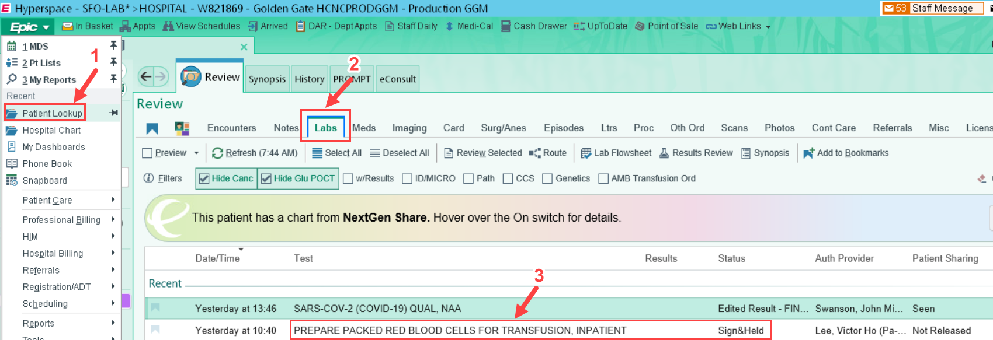

1. If there is no IP PR RBC order, indicate ‘No IP PR RBC’ on the OR Schedule.
   1. If the patient is admitted, call the RN to request a clinician to place a Prepare Order.
   2. If the patient is SDA for CVOR, **cortext** message template below to **SFO BB CVNP Group**.
   3. If the patient is SDA for non-CV, **cortext** message template below to **the Surgeon.**

**IP PR RBC Cortext Message Template: (First fill in the information then copy and paste to cortext.)**

**This notification informs providers that the Transfusion Service requires an Inpatient Prepare RBC order (IP PR RBC #251086) to be placed in KPHC and released prior to blood pickup for surgery.**

**The transfusion service has ______ units of RBC crossmatched pre-operatively for the patient identified below.**

**Please note that blood product without an Inpatient Prepare order cannot be scanned into BPAM and will require a two person manual paper safety check.**

Please call the Blood Bank (833-3881) with inquiries.

This request will not be repeated and requires action by a provider.  Thank you.

**Patient name:**

**MRN:**

**Date of Sx:**

**Case procedure:**

**Order on PreOp requisition (e.g., TX 2 RBCs):**