**Inventory Management**

1. **Number of Platelets to Order for CVOR the Next Day**

|  |  |
| --- | --- |
| Number of CVOR cases that starts **before noon**  (Do not count TAVR) | Number of Platelets to Order  (2 platelets per case + 2 extra) |
| 1 | 4 |
| 2 | 6 |
| 3 | 8 |
| Redo/Revision | 4 per case – add to # above |
| Aortic Repair | 4 per case – add to # above |
| IRR | 2 per case – include in total above |
| Rh Neg F<50 yrs | 2 per case – include in total above |

**NOTE:** Do Not Order Rh Neg platelets for non-CVOR patients. Request order to be delivered after midnight. Place separate STAT order for stock platelets (4 units at all times) if needed.

1. **Platelet Replenishment During Surgery Hours**

**Order replenishment platelets** **immediately**: (keep in mind the 2 PRT platelets on standing order M-F)

1. Order replenishment platelets as the units on the shelf are assigned to have 4 at all times.
2. When platelet is requested for non-CVOR patient e.g. CVICU, ICU, L&D, INF CTR, etc. – Order the same number of units requested, 1 to 1 replacement, if there are no extra platelets in stock.
3. When any patient is bleeding – Order 2 units STAT if no extra platelets in stock.
4. When MTP is initiated - Order 2 units STAT if no extra platelets in stock.
5. **Platelets for ‘To-Follow’ Afternoon CVOR**

**At** **11am (or earlier if ‘To-Follow’ cases are scheduled before noon) Monday-Friday:**

Day Shift checks Platelet Inventory and order additional units if needed ensuring 2 platelets for each CVOR case (4 platelets for Redo/Revision or Aortic Repair) + 2 extra.

1. **Short-dated Platelets which Cannot be Credited**

**All Shifts** - At the time of receipt, place **'Short Dated Use First'** sticker on platelets that will expire the next day (i.e. platelets that will not be credited if expired unused).

**All Shifts** – If you receive an order for imminent transfusion, switch out assigned **'Short Dated Use First'** platelets if any and use for your patient.

**Swing Shift** – When performing platelet inventory, place **‘Short Dated Use First’** sticker on platelets expiring the next day that will not be credited if expired unused.  ***Consider transferring 1-2 short dated platelets if there are more than 2 units expiring the next day (order replacement units with better outdates).***

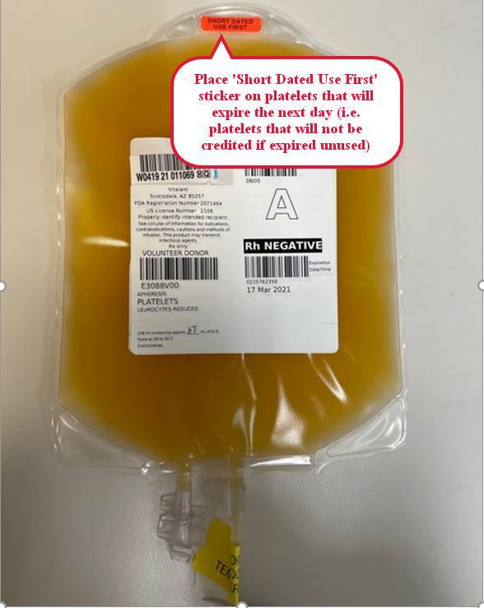

1. **Excess Platelets Management**

**After conclusion of surgery:**

Swing Shift checks Platelet Inventory and transfer excess units to another KP facility.

1. Call KP facility in the following order to inquire if and how many platelets we can transfer:
   1. KP SCL (8401-6310)
   2. KP OAK (8492-6081) – **only accepts PRT or CMV- IRR**
   3. KP SSF (8436-2203)
   4. KP RWC (8424-2420)
   5. KP SLN (8524-4260)
   6. KP SRF (8441-2065)

**NOTE:** If there is no answer, call Operator and ask to be connected to the Blood Bank of that facility.

1. Transfer Platelets in Millennium using Final Disposition module. Add Product Comment ‘Transferred from KPSF’. ***Make a copy of the printout for NON-Vitalant facilities.*** Place original in the tray labeled ‘Transferred’.
2. Transfer Platelets in Vitalant Customer Portal if sending to affiliated KP facilities, **SSF, RWC and SRF**. Use [***Transfer Document*(BS 5150)**](https://www.vitalant.org/Doc-Control-(1)/BS_5150_R5.aspx)  form for all other KP facilities (**except** **for facilities supplied by ARC**) printed from <https://hospitals.vitalant.org/For-Customers/Printable-Forms.aspx> . ***Fax completed form to Vitalant.***

KP facilities supplied by **ARC**: SCL, SJO, OAK, SLN, RCH, FRE.

1. Pack platelets in Vitalant Platelet Transport Box.
   1. For NON-Vitalant facilities:
      1. Place a note in the box, ‘Please send back box to KPSF BB via Reg Lab courier’ and a copy of the Final Disposition printout.
   2. For Vitalant facilities:
2. We don’t need the Platelet Box back. Place a copy of the Transfer printed from Vitalant Customer Portal.
3. Call a courier to transport the blood products.

|  |  |  |
| --- | --- | --- |
| **Courier name** | **Tel#** | **Acct#** |
| **CBX** | **1-925-551-8788** | **124001** |
| **UltraX** | **1-800-882-1000** | **7559** |
| **Desoto Taxi Cab** | **415-970-1300** | **6-31-6940** |

1. Record on the ***‘Blood Product Transfer Tracker Log’***.