**TOSOH G-8 HISTOGRAM/QC EXAM**

Answer the following questions. Passing score is 80 %. This is part of your chemistry yearly competency accessment

1. 800 mL Elution Buffer bags are stable on the instrument for :
2. 1 week
3. 1 month
4. 2 weeks
5. 3 months
6. The system filter should be changed:
7. Every week
8. Every month
9. Every 400 samples
10. Every 2500 samples
11. True or False If a primary tube has less than 1 mL, whole blood can be poured into a sample cup and run in the alternate sampling mode.
12. Possible causes of high pressure are :
    1. Dirty filter
    2. New filter not installed properly
    3. Crimped peek tubing
    4. All the above
13. What criterion is acceptable for Total Area?
    1. 500-4000
    2. 1000-5000
    3. 2000-6000
    4. 600-9000
14. SA1c retention time must be between
    1. 0.56 – 0.60
    2. 0.59-0.63
    3. 0.57-0.61
    4. 0.56-0.62
15. Indicate reportable or not reportable following patient chromatographs (Circle the Correct Answer)



Reportable Reportable

Not Reportable Not Reportable

1. Indicate reportable or not reportable following patient chromatograph (Circle the Correct Answer)



Reportable

Not Reportable

1. Indicate reportable or not reportable following patient chromatograph (Circle the Correct Answer)



Reportable

Non Reportable

1. Indicate reportable or not reportable following patient chromatographs (Circle the Correct Answer)

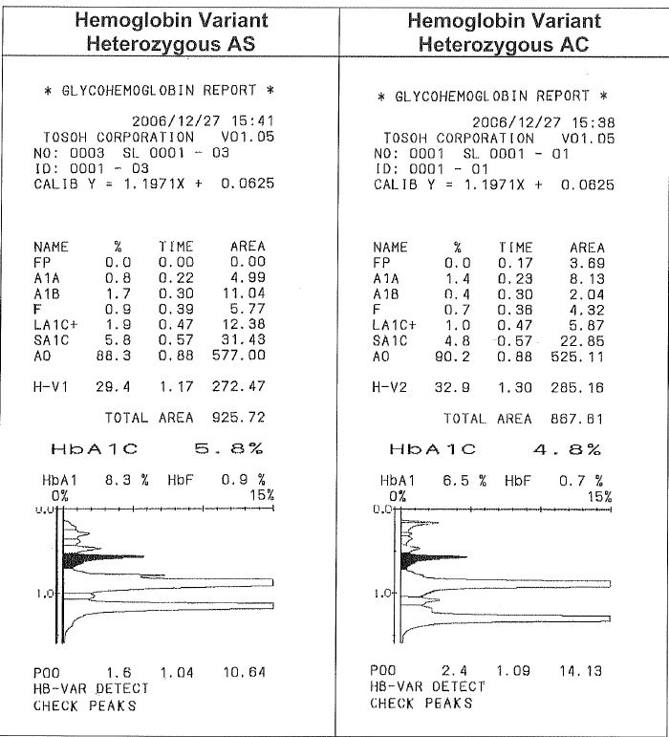

REPORTABLE REPORTABLE

NOT REPORTABLE NOT REPORTABLE.