SOP HISTORICAL RECORD
DATE | WRITTEN/REVISED* BY | SUPERVISOR REVIEW/APPROVAL | MD  REVIEW/APPROVAL
7-17-2014 | C. Spaniol | B. Hall 7-18-14 | R. Khera 7-18-14
2-6-15 | C. Spaniol | B. Hall 2-6-15 | R. Khera 2-6-15
 |  | B. Hall 1-30-17
 |  | B. Hall 5-4-18
 |  | B. Hall 5-1-2020
5/16/22 | E. Skelly | B. Hall 5/16/22 | RK 5/16/22
7/13/22 | E. Skelly | BMH 7/14/22 | RK 7/14/22

*REVISION DATE | REVISION DESCRIPTION | ALL COPIES REVISED?
2-6-15 | Added section on temperature monitoring, 6 month optional | yes
 | competency added
5/16/22 | Updated “patient location” in the Accessioning and Entering Results in VISTA section to include active locations | Yes
7/13/22 | Update temperature monitoring | Yes

DOCUMENT CONTROL
THIS DOCUMENT IS ONLY CONTROLLED IN THE MANUAL OR ELECTRONICALLY.

EFFECTIVE DATE: | 7-21-2014
LOCATIONS OF ALL COPIES: | [MASTER - electronic]  Lab-Dept. Shares
LOCATIONS OF ALL COPIES: | Ancillary manual-lab
LOCATIONS OF ALL COPIES: | Ancillary manual-AMBS
REMOVED FROM SERVICE:

Purpose
PyloriTek is a simple threshold test designed to detect an active H. pylori infection in gastric biopsy specimens. In several major studies, the average specificity was reported as 95% (range 94% - 97%) and the average sensitivity as 97% (range 94% - 99%).
Over 90% of patients with duodenal ulcer and about 80% of those with gastric ulcer have been reported to have H. pylori infection. In addition, H. pylori has been associated with gastric cancer. Eradication of H. pylori has proven effective in eliminating or reducing recurrence of gastric and duodenal ulcers.
H. pylori infection is believed to be spread by fecal/oral and possibly oral/oral contact. Higher incidence of infection is found in geographical areas with poor hygiene and sanitation practices.
Principle
The PyloriTek Test Kit detects urease activity in gastric biopsy specimens for the presumptive identification of Helicobacter pylori organisms. This organism produces high levels of an enzyme called urease, which is not present in mammalian tissue. If urease is present in the gastric biopsy, it reacts with urea in the Substrate Pad of the PyloriTek Reagent Strip to generate ammonia. A pH indicator in the PyloriTek Reaction Pad turns from yellow to an intense purple/blue color when ammonia is detected.
The PyloriTek Test Kit is a CLIA waived test kit.
Specimen
Patient Preparation:
The current medical consensus is that the patient should refrain from taking antibiotics and/or bismuth for 14-28 days prior to the gastroscopy procedure. Proton pump inhibitors should also be avoided for seven to fourteen days prior to the procedure. These drugs have been shown to reduce urease activity of H. pylori and to reduce the density and number of organisms, thereby increasing the chance of a false negative test result.
Type:
Gastric specimen.
Only one biopsy is required, however up to three biopsies from one patient can be placed on the Reaction Pad of one PyloriTek Reagent Strip.
The area to be biopsied and the number of biopsies is determined by the doctor, but areas commonly biopsied are the greater curvature of the pre-pyloric antrum, the antral lesser curvature near the incisura and the greater curvature of body of the stomach. Avoid areas of erosion or ulceration.
Handling Conditions:
The gastric biopsy must be transferred directly from the forceps to the Reaction Pad of the PyloriTek Reagent Strip in a timely manner to minimize loss of urease activity in infected specimens. Use a wooden applicator stick or plastic pick to transfer the biopsy to the Reaction Pad. Do not place the gastric biopsies on gauze or filter paper prior to placing it on the Reaction Pad. Mucous containing H. pylori organisms may inadvertently be transferred to the gauze and increase the chance of a false negative result.
Avoid contamination of biopsy specimens with formalin from biopsy forceps, work surfaces or other sources. Formalin can inhibit H. pylori urease activity and lead to false negative test results.
Supplies

Test Kit
PyloriTek Test Kit (Serim Research Corp. cat #05140K) contains:
Reagent Strips
Hydration Reagent
Disposable Reaction Pouches

External QC:
PyloriTek Positive Control (cat # 5146 – PyloriTek Positive Control Papers)

Timer
Wooden applicator stick or plastic pick
Test Kit Storage Requirements
- Store the unopened PyloriTek Test Kit in the P&LMS Microbiology refrigerator at 2°- 7°C (36°- 45°F) until the kit is to be used.

- Always allow the kit components to come to room temperature 15°-30° C (59°-86°F) prior to opening and use.

- Once the bottle has been opened, store all kit components at room temperature 15-30°C (59°- 86° F) in Ambulatory Surgery.

- Write the opened date on the bottle. PyloriTek Reagent Strips must be used within 3 months of first opening the bottle or before the kit expiration date, whichever occurs first.

- Do not store test strips near sources of heat, ammonia, or formaldehyde. Extreme heat or chemical fumes may cause development of extraneous background color on the strip.

Temperature Monitoring

Room temperature will be monitored by hospital Metasys (OR temp range 68-72F). If the temperature is out of acceptable range, staff will be notified by boiler plant. PyloriTek kit will need to be removed until room is back within acceptable temperature range. Notify the Ancillary Testing Coordinator that QC needs to be run before patient testing continues.

Handling Procedures

- Do not remove a PyloriTek strip from the bottle until immediately before use.

- Replace the bottle cap immediately and tightly after removing a strip.

- Do not return unused strips exposed to ambient conditions to the bottle.

- Do not place strips back in the bottle once Hydration Reagent has been added.

- Avoid touching the red control spot on the reaction pad.

- Do not remove the desiccant pack.

- Do not use a strip if the Reaction Pad displays atypical purple, blue or gray areas prior to use. (Some strips may have a “mottled” yellow-orange Reaction Pad, but this slight variation in color is normal and it does not affect performance of the PyloriTek Reagent Strip.)

Special Safety Precautions

Personal Protective Equipment (gloves) should be utilized.
Specimens and controls should be considered potentially hazardous and handled as an infectious agent. Discard all material in the proper biohazard container.
Disinfect work surfaces after testing.
Hazardous component: Hydration reagent contains 0.1% as a preservative. Harmful if swallowed and may be absorbed through the skin.
Procedure
Prior to testing
STEP | ACTION
1. | Make sure all the components of the PyloriTek Test Kit are on hand and at room temperature; one bottle of PyloriTek Reagent Strips, one bottle of Hydration Reagent and Disposable Pouches equivalent to the number of reagent strips in the kit.
2. | Check the expiration dates on the PyloriTek Reagent Strips and Hydration Reagent to make sure they have not expired.
3. | Immediately prior to use, remove one PyloriTek Reagent Strip from the bottle. (Do not remove strips from the bottle until ready to use.)
4. | Do not touch the white pads on the back of the Reagent Strip, but make sure the Positive Control Spot (small red dot) is visible in the upper left-hand corner of the Reaction Pad. (Refer to Diagram 1A.)
5. | Place the strip on a clean, dry surface with the white pads and Positive Control Spot facing down (in preparation for writing the patient’s name)
6. | Replace the cap on the bottle and tighten securely.

PyloriTek Reagent Strip

Diagram 1A  Diagram 1B  substrate pad
Unreacted Positive Control Spot on the reaction pad
Back view Front view
7. | Write the patient’s name or I.D. number and the time the test is started on the front of the PyloriTek Reagent Strip. (Refer to diagram 1B)
8. | Turn the strip over. Crease the strip at the perforation (pads facing in); then add 4 drops of Hydration Reagent to each quadrant of the Substrate Pad (Substrate pad is the one adjacent to the 4 printed droplets, opposite the pad containing the positive control. See Diagram 1B). To moisten evenly, it is recommended to place a drop on each quadrant. Make sure the hydration reagent is fully absorbed before adding biopsies.
9. | Place up to 3 biopsies, properly spaced, from the same patient on the Reaction Pad (side with positive control See Diagram 1A). Do not place the biopsy on or very near the red control spot, or in the upper quadrant of the reaction pad as this is the negative control area.
10. | Fold the Substrate Pad over onto the Reaction Pad and insert the strip into the Disposable Pouch.
11. | Set a timer for 60 minutes, but check the strip periodically.
12. | Interpret the results of the test at 60 minutes. A positive result may be evident before the 60 minutes has expired. However, a full 60 minutes is needed to confirm a negative result.

- Note: Do not carry pouches with developing tests in the pockets of your clothes during the one hour development time. As biopsy tissue may contain potentially infectious organisms, the pouch and contents should be considered a potential hazard.
- Tests must be inserted in the disposable pouch provided with the test kit. This is designed to provide evenly dispersed pressure and optimum contact between the moistened Substrate Pad and the Reaction Pad/biopsy/positive control spot. Pressing the two pads together initiates the reaction and channels the ammonia gas generated by the reaction through the semi-permeable membrane to the pH indicator. Taping or clipping the strip together may result in uneven, inadequate contact, causing false negative results.

Quality Control
Internal Controls
A positive and negative control is incorporated into each PyloriTek Reagent Strip. No additional preparation is required and controls are “automatically” run every time a reagent strip is used. These procedural controls verify that the Hydration Reagent was added and that the test system is working as expected.

Internal Positive Control
An unreacted Positive Control appears as a red spot located on the Reaction Pad in the upper left-hand corner. (Refer to Diagram 2.) The red spot contains urease and acts as an integral reactive Positive Control meaning that the control spot actually contains the target analyte (urease). This spot also serves as a process control; its development indicates that all the steps of the test procedure have been performed properly.

Reacted Positive & Negative Controls
(Front view)
Unreacted Positive Control
(Back view)
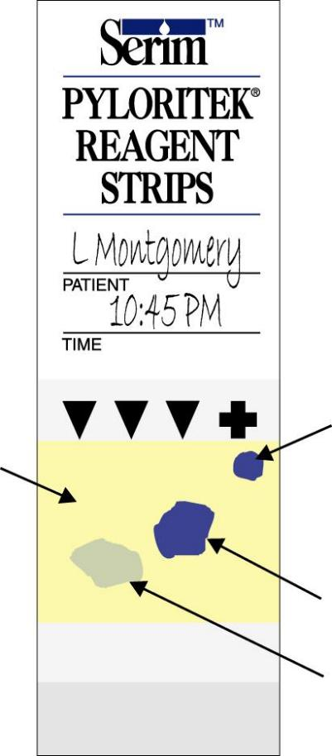
Unreacted Positive Control spot
Spot
Reacted Positive Control
Negative Control Area
Positive Specimen
Negative Specimen

Diagram 2 Diagram 3

Corrective Actions
- If the red Positive Control Spot is not visible on the back of the PyloriTek Reagent Strip
- Do not use the strip.
- Obtain another reagent strip to perform the H. pylori test.
- Retain the strip with the missing Positive Control Spot and contact the Ancillary Testing Coordinator.
- If the Positive Control does not develop by the full 60 minute development time
- The test is invalid and the results should not be reported.
- The biopsy(ies) may be transferred once to a second PyloriTek Reagent Strip for repeat testing. This decision should be made by the attending physician based on the patient’s history, symptoms and observations during endoscopy.
- An alternative method is to place the biopsy(ies) in formalin and send it to pathology for histological staining and pathological interpretation.

Internal Negative Control
Viewed from the front of the PyloriTek Reagent Strip, any area of the yellow Reaction Pad other than directly above the Positive Control Spot or a gastric biopsy can be chosen to serve as a Negative Control area. (Refer to Diagram 3.) This is a procedural control; maintenance of a creamy yellow or yellowish-orange color in this area during the entire 60-minute development time indicates that the integrity of the Reagent Strip has been maintained.

Corrective Actions
- If the unreacted yellow Reaction Pad displays an atypical color prior to use:
- Do not use the strip.
- Obtain another reagent strip to perform the H. pylori test.
- Retain the strip with the atypical color and contact the Ancillary Testing Coordinator.
- If the yellow Negative Control area of the Reaction Pad displays an atypical color during the 60 minute development time (refer to Diagrams 4A & B):
- The test is invalid and the results should not be reported.
- An alternative method is to place the biopsy(ies) in formalin and send it to pathology for histological staining and pathological interpretation.
- Retain the strip with the atypical color and contact the Ancillary Testing Coordinator.
- Failed Negative Controls
(Color in areas other than above a gastric specimen or Positive Control Spot)
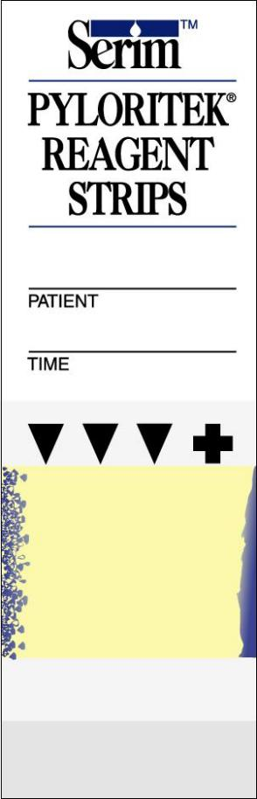

Front of strip

Diagram 4A Diagram 4B

- Should the controls for any strip react incorrectly, the test is invalid and the results should not be reported.
External controls
An external positive control for PyloriTek (request Product Code 5146 – PyloriTek Positive Control Papers) will be run on each new lot number/shipment.

This reactive control contains urease (the same enzyme produced by H. pylori bacteria) and mimics the result of an H. pylori-infected gastric biopsy. Use of this control will assist in monitoring the testing process, from biopsy application to result interpretation, to assure proper test performance.

External QC records and lot numbers will be maintained in P&LMS by the Ancillary Testing Coordinator.

Result Interpretation
Sixty minutes after inserting the PyloriTek Reagent Strip into the Disposable Pouch, interpret the results of the test by observing the area of the Reaction Pad over the gastric biopsy for color development and comparing it to the Positive Control. The Reaction Pad should also be observed to assure that the Negative Control areas remained yellow. Disregard any color formed more than 60 minutes after insertion of the strip into the Disposable Pouch.
Areas to interpret  on the PyloriTek Reagent Strip | Description of Normal Appearance
Positive Control Spot | Intense purple/blue color in upper right-hand corner of the yellow Reaction Pad
Negative Control Areas | Reaction Pad remains yellow in areas  other than above the Positive Control  or an infected gastric biopsy.

Positive
If the Negative Control areas remain yellow, and the Positive Control Spot in the upper right-hand corner displays an intense purple/blue color and a similar color has developed over the gastric biopsy within 60 minutes of starting the test, the result is reported as “Positive”; the biopsy is infected with H. pylori. Occasionally, the color over a positive biopsy may not develop as a dense, unbroken shape like the Positive Control, but appear stippled containing intense purple/blue irregular-shaped spots.

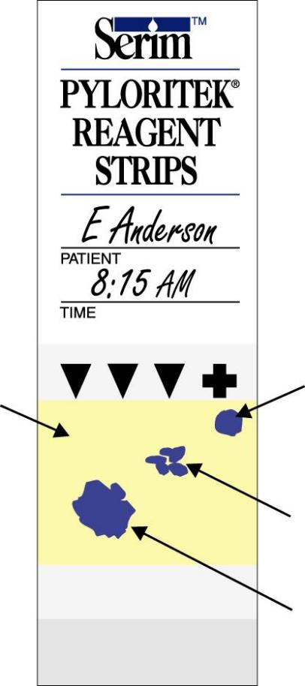
Positive Control
Negative Control Area
Positive Specimen (stippled)
Positive Specimen

Diagram 5

Occasionally, the patient’s specimen may yield a positive reaction before the control spot develops. In these cases, wait the full 60 minutes for the Positive Control Spot to develop before interpreting the final test results. Occasionally, a dark blue stippled pattern (see Diagram 5) may appear over the biopsy. This should be interpreted as a positive result. Positive results can be interpreted any time up to 60 minutes if an intense purple/blue color appears over both the biopsy specimen and the Positive Control Spot and the Negative Control areas remain yellow.
Negative
If, 60 minutes after starting the test, the Negative Control areas remain yellow, and the Positive Control Spot in the upper right-hand corner displays an intense purple/blue color, but there is no color or only a pale blue or faint gray color over the gastric biopsy, the result is reported as “Negative”; the biopsy is not infected with H. pylori. Occasionally a pale blue or gray color will appear over an uninfected gastric biopsy. This result should be interpreted as Negative.

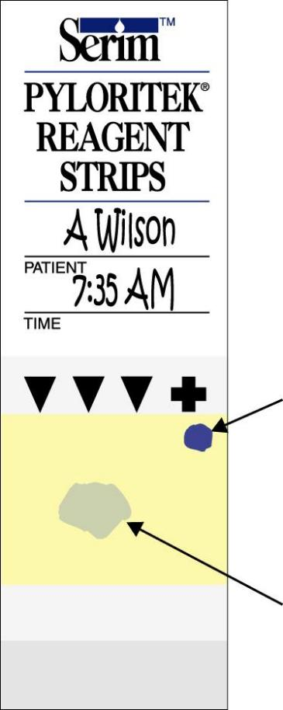
Positive Control
Negative Specimen

Diagram 6

Should the controls for any strip react incorrectly, the test is invalid and the results should not be reported. Disregard color formed more than 60 minutes after insertion of the strip into the Disposable Reaction Pouch.

Refer to the “PyloriTek Quick Reference Guide” for a visual guide to interpreting reaction patterns.
Result Interpretation

PyloriTek test results are reported as Positive or Negative for an H. pylori infection.
Internal control is reported as valid (if invalid see corrective actions page 8 this SOP).

PROCEDURE NOTES:
- Allow all kit components to come to room temperature prior to opening the kit and prior to use. This prevents condensation from forming inside the bottle of PyloriTek Reagent Strips.
- Make sure the red control spot is present on the Reaction Pad before using the strip.
- Do not lay the strip on a wet counter.
- Do not handle the strip with wet gloved hands as the Positive Control Spot could be smeared or rubbed off.
- Make sure the Hydration Reagent is added to the Substrate Pad. Place 1 drop of Hydration Reagent on each quadrant of the Substrate Pad.
- Do not add more or less than 4 drops of Hydration Reagent; just enough to be sure the Substrate Pad is thoroughly and evenly moistened before folding/closing the strip.
- After moistening the Substrate Pad, do not repeatedly fold and unfold the strip. If more than 1 biopsy is to be placed on the strip, do not fold the strip until the last biopsy is in place.
- Place the biopsy on the Reagent Strip as soon as possible after retrieval so that urease activity in the biopsy is not lost.
- Applicator sticks or plastic picks can be used to transfer the biopsy from the forceps to the Reagent Strip. Avoid using needles to prevent inadvertent needle sticks.
- Use only the Disposable Reaction Pouch supplied in the kit to hold the folded PyloriTek Reagent Strip.
- Insert the PyloriTek Reagent Strip into the Disposable Pouch until the strip touches the bottom of the pouch. Do not use tape or paper clips to hold the PyloriTek Reagent Strip closed.
- The patient’s specimen may yield a positive reaction before the control spot develops. In these cases, wait until the Positive Control Spot develops (allow the full 60 minutes if necessary) before interpreting the final test results.
- If the controls on a particular strip do not react properly, retain the bottle of remaining strips for return to the PyloriTek Sales Representative.

Accessioning and Entering Results in VISTA

Select Process Test/Data Option: ^FAST

1 Fast Bypass Data Entry/Verify [LRFASTS]
2 Fast lab test order (ROUTINE) [LROW ROUTINE]
3 Fast lab test order (SEND PATIENT) [LROW SEND PAT]
4 Fast lab test order (WARD COLLECT) [LROW WARD COL]

Choose #1 Fast Bypass Data Entry/Verify

Do you want to review the data before and after you edit? YES//
Select Performing Laboratory: ERIE VAMC// PA VAMC 562

WANT TO ENTER COLLECTION TIMES? Y//
Select ACCESSION TEST GROUP: LEAVE BLANK
Select one or more tests from which you will be generating your entries.
Select LABORATORY TEST NAME: HELICOBACTER PYLORI (POC) (START SPELLING IT OUT AND THE COMPPUTER SHOULD FINISH
The Sample Is BIOPSY
Select SITE/SPECIMEN: GASTRIC MUCOUS MEMBRANE 63010
Same specimen/source for the rest of the order? No// (No)
Select LABORATORY TEST NAME:

SELECT PATIENT NAME: ZZAQA,PATIENT A 1-139 000001122 NO NSC VETERAN

WARNING : You may have selected a test patient.
Enrollment Priority: GROUP 8g Category: NOT ENROLLED End Date: 03/19/2010

*** WARNING ***
*** PATIENT ENROLLMENT ENDED EFFECTIVE 03/19/2010 ***

Select one of the following:

LC LAB COLLECT(INPATIENTS-MORN. DRAW)
SP SEND PATIENT
WC WARD COLLECT
I Immed COLLECT

Specimen collected how ? : WC// WARD COLLECT
PATIENT LOCATION: ERI SUR// (Choose the appropriate location based on surgeon)
PROVIDER: KHERA//
LAB Order number: 526203
Other tests? N//
Nature of Order/Change: W WRITTEN

You have just selected the following tests for ZZAQA,PATIENT A 000-00-1122
entry no. Test Sample
1 HELICOBACTER PYLORI (POC) BIOPSY GASTRIC MUCOUS MEMBRANE

All satisfactory? Yes// (Yes)

LAB Order number: 526203

Collection Date@Time: NOW// (JUL 15, 2014@07:31:49)
Print labels on: LABLABEL// <<<Select Label Printer here>>>

ACCESSION: POCS 0715 2 <6841960002>
HELICOBACTER PYLORI (POC) BIOPSY GASTRIC MUCOUS MEMBRANE

Work Load Area: SUR POC
ZZAQA,PATIENT A 000-00-1122 LOC:LAB

Sample: BIOPSY
Specimen: GASTRIC MUCOUS MEMBRANE
1 HELICOBACTER PYLORI (POC)

ZZAQA,PATIENT A SSN: 000-00-1122 LOC: LAB
Pat Info: Sex: FEMALE Age: 75yr as of Jul 15, 2014
Provider:xxxx,xxxx Voice pager:
Phone: 814 860-2177 Digital pager:

ACCESSION: POCS 0714 1 POCS 0715 2 [6841960002]
7/14 15:23d 7/15 07:31d
H. PYLORI (POC) //N Negative (ENTER N OR P)
INTERNAL CONTROL //V VALID
Select COMMENT:

ZZAQA,PATIENT A SSN: 000-00-1122 LOC: LAB
Pat Info: Sex: FEMALE Age: 75yr as of Jul 15, 2014
Provider: KHERA,RITU Voice pager:
Phone: 814 860-2177 Digital pager:

ACCESSION: POCS 0714 1 POCS 0715 2 [6841960002]
7/14 15:23d 7/15 07:31d
H. PYLORI (POC) Negative Negative POS/NEG
INTERNAL CONTROL VALID VALID
SELECT ('E' to Edit, 'C' for Comments, 'W' Workload):
Approve for release by entering your initials: YOUR INITIALS HERE

Operator competency

- Initial Training will be done by the Ancillary Testing Coordinator. Initial competency records will be kept on file in the main laboratory. Training will consist of receiving training on the test procedure, demonstrating the ability to properly run the test, and taking a written quiz. Operators who have not been deemed competent may not perform testing.
- During the first year, competency will be assessed at the discretion of the ancillary testing coordinator depending on test volume, number of operators and difficulty of testing, etc.
- Yearly competency will be a written quiz, and record review.
- Failure to complete and/or pass competency testing will exclude the operator from performing that test until re-training occurs.

Proficiency Testing

Proficiency testing will be done two times a year with three simulated gastric biopsy specimens received from CAP. Specimens will be received in the P&LMS and delivered to AMBS for testing.

Limitations
- PyloriTek Reagent Strips detect ammonia generated by H. pylori urease-catalyzed hydrolysis of urea in the Substrate Pad. Ammonia can also be produced by tissue autolysis or can be found in blood as a waste product. However, these non-specific reactions usually occur at a slower rate than can be detected visually in 60 minutes by the PyloriTek Test Kit. It is possible that abnormal increases in these reactions may give a false positive result.
- False negative results may occur if the area biopsied has not been colonized by H. pylori or if the patient has been on antibiotic and/or bismuth salt therapy.
- A positive test does not distinguish between asymptomatic colonization and a symptomatic infection.
- The PyloriTek Test Kit is to be used as an aid in diagnosis only for those patients with clinical symptoms of H. pylori infection.
References Serim Research Corp. NCCLS version MKT 01-2 Rev 12/09
Pyloritek Test Kit package insert 11025 R6/11
Attachments
- Serim Pyloritek Test Kit package insert 11025 R6/13
- PyloriTek Troubleshooting Tips
- PyloriTek Quick Reference Guide

