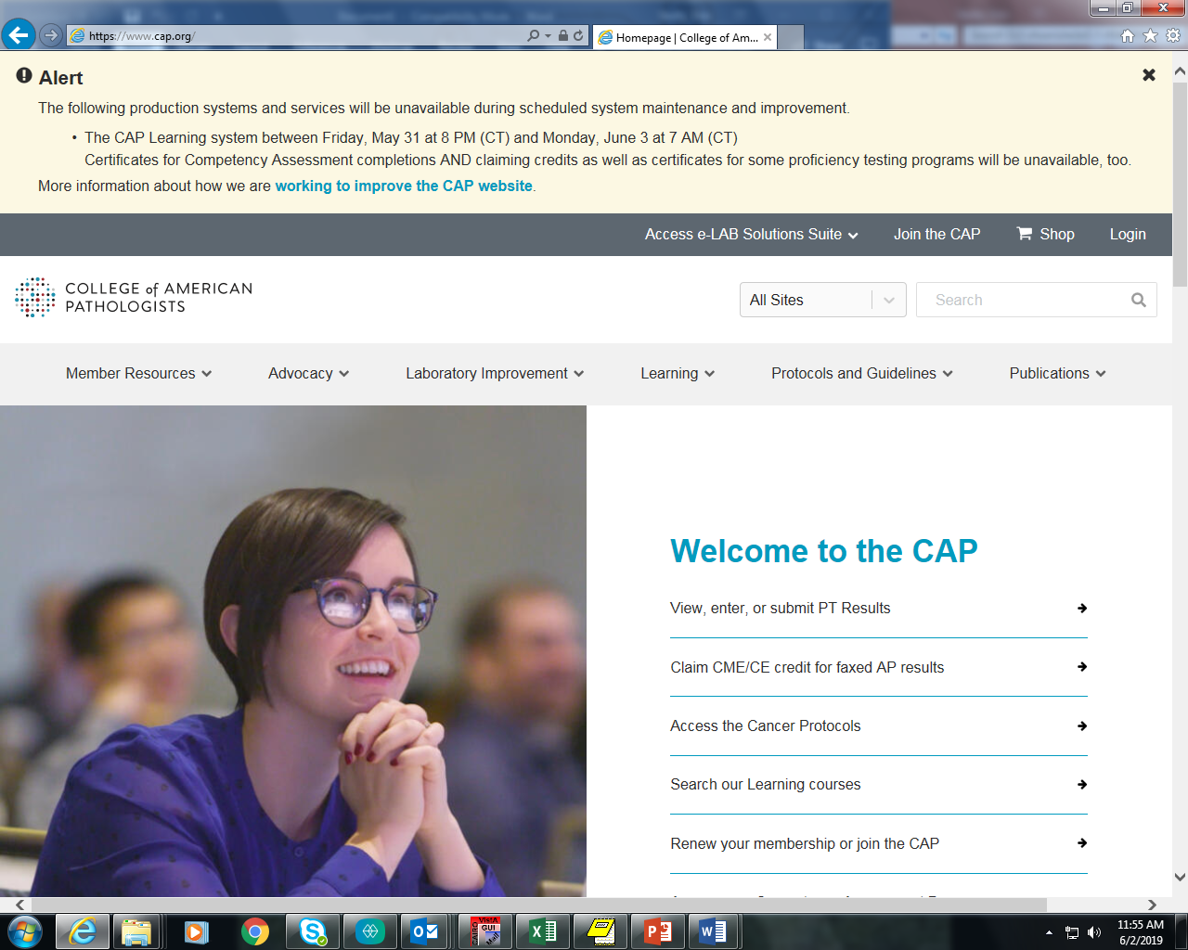

Click on Login to sign onto to site.

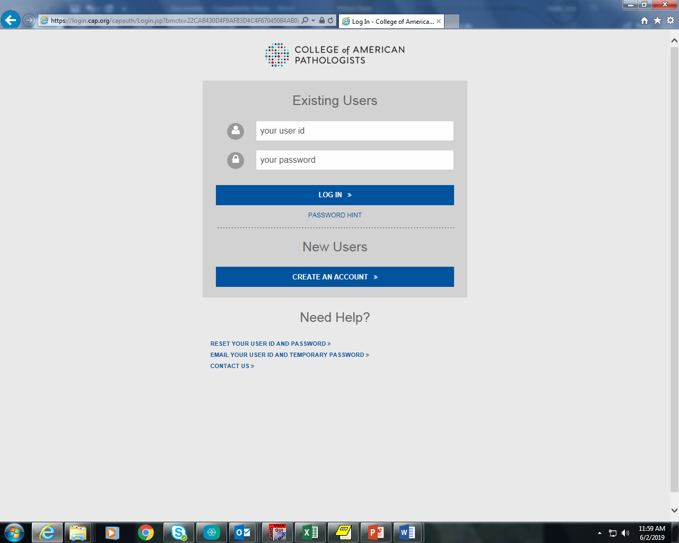

Sign in either using existing user name and password or click on CREATE AN ACCOUNT if new user.

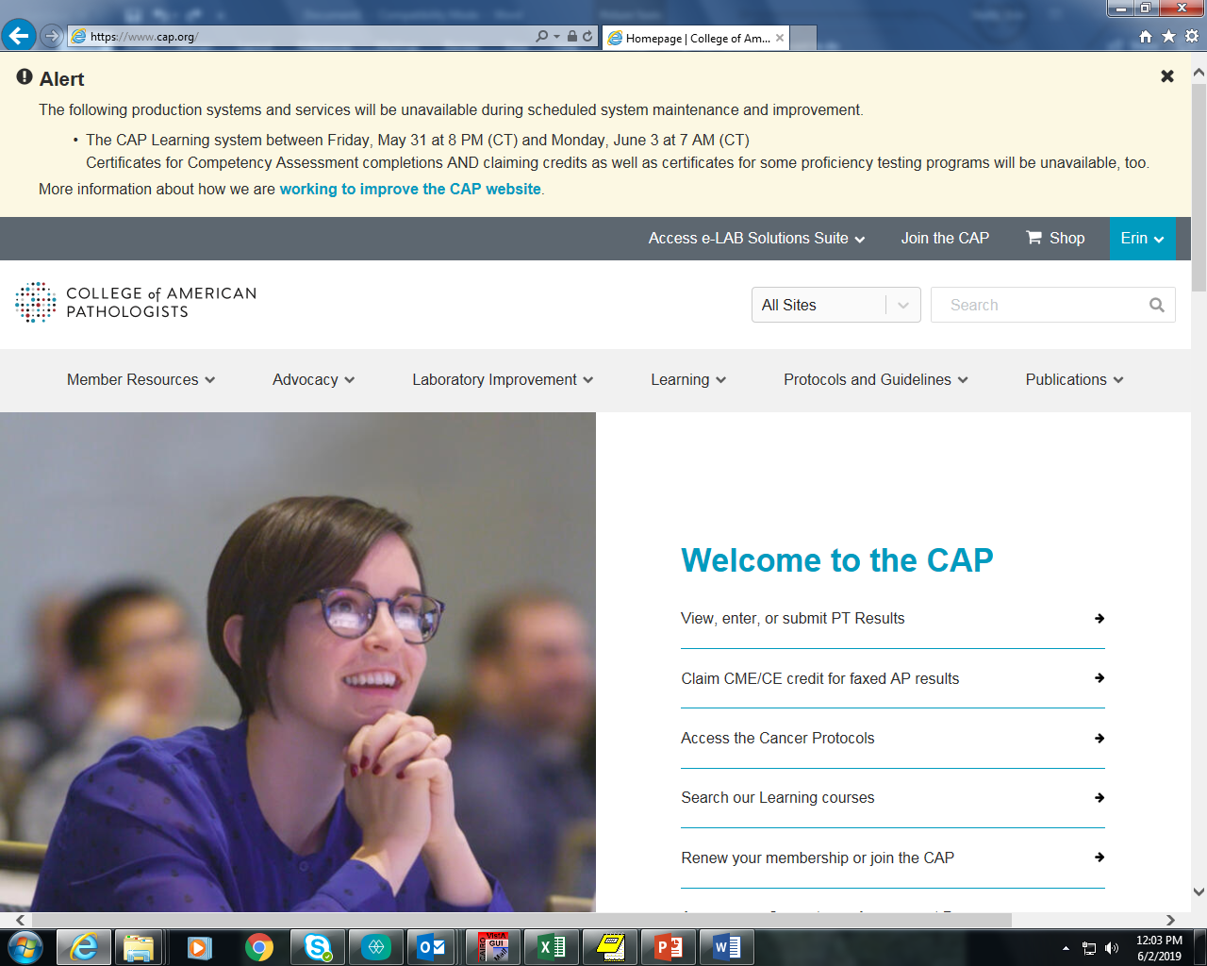

Click here

+

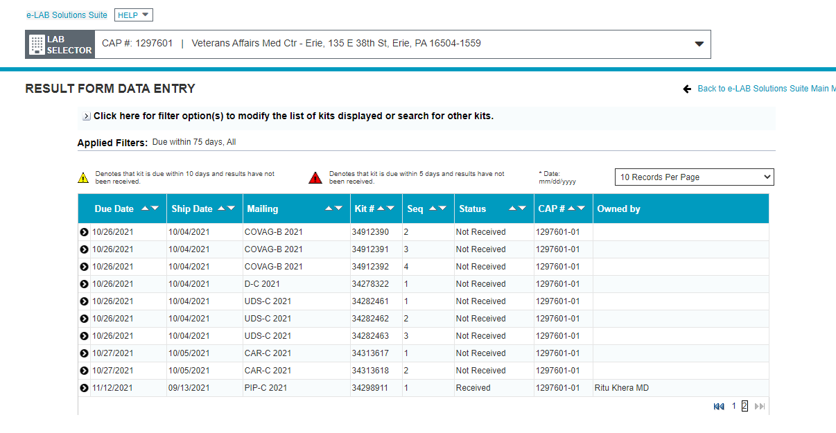

Verify that current selected laboratory is correct.

Click on the mailing name to begin entering survey results (ex. COVAG-B 2021)

**NOTE: Select the correct sequence for your location:**

**Dental Clinic: Sequence #2**

**CLC Alpha: Sequence #3**

**CLC Beta: Sequence #4**

**Ambulatory Surgery: Sequence #5**

Click Enter Data

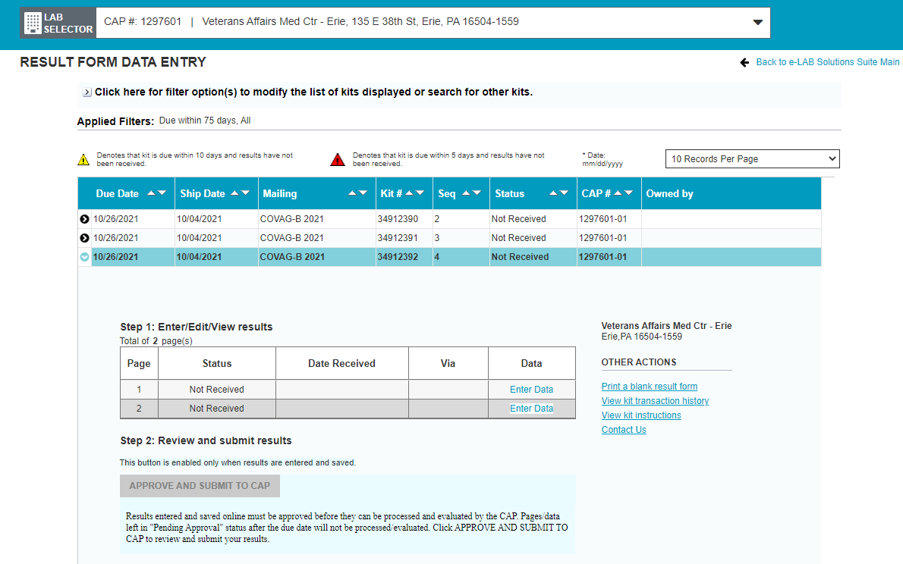

Click on Enter Data to begin entering results.

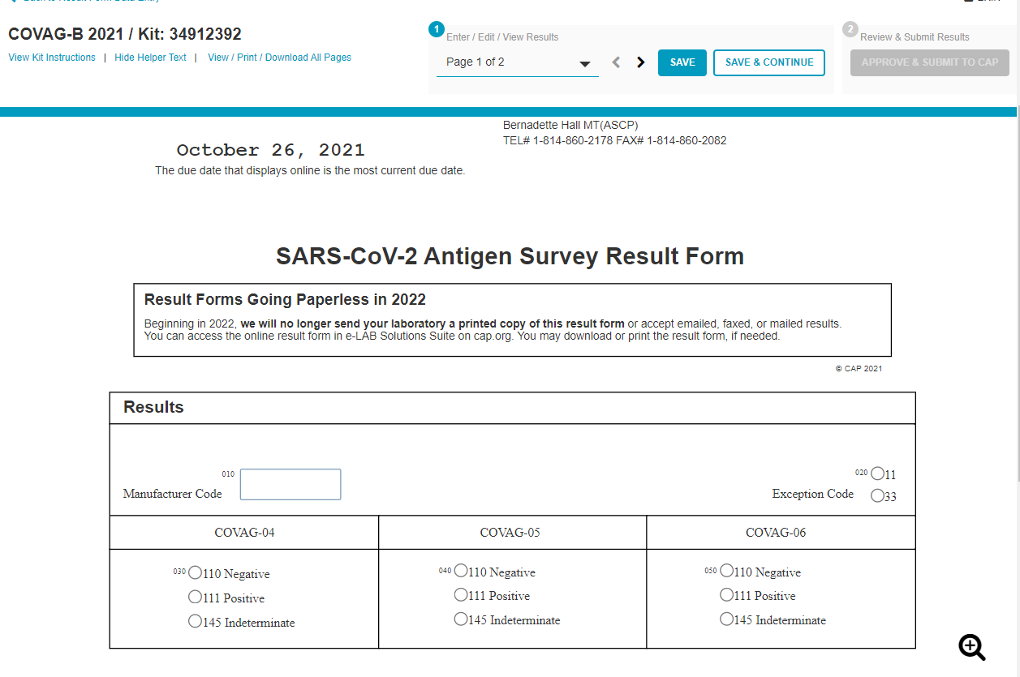

Enter all information for each page and click SAVE & CONTINUE for each subsequent page.

A method code and/or instrument code needs entered for peer group evaluation. It should default to the correct code. Codes can be verified on the last pages of the testing booklet.

At Attestation/Use of Other Form enter the nurse manager as “Director” and all testing personnel’s full name under “Testing Personnel (signature required)”.

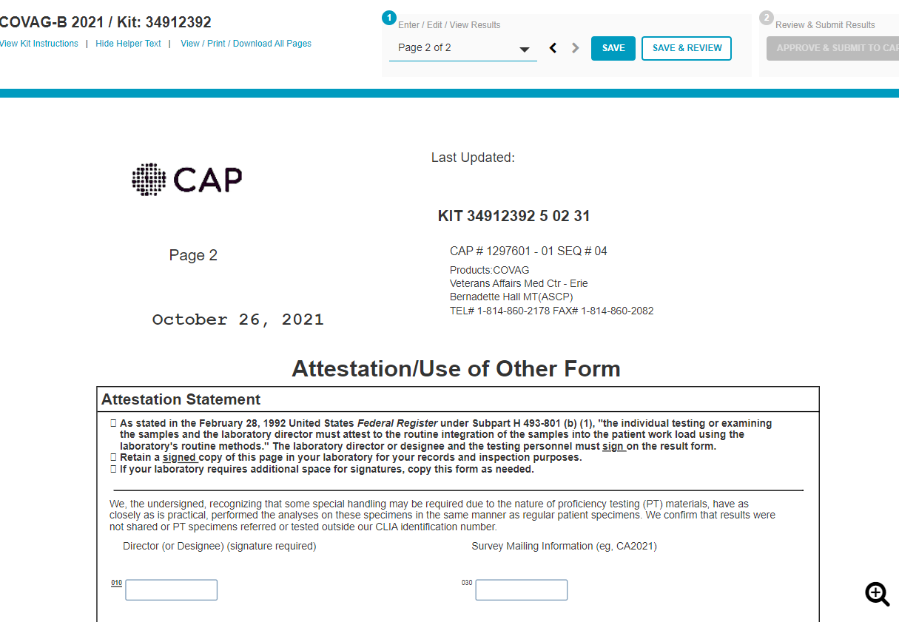

When all data is entered click “Save & Review”. A document will display to print. Print this document to review and save for you records. Once reviewed, click APPROVE & SUBMIT TO CAP.

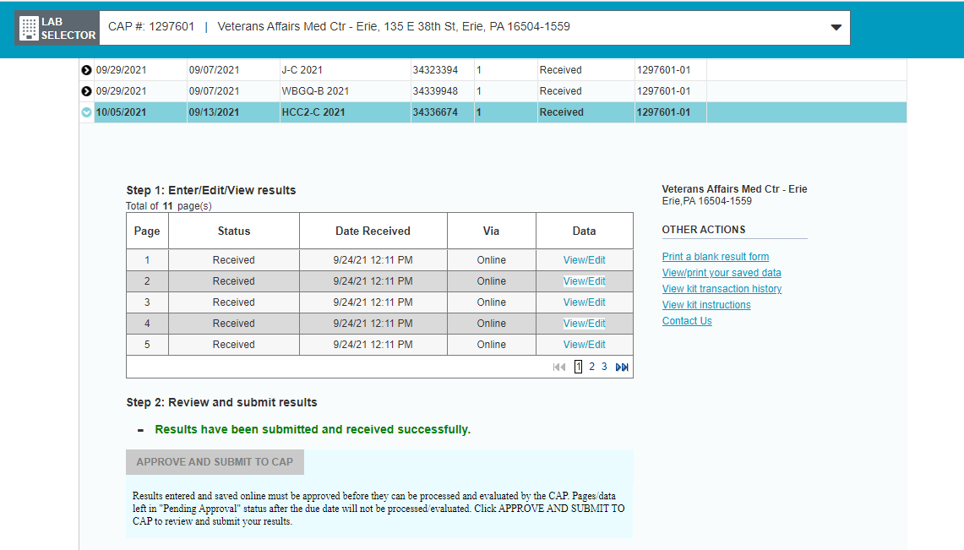

Once results are submitted, print this page and save with submitted results. The Status should say “Received”.