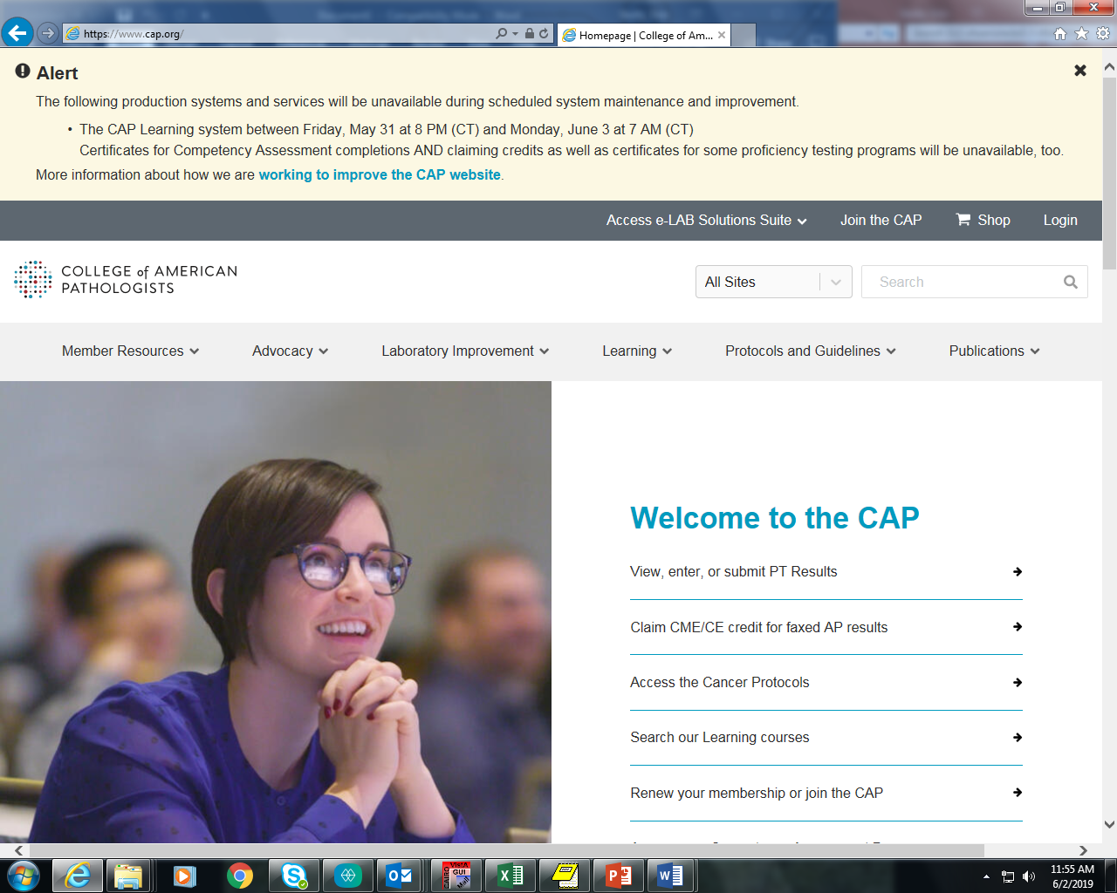

Click on Login to sign onto to site.

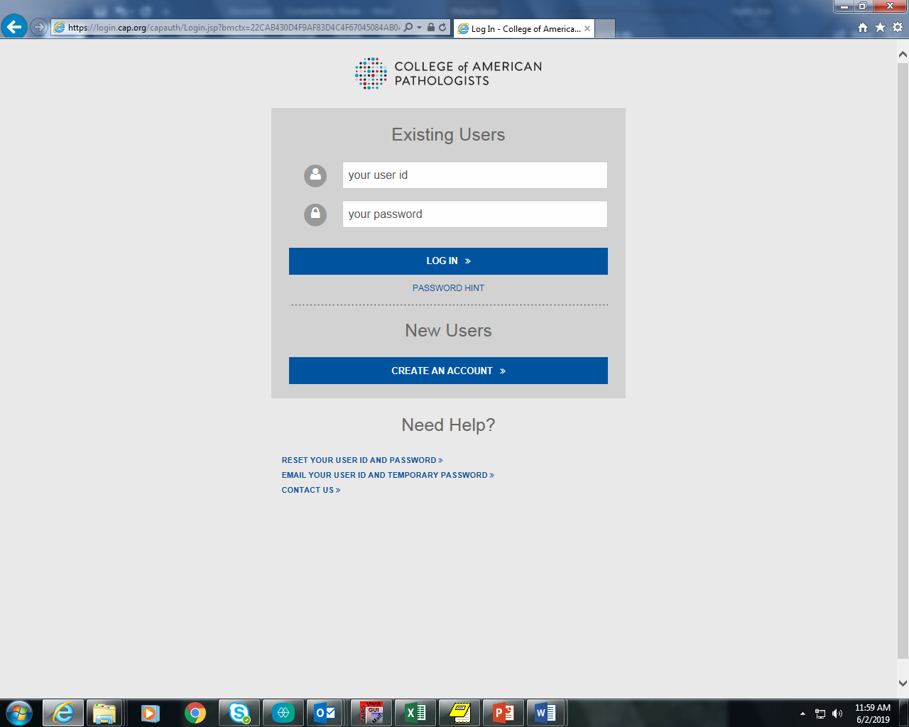

Sign in either using existing user name and password or click on CREATE AN ACCOUNT if new user.

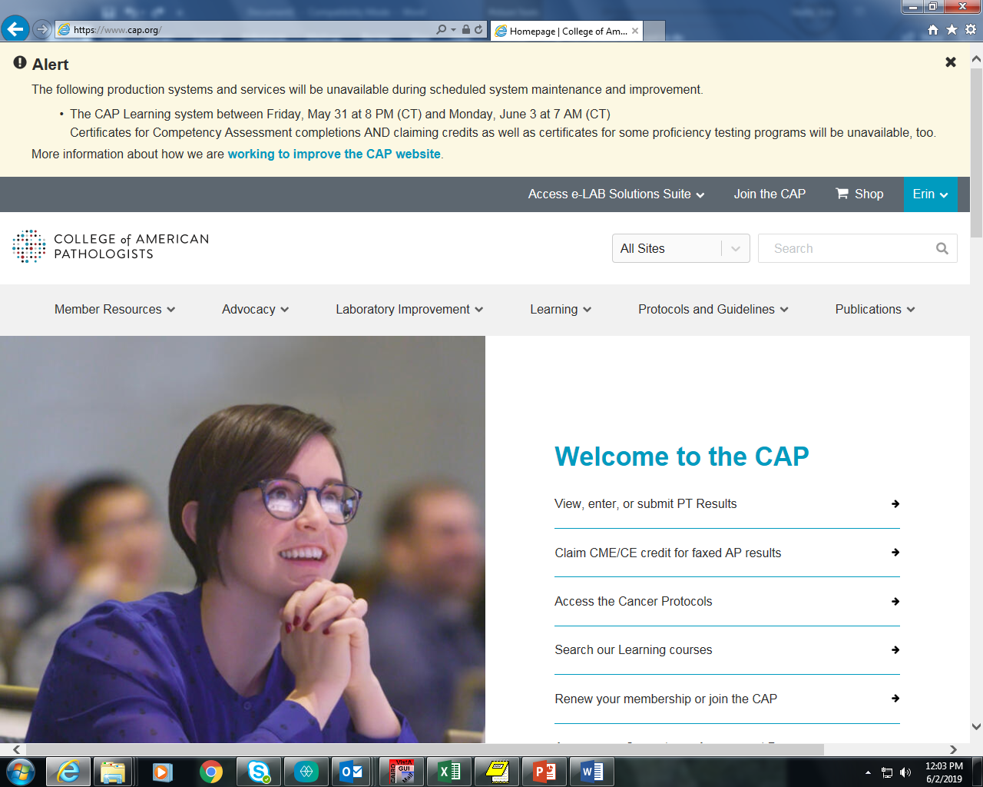

Click here

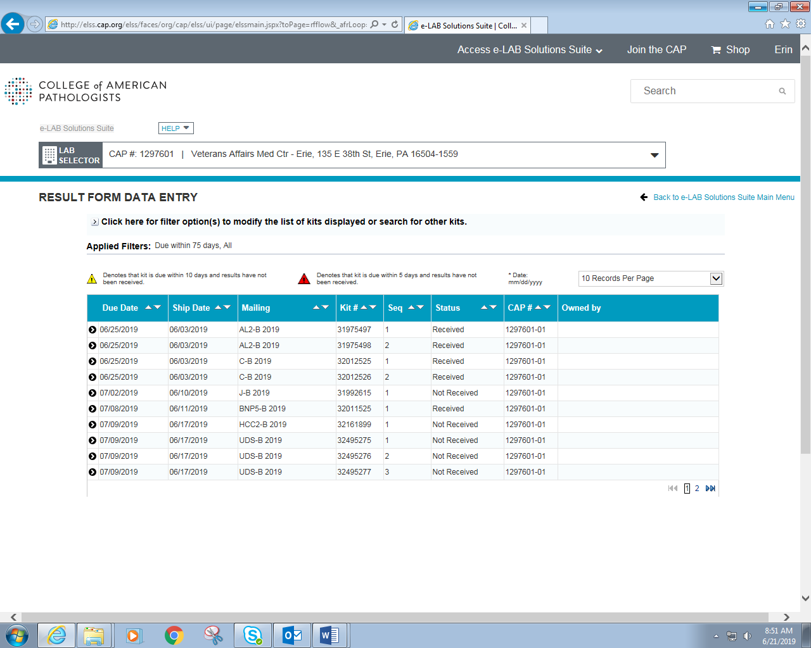

Click on the correct mailing name to begin entering survey results (ex. UDS-B 2019)

**NOTE: Point of Care UDS survey will always be sequence #3**

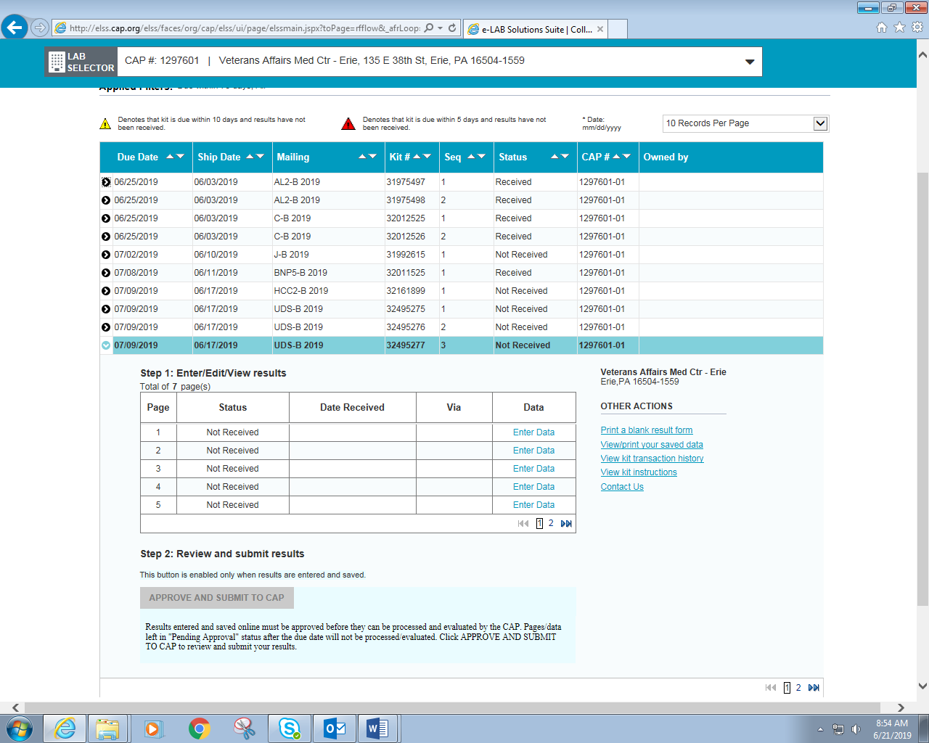

Click Enter Data

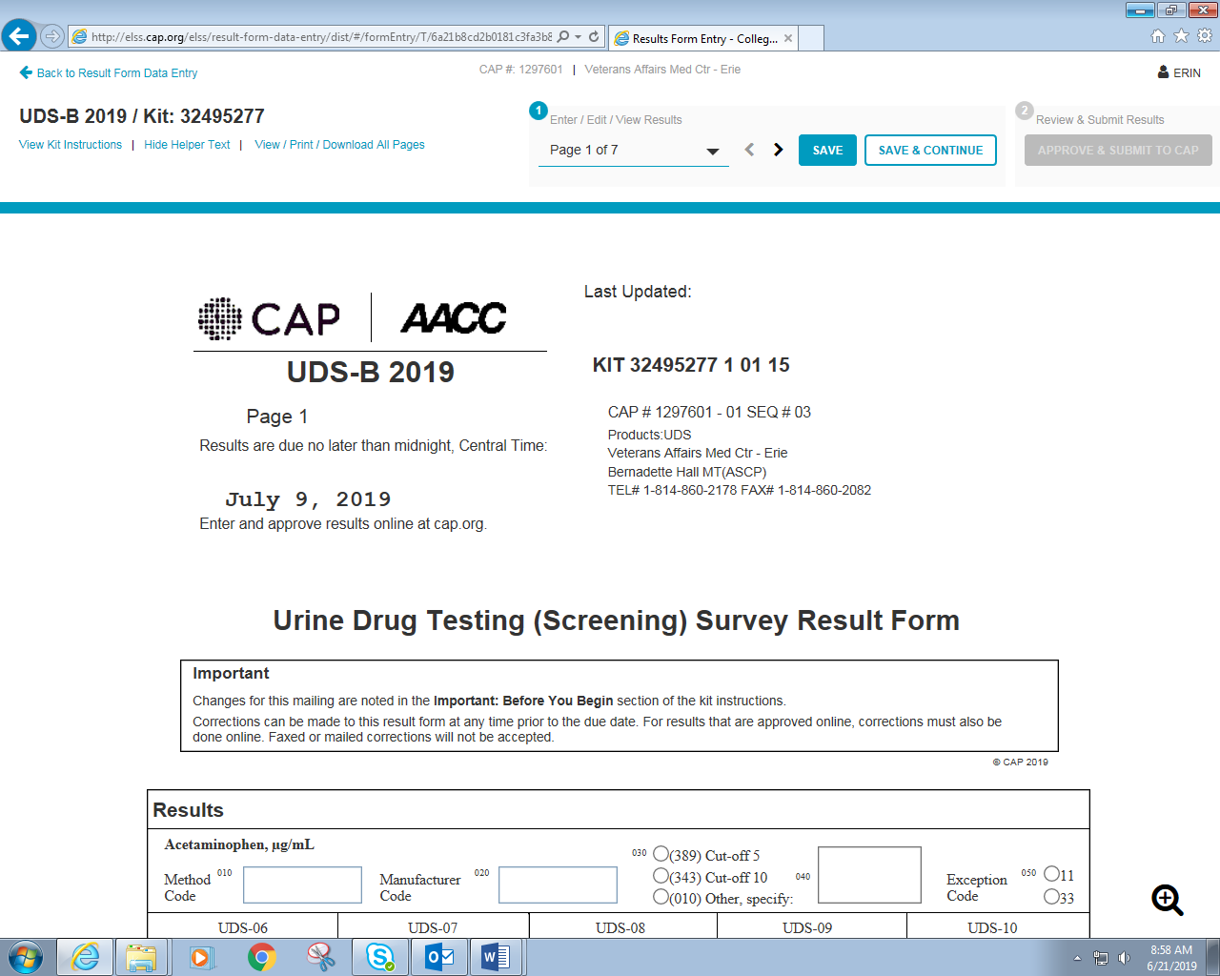

Enter all information for each page and click SAVE & CONTINUE for each subsequent page. When all data is entered, click Review & Submit Results. A document will display to review and once reviewed click APPROVE & SUBMIT TO CAP.

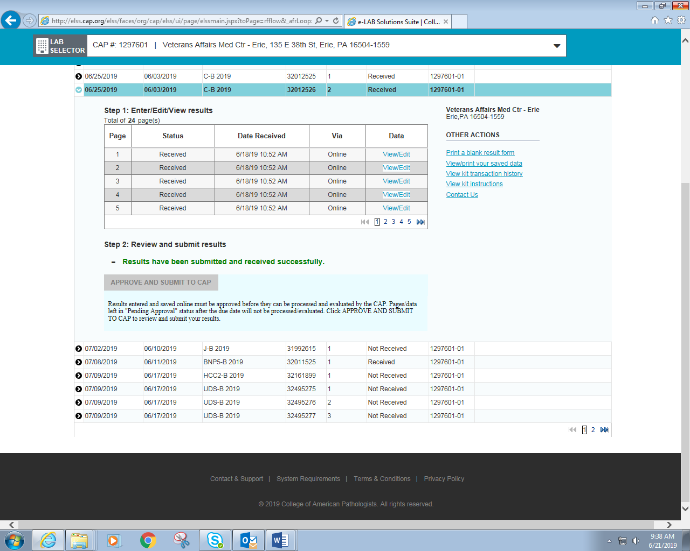

Once results are submitted, print this page and save with submitted results.