1.Sign into CAP website

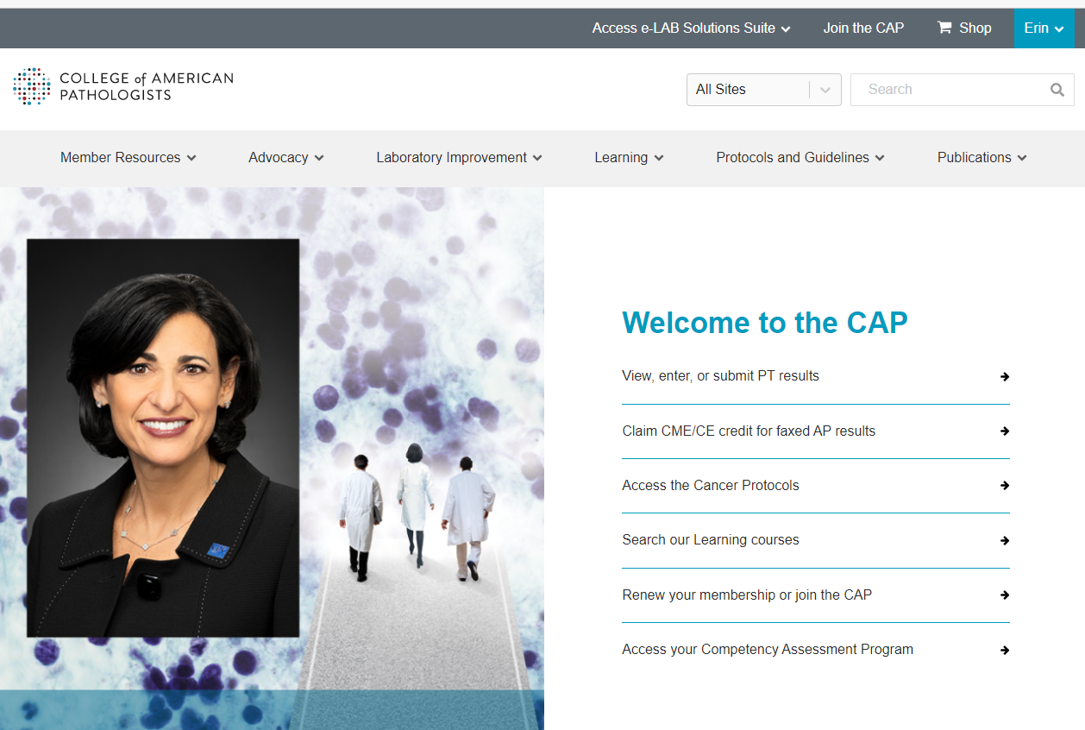

2. Click on View, enter, or submit PT results

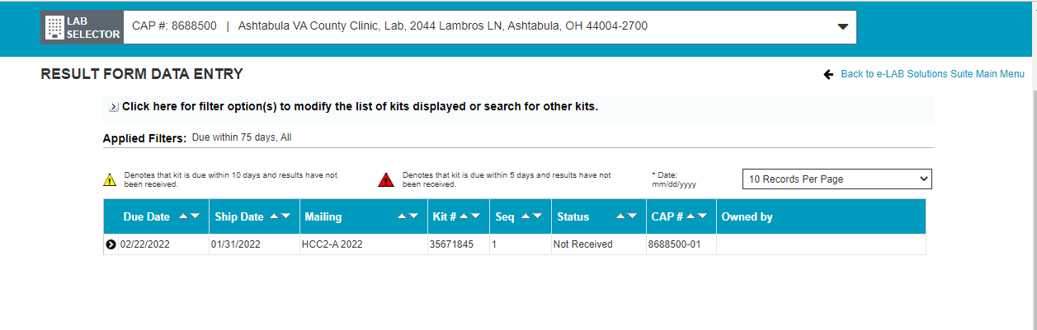

3. Click on survey that needs result sheets printed.

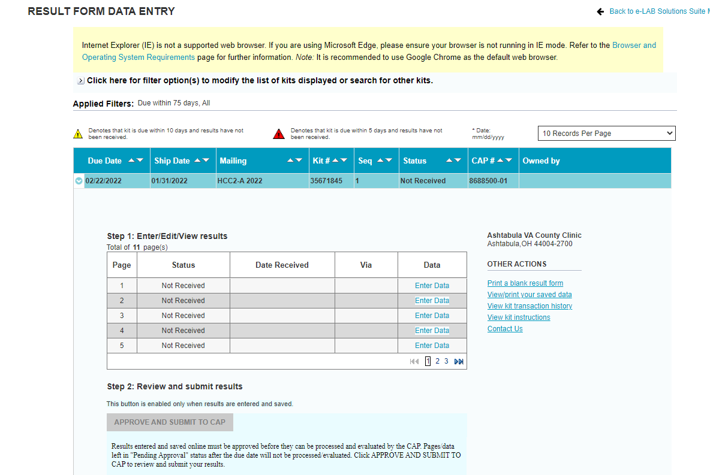

4. Click on “Print a blank result form” and it should open up to print all result forms. Print these forms and place with survey sample.