## Title: QuPID PLUS PREGANANCY TEST KIT Document No. POC Rev. No. 3.0



**POC QuPID PLUS PREGANANCY TEST KIT**

**Copy of version 3.0 (being edited)**

**Uncontrolled Copy** printed on 8/13/2021 4:31 PM

**Printed By** Kimberly Ballard

**Organization** VA Memphis - Shequita Banks

**Approval and Periodic Review Signatures**

|  |  |  |  |  |  |
| --- | --- | --- | --- | --- | --- |
| **Type** | **Description** | **Date** | **Version** | **Performed By** | **Notes** |
| Approval | Lab Director | 1/28/2021 | 2.0 | Eugene Pearlman |  |

Approval Lab Director 9/4/2019 1.0 Dr. Eugene

Pearlman

Recorded when document uploaded to MediaLab

Periodic review

Designated Reviewer

9/4/2019 1.0 Dr. Eugene

Recorded when document uploaded to MediaLab

Pearlman

Approvals and periodic reviews that occurred before this document was added to the MediaLab Document Control system may not be listed.

**Version History**

|  |  |  |  |  |  |
| --- | --- | --- | --- | --- | --- |
| **Version** | **Status** | **Type** | **Date Added** | **Date Effective** | **Date Retired** |
| 2.0 | Approved and Current | Major revision | 9/7/2020 | 1/28/2021 | Indefinite |
| 1.1 | Retired | Minor revision | 4/9/2020 | 9/3/2020 | 1/28/2021 |
| 1.0 | Retired | First version in Document Control | 9/18/2019 | 9/3/2019 | 9/3/2020 |

**n/a**



# QUPID PREGNANCY TEST KIT

Memphis VA Medical Center

# POC 09 113

## Service Line(s):

Memphis, TN 38104

## Signatory Authority:

Chief, Pathology and Laboratory Medicine Service

## Responsible Owner:

Ancillary Testing

# PURPOSE AND AUTHORITY

Pathology and Laboratory Medicine

Service

## Effective Date:

June 10, 2020

## Recertification Date:

June 30, 2025

* 1. The purpose of this standard operating procedure (SOP) is to describe the procedure for use of the QuPID Plus One Step Pregnancy Test device used for the qualitative determination of human Chorionic Gonadotrophin (hCG) in urine to aid in the early detection of pregnancy.
  2. The test device provides a rapid reliable measurement of hCG in urine or serum.
  3. This SOP sets forth mandatory procedures and processes to ensure compliance with VA/VHA Directive 1106.01, Pathology and Laboratory Medicine Service (P&LMS) Procedures, January 29, 2016, Joint Commission, and College of American Pathology.

# ASSIGNMENT OF RESPONSIBILITIES

* 1. **Chief of P&LMS.** Overall responsible for ensuring the overall standardization of this SOP.
  2. **Ancillary Testing Coordinator (ATC).** Responsible for review of this SOP before submission to Laboratory Director for accuracy

1. Ensure all employees are educated on and comply with this policy.
2. Ensure a standardized approach to hand off communication is developed and implemented for their services as well as interactions with other services.
   1. **Ancillary Testing Specialist (ATS).** Provide technical assistance to testing personnel.

(1) Assist the Ancillary Testing Coordinator in the performance of his/her duties.

* 1. **All other staff members.** Responsible for adhering to institutional and laboratory safety policies while performing procedures.

## 1

1. Performing tests as indicated in this SOP.
2. Performing proficiency testing assigned to locations that perform ancillary testing.

# DEFINITIONS

None

# SPECIMEN INFORMATION

* 1. Urine sample collected in a disposable container without preservatives.
  2. A sample can be collected anytime but a first morning urine specimen is most sensitive.
  3. If testing delayed by a few hours, the urine should be stored in a refrigerator (2-8 degrees) for up to 72 hours but must be brought to room temperature before testing.
  4. If testing is delayed by more than 72 hours, the urine should be frozen. The frozen urine should be completely thawed, thoroughly mixed and at room temperature prior to testing. Avoid repeated freezing and thawing.

# SPECIAL SAFETY PRECAUTIONS

* 1. Store kit at room temperature (15°C-30°C). Kit contents are stable until the expiration date on the box. Do not freeze.
  2. Do not interchange reagents or supplies between the kits. Use only items in kits unless otherwise noted in the procedure or manufacturer’s instructions.

# EQUIPMENT/ FORMS

* 1. ACCU-Chek Glucose Monitor

# REAGENTS

* 1. QuPID Plus Test cartridge
  2. ACCU-Chek Glucose Monitor
  3. Disposable, plastic dropper
  4. Timing device
  5. Patient urine sample or quality control material

# QUALITY CONTROLS

## 2

* 1. Internal Controls: A positive procedural control (Control Zone “C”) is built in the test device. This control line will always appear if the test is performed correctly and if the device is working properly. An absence of this control line indicates incorrect procedure or deterioration of reagents. The absence of interfering background is a negative procedural control.
  2. External Controls: Should be tested with each new lot or shipment of test materials once for each test kit.
  3. The use of internal and external controls are to ensure the reagents and assay are performing correctly.

# EQUIPMENT CALIBRATIONS AND MAINTENANCE

* 1. See procedure POC 4 113 for Accuchek on maintenance schedule for the meter.
  2. No calibration is required for urine pregnancy test kits.
  3. Lot to lot validations are performed on new shipments.

# PROCEDURES

* 1. General Procedure

1. Bring specimen(s) to room temperature.
2. Remove the test cartridge and enclosed plastic dropper from wrapper.
3. Place cartridge on a flat surface and label the cartridge with patient or control identification.
4. Aspirate patient sample or control material using the dropper.
5. Dispense 2 full drops of sample or quality control into the round sample well.
6. Set timing device for 3 minutes.
7. Read results after three (3) minutes.
8. Enter patient results via Accu-chek glucose monitor.
9. Turn on Accu-chek monitor. Scan or enter operator I.D. and passcode.
10. From menu, select “Patient Test”, then “Pregnancy” or “Other”.
11. Scan or enter patient full social security number as patient identification.
12. Manually enter the date of test. Note that the meter will default to the current date.

## 3

1. Manually enter the time of test. The mater will default to current time.
2. Scan or manually enter the kit lot number. Press √ to confirm.

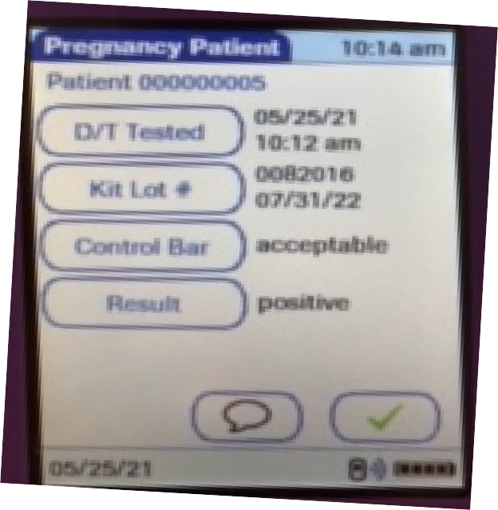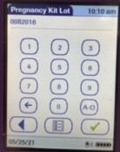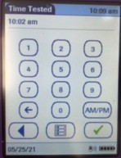

1. Manually enter the expiration date of the test kit. Press √ to confirm.
2. Select result of internal pregnancy control i.e. acceptable or unacceptable.
3. Select correct patient result i.e. Negative or Positive. Press √ to confirm.
4. Review all entries for accuracy, then press √ to confirm. You may go back to edit and item by touching the entry. You will then be prompted to a screen to change the entry then to result confirm screen.
5. Place glucose monitor on downloading base to upload results into patient record in VISTA/CPRS.
   1. Limitations
      1. Several conditions other than pregnancy, including trophoblastic disease and certain non-trophoblastic neoplasms, cause elevated levels of hCG. These diagnoses should be considered if appropriate to clinical evidence.

## 4

* + 1. Normal pregnancy cannot be distinguished from an ectopic pregnancy based on hCG levels alone. Spontaneous miscarriage may also cause confusion in interpreting assay results.
    2. Specimens from patients who have received preparations of mouse antibodies for diagnosis or therapy may contain human anti-mouse antibodies (HAMA). These specimens may demonstrate either false positive or false negative results when tested with assays which employ mouse monoclonal antibodies.
    3. HCG levels may remain detectable for several weeks after normal delivery, delivery by caesarean section, spontaneous abortion, therapeutic abortion, or HCG injections.
    4. Excretion of HCG is often decreased an extra uterine pregnancy, toxemia of pregnancy, or threatened abortion. Such circumstances can yield false negative results
    5. High urine HCG levels can occur in patients suffering from chorionic epithelioma or hydatid mole. In these cases a false positive may occur.
    6. If a urine specimen is too dilute i.e. low specific detectable it may not contain representative levels of HCG. If pregnancy is still suspected, a first morning urine should be obtained 48 to 72 hours later.
    7. In urine as with all pregnancy tests, the final diagnosis should be based on a correlation of test results with typical clinical signs and symptoms.

# ENTRY OF RESULTS

* 1. The test is POSITIVE if two (2) colored lines appear (one colored line will appear in the specimen zone “S” and one at the control zone “C”).
  2. Any colored line at the specimen zone should be considered positive.
  3. Weak positive results may show a lighter colored line than the control.
  4. The test is NEGATIVE if only one line appears at the control zone.
  5. The test is considered INVALID if no colored line appears at the control zone even if a colored line appears at the specimen zone. The test should be repeated.
  6. Results should be reported as POSITIVE or NEGATIVE.

# NOTIFICATION

None

**5**

# REFERENCES

* 1. VHA Directive 1106.1, Pathology and Laboratory Medicine Service (P&LMS) Procedures, January 29, 2016, [http://vaww.lab.med.va.gov/References_Directives_and Regulations_P.asp](http://vaww.lab.med.va.gov/References_Directives_and%20Regulations_P.asp)
  2. Stanbio Laboratory QuPID Plus One Step Pregnancy Test Package Insert, 2019

# APENDICES

None

# REVIEW

This SOP will be reviewed at least every 2 years, when there are changes to the government document that need to be made and any regulatory requirement for frequent review.

# RECERTIFICATION

This SOP is scheduled for recertification on or before the last working day of June 2025. In the event of contradiction with national policy, the national policy supersedes and controls.

# SIGNATORY AUTHORITY

Dr. Eugene Pearlman

Pathology and Laboratory Medicine Service, Chief Date Approved: June 10, 2020

***NOTE:*** *The signature remains valid until rescinded by an appropriate administrative action.*

**DISTRIBUTION:** This SOP is available in Media Lab: [https://www.medialab.com/lms/admin/ad_tab_doc_frameset.aspx?leftdest=todo&oid=39](https://www.medialab.com/lms/admin/ad_tab_doc_frameset.aspx?leftdest=todo&oid=39106449&o=691e25a40e2e478b7ca4976a6b86b7a9&docid=1304491&dochash=8f6ac47f2a49bfdd7580b8926a2ef792&revisionid=2188347&revhash=3ea36678464da1af6d30269f3e62e0da) [106449&o=691e25a40e2e478b7ca4976a6b86b7a9&docid=1304491&dochash=8f6ac4](https://www.medialab.com/lms/admin/ad_tab_doc_frameset.aspx?leftdest=todo&oid=39106449&o=691e25a40e2e478b7ca4976a6b86b7a9&docid=1304491&dochash=8f6ac47f2a49bfdd7580b8926a2ef792&revisionid=2188347&revhash=3ea36678464da1af6d30269f3e62e0da) [7f2a49bfdd7580b8926a2ef792&revisionid=2188347&revhash=3ea36678464da1af6d30](https://www.medialab.com/lms/admin/ad_tab_doc_frameset.aspx?leftdest=todo&oid=39106449&o=691e25a40e2e478b7ca4976a6b86b7a9&docid=1304491&dochash=8f6ac47f2a49bfdd7580b8926a2ef792&revisionid=2188347&revhash=3ea36678464da1af6d30269f3e62e0da) [269f3e62e0da](https://www.medialab.com/lms/admin/ad_tab_doc_frameset.aspx?leftdest=todo&oid=39106449&o=691e25a40e2e478b7ca4976a6b86b7a9&docid=1304491&dochash=8f6ac47f2a49bfdd7580b8926a2ef792&revisionid=2188347&revhash=3ea36678464da1af6d30269f3e62e0da)

**6**