4/13/2023

To: All staff performing point of care urine pregnancy test

From: Kim Ballard, Ancillary Testing Coordinator

ATTENTION:

When performing URINE PREGNANCY TEST using the

**CARDINAL HEALTH PREMIUM hCG COMBO CASSETTE**

Remember the following:

* This test cartridge requires ***4 drops*** of urine.
* Do not interpret results after 7 minutes.
* 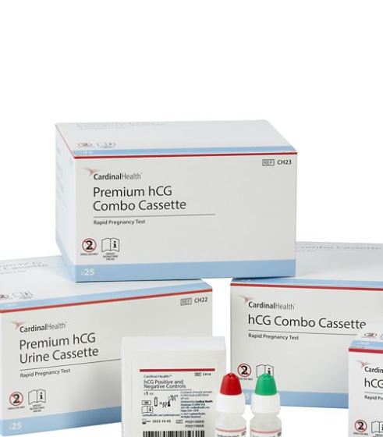Test is invalid if no line appears at the “C” (control) region within 5 minutes.

Due to back order of previous supply of STANBIO QuPID PLUS ONE-STEP PREGNANCY TEST, we will utilize the above test. Until further notice, we will continue to use these test kits.