Intro/Overview

* All Point of Care Test Operators are required to read the testing policies and procedures for the devices they are trained/certified to use.
  + After initial training and certification, Competency Assessment is performed on an annual basis.
* All Point of Care tests procedures are written to follow the manufacturer’s instructions.
  + Following the manufacturer’s instructions is a regulatory requirement.
* ALWAYS use 2 full patient identifiers: Full name and full social security # on the sample cup.
* If the Clinitek device is not working properly, send all specimens to the main lab for testing.
  + Do not manually read urine dipsticks, or HCG cassettes.
* Any positive results should be confirmed by the main lab before clinical decisions are made.
  + The dipstick and pregnancy tests are screening tests only.
* Test Principle: Colors change/develop over a set amount of time.
* Do NOT perform these tests using dark brown, dark amber, or bloody samples (interfere with color change).
* If the Clinitek gives any kind of error message, the test must be repeated.
  + Never re-use a dipstick or HCG cassette
* All results are automatically uploaded to CPRS once the test is complete.
  + Exception: If the patient ID is typed incorrectly, it will not transmit to CPRS.
    - I recommend using the barcode on the demographic label (if this is an option).
    - If manually entering Patient IDs, take the time to make sure they have been entered correctly.

Quality Control Materials (for both dipstick and hCG testing)

* There are 2 levels of Quality Control
  + Level 1 (Pink cap) = Normal UA / Negative hCG
  + Level 2 (Purple cap) = Abnormal UA / Positive hCG

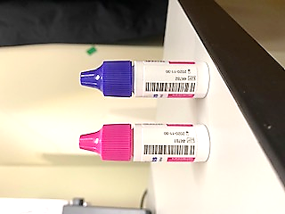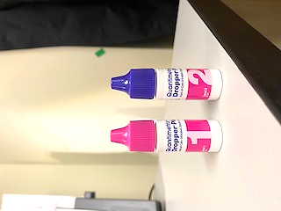

* Once opened, QC bottles are good for 30 days (when stored at room temp).
  + Use the orange “Use by” stickers to label the bottles with the new 30-day expiration date after opening (I believe these stickers are kept in the med room, possibly on the med cart?)
* If storing QC bottles in the refrigerator and bringing to room temp before each use, control bottles will expire the day after the expiration date printed on the bottle.
* **Safety Tip!**
  + These Quality Control liquids need to be treated as biohazardous material.
  + Wear gloves and be careful of splashing.
  + If you get it on your skin, wash well with soap and water.

UA Dipsticks and HCG Cassettes

* The Multistix 10SG Dipsticks and Clinitest HCG Cassettes have their own barcodes, printed lot numbers and expiration dates (just like the liquid QC bottles do).
* When the instrument asks you to enter this information, use the barcode scanner instead of typing it in.

Cassette Back

Cassette Front

Dipstick Container

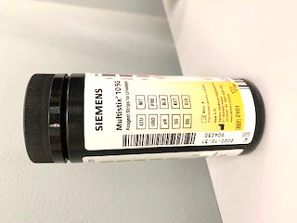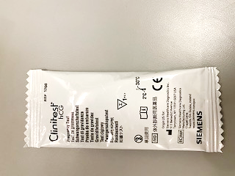

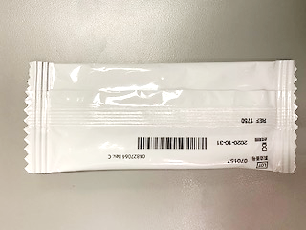

Where and How to Get Clinitek Supplies

* All reagents and testing materials are stored in the main lab, Bldg. 100, RM 2C-118.
  + Dipstick and Cassettes are stored in 2C-115.
  + Quality Control Dropper Bottles are stored in walk-in refrigerator.
* If you need supplies, here are a few options
  + Call me x56749
  + Skype me
  + In the “find someone” field type my email address (below)
  + Send me an email [Jennifer.Parker4@va.gov](mailto:Jennifer.Parker4@va.gov)
  + If you can’t get a hold of me, or if I am out of office, take a walk to the lab and pick them up.
    - Because the lab is a secure area, you may want to call the front desk x56715 ahead of time, so they can let you in.
    - The easiest point of entry is the hallway by the Blood Bank.

A Little Advice

1. **Read the Clinitek screen as you go along.** 
   * This device has a lot of screens and asks for a lot of things (it is strict with its rules)
   * The most common things I see
     + Wrong level of Quality Control used (mixing up levels 1 and 2)
     + Staff DUZ # entered as a patient ID
     + Staff DUZ # entered as a QC, dipstick or HCG cassette lot #
2. **When you get to the screen with the START button, make sure you have all the supplies ready to go.**
   * Check the tray table is in the correct position for the test you are doing.
   * This way, when the 8 second countdown timer starts, you have everything you need.