Sysmex WAM v5.0 Software
Customized decision support software for the clinical laboratory

PRINCIPLE
The Sysmex WAM software application is a hematology information management system that offers a comprehensive analyzer and result management tool. Sysmex WAM consolidates data from multiple analyzers, performs complex rule-based functions and then communicates this information to the LIS. Sysmex WAM displays state-of the-art graphics and images to aid the physician in results review and data interpretation.
- The Sysmex WAM software maximizes the efficiency of the results handling process by providing a single window to simultaneously manage multiple analyzer data, present this data to the operator and provide keyboard functionality to record cell morphology.
- Sysmex WAM offers a sophisticated Rerun Manager screen that allows the operator to review subsequent reruns on one detailed screen.
- Sysmex WAM provides the ability to display previous patient results with the current results on the Main Result Validation screen. The ability to store previous patient results within the WAM database enables the software to perform delta checking for additional rule application and provide valuable information to the operator to validate current results.
- Sysmex WAM offers the ability for the software to automatically release results to the LIS that meet the customer-defined rule criteria. The results can be auto-validated without further operator intervention so as to improve laboratory productivity and reduce the amount of time spent reviewing normal data.
- Sysmex WAM provides a sophisticated rules engine that allows real-time data checking based upon test results, analyzer flags and/or user selected rule definitions that can automatically generate a test rerun or allow the addition of reflex testing.

SPECIMEN
Not applicable

SUPPLIES AND REAGENTS

  - Supplies
    - Sysmex WAM Server – Sysmex supplied
    - PC Workstation – Sysmex or customer supplied
    - Network Printer – Customer supplied
    - LIS Interface to Sysmex WAM – Order and Results
  - Reagents
    - None

CALIBRATION
Not applicable.

QUALITY CONTROL
Not applicable.

OPERATING PROCEDURE
A. Start-up

To access the Sysmex WAM software application, proceed as follows:
- Turn on the Sysmex WAM PC workstation and allow the software sign on screen to load.
- On the front page, click on the appropriate icon to be used for your work session:
  - Sysmex WAM v5.0– this is the production version of your system.
  - Sysmex WAM v5.0 (Test) – this is your test system.
.
- The Sysmex WAM Production or test software application will launch for immediate use.

- Log On
To launch the Sysmex WAM Production software application, double-click on the Sysmex WAM Production icon. The Welcome Dialogue box appears prompting you to enter either your pre-assigned User Logon or User ID and Password. (See your system administrator for additional information.)

Figure 1: Sysmex WAM Production Icon
Proceed as follows:
- Click on the Sysmex WAM Desktop icon to launch the application.
- Enter your User ID – minimum of (3) alphanumeric characters. Press tab.

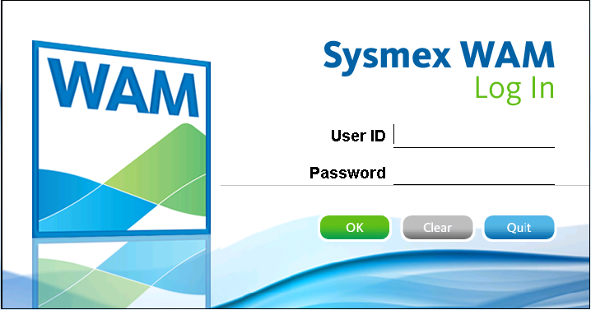
Figure 2: Sysmex WAM Production Icon

- Enter your password, and then click OK. Your password must contain at least one letter, one number, and one keyboard character. (!,@,#,$,%,^,&,*) It must be at least three characters long by default.
- Click OK.

- Site Selection

If the user is assigned to one or more sub-sites; the user will be asked to select their working site for this session.
- Click the row that represents the site.
- Click the OK button.
- The Sysmex Discipline screen will display.
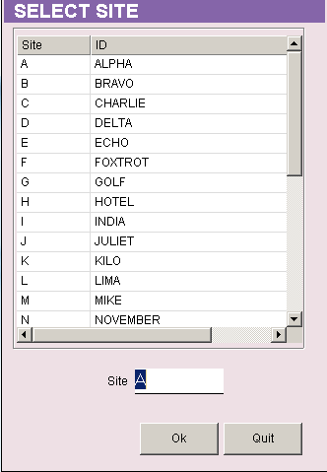
Figure 3: Selection of Site

- Discipline Selection

If the user is assigned to one or more working disciplines, then the user will be required to select a Discipline.
- Select a Discipline bar for the appropriate working discipline.
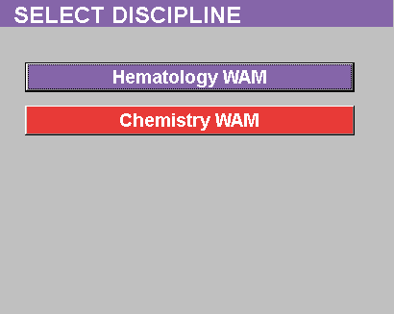

Figure 4: Discipline Selection Screen
- The Sysmex WAM Main Menu will display for that discipline.

- Menu Selection

To review results for manual validation, proceed to section F.

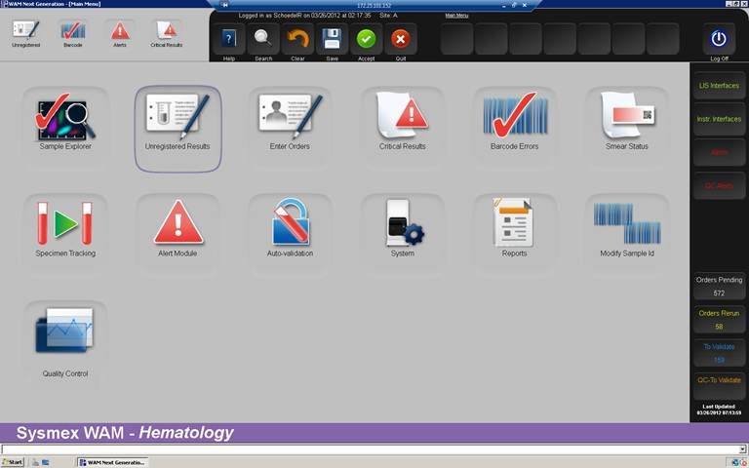

Figure 5: Sysmex WAM Main Menu Screen

- Manual Validation

- From the Sysmex WAM Main Menu screen, select the Sample Explorer icon and then the Validate Results radio button.

- In the Validation Selection screen, enter search criteria to retrieve the Sample IDs that require manual validation.

Note: Only those Sample IDs with at least one test result at status 1 will be retrieved for validation. If a Sample ID is in a rerun status or all results are pending (status 0), the Sample ID will not be retrieved for result review and approval.

- Select and/or enter one or more criteria to retrieve Sample IDs ready for result review and approval.

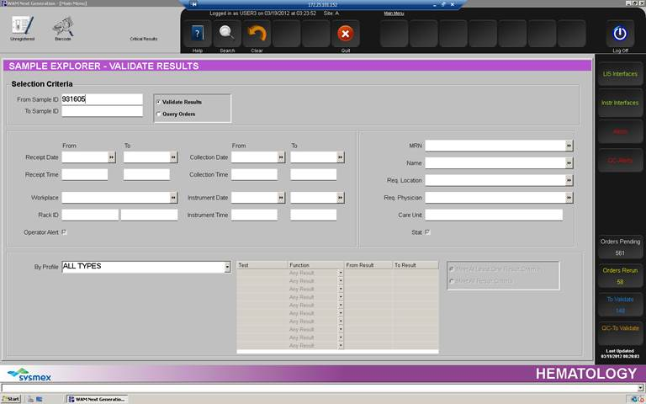

Figure 6: Validation Selection Screen

  - Default: Search for all orders requiring validation:

- Select: All Types default (Test/Profile).
- Click the Search icon.

Note: All pending Sample IDs with at least one result available to be validated (status 1) will be retrieved. An SID list created with these criteria on the Result Validation screen will automatically update with this selection.

  - Search by specific Sample ID:

- Enter Sample ID.
- Select from Test/Profile drop down box.
- Click the Search icon.
- The SID list will not update.

  - Search by Patient Demographic Specific Filter Criteria:

- Enter information in one or more fields to retrieve specific Sample IDs.
- Select from Test/Profile drop down box.
- Click the Search icon.
- The SID list will not update.

  - Search by Sample Specific Filter Criteria:

- Enter information in one or more fields to retrieve specific Sample IDs.
- Select from Test/Profile drop down box.
- Click the Search icon.
- The SID list will not update.

- The Result Validation screen will display for selection of Sample IDs and review of results.

  - SID List

Sample IDs are displayed at the far left of the screen, in priority order with Critical samples first and STAT samples second. All Sample IDs appear in alphanumeric order within category. Click a Sample ID to display all applicable information. You can approve the results and then click the next Sample ID in the list, or select any Sample ID to access the Sample ID.

Priority | Color Code
Critical | Maroon background, white lettering
STAT | Red background, white lettering
Normal Priority | White background, blue lettering
Blue indicator | A blue indicator to the left of the Sample ID indicates that the SID is ‘unregistered.’

- The software performs a default scan of the database every 2 minutes to search for Sample IDs that qualify as status 1 to add to or remove from (fully validated) the Sample ID list in the Result Validation screen.
- The Sample IDs are added to the list in order of priority of Critical and STAT, and then by Sample ID sequence number (alphanumeric sort).
- You can update the Sample ID list before the two minute update by clicking the Refresh icon.
- Sample IDs that are fully validated are removed from the list every two minutes or on manual refresh.
- All Unregistered Sample IDs with pending orders will remain on the list until the order is received from the LIS.

  - Result Color Coding

Results are color-coded to indicate their status:
- Critical Results:
      - l (lower case l) = Yellow letters with a blue background
      - h (lower case h) = Yellow letters with a red background
      - L (very low) = Light Blue letters with a dark blue background
      - H (very high)= Black letters with a dark red background
- Delta Value: All delta values that have triggered a delta rule are blue letters, green background.
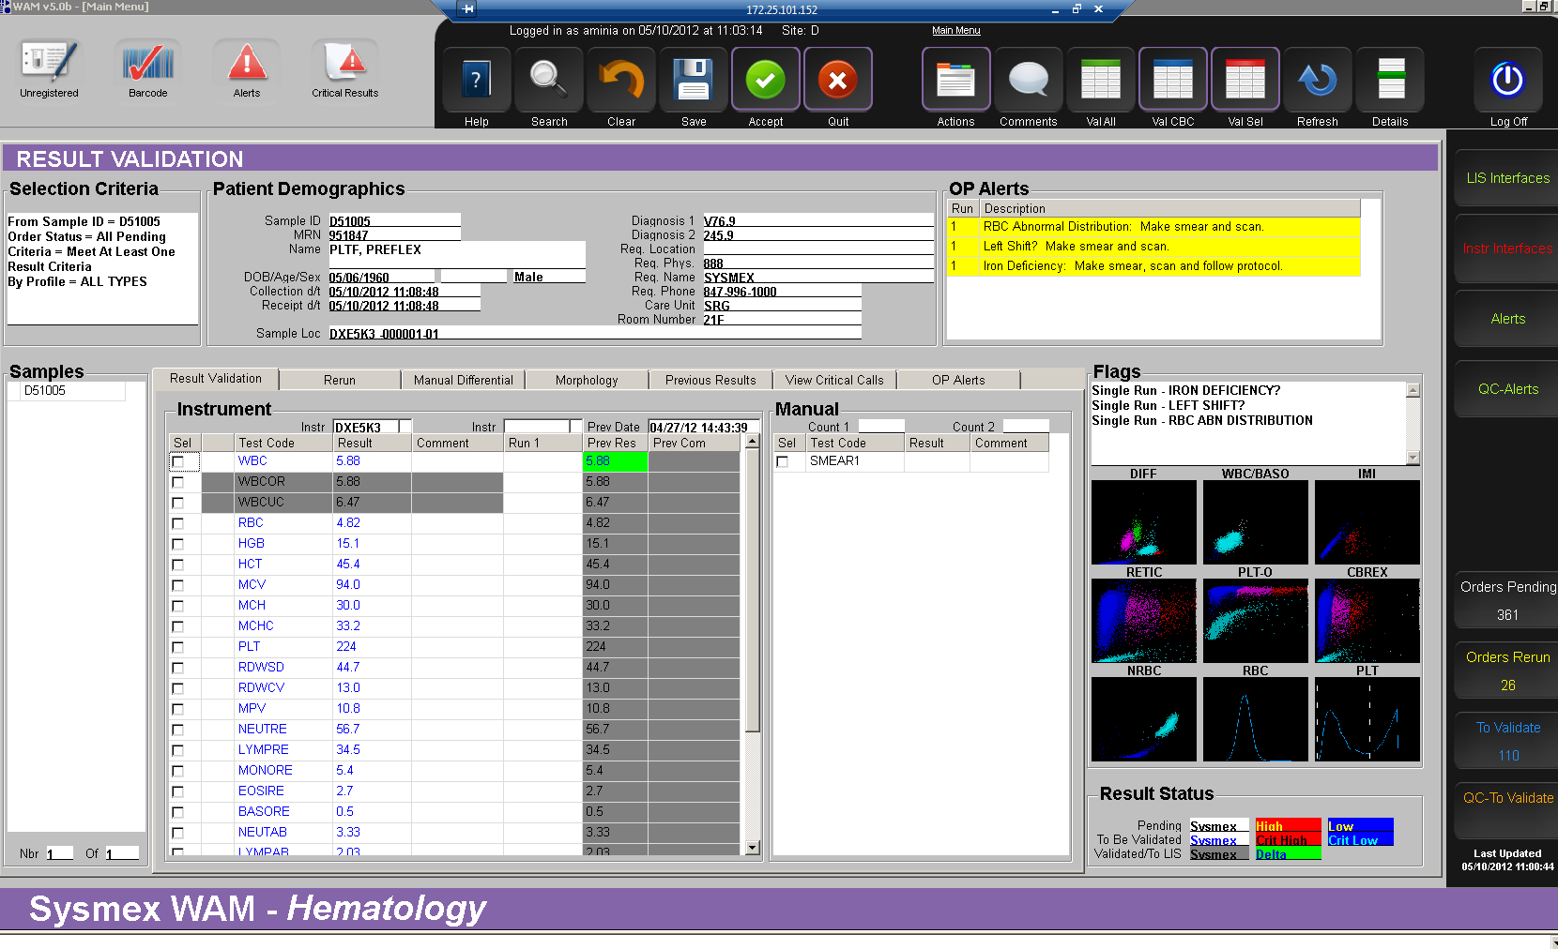

Figure 7: Result Validation Screen

  - Unregistered Order Color Coding
All Unregistered Sample IDs will display a “U” highlighted in blue on the patient demographics screen to identify the order as unregistered.
- Select a Sample ID from the SID list by clicking on the specific SID. Use the up/down slide bar to review more sample ID’s if available.
- Review the Operator Alerts for instructions on how to process the specimen.

- Select a rerun – proceed as follows:
- Click the Rerun menu tab.

- In the Rerun Manager screen, select the run.

- Click the Column Header (RUN 1 or RUN 2 etc) of the results that you wish to report.

- Click the Result Validation tab to accept the run selected and return to result validation.

- Add Test Level Coded Comment – proceed as follows:

- In the Result Validation screen, double click in the COM field for a specific parameter.

- The Coded Comment screen will display.

- With the cursor, check the box next to the coded comment(s). The coded comments(s) will display in the Current Content box at the bottom of the screen. . Press the Save icon.

- You will be returned to the Result Validation screen.

- The comment code will be displayed on the Result Validation screen with the ‘coded comment’ e.g., CAL. If there is more than one coded comment, they will be separated by#| [pipe] e.g. #CAL#|RNV.

- Add Test Level Free Text Comment – proceed as follows:

- In the Result Validation screen, click in the Com field for a specific parameter.

- Type the free text in the Com field.

- Add Internal or Report Order Comment – proceed as follows:

- In the Result Validation screen, click the Comments icon to display the order Comment screen.
- Select a radio button or Internal or Report comment type.
- Double click in the Code field and select one or more comments from the list. Press the OK button.
- Click the Save button and then Quit to return to the Result Validation screen.

- Perform a Manual Differential and Morphology – proceed as follows:

- From the Result Validation screen, select the Manual Differential tab.

- Select the Counter type if you are assigned to more than one counter from the menu at the bottom right of the screen.

    - Start counting cells types as you view them under the microscope.
    - Press the key that represents the cell type e.g. 3 key = NEUT. 2 = LYMP.
    - When the number of cell types reaches 100, the keyboard will lock from adding more cells.
    - Click Result Validation tab screen or select the Morphology tab. Proceed to step f.

- In the Morphology screen – proceed as follows:

- Double click in the appropriate row that represents the morph comment code.
- The Coded Comment screen will display.
- Click the appropriate row that represents the result type (e.g., 1+, 2+ 3, + or few, moderate, many).
- Click the Save button to return to the Morphology screen.
- Continue to add morphology comments as appropriate.
- Click the Result Validation tab to return to the Result Validation screen.

- Click the Save icon to execute all rules and calculations before validating results.

- In the Result Validation screen, the Manual Differential and Morphology comments will display at unvalidated (status 1). To approve results, press one of the following icons from the top menu to complete the validation (approval) process:

- Validate All – Click the Validate All icon. This will validate all available results on the Result Validation screen.

- Validate Selection – press the Sel button in the Instrument window or select individual test results for result approval and then click on the Validation Selection icon.

- Critical Result Documentation screen. This is an optional feature for the Critical Result Documentation Edit screen to display. This screen will only display if critical documentation is enabled, one of the Validation icons in the top menu is selected in step 10 (Validate All, Validate CBC, Validate Selection) and the test result is critical.

Enter the following information to record details of the Critical Result documentation:

- Call To/Loc: Enter the person that was contacted.

- Read back: Select Y or N from the drop down box to document the read back function.

  - Comment: Enter a free text comment OR select from the drop down box of available coded comments.

- Click the Save icon.

- The Result Validation screen will display.

- The Sample ID will move off the SID list if all tests have been validated and/or a rerun is generated as the result of a rule trigger leaving no tests at a ‘to be validated’ status.

- After the results are available from the analyzer for the rerun, the Sample ID will display on the SID list ready for validation actions.

DAILY MAINTENANCE
The following maintenance is required to be performed daily to resolve barcode errors and orders with unregistered results.
- Barcode Errors
Check the Barcode Read Errors screen periodically to remove samples with barcode errors.The Sample ID barcodes can be removed from the Barcode Read Errors screen by performing the following:
- Select the Barcode Errors icon from the fast menu or main menu.

- Select the Site code from the drop down box.

- Use Selection Criteria to further filter your selection.

- Click the Search icon.

- Check individual box for desired selection or press Sel button to select all sample ID’s. Click the Print icon and take printed list to instrument.

- Correct the Sample ID at the instrument and resend the results to the host (Sysmex WAM).

- In the Barcode Errors screen, select the Sample IDs that have been corrected or click the Sel button to select all records.

- Click the Delete icon to remove the Sample IDs from the list. Continue until completed.

- Click the Quit icon to return to the main menu.

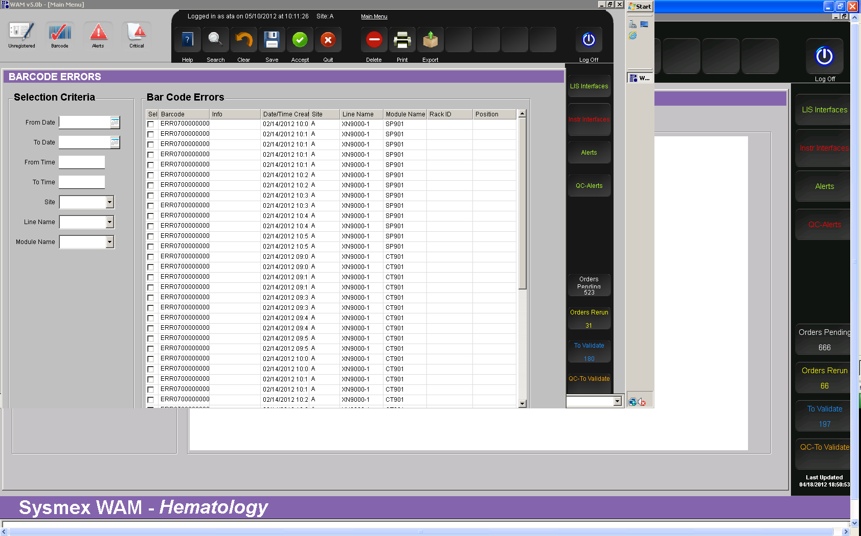
Figure 8: Barcode Errors Screen

- Unregistered Results
Check the status of orders in the Unregistered screen periodically. The Sample IDs should be researched to determine why the order has not been received in Sysmex WAM. If a Sample ID order without results will never be received, the Sample ID should be removed from the Unregistered list.
The Sample ID can be deleted from the Unregistered Sample ID list if an order will never be received.
Proceed as follows to remove the Sample ID order from the Unregistered Sample ID list:
- Select the icon from the fast menu or main menu.

- In the Unregistered Result screen, enter Sample ID or other selection criteria and click the Search icon.
- Review the list and determine why the order has not been received into Sysmex WAM.
- If order exists in LIS, re-transmit order from the LIS to Sysmex WAM if LIS can accept retransmission.
- For Sample IDs with no order in LIS that requires deletion, click the Delete Order icon to remove the Sample ID from the Unregistered list.
- A warning message will confirm the deletion.
- Click the Quit icon to return to the main menu.

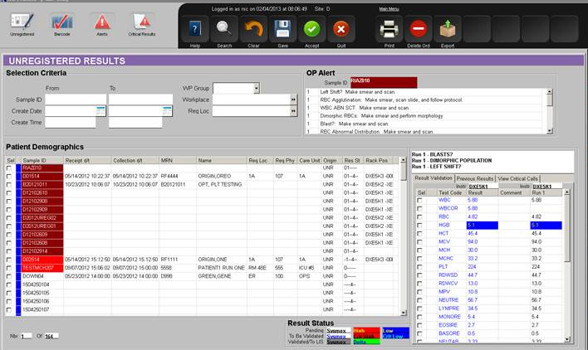
Figure 9: Unregistered Result Screen

CALCULATIONS
The following are the configurable standard calculations that are performed on Sysmex WAM.
- WBC/NRBC Correction calculation (X-Series Analyzers Only)
  - NRBCMI correction – correction of the WBC based on the NRBCMI from the manual differential
- Manual Differential Absolute calculations – The standard calculation is per the following for the common cell types: NEUT, LYMPH, MONO, BASO, and EOS etc.
  - Manual diff cell type% x WBC/100 = Absolute Number
(NEUT% x WBC/100) = NEUTAB
- ANC (Absolute Neutrophil Count) calculation
- ANC = WBC x (NEUT + BAND) /100
- ALC (Absolute Lymphocyte Count) calculation
  - ALC = WBC x (LYMPH+ATYLY) /100

REPORTING RESULTS
Sysmex WAM transmits test results based on the customer selection via the Sysmex WAM settings document. Test results are transmitted via the standard Sysmex WAM HL7 or ASTM requirements.

Results are transmitted to the LIS based on the following:

- Auto-validation – No rules or actions required. The test results are marked as validated and transmitted to the LIS as ‘completed.’ The following data is transmitted with the results:
  - Analyzer ID
  - User: 6000 or 9000

- Manual Validation – If a rule is triggered and/or an action is required, the Sample ID is required to be manually validated in the Result Validation screen. When the user approves the results, the following data is transmitted with the test result:
  - Method Code - MDIFF
  - User ID
  - Free text or coded comment code or coded comment either as a description (decoded) or coded comment based on the site configuration

TROUBLESHOOTING

The following are common Sysmex WAM issues and recommended actions to resolution.

Patient Lock Record
Issue: Patient File Lock
Probable Cause | - More than one user trying to perform activities on the same Sample ID at the same time or,  - User has walked away from PC workstation and suspended actions and another user is trying to access Sample ID or,  - There was a power outage or shut down of the WAM workstation while on a patient record.
Corrective Action | - One user must log out of screen that is accessing Sample ID.  - Wait for Sample ID file to unlock.  - Wait for Sample ID to unlock  - Notify site administrator to unlock Sample ID via the Record Locking Management screen. Refer to the Sysmex WAM v5.0 User Manual for instructions.

Unregistered Results
Issue: Results cannot be validated in the Result Validation screen.
Probable Cause | - No order was received from LIS.  - Sample ID was entered into analyzer.
Corrective Action | - Transmit order from LIS for 1 and 2.  - Return to Result Validation screen to validate (approve) results. If no validation is required, results are released automatically upon receiving LIS order.

Sample ID Barcode Errors
Issue: Too many sample ID barcode errors on Sysmex WAM.
Probable Cause | - Specimen label problem  - Barcode reader mis-alignment  - Barcode reader configuration issues on analyzer or device
Corrective Action | - Check barcode labels on specimen container tubes for any cracking, stickiness or more than two labels. Correct labeling problem.  - Check barcode reader on device or analyzer for alignment issues and re-align.  - Check barcode reader on device or analyzer and contact Sysmex.

Rules Conflicts
Issue: Rule is not working.
Probable Cause | - Specific rule did not trigger as expected – Rule conflict.  - Rule did not perform action as expected – Rule overlapping.
Corrective Action | - A rule conflict has occurred and one rule has priority over the other.  - Rules are overlapping and the rule with the most specific actions will be performed.  - Contact site administrator to check rule conflict via the Rule Conflict checker screen.  NOTE: Contact Sysmex if you are unable to resolve the issue.

No Sample ID Orders
Issue: Order or Orders are not being transmitted from LIS to Sysmex WAM.
Probable Cause | - LIS did not receive order.  - LIS encountered error in transmitting error from LIS.  - Configuration issue with LIS for download order code.  - Problem with the LIS interface communication.
Corrective Action | - Check LIS for receipt of order in system.  - Check LIS for transmission confirmation of order to Sysmex WAM. Check for any interface errors.  - Check order code in LIS to ensure this is an order code that Sysmex WAM is expecting.  - Click LIS Interface icon on the Alert bar. The Process Monitor screen will display. Click the LIS process. Press the START icon to start the LIS interface.  NOTE: Contact Sysmex if you are unable to resolve the issue.

No Results on Result Validation Screen
Issue: Order is not available on Result Validation Screen when searching by Criteria 2 and 3 in Validation Selection screen.
Probable Cause | - LIS did not transmit order.  - No results from analyzer – at status 0.  - Rerun pending and no results from analyzer – order set to status 0.
Corrective Action | - Check LIS for receipt of order and/or transmission errors in sending order to Sysmex WAM.  - Sample ID not run on analyzer yet.  - Rerun not performed on Sample ID yet.

Rerun Block
Issue: Rerun does not display on rerun screen.
Probable Cause | - Rule was not triggered for rerun.  - User placed specimen on analyzer without ordering a rerun via the Action Box in the Result Validation screen.
Corrective Action | - Check rule definitions.  - Software prevents display of run if not ordered via a rule and/or user adds rerun via the Result Validation screen.

Refresh Screen
Issue: Screen does not display full details when entered into the Result Validation screen from Validation Selection.
Probable Cause | - Screen did not fully load on screen upon initial entry.  - Screen did not fully load between screens.
Corrective Action | - Press the Refresh icon on the Result Validation screen.  - Contact Sysmex if problem persists.

Unable to Query for Orders
Issue: Unable to Query for Orders on Query Order or Validation Selection Screen.
Probable Cause | - LIS not sending orders to Sysmex WAM.  - User is logged into the wrong site per access code for multi-site WAM.
Corrective Action | - Check with LIS for issues with transmitting orders. Verity LIS communication in the Process Monitor.  - Check to see if user is logged into correct site per access code. Change Site by selecting the Log Off from the top menu and selecting Change Site.  Note: Contact Sysmex to investigate the issue.

LIS Connection
Issue: No new orders being processed by Sysmex WAM.
Probable Cause | - LIS not sending orders to Sysmex WAM.  - LIS connection issue with Sysmex WAM. Alert pop-up indicates that there is LIS interface issue.
Corrective Action | - Check with LIS for issues with transmitting orders.  - Click LIS Interface icon on the Alert bar. The Process Monitor screen will display. Click the LIS process. Press the START icon to start the LIS interface.  Note: Contact Sysmex to investigate the issue.

Analyzer/Device Connection
Issue: No new results or information being processed by Sysmex WAM.
Probable Cause | - Analyzer or device not sending results or information to Sysmex WAM.  - Analyzer or device connection issue with Sysmex WAM. Alert pop-up indicates that there is LIS interface issue.
Corrective Action | - Check analyzer or devices for operational errors.  - Click Instrument Interface icon on the Alert bar. The Process Monitor screen will display. Click the appropriate analyzer process. Press the START icon to start the analyzer process.  Note: Contact Sysmex to investigate the issue.

Scattergrams/Histograms Not Displaying
Issue: No graphical images on Result Validation Screen.
Probable Cause | - No Scattergrams or Histograms displaying on Result Validation screen upon initial Sample ID review – graphical integration problem.  - Analyzer software update issue.  - Image integration issue.
Corrective Action | - Contact Sysmex.  - Contact Sysmex.  - Contact Sysmex.

REFERENCES

  - Sysmex WAM v5.0 User Manual Hematology
  - Sysmex WAM v5.0 Hematology Quick Guide
  - Sysmex WAM ASTM IF Specs
  - Sysmex WAM HL7 IF Specs

Sysmex WAM v5.0 Software

Error! Cannot open data source.DOCUMENT HISTORY PAGE
Effective Date:
Change type: new, major, minor etc. | Changes Made to Document – Describe | Area Lab Manager Reviewed/ Date | Lab Operations Director Reviewed/ Date | Medical Director Reviewed/ Date | Date change Imp.
NEW

IMP = Implemented

