Erythrocyte Sedimentation Rate using the Alcor iSED ESR Analyzer

Safety Message | Use appropriate universal precautions when performing the test.

Purpose | This procedure provides instructions for performing an automated erythrocyte sedimentation rate using the iSED ESR analyzer. The rate at which red blood cells aggregate in whole blood has a direct effect on the resulting sedimentation rate. Sedimentation rate is therefore an indirect representation of the rate of aggregation. The iSED erythrocyte sedimentation analyzer uses photometrical rheology to directly measure the aggregation of red blood cells. Once the sample is automatically processed and in position a sensitive optical detector in the iSED follows the progress of aggregation over time. This produces a signal that is a direct representation of the aggregation. The magnitude of time-dependent change is correlated to the Westergren method.

Specimen Requirements | - Sample volume required for testing/ Minimum dead volume: 100uL/ 400uL  - Sample must be whole blood collected in K3-EDTA or K2-EDTA anticoagulant tube (13 X 75 tube with pierceable cap or BD Microtainer® MAP Microtube)  - Sample must be neither clotted nor hemolyzed  (Do Not Mix Vigorously)  - Sample should be tested within 4 hours at room temperature or within 24 hours refrigerated (4C)  - Sample must be at room temperature for at least (15) minutes if previously refrigerated (4C)

Reagents | - iWASH cleansing agent (reorder item #112-12-001)  - Waste bottle (reorder item #112-12-002)  - Seditrol® ESR Quality Control (reorder item#DSO5233)

Erythrocyte Sedimentation Rate using the Alcor iSED ESR Analyzer

Calibration | iSED instruments are factory calibrated utilizing samples which are compared with results from a unique Reference Instrument. The Reference Instrument is correlated with the reference Westergren method. The instrument range is from 1 to 130 mm/hr. During normal operation, parameters affecting calibration are constantly monitored by the iSED and, if not within expected limits, an error message is given and further testing is prevented. No recalibration is required by the Operator.

Procedure | Follow the steps below to run a barcoded patient sample.

Step | Action
1 | Touch the “Add Sample” icon on the instrument’s touch screen:  
2 | The sample wheel rotates to position the next open slot in the sample entry port.
3 | The onscreen information bar will report “iSED is Waiting” and the instrument will beep quietly for five (5) seconds. As the five (5) second window draws to a close, beeping will become faster.
4 | Insert the barcoded tube with the barcode oriented to the right. A red light will illuminate and a distinctive beep will sound when the barcode is successfully recognized
5 | Automatic sample processing then begins.
6 | Repeat steps 2 – 4 until all samples have been loaded and/or all positions in the sample wheel are occupied.  NOTE: If the five (5) second window is missed, simply select the  icon again to restart the sample scheduling process.

Erythrocyte Sedimentation Rate using the Alcor iSED ESR Analyzer

Procedure | Follow the steps below to run a manual data entry patient sample.

Step | Action
1 | Touch the “Add Sample” icon on the instrument’s touch screen:  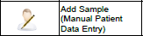
2 | The sample wheel rotates to position the next open slot in the sample entry port.
3 | The onscreen information bar will report “iSED is Waiting” and the instrument will beep quietly for five (5) seconds. As the five (5) second window draws to a close, beeping will become faster.
4 | Insert the tube. The instrument will try and read the barcode. If unable, the operator will be prompted to enter patient identification data manually using the alphanumeric keyboard.
5 | Remove tube from the sample wheel to allow for a visual tube identification to input patient data
6 | Patient information must be recorded in one or more of the following data fields:  - Alphanumerical ID  - Patient’s First Name  - Patient’s Surname
7 | Touch the icon to skip a data field or to confirm entered information.
7 | Sample processing will begin once patient data has been entered
6 | Repeat steps 2 – 4 until all samples have been loaded and/or all positions in the sample wheel are occupied.  NOTE: If the five (5) second window is missed, simply select the  icon again to restart the sample scheduling process.

Erythrocyte Sedimentation Rate using the Alcor iSED ESR Analyzer

Quality Controls | Seditrol® Quality Controls  - Seditrol® is human based whole blood quality control  - Seditrol® QC is kept at room temperature (18 – 30 C)  - Seditrol® QC open vial stability is 31 days.  - The unopened shelf life of Seditrol® QC is 18 months from the date of manufacture.  - Test time for QC is 20 seconds after 5 minutes of mixing.  - The Seditrol® QC tubes can be pierced up to 40 times without degrading the performance  - Two different levels of Seditrol® QC are analyzed at least once in 24 hours.

Procedure | Follow the steps below to run controls.

Step | Action
1 | Touch the “Add Sample” icon on the instrument’s touch screen:
2 | The sample wheel rotates to position the next open slot in the sample entry port.
3 | The onscreen information bar will report “iSED is Waiting” and the instrument will beep quietly for five (5) seconds. As the five (5) second window draws to a close, beeping will become faster.
4 | Insert the barcoded Seditrol® Level 1 control tube with the oriented to the right. A red light will illuminate and a distinctive beep will sound when the barcode is successfully recognized.
5 | Automatic sample processing then begins.  NOTE: The mix cycle for Seditrol® ESR Quality Control is five (5) minutes.
6 | Repeat steps 2 – 4 to run Seditrol® Level 2.
7 | Quality Control Limitations:  - The quality control product should not be used past expiration date.  - The quality control product is not intended for use as standard.  - Inability to obtain expected values may indicate product deterioration. Discoloration of the product may be caused by excessive heat or cold during shipping or storage.

Erythrocyte Sedimentation Rate using the Alcor iSED ESR Analyzer

Result Reporting | Results are shown on screen after analysis and also printed by the instruments internal printer.  Follow the steps below to release results in Cerner.

Releasing the results: Results will be AUTOVERIFIED. If autoverification is OFF, then follow workflow below.

 | If the instrument is … | Then you can ...
 | Interfaced | Release the results in Cerner through ARE, instrument queue.
 | Not interfaced | Release results in Cerner through ARE manually.

Result Reporting, continued | Reporting Notes:  - In the event that the instrument is unable to analyze the sample and report results, the print out will replace the result field with an error code.  - For results with error codes, refer to operator’s troubleshooting section of the manual to determine if follow up steps must be taken prior to accepting and reporting results.  - Always check the printout, before accepting the run and releasing results.  - For any result outside of the linearity (<1 or >130), you need to verify it by re-running the sample on the other instruments.  IMPORTANT NOTE:  The results for outside linearity will not post to Cerner. The CLS would need to check the print-out for the result. When resulting manually in Cerner ARE, CLS would need to type in '0' for the less than 1 result or 131 for the greater than 130 results. Cerner would automatically convert the result to <1 or >130 with the flag.

Erythrocyte Sedimentation Rate using the Alcor iSED ESR Analyzer

Reference ranges
  Male | <50 Years | 0-15 mm/hr
  Male | >50 Years | 0-20 mm/hr
  Female | <50 Years | 0-20 mm/hr
  Female | >50 Years | 0-30 mm/hr
  Children | ≤14 Years | 0-10 mm/hr

Limitations of the Procedure | - Reportable range: 1 – 130 mm/hr  - Blood that is hemolyzed, clotted or grossly lipemic should not be tested and should be redrawn.  - iSED results are NOT affected by Hematocrit or MCV.  - Some interferences which will increase ESR:  - Increased level of fibrinogen, gamma globulins  - Technical factor: mechanical vibration, high room temperature  - Some interferences which will decrease ESR:  - Abnormally shaped RBCs (sickle cells, spherocytosis)  - Technical factors: low room temperature, delay in test performance (> 2hr), clotted blood sample, excess anticoagulant, bubbles in tube.  - ESR is a nonspecific reaction. It is highly recommended to perform other tests together with ESR, since an ESR value is not enough to exclude that the patient is not affected by a pathology or to diagnose a clinical condition.

Erythrocyte Sedimentation Rate using the Alcor iSED ESR Analyzer

Preventive Maintenance | The instrument does not require any special daily maintenance, however it is recommended that the instrument be kept free from dusty and particulate environments at all times for best performance. If such environments are unavoidable, periodically inspect interior surfaces and rear fan assembly for heavy dust accumulation and clean as needed.  It is recommended that the sample needle be replaced after 30,000 piercings. Please contact Technical Support for instructions on replacing the needle.  To replace Printer Paper follow steps below:
  Step | Action
  1 | Pull lever A until the lid is released from its locked position  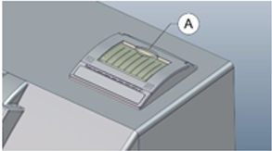
  2 | Open the paper cup lid and remove the remaining paper.
  3 | Insert thermal paper roll into the printer with the paper unwinding from the bottom of the roll.
  4 | Reel off a few inches from a new roll of paper. Hold approximately two (2) inches of paper outside the printer as you place the new roll into the reservoir.
  5 | Close the lid by applying equal amounts of pressure on each side ensuring the lid is in the locked position.
  6 | Now tear the spare paper away.  NOTE: If the paper roll is incorrectly inserted, paper advances, but the unit does not print.

Erythrocyte Sedimentation Rate using the Alcor iSED ESR Analyzer
To replace the Waste Bottle follow steps below:

Step | Action
1 | Open the front door to access the bottle compartment (A)  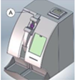
2 | Locate the waste bottle in the upper compartment (B)  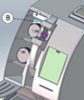
3 | Disconnect the LUER connector © from the waste bottle screw cap.  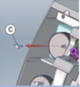
4 | Remove the waste bottle from the instrument and dispose according to your laboratory biologic waste protocol.
5 | Replace the waste bottle in the upper compartment (B) and firmly reconnect the LUER Connector (C) on the plastic screw cap with the vent hole positioned at top.
6 | Close the front door (A)  NOTE: Be sure to replace the plastic cap with the vent hole at the top.  NOTE: Be careful not to kink the line when replacing the bottle.  NOTE: It is recommended that the waste bottle be changed daily.

Erythrocyte Sedimentation Rate using the Alcor iSED ESR Analyzer
WASTE BOTTLE FULL INDICATORS AND ALARMS:

- When the waste bottle is full or nearly full, a warning message will appear on the screen and be accompanied by an alarm alerting the operator of an error or warning message. (below)



- Full Waste Bottle

  - When Waste Bottle is Full, an error message will appear on the screen and can be resolved by choosing one of the two options indicated: (below)
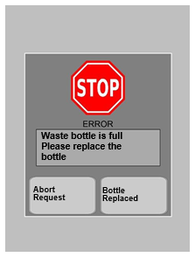

Abort Request – if this option is selected, the instrument automatically aborts the sample loading procedure.

Erythrocyte Sedimentation Rate using the Alcor iSED ESR Analyzer

Bottle Replaced – This option can be selected immediately prior to the operator replacing the waste bottle or immediately after the waste bottle has been replaced.

      - The instrument will not allow the operator to delay waste bottle replacement if this option is selected.

      - The waste bottle counter will automatically reset once the Bottle Replaced button is pressed and the instrument will continue with the samples loading process. (located later in procedure)

- Nearly Full Waste Bottle

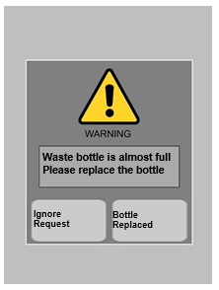

  - Ignore Request – if this option is selected, the instrument skips the warning and the operator can continue the sampling loading process.

- Bottle Replaced – This option can be selected immediately prior to the operator replacing the waste bottle or immediately after the waste bottle has been replaced.

Erythrocyte Sedimentation Rate using the Alcor iSED ESR Analyzer

      - The instrument will not allow the operator to delay waste bottle replacement if this option is selected.

      - The waste bottle counter will automatically reset once the waste bottle has been replaced and the instrument will continue with the samples loading process. (located later in procedure)

To replace the iWash Bottle follow steps below:

Erythrocyte Sedimentation Rate using the Alcor iSED ESR Analyzer

Step | Action
1 | Open the front door to access the bottle compartment (A)
2 | Locate the iwash bottle in the lower compartment (D)  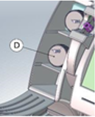
3 | Disconnect the LUER connector (E) from the iwash bottle screw cap.  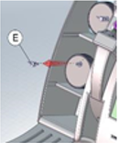
4 | Remove the empty iwash bottle, unscrew the cap and replace it with a new iwash bottle
5 | Place a new iwash bottle in the lower compartment and firmly reconnect the LUER connector (E) on the plastic screw cap with the vent hole positioned at the top.

Erythrocyte Sedimentation Rate using the Alcor iSED ESR Analyzer

Step | Action
6 | Close the front door (A)  NOTE: Be sure to replace the plastic cap with the vent hole at the top.  NOTE: Be careful not to kink the line when replacing the bottle.  NOTE: The instrument is programmed to perform self –cleaning after being idle for fifteen (15) minutes following the last sample tested. The process takes approximately one (1) minute and utilizes 3ml of iwash for each iwash cycle. Once completed, testing can resume as normal.

iWASH Bottle Empty Indicators and Alarms

When the iWASH bottle is empty or nearly empty, a message will appear on the screen and be accompanied by an alarm alerting the operator of the error or warning message.

Empty iWASH Bottle – in the event that iWASH bottle is empty the error message below will appear on the screen and can be resolved by choosing one of the two options indicated.
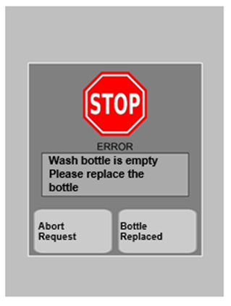

Erythrocyte Sedimentation Rate using the Alcor iSED ESR Analyzer

Abort Request – if this option is selected, the instrument automatically aborts the sample loading procedure.

Bottle Replaced – This option can be selected immediately prior to the operator replacing the iWASH bottle or immediately after the iWASH bottle has been replaced.

      - The instrument will not allow the operator to delay iWASH bottle replacement if this option is selected.

      - The iWASH bottle counter will automatically reset once the Bottle Replaced button is pressed and the instrument will continue with the samples loading process. (located later in procedure)

Nearly Empty iWASH Bottle – in the event that iWASH bottle is nearly empty the error message below will appear on the screen and can be resolved by choosing one of the two options indicated.
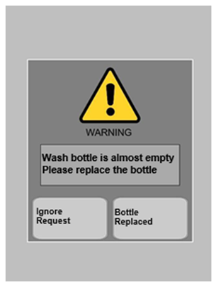
Ignore Request – if this option is selected, the instrument skips the warning and the operator can continue the sampling loading process.

Bottle Replaced – This option can be selected immediately prior to the operator replacing the iWASH bottle or immediately after the iWASH bottle has been replaced.

Erythrocyte Sedimentation Rate using the Alcor iSED ESR Analyzer

      - The instrument will not allow the operator to delay iWASH bottle replacement if this option is selected.

      - The iWASH bottle counter will automatically reset once the iWASH bottle button has been pressed and the instrument will continue with the samples loading process. (located later in procedure)

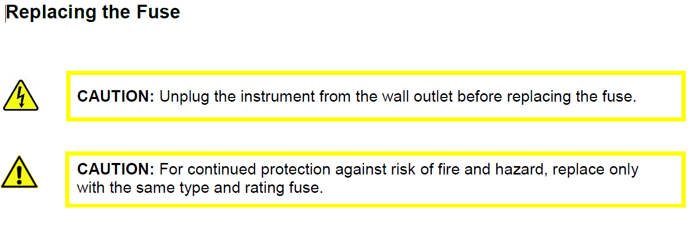

Erythrocyte Sedimentation Rate using the Alcor iSED ESR Analyzer

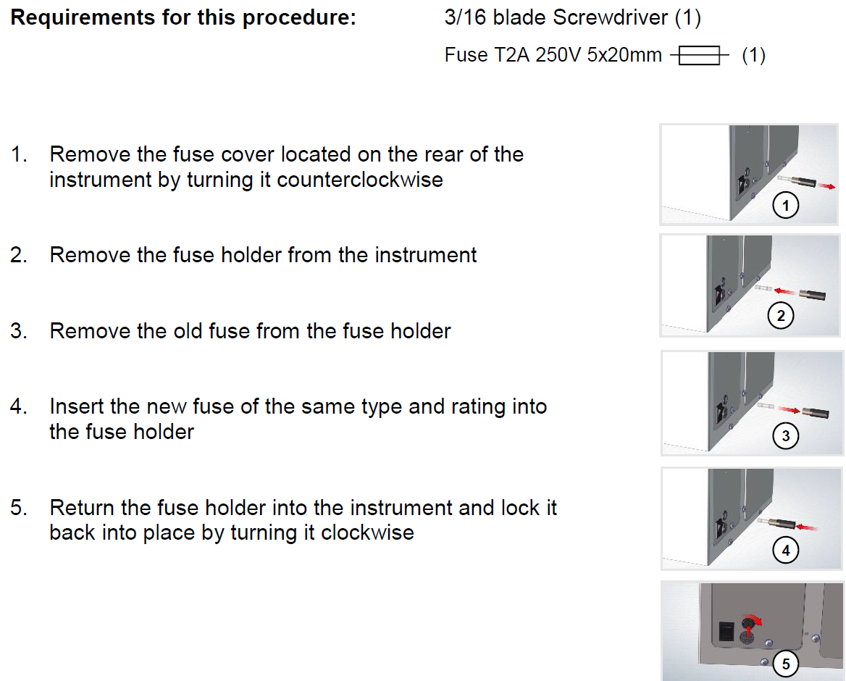

Erythrocyte Sedimentation Rate using the Alcor iSED ESR Analyzer

SYSTEM STATUS, ERROR CODES AND WARNING MESSAGES

The instrument touchscreen display has a gray highlighted “window” at the top of the screen where all active system messages appear. There is a 4-line display, with the first two lines dedicated to System Status Messages reporting on the number of available sample wheel positions and the number of Test Credits remaining. An animated emoticon in the lower right corner of the status window provides a quick visual reference to general operating status.

  - System Status Messages – each of the messages below display on the touch screen as the system is processing specimens.

Line 1 | Status
“Available Positions” | Sample positions currently available on sample wheel
Line 2 | Status
“Available Credit” | ‘Quantity’ Tests Available  Low – Purchase More Tests  0 – No Tests Available
Lines 3 & 4 | Status
“iSED Is”:
Positioning Sampler | Sample Wheel being positioned for loading a new tube, aspiration or tube extraction
Waiting Cuvette | Waiting for Sample (repeating beeps)
Memo Sample | Sample Barcode Successfully Read, or barcode acquisition time window elapsed
Mixing | Sample wheel rotating to mix all samples.
Withdrawing | Sample wheel positioned and probe is withdrawing sample
Measuring | Sample is positioned in read cell and analysis is underway
Extracting | Testing is complete and tube is being extracted from iSED instrument
Idle | All scheduled testing complete

NOTE: Unless the third line starts with “iSED is Warning” or “iSED is in Error”, the operation is normal. Descriptions for iSED Warning and Error messages are listed in the following sections.

Erythrocyte Sedimentation Rate using the Alcor iSED ESR Analyzer

System Warning Messages

System Warning Messages are general messages about the instrument’s current operation. The following alert will appear on the instrument’s screen and be accompanied by the appropriate warning message:

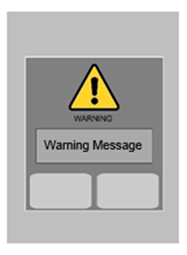

The table below shows examples of the warning messages you may see while operating the instrument and some possible solutions. Should you experience other warning messages, please refer to the Troubleshooting Chart found in this manual.

“iSED is in Warning” | Solution
Available Positions = 0 | Please wait for next available slot
‘Unavailable credit Please Add credits’ | Download more credits to continue; see page 24 of iSED Operator’s Manual
‘iSED Credits are low Please add credits’ | Download more credits or skip to continue; see page 24 of iSED Operator’s Manual
‘Waste Bottle Full’ message displayed and Alarm | Remove and replace waste bottle; see page 28 of iSED Operator’s Manual
‘Wash Bottle Empty Message’ displayed and Alarm | Replace iWASH bottle; see page 31 of iSED Operator’s Manual

Erythrocyte Sedimentation Rate using the Alcor iSED ESR Analyzer

“iSED is in Warning” | Solution
Ejection Out | Check for blocked ejection port
Paper Error/Out (Flashing Green Light) | Replace paper; see page 27 of iSED Manual
Rotor Finger | Remove any foreign object from area around sample entry port
Wash not Ok  ‘Wash Nok’ displayed | Check to see that iWASH bottle line is connected and there are no kinks in the line. Run wash cycle again.

System Error Messages

In the event of a system error, the following alert will appear on the instrument’s screen and be accompanied by the appropriate error message:

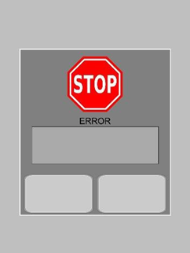

The following table shows examples of the error messages that may be observed while operating the instrument and some possible solutions.

NOTE: Contact Technical Support if the error cannot be resolved by any solution provided below:

“iSED in Error” | Solution
Rotor Home | Restart the unit, eject the sample and re-enter the sample. If the error appears again, contact Technical Support.

Erythrocyte Sedimentation Rate using the Alcor iSED ESR Analyzer

“iSED in Error” | Solution
Syringe Home | Restart the unit, eject the sample and re-enter the sample. If the error appears again, contact Technical Support.
Syringe Up | Restart the unit, eject the sample and re-enter the sample. If the error appears again, contact Technical Support.
Syringe Probe | Restart the unit, eject the sample and re-enter the sample. If the error appears again, contact Technical Support.
Syringe No Tube | Restart the unit, eject the sample and re-enter the sample. If the error appears again, contact Technical Support.
Ejection home | Restart the unit, eject the sample and re-enter the sample. If the error appears again, contact Technical Support.
Ejection lock | Restart the unit, eject the sample and re-enter the sample. If the error appears again, contact Technical Support.
Ejection Out | Restart the unit, eject the sample and re-enter the sample. If the error appears again, contact Technical Support.
Ejection Tubes Jam | Remove source of jam. Sensor will reset once tube is removed. If problem persists contact Technical Support
Tail sensor | Restart the unit, eject the sample and re-enter the sample. If the error appears again, contact Technical Support.
Unable to withdraw | Check sample volume and perform wash cycle. If the error message appears again, contact Technical Support.

Sampling Error Messages

In the event of a sampling error, the following messages will be printed:

Error Message (Printed) | Solution
“No Flow detected” | New specimen should be drawn
“Abnormal sample” | New specimen should be drawn
“Abnormal reaction” | New specimen should be drawn
“Insufficient data points” | New specimen should be drawn
“Sample too dark” | New specimen should be drawn
“No HCT detected” | New specimen should be drawn
“Sample too clear” | New specimen should be drawn

Erythrocyte Sedimentation Rate using the Alcor iSED ESR Analyzer

“Unable to withdraw” | Contact Technical Support
“No flow detected” (in) | Contact Technical Support
“No flow detected” (out) | Contact Technical Support

Print Out of Sampling Error Message:

In the event of a sampling error, the instrument will try to resolve it automatically up to a maximum of three (3) attempts. After the third attempt, the instrument is unable to resolve the sampling error, the following error message will print:

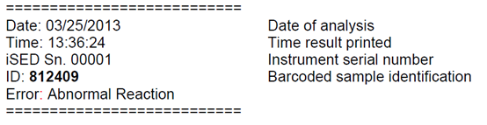
Please contact Technical Support should your instrument display and/or print a sampling error message

Erythrocyte Sedimentation Rate using the Alcor iSED ESR Analyzer

TROUBLESHOOTING

iSED is a fast and reliable medical instrument, however, as with any instrument, problems may occur. The following Troubleshooting Chart will help diagnose some simple problems and offer a solution.

Situation | Possible Causes | Solutions
Instrument will not power ON | Loose power connections Bad fuse | Check all power connections at the rear of instrument, power supply, and wall outlet. Reconnect power cord at all locations. Wait 30 seconds. Plug back in.  Remove fuse cap immediately above power connection on rear of instrument. Check fuse and replace if necessary.
Sample tube stuck in the wheel | Tube dropped during sample entry | Power OFF the instrument and manually remove the tube(s) from the wheel.
Touch screen not responding | Touch screen is out of calibration | Contact Technical Support for calibration instruction.
Results are running low/high | Lipemic, hemolyzed, or clotted specimen  Pre-analytical sample handling change or system error | Verify condition of specimen.  Run controls. Once complete if results are within range, resume normal operation; if out of range, discontinue testing and contact Technical Support.
Instrument is not scanning patient barcode | Damaged, incompatible, or no barcode label  Barcode reader misaligned | Validate barcode label  Contact Technical Support for instruction.

Erythrocyte Sedimentation Rate using the Alcor iSED ESR Analyzer

TECHNICAL SUPPORT:

If you experience any problems while operating the instrument, please contact ALCOR Scientific Inc., or your local authorized ALCOR Scientific Distributor. ALCOR Scientific offers Technical Support Monday through Friday 8:30am-5:00pm EST (excluding all USA Federal Holidays). They can be reached by any of the following:

Toll Free: (800) 495.5270 (USA Only) Fax: +1 (401) 737.4519

International: +1 (401) 737.3774

Mail: | ALCOR Scientific Inc. | Email: | techservice@alcorscientific.com
 | 20 Thurber Blvd
 | Smithfield, RI 02917
 | USA

Reference | The following reference is used in this procedure.  - iSED® Erythrocyte Sedimentation Rate Analyzer Operator Manual, ALCOR Scientific Inc. (OM112-09-043)  - CLSI/NCCLS Clinical Laboratory Technical Procedure Manual; Approved Guideline, GP02

Erythrocyte Sedimentation Rate using the Alcor iSED ESR Analyzer
Error! Cannot open data source.DOCUMENT HISTORY PAGE
Effective Date: 4/4/17
Change type: new, major, minor etc. | Changes Made to Document – Describe | Area Lab Manager Reviewed/ Date | Lab Operations Director Reviewed/ Date | Medical Director Reviewed/ Date | Date change Imp.
NEW | Change in instrument technology. | N.Taft 1/17/17 | J.Wolf 2/28/17 | S.Wirio 3/3/17 | 4/4/17
MAJOR | Added Autoverification step

IMP = Implemented

