**Workplace Safety Message:** All employees are expected to maintain a safe working environment and an injury-free workplace. Employees are responsible for their own safety, the safety of others and in adhering to all departmental and medical center safety policies and procedures.

**REFERENCES:**

1. **Trovo et al., Premature Membrane Rupture. Comparison of Diagnostic Tests. Minerva Ginecologica 50(12):519-22, 1998 Dec.**
2. **Friedman, M.L. McElin, T.W. “Diagnosis of Ruptured Fetal Membranes: Clinical Study and Review of Literature” Am. J. Obstet. Gynecol. 104:544, 1969.**
3. **Manual of Clinical Microbiology. Pleomorphic Gram-Positive Bacilli. Chapter 19, 6th ed., 1995.**

**PURPOSE:**

This method enables the provider to detect and confirm premature leakage of amniotic fluid from fetal membrane in minimal time during pregnancy.

**PROCEDURE:**

This test is based on the ability of amniotic fluid to form a fern pattern when air dried on a slide due to the fluid’s sodium, protein and carbohydrate content. Ferning is a particular form of crystallization that may be observed microscopically as part of diagnosing rupture of the amniotic membranes during pregnancy.

**SCOPE:**

Test will be performed by authorized Clinicians and Medical Practitioners. (Doctor of Medicine, Registered Nurse Practitioner, Certified Nurse Midwife)

**EQUIPMENT & MATERIALS:**

* Vaginal speculum
* Sterile swab
* Microscope
* Microscope slide
* Gloves

**REAGENTS:**

None

**SPECIMEN REQUIREMENTS:**

Vaginal swab is obtained from the posterior vaginal pool.

* Avoid the use of any lubricants or antiseptics.
* Use a sterile swab and do *not* touch the mucus plug.
* Prepare a thin smear on a glass microscope slide by spreading evenly.
* Allow the slide to dry. Do not apply heat. Do not put a coverslip.

**TEST ORDER:**

All Fern test must be ordered in the patient’s medical record (POCT section in KP Health Connect).

**PROCEDURE:**

Use universal standard precautions.

* Collect vaginal secretion from the posterior vaginal pool with a sterile swab.
* Rub the swab on a slide.
* Allow the slide to dry.
* Examine the slide under the microscope.
* Observe for frondlike, crystalline pattern “ferning”.
* Inspect entirety of the slide thoroughly if ferning is difficult to locate.

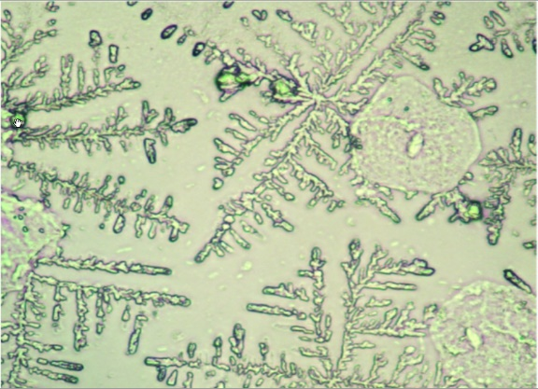

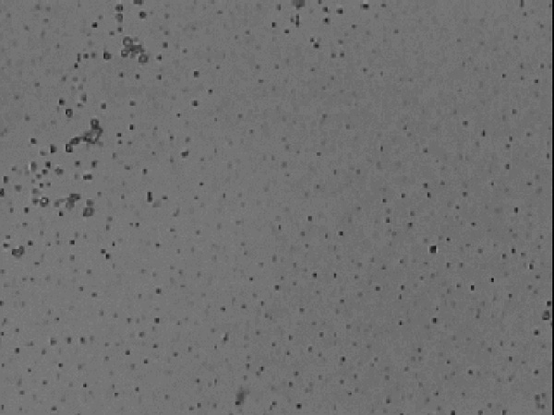

|  |
| --- |
| Positive Fern Test- note “fern-like” crystal Negative Fern Test- no "fern-like" crystal  formations formation |

**INTERPRETATION OF RESULTS:**

**Positive** – Presence of fern-like crystal

**Negative** – No fern-like crystal formation

**REFERENCE RANGE:**

Not applicable

**CRITICAL RESULT:**

Not Applicable