**\*\*\*This process is applicable to all other high enzyme results (e.g. ALT, AST) with a “greater than “ result in the “dns” field.\*\*\***

If Lipase raw data is greater than 2000 and dilution is done, enter diluted value in “dns Lipase”

DO NOT convert to freetext – this will not fire the rule to calculate the Lipase

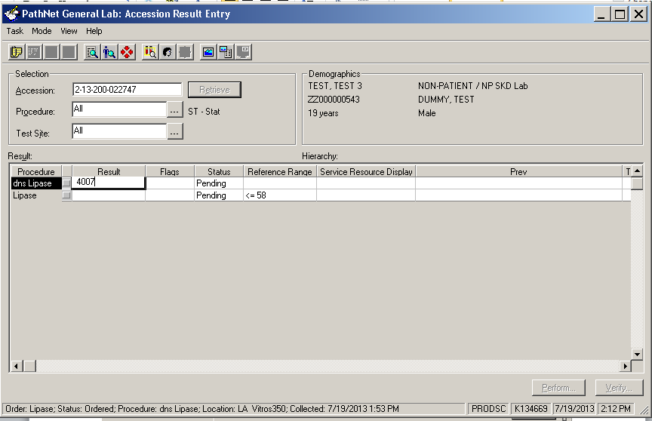

Once the value is entered (ENTER key is pressed) - the system will automatically calculate the Lipase

Right click and select “Comments”

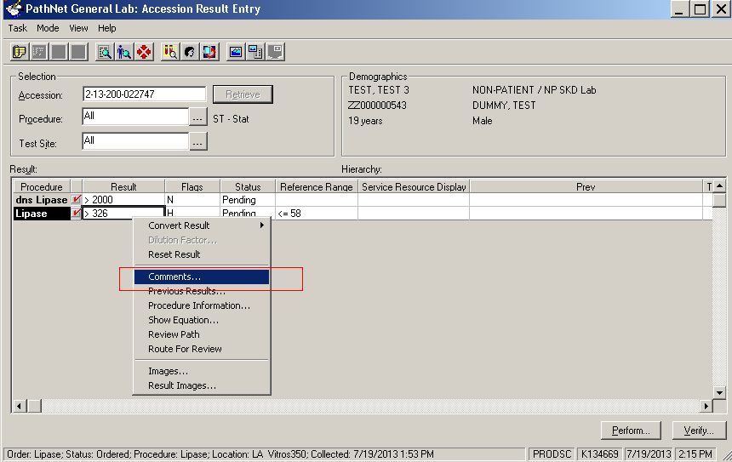

The Comments box will open – click Edit

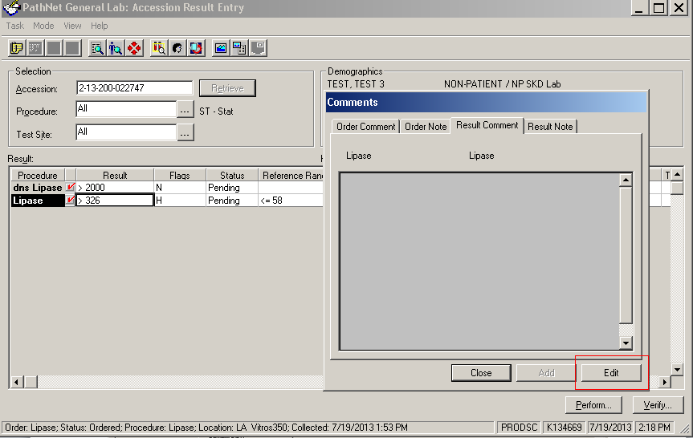

Manually calculate diluted Lipase result & enter freetext comment in Result Comment box and click OK

Result **Comment** text – is chartable

Result **Note** text – is internal and will not post

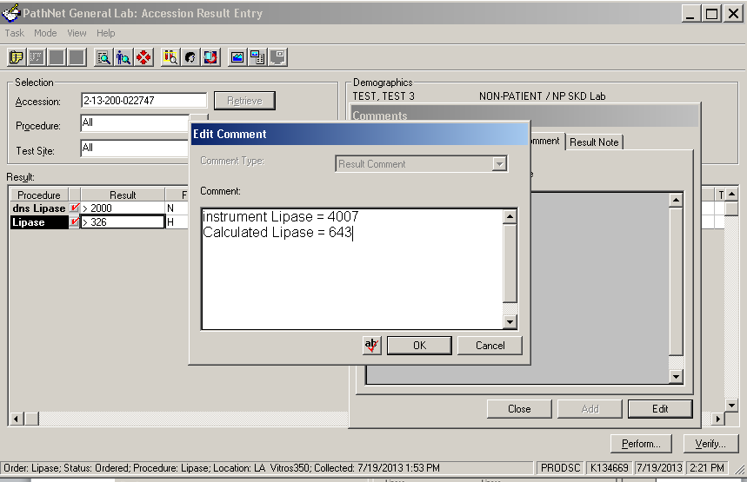

The text entered above is just an example (remember that what is entered here is posted). Instead, CLS staff must enter result in the Result Comment using the format below:

**Diluted**

**Lipase=643**