HEMACYTOMETER – INCYTO C-CHIP
Policy | Hemacytometer- INCYTO c-chip is used to do cell counts on body fluids and blood as required.

Workplace safety
  All laboratory employees are expected to maintain a safe working environment and an injury-free workplace. Laboratory employees are responsible for their own safety, the safety of others and adhering to all departmental and medical center safety policies and procedures.
  - For standard precautions and safety practices in the laboratory; see LGM 8000, specifically, but not limited to, equipment safety, proper body mechanics, sharps exposure and proper use of personal protective equipment (PPE).
  - For Universal Body Substance precautions, see LGM 8005, specifically, but not limited to, exposure to body fluids.
  - For proper hand washing, see LGM 8010, specifically, but not limited to, proper hand washing.
  - For proper infection control, see LGM 8004, specifically, but not limited to, proper use of gloves.
  - For proper handling of regular and infectious waste, see LGM 8006, specifically, but not limited to proper disposal of regular and biohazardous waste.
  - For proper cleaning of work area, see LGM 8007 - Cleaning Work Areas.
  - For proper handling of chemicals and reagents, see the Chemical Hygiene Plan.
  For proper storage and disposal of chemical hazardous waste, see LGM 8012.

Procedure | The C-chip is a disposable plastic hemocytometer used for manual cell counting. It is composed of two counting chambers that are separated by a horizontal grooved canal and bordered on each side by a similar vertical moat. The C-chip is exactly the same as the Neubauer Improved. It consists of 9 large squares, each measuring 1x1 mm, and the depth of the chamber is 0.1 mm. The area of each chamber is 3mm x 3mm= 9 mm². The volume of the chamber is 0.9 mm³. The C-chip is used to enumerate blood cells and other cellular elements. See below for general formula for calculating cell counts.

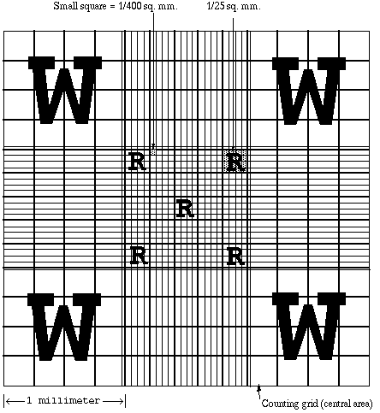
Large Square (W) = 1 mm²

Small Square (R) = 0.04 mm² for one small square
= 0.2 mm² for all 5 small squares

HEMACYTOMETER – INCYTO C-CHIP, Continued

General formula for cell counts
Total cells/ μl = Total Average Count x 10 cells/μl x dilution factor
# of square mm counted

Analysis | Refer to LHM204 Body Fluid Analysis and LHM287 Fluid Quality Control Procedure for step by step usage of instrument

Non-controlled documents

1 | Clinical Diagnosis and Management by Laboratory Methods, 17th ed. W.B. Sounders Co. Philadelphia, 1984, pg 589-591
2 | Clinical Diagnosis and Management by Laboratory Methods, 18th ed. W.B. Sounders Co. Philadelphia, 1991, pg 564-566
3 | Hematology for medical technologists, Seiverd, Charles, Lea&Fegiger, Philadelphia, 1983, pg. 93-177.

Controlled documents | See list below

#
LGM8000 | Standard precautions and safety practices in the laboratory
LGM8005 | Universal Body Substance precautions
LGM8010 | Proper hand-washing
LGM8006 | Infection control
LGM8007 | Cleaning Work Areas
LGM8012 | Proper storage and disposal of chemical hazardous waste
LHM204 | Body Fluid Analysis
LHM287 | Fluid Quality Control Procedure

Author | Alvin Castillo, CLS

