CRYSTAL EXAMINATION for Synovial Fluid
Policy | Crystal exams on synovial fluid will be performed only when ordered by a provider.

Workplace safety
  All laboratory employees are expected to maintain a safe working environment and an injury-free workplace. Laboratory employees are responsible for their own safety, the safety of others and adhering to all departmental and medical center safety policies and procedures.
  - For standard precautions and safety practices in the laboratory; see LGM 8000, specifically, but not limited to, equipment safety, proper body mechanics, sharps exposure and proper use of personal protective equipment (PPE).
  - For Universal Body Substance precautions, see LGM 8005, specifically, but not limited to, exposure to body fluids.
  - For proper hand washing, see LGM 8010, specifically, but not limited to, proper hand washing.
  - For proper infection control, see LGM 8004, specifically, but not limited to, proper use of gloves.
  - For proper handling of regular and infectious waste, see LGM 8006, specifically, but not limited to proper disposal of regular and biohazardous waste.
  - For proper cleaning of work area, see LGM 8007 - Cleaning Work Areas.
  - For proper handling of chemicals and reagents, see the Chemical Hygiene Plan.
  For proper storage and disposal of chemical hazardous waste, see LGM 8012.

Principle | Monosoduim urate (Gout) and calcium pyrophosphate dihydrate (pseudogout) crystals as well as cholesterol and steroid crystals can best be identified using crossed polarizing filters and a first order red compensator.  The two most important aspects of synovial fluid examinations are looking for crystals and microbiological study. Five general types of endogenous crystals may precipitate in or around joints and cause symptoms of clinical arthritis. They are as follows:

Clinical Condition | Crystal
Urate gout | Monosodium urate monohydrate
Pyrophosphate gout | Calcium pyrophosphate dihydrate
Apatite gout | Basic calcium phosphates
Lipid gout | Lipid
Oxalate gout | Calcium oxalate monohydrate  Calcium oxalate dihydrate

CRYSTAL EXAMINATION for Synovial Fluid , Continued

Clinical Significance | These crystals are most commonly seen in synovial fluid samples from patients with degenerative arthritis but may also be seen in hereditary forms of pseudogout.

Supplies needed | Gather the following list of supplies before starting the procedure:  - Glass slides  - Coverslips  - Microscope with polarizing lenses

Quality Control | Use a positive commercial control or previously identified known positive crystal slide to verify that polarizer is set correctly and that crystals can be seen. The known positive slide is also used to calibrate the polarizing lenses.  Commercial Control:  Streck Cell-Chex , Two “levels”  - L1-UC – contains monosodium urate crystals  - L2 – negative for crystals  Quality control is performed by each testing CLS at least one level per 8 hour shift(L1 AM & GY and L2 AM & PM) and documented in the Body Fluid Quality Control log

Specimen needed | Synovial fluid on a heparinized tube, red top tube (no anticoagulants), or a slide prepared by a provider.

Continued on next page

CRYSTAL EXAMINATION for Synovial Fluid, Continued

Procedure | Follow the steps below to examine specimen for crystals

Step | Action
1 | Initial examination for crystals should be conducted on a wet preparation, using both phase and polarized light.
2 | Use a clean glass slide and a glass coverslip. This is necessary because birefringent dust particles can cause confusing artifacts
3 | The aspirated fluid should be mixed by inverting the container several times to suspend the particles. Place a drop of freshly aspirated joint fluid on the slide and cover immediately. Centrifugation of the specimen in not necessary.
4 | Release the polarizer clamp screw and slowly rotate to polarizer whole unit until the dark cross image is formed on the exit pupil. Clamp the polarizer in this position.
5 | Adjust the microscope prior to aligning the polarizer with the tint-plate. Swing the tint-plate out of the optical path by rotating it on its pivot.
6 | Pull the analyzer vibration index lever to the first position. Note: The polarizer should be clamped firmly onto the condenser. Focus the microscope as usual.
7 | Assure of the following:  Turn the tint-plate rotation lever to its extreme left position. The view field will be magenta.  Turn the tint-plate rotation lever to its extreme right position. The view field will be magenta once again

Continued on next page

CRYSTAL EXAMINATION for Synovial Fluid, Continued

Microscopy

Step | Action
1 | Swing the tint-plate out of the optical path
2 | Observe the control specimen on the stage and sharply focus on the specimen which will appear white in the dark view field.
3 | Among the needle-shaped crystals seen in the view field, remember the crystals with those long mechanical dimension running north south axis on the stage.
4 | Bring the tint-plate into the optical path and observe the crystals to check the color changes.  If the observed crystals are Monosodium Urate (from gout), they appear yellow when the tint-plate rotation lever is turned to its extreme left position and blue when it is turned to its extreme right.  If the observed crystals are calcium pyrophosphate dihydrate (from pseudo-gout), they appear blue when the tint-plate rotation lever is turned to its extreme left position and yellow when it is turned to its extreme right.

Continued on next page

CRYSTAL EXAMINATION for Synovial Fluid, Continued

Results
- Crystals of monosodium urate (MSU) appear as birefringent rods or needles under polarized light, varying from 5 to 20⁰ F in length. The presence (or absence) of intracellular crystals should be noted; intracellular crystals are characteristic of acute urate gout. A control slide should always be used for comparison. MSU crystals may also be seen in patients with urate gout plus septic arthritis. The presence of MSU crystals does not exclude bacterial arthritis. With a red compensator, they appear yellow when their longtitudinal axis is parallel to the slow component of the compensator. These crystals are considered negatively birefringent. (The crystals appear blue when they are perpendicular to the axis of the compensator.)

Certain crystalline corticosteroid preparations appear morphologically identical to MSU. Although most cholesterol crystals appear as thin flat plates with notched corners, some cholesterol crystals can appear as birefringent needles with an appearance similar to MSU.

- Crystals of calcium pyrophosphate dihydrate (CPPD) are characteristic of a group of conditions referred to as "pyrophosphate gout" or "CPPD crystal deposition disease." These crystals may be seen in patients with degenerative arthritis, and in arthritides associated with hypothyroidism, hyperparathyroidism, hemochromatosis, and other conditions. The CPPD crystals appear as birefringent rods, rectangles, or rhomboids varying from 1-20 F in length and up to approximately 4 F in width. When a red compensator is used, calcium pyrophosphate crystals appear blue when their longitudinal axis is parallel to the slow component of the compensator. They are then considered to be positively birefringent. (The crystals appear yellow when they are perpendicular to the axis of the compensator.)

- Crystals of hydroxyapatite (HA) serve as the prototype for several basic calcium phosphates. Detection of such crystals is difficult, since they are non-birefringent and too small to be readily identified by light microscopy. However, the crystals may clump as spherical microaggregates, which vary from about 1-50 Fm in diameter and such clumps can be detected by light microscopy. Special techniques such as analytical electron microscopy are required to demonstrate HA crystals in synovial fluid.

- Crystals of lipids have been implicated as causing acute arthritis. These show Maltese cross birefringence, in contrast to other lipid particles which are not birefringent.

5. Crystal of calcium oxalate have been reported in patients undergoing chronic renal dialysis. Acute, subacute, or chronic joint symptoms may occur with crystals present in synovial fluid phagocytes. Calcium oxalate dihydrate has a bipyramidal morphology and is easily identified by phase contrast microscopy. the monohydrate form is birefringent but does not have a characteristic appearance.

- Glove powder introduced during joint surgery may present a Maltese cross appearance under polarized light similar to lipids. Such crystals may be as small as 5-10 F.

Continued on next page

CRYSTAL EXAMINATION for Synovial Fluid, Continued

- Crystals of corticosteroids may appear under polarized light as long needles or rhomboids identical in appearance to MSU or CPPD; they may also appear as short rods, plates, fragments or clumps. Such crystals may persist for several months following intra-articular injection.

8. Collagen fibrils and fibrin strands vary from 2F to over 100F in length. Although these may resemble MSU crystals under ordinary light, they show little or no birefringence with polarized light.

9. Fragments of cartilage may appear birefringent under polarized light but unlike MSU or CPPD do not have parallel margins. These fragments may be present in synovial fluid of osteoarthritis or traumatic arthritis.

10. Cholesterol crystals typically appear as irregular birefringent plates, often with notched margins.
However, in chronic effusions, cholesterol crystals may appear as long birefringent needles or as rhomboids. similar to MSU or CPPD. Such chronic effusions may be caused by tuberculous or rheumatoid arthritis.

RESULTS REPORTING:

Crystals are identified and reported by listing the observed attributes.

Results are entered in Micro Result Entry. . The chart view report that is released to the patient medical record is composed by stringing the response codes together in the following format (1_2_3_4_5_):

1 | 2 | 3
F = Few  Mod = Moderate  M = Many | NEED = Needle Shaped  RHOM = rhomboid shaped  RECT = rectangular shaped | POSB = positively birefringent  NEGB = negatively birefringent

4 | 5
INTRA C = intra-ceullar crystals  IN AND EX = Both intra and extra-cellular crystals  Extra C = extra-cellular crystals | MSU = consistent with monosodium urate  CPPD = consistent with calcium pyrophosphate dihydrate  CHO = consistent with cholesterol

Continued on next page
CRYSTAL EXAMINATION IN SYNOVIAL FLUID, Continued

Report response codes:
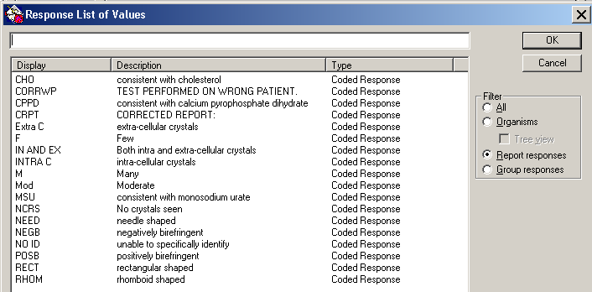

Example:
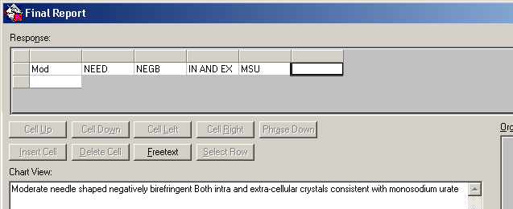

If no crystals are seen, report NCRS = No crystals seen.

If unable to specifically identify the crystals; indicate amount, shape, birefringent as well as unable to specifically identify (NO ID = unable to specifically identify).

Continued on next page

CRYSTAL EXAMINATION IN SYNOVIAL FLUID, Continued

Reference | Henry, J.; Clinical Diagnosis and Management by Laboratory Methods, W.B. Saunders Company, 1991, p.459-461  Kjeldsberg, Carl; Knight, Joseph “Body Fluids.” American Association of Clinical Pathologists Press, Chicago IL. 1986 P 129-150

Controlled Documents

#
LGM8000 | Standard precautions and safety practices in the laboratory
LGM8005 | Universal Body Substance precautions
LGM8010 | Proper hand-washing
LGM8006 | Infection control
LGM8007 | Cleaning Work Areas
LGM8012 | Proper storage and disposal of chemical hazardous waste

Author | Maaret Toprakci, MS, CLS, MT(ASCP)
Revised by | Alvin Castillo, CLS

