Workplace Safety | All laboratory employees are expected to maintain a safe working environment and an injury-free workplace. Laboratory employees are responsible for their own safety, the safety of others and adhering to all departmental and medical center safety policies and procedures.  - For standard precautions and safety practices in the laboratory; see LGM 8000, specifically, but not limited to, equipment safety, proper body mechanics, sharps exposure and proper use of personal protective equipment (PPE).  - For Universal Body Substance precautions, see LGM 8005, specifically, but not limited to, exposure to body fluids.  - For proper hand-washing, see LGM 8010, specifically, but not limited to, proper hand-washing.  - For proper infection control, see LGM 8004, specifically, but not limited to, proper use of gloves.  - For proper handling of regular and infectious waste, see LGM 8006, specifically, but not limited to proper disposal of regular and bio-hazardous waste.  For proper cleaning of work area, see LGM 8007 - Cleaning Work Areas. For proper handling of chemicals and reagents, see the Chemical Hygiene Plan

Policy | Slides are made and stained when needed for a slide review or a manual differential

Continued on next page

Preparing slide | Follow the steps below to prepare a slide for evaluation.

STEPS | ACTION
1 | Place a drop of blood (from an EDT A tube using Diff-Safe, from an EDTA tube using two sticks to pick up a drop of blood, or direct from a finger) about 1/2 inch from one end of a clean glass slide
2 | Lay the slide on a flat surface. Place the end of a second slide, held with the fingertips at an angle no greater than 30°, in front of the drop of blood.
3 | Pull the spreader slide back into the drop of blood. When the blood has spread along 2/3 of the width, push the spreader slide forward with a steady even motion. The angle of the pusher slide and the speed of pushing may be changed to vary the thickness of the smear. The greater the angle, the thicker the smear. The purpose of this step is to have a feathery edge on the smear that will create a monolayer of cells when checked on the microscope.
4 | Try to have a smear that ends at least 1/2 -2/3 inch from the other end of the slide.  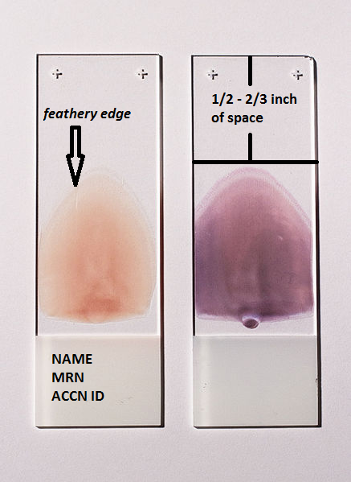
5 | Allow the smear to air dry (fan drying such as a hair dryer is preferable). Do not blow on it.
6 | Use the Zebra barcode/QRcode generator sticker by scanning the accession number from the tube to label the slide. Double check if the accession number produced is the same with the tube. Write down the name of the patient on top of the sticker.

Continued on next page
Evaluating the slides | Follow the steps below to evaluate a patient slide

1 | Stain the smear using an automated slidestainer- Beckman SMS or Hematek
2 | The stained smear should be scanned for adequacy of slide before the differential is completed.
3 | The WBC count can be estimated from a smear using the HIGH dry objective (40X) on the microscope using the following criteria
  CELLS/HPF | Approximate Count
  2-4 | 4,000-7,000
  4-6 | 7,000-10,000
  6-10 | 10,000-13,000
  10-20 | 13,000-20,000
4 | The Platelet count can be estimated from the slide using the 100X oil immersion objectives.  - Count the platelets by averaging platelets seen in 5 fields  - Multiply the average count by 15,000 for the estimated count  - Example: average platelet in 5 fields = 4 platelets  4 x 15,000 = 60,000 estimated platelet count
  Platelet count | Platelet estimate
  <130,000 | Decreased
  130,000-400,000 | Adequate
  >400,000 | Increased
5 | Manual DIFFERENTIALS:  Performed on a properly prepared Wright's stained blood smear using OIL immersion (100x) and HIGH light in the "rainbow" area where the red cells just touch.  The leukocyte differential is done to classify the type of leukocytes present in the blood. The slide is scanned from side to side counting & identifying 100 consecutive WBC's using counter keys = relative (%).  Segs %- Lymphs %-Monos %-Eos %-Basos %  - Low WBC count will have 2 blood smears prepared for differentials.  - For Differentials with < 25 cells differentiated in 2 blood smears, calculate the percentage of each cell differentiated and enter the total number of cells counted in the comment field.

Continued on next page
5 | Example: Cells differentiated in 2 blood smears  = 1 lymphocyte, 1 neutrophils = 50%LYMPHS 50%NEUT  Enter in comment field:  Total Cells Differentiated = 2
6 | RBC Morphology  Refer to LHM279 HEMATOLOGY SCAN DIFFERENTIAL AND REPORTING CRITERIA PROCEDURE

Sources of error in the preparation of the slide | Some of the sources of error when making the slides are:  - Dirty or Greasy slides  - Excessive pressure of the spreader slide will cause lining up of leukocytes along the edges and at the end of the smear.  - Excessive delay in spreading the blood may result in the blood clotting

Evaluation of a good slide | A good slide smear should meet the following criteria:  - The entire smear should cover no more than 2/3 of the area of the slide.  - No portion of the smear should extend to the lateral edges of the slide.  - There should be no ridges, lines or holes in the smear.  - Somewhat proximal to the feather edge there should be a zone at least 3 low power fields in width where the RBC's barely touch but do not overlap creating a monolayer of cells.  - Leukocytes should be evenly distributed.

Controlled documents | See list below

#
LGM8000 | Standard precautions and safety practices in the laboratory
LGM8005 | Universal Body Substance precautions
LGM8010 | Proper hand-washing
LGM8006 | Infection control
LGM8007 | Cleaning Work Areas
LGM8012 | Proper storage and disposal of chemical hazardous waste
LHM279 | Hematology Scan Differential and Reporting Criteria Procedure

Author | Alvin Castillo, CLS

