Specimen Log-In, Cerner Millennium

Purpose | To outline steps required in logging-in specimen/s on Cerner Millennium.

Workplace Safety | For equipment safety, proper body mechanics, sharp exposure, other safety practices, see LGM 8000 - Safety Practices.

Procedure | Specimen log-in must occur before the tests can be resulted or the specimen added to a transfer list. Follow the steps listed below:  Click the Specimen Log –In button on the Cerner AppBar.  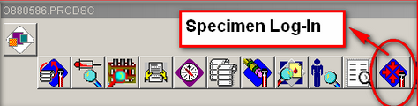  A box, “PathNet Collections: Specimen Log-In” will appear on your screen. Choose Log-In By: Accession and click Retrieve.  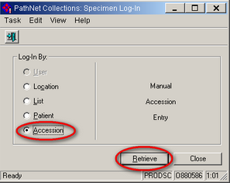

Specimen Log-In, Cerner Millennium, Continued
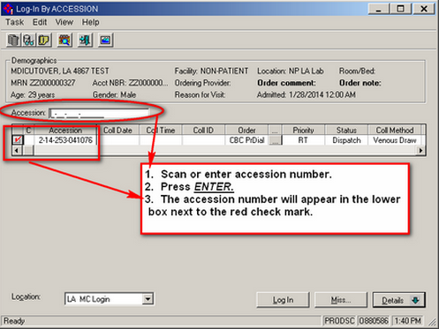

Enter information for Coll Date, Coll Time and Coll ID, if not already present.
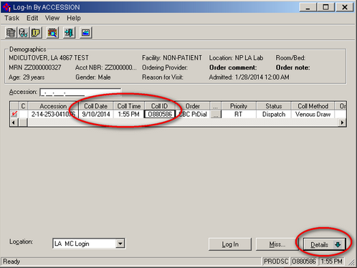

Dnkfnoeijroi

Specimen Log-In, Cerner Millennium, Continued

Inpatient Collector | Accepted Coll ID
Lab Assistant or Phlebotomist | Their assigned NUID
Nurse | RNC
Physician | MDC
Emergency Department | EDC

Click Detail at the lower right corner to review every single test orders attached to the accession number. To prevent problems, it is important to uncheck the box if specimen is not submitted for the testing.
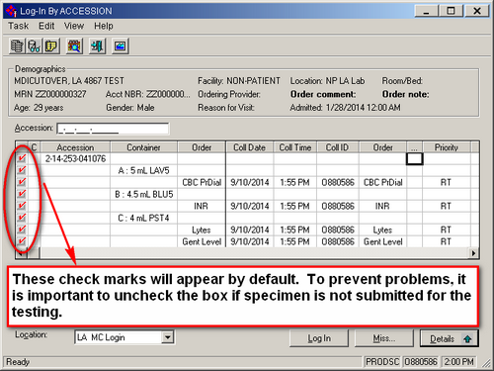

Verify the Location is correct and click Log-In
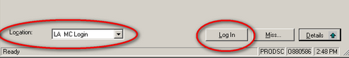

Specimen Log-In, Cerner Millennium, Continued
The status changes from Dispatched to Collected to In-Lab.
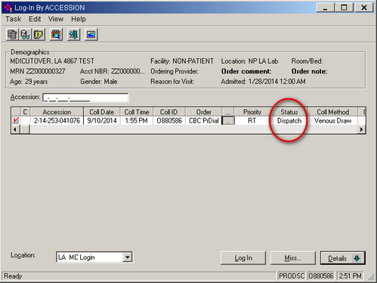

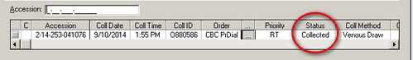

In-Lab status on Cerner’s Order View Entry:
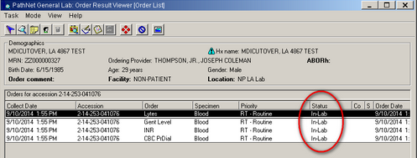

Specimen Log-In, Cerner Millennium, Continued

SIGNATURE | DATE
- Jo-Ann Calalang, CLS
Laboratory Systems Manager - Los Angeles Medical Center
Julie Toti, CLS, MS
Manager, Clinical Laboratory – Los Angeles Medical Center
Joseph Thompson, M.D.
Director, Clinical Laboratory – Los Angeles Medical Center

Specimen Log-In, Cerner Millennium, Continued

HISTORY PAGE

Change type:  New, major, minor | Changes made to SOP - describe | Signature responsible person/date | Laboratory Director review/date | Laboratory Manager review/date | Date change implemented
New

