Purpose | This document will define the procedure for the staining, detection and quantification of white blood cells in a stool specimen.
Workplace Safety | All laboratory employees are expected to maintain a safe working environment and an injury-free workplace. Laboratory employees are responsible for their own safety, the safety of others and adhering to all departmental and medical center safety policies and procedures.  - For standard precautions and safety practices in the laboratory; see LGM 8000, specifically, but not limited to, equipment safety, proper body mechanics, sharps exposure and proper use of personal protective equipment (PPE).  - For Universal Body Substance precautions, see LGM 8005, specifically, but not limited to, exposure to body fluids.  - For proper hand-washing, see LGM 8010, specifically, but not limited to, proper hand-washing.  - For proper infection control, see LGM 8004, specifically, but not limited to, proper use of gloves.  - For proper handling of regular and infectious waste, see LGM 8006, specifically, but not limited to proper disposal of regular and biohazardous waste.  - For proper cleaning of work area, see LGM 8007 - Cleaning Work Areas.  - For proper handling of chemicals and reagents, see the Chemical Hygiene Plan.  For proper storage and disposal of chemical hazardous waste, see LGM 8012.

Specimen | - Fresh random stool specimen collected in a sterile container without any preservatives delivered to the laboratory as soon after collection as possible.  - Stool specimens contaminated with urine are rejected.

Supplies needed | The following is a list of supplies needed before proceeding with the procedure:  - Glass slide  - Wooden applicator sticks.  - Saline.  - Hema-tek slide stainer(Wright-Giemsa Stain)

Preparing slide | Follow the steps below to prepare a slide:
Preparing slide |  | If the stool is … | then you would …
Preparing slide |  | liquid | place a drop of the liquid stool on a glass slide
Preparing slide |  | formed | - Place a drop of saline on the slide  - Using a wooden applicator stick pick up a small portion of stool.  - Mix the stool with the saline on the slide.
Preparing slide |  | full of mucus | Smear some of the mucus drops into an area about 1/3 of the slide using a wooden applicator stick.

Completing analysis | Follow the steps below to complete the analysis for white blood cells in stool specimens.

Step | Action
1. | Allow smears to air dry.
2. | Place dry smears on the Hema-Tek slide stainer for staining.
3. | View the slide using the oil immersion lens (100x), looking for the presence of white blood cells(polymorphonuclear neutrophils only).
4. | Semi-quantitate the white blood cells if any are present.
5. | Results are reported in Cerner Micro Result Entry  
6 | Type FIN under Entry field to show Final Report window  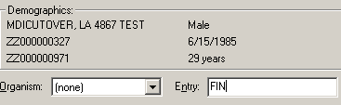
7 | After the Final Report window pops up, Press F2 and choose Report responses to show Response List of Values  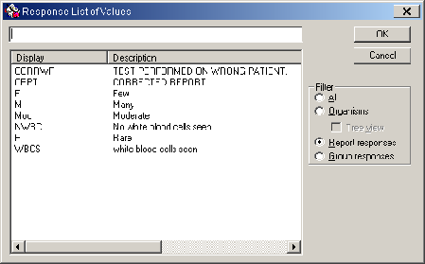
8 | Report responses are:  - Rare WBC’s seen = 0-1 WBC/oil immersion field.  - Few WBC's seen = 1-5 WBC/oil immersion field.  - Moderate WBC"S seen = 5-10 WBC/oil immersion field.  - Many WBC's seen = >10 WBC/oil immersion field.
9 | Choose the necessary response code combination to report Fecal WBC.  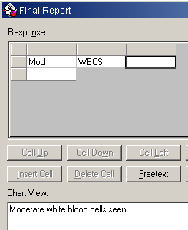
10 | Click Verify to report Final Result

Procedural note | Identification of white cells is more difficult if the slide is too thick. The slide should be remade using less specimen.

Quality of stain | No Fecal WBC QC is performed, we check Quality of stain as part of the Hema-tek stainer Daily Maintenance.

Uncontrolled documents | Balows, A. Hauser, W.J. Jr. Herrman, K.L. Isenberg, H.D. Shadony, H.J: Manual of clinical Microbiology, 5th ed. Pgs. 30, 365, 1308, 1991

Controlled Documents | See list below

LGM8000 | Standard precautions and safety practices in the laboratory
LGM8005 | Universal Body Substance precautions
LGM8010 | Proper hand-washing
LGM8006 | Infection control
LGM8007 | Cleaning Work Areas
LGM8012 | Proper storage and disposal of chemical hazardous waste

Author | Alvin Castillo, CLS

HISTORY PAGE

Change type: New, Major, Minor etc. | Changes Made to SOP – describe | Signature responsible person/date | Quality officer reviewed/date | Lab. Director  reviewed/date | Med. Director  reviewed/date | Date change implemented
NEW

Reviewed and approved by:

SIGNATURE | DATE
Alvin Castillo, CLS
Hematology supervisor
Los Angeles Medical Center
Jocelyn Javier, CLS, MT
Quality Officer, Clinical Laboratory
Los Angeles Medical Center
Julie Toti, CLS, MS
Laboratory Director, Clinical Laboratory
Los Angeles Medical Center
Joseph Thompson, M.D.
Medical Director, Clinical Laboratory
Los Angeles Medical Center

