Q SCORE, SPUTUM CULTURE PROTOCOL
Policy | Q score is ordered on all sputum specimens. Prepare a gram stained slide. Examine the slide for Polymorphonuclear neutrophils (PMN's), mucus and squamous epithelial cells (SEC). Score the elements on the slide according to the table below.

Purpose | The Quality score (Q-Score) will be used to determine the quality of sputum specimens and to determine the acceptability for culture processing. The evaluation will include the Q-Score and a Gram stain.  Note:  Sputum screening is not indicated for fungal, virus, AFB, naso-tracheal, trans-tracheal or bronchoscopy samples.

Work place safety | All laboratory employees are expected to maintain a safe working environment and an injury-free workplace. Laboratory employees are responsible for their own safety, and the safety of others and adhering to all departmental and medical center safety policies and procedures.  - For standard precautions and safety practices in the laboratory; see LGM  8000, specifically, but not limited to, equipment safety, proper body mechanics, sharps exposure and proper use of personal protective equipment (PPE).  - For Universal Body Substance precautions, see LGM 8005, specifically, but not limited to, exposure to body fluids.  - For proper hand-washing, see LGM 8010, specifically, not limited to, proper hand-washing.  - For proper infection control, see LGM 8004, specifically, but not limited to, proper use of gloves.  - For proper handling of regular and infectious waste, see LGM 8006, specifically, but not limited to, proper disposal of regular and bio hazardous waste.  - For proper cleaning of work area, see LGM 8007 – Cleaning Work Areas.  - For proper handling of chemicals and reagents, see the Chemical Hygiene Plan.  - For proper storage and disposal of chemical hazardous waste, see LGM 8012.

Continued on next page

Q SCORE, SPUTUM CULTURE PROTOCOL, continued
Specimen | The required specimen is an expectorated sputum sample

Reagents and Materials | The table below lists the reagents and materials needed when performing a Q Score(refer to LBM209 Gram Stain procedure for additional information
  REAGENTS | MATERIALS
  - Methanol  - Gram Stain Reagents | - Clean Glass slides  - Cotton swabs  - Microscope

Smear Preparation | Follow the steps below to prepare the slide for Q-Score and Gram Stain Evaluation.
  Step | Action
  1 | Using a biosafety cabinet, prepare a smear from sputum, making sure to use the most purulent portion of the specimen
  2 | Take the cotton swab that has been dipped in the specimen and gently roll the material on the slide
  3 | Air-dry the slide in the biosafety cabinet
  4 | Fix the smear with methanol.
  5 | Gram Stain the slide. Refer to LBM209 Gram Stain Procedure for additional information

Q-Score Procedure | Using the Gram stain slide, follow the steps detailed below when determining the concentration of PMNs, SECs, and mucus for the Q-Score.
  Step | Action
  1 | Examine the Gram stain slide under low power(10X) using oil on the slide
  2 | Scan 5-10 low power(10X) fields.
  3 | Obtain an average number of PMNs and SECs by separately adding the number PMNs and SECs from each field that was scanned, and then dividing by the number of fields

Continued on next page

Q SCORE, SPUTUM CULTURE PROTOCOL, continued
Step | Action
4 | Use the following system to score the quality of the specimen  For PMNs  For SECs
  If the number of PMNs per 10X low power field is… | Then report the value as…
  <10  10-25  >25  If mucus is present | 0  +1  +2  +1
  If the number of SECs per 10X low power field is… | Then report the value as…
  <10  10-25  >25 | 0  -1  -2
5 | Use the reported numbers obtained in step 4 in the table below to determine the Q-Score of the specimen.
   | Squamous Epithelial Cells (SEC)
  PMNs | Cells/LPF |  | <10 | 10-25 | >25
  PMNs |  | Reported Value | 0 | -1 | -2
  PMNs | <10 | 0 | 0 | -1 | -2
  PMNs | 10-25 | +1 | +1 | 0 | -1
  PMNs | >25 | +2 | +2 | +1 | 0
5 | COMPOSITE Q SCORE
6 | Calculate Q-Score with the presence or absence of mucus. If mucus present add 1 the number from grid.
7 | Based on the total Q-Score value, use the table to determine the need to report Gram stains findings.
  If the Q-Score is… | Then…
  +1 or greater | Examine under oil immersion; enter on the manual log as appropriate  - The quantity of bacteria seen as FEW, MODERATE, or MANY and the morphology of the organisms, i.e., Gram positive cocci in clusters, or  - NOS(No organisms seen)
  0 or less | Do not report Gram Stain, do not enter Gram stain on manual log.

Continued on next page

Q SCORE, SPUTUM CULTURE PROTOCOL, continued
Step | Action
8 | Proceed to Result Reporting

Aid in Quantitation of Microorganisms | Use this table as a reference for quantifying the number of microorganisms
  Observation  (per 100x oil immersion field) | Quantitation
  0-1 | RARE
  2-5 | FEW
  6-10 | MODERATE
  >10 | MANY

Result Reporting | When the total score and Gram stain have been determined, follow the directions below.  - Enter results from the manual log in the appropriate result field (Date, Patient name, Accession number, Q-Score, Gram Stain, if Culture is needed).  - Follow steps below for entering results to LIS

REPORTING RESULTS in CERNER:

Step | Action
1 | Log onto CERNER.
2 | On your CERNER Apps:  - Click on Result Entry for Microbiology  
3 | At the Result Entry:  - Enter the accession number of the patient to be resulted on the Accession Field  - Type Q[space]Score on the Entry Field, and press Enter

Continued on next page

Q SCORE, SPUTUM CULTURE PROTOCOL, continued
REPORTING RESULTS in CERNER:

Step | Action
3 | 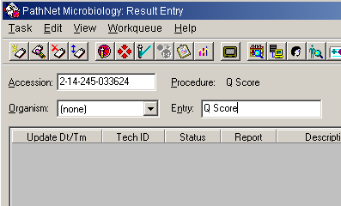
4 | Click the Biochemical radio button, verify that Q Score is selected, and Click Add.  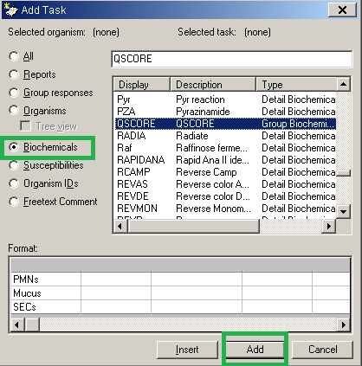
 | Continued on next page

Q SCORE, SPUTUM CULTURE PROTOCOL, continued
REPORTING RESULTS in CERNER:

Step | Action
5 | Use the down arrow in each Biochemical codded result field to indicate the appropriate value. Click Verify  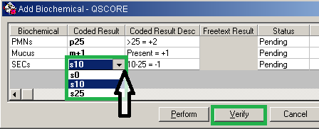
6 | Create a Q Score Final Report  - Type FIN on the Entry Field (final report)  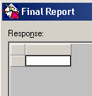  - Press F2 to access the Response List of Values  - Filter the by choosing Report Response  - Click on the necessary response code for reporting and press OK  - After inputting the codes for resulting  - Choose Perform to add additional Response Values or to save the result.  - Choose Verify to release the Final report.  DO NOT VERIFY if a Gram Stain will be added.

Continued on next page

Q SCORE, SPUTUM CULTURE PROTOCOL, continued
REPORTING RESULTS in CERNER:

Step | Action
6 | 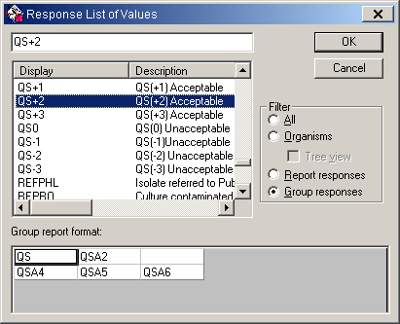  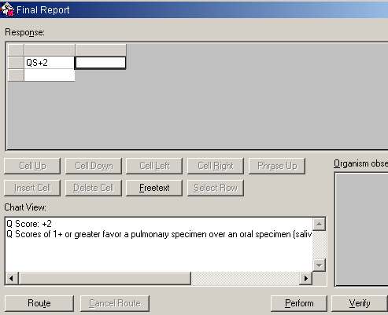

Q SCORE, SPUTUM CULTURE PROTOCOL, continued
REPORTING RESULTS in CERNER:

Step | Action
7a | Q Score of Zero/Negative Q Score  - DO NOT REPORT Gram Stain. Verify Q Score only  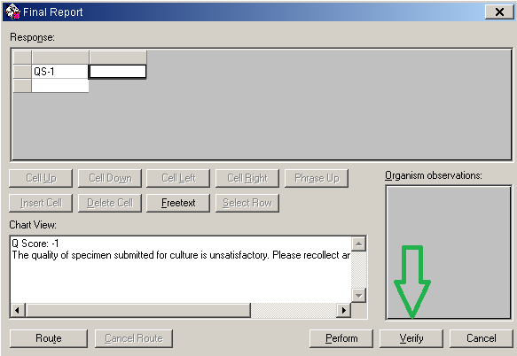  - If a sputum Culture has been ordered, cancel the Sputum Culture from Order Result Viewer , use cancel reason Spn Unacceptable for Cx, pls reorder PRN.  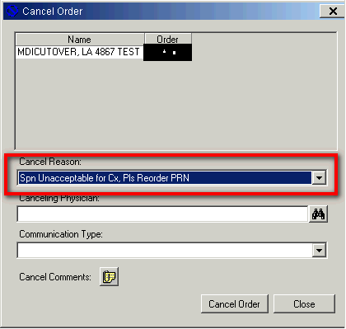

Q SCORE, SPUTUM CULTURE PROTOCOL, continued
REPORTING RESULTS in CERNER:

Step | Action
7b | Q Score +1 or Greater  - Add a Gram Stain Result to a Q Score +1 or Greater  - Double-click the Final Report in the center pane.  - Type GS in the Response field below the Q Score, and press Enter.  - Type the appropriate Response Value, and press enter.  - Click Perform to Save or Verify to release results Final Report.  - Refer to LBM209 Gram Stain Procedure for additional information  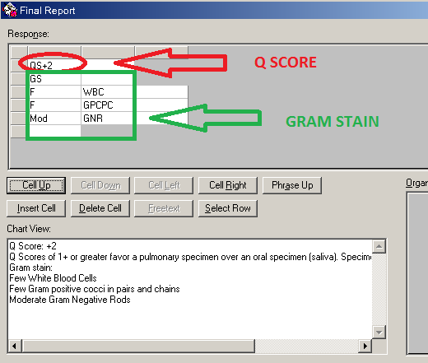  - Sputum culture log in/add order  - Login as received Sputum culture order or add on order if there is no order available using KRMS.  - Plate the specimen for Respiratory Culture.  Ship the plates to the Sherman Way Regional Laboratories per transport requirements.

Q SCORE, SPUTUM CULTURE PROTOCOL, continued

Limitation and Precaution | - Expectorated sputum samples for routine bacterial cultures must be processed under the biological hood.  - Routine “sputum” specimens often contain squamous epithelial cell, few inflammatory cells and grow pharyngeal flora, obscuring any true lower respiratory tract pathogens. For this reason, only those sputum specimens, which appear to be of acceptable quality will be processed.  - Keep in mind that severely leukopenic patients may not have white cells in their sputum.

Non-controlled Documents | - Lennette, E. H., Balows, A., Hausler, W Manual of clinical Microbiology, Am. Scc. For Microbiology, Washington D. C., 3rd ed., 1980  - Finegold, S. M., Mortin, W. J., Bailey and Scott’s diagnostic microbiology, The C. V. Mosby Co., St. Louis, Toronto, London, 9th ed., 1994  Balows, A., Hausler, W. Jr., Hermann, K. H. D., Shadony, H. J., Manual of Clinical Microbiology, 5TH ED., 1991

Controlled documents | See below

Documents | Title
LGM 2022 | Quality Manual
LGM 8000 | Safety Practices
LGM 8004 | Infection Control
LGM 8005 | Universal Body Substance Precautions
LGM 8006 | Handling of Regular and Infectious Waste
LGM 8007 | Cleaning Work Areas
LGM 8010 | Hand-washing Policy
LGM 8012 | Storage and disposal of Chemical Hazardous Waste
LBM202 | Handling of Bacteriology Specimens for Primary Culture
LBM209 | Gram Stain

Author | Maaret Toprakci, MS, CLS, MT(ASCP),
Revised by | Alvin Castillo, CLS

