QUALITY CONTROL (QC) POLICY

Purpose | To define the policy of running Quality Controls (QC) for every assay testing laboratory location at the Los Angeles Medical Center Area, and to ensure compliance with applicable CAP, JCAHO, COLA, Centers for Medicare and Medicaid (CMS) and the California Department of Health and Services (CDHS) regulations/requirements.

Workplace Safety | Not applicable.

Policy | - Control procedures are performed to monitor the stability of the method or test system and to ensure that correct patient results are reported. Control and calibration materials provide a means to indirectly assess the accuracy and precision of patient test results.  - For an every 8-hour control frequency, ranges in excess of ±30 minutes, producing a window of over an hour are not acceptable.  - Controls must be reviewed and deemed acceptable prior to reporting patient results.

Quantitative Analysis | Except as noted otherwise in specific procedures, at least 2 levels of controls within the analytical range of the assay must be included with each run of patient specimens. A run is defined as every 24 hours. These are Federal regulatory requirements, and may be more stringent in other defined areas, e.g., CBC, coagulation tests, and blood gas testing, in which, a run is defined as every 8 hours.  Control specimens must be treated the same as patient samples during each phase of testing.  Control specimens must be analyzed by routine testing personnel, and control samples must be rotated among all testing personnel on all shifts.  Controls must be assayed whenever a new variable is introduced into the system, e.g. newly prepared reagents, instrument maintenance, and recalibration.  Continued on next page
QUALITY CONTROL (QC) POLICY, Continued

Chemistry Testing |  | The table below describes the QC policy for Chemistry testing in every LAMC laboratory location.
 | Location |  | QC Ranges Determination | Frequency/Levels of QC | QC Rule
 | Main Lab  (AU680)  Routine Chemistry |  | - For unassayed controls, collect new QC data concurrently with retiring QC, at least 20 runs performed on different days.  - Use established historical SD and calculated mean. | - Twice daily  - 2 levels of QC  - Except BUN – 3 times daily, 3 levels | - 1_{2s}  - 1_{3s}  - 2_{2s}  - R_{4s}
 | Main Lab  (AU680) TDM, CRP  Urine/CSF Chemistry, Pediatric Bilirubin, Ammonia, Alc., Lithium |  | - For unassayed controls, collect new QC data concurrently with retiring QC, at least 20 runs performed on different days.  - Use established historical SD and calculated mean. | - Twice daily  - 2 levels of QC  - Except Digoxin and Gentamicin – 3 times daily, 3 levels | - 1_{2s}  - 1_{3s}  - 2_{2s}  - R_{4s}
 | Roche Diagnostics AVL 9180 (ionized Calcium) |  | - For unassayed controls, collect new QC data concurrently with retiring QC, at least 20 runs performed on different days.  - Use established historical SD and calculated mean. | - Daily  - 3 levels of QC | - 1_{2s}  - 1_{3s}  - 2_{2s}  - R_{4s}
 | Main Lab (BioMerieux MiniVidas – PCT) |  | - For unassayed controls, collect new QC data concurrently with retiring QC, at least 20 runs performed on different days.  - Use established historical SD and calculated mean. | - Once daily  - 2 levels of QC | - 1_{2s}  - 1_{3s}  - 2_{2s}  - R_{4s}
 | Pasadena  (AU480) |  | - For unassayed controls, collect new QC data concurrently with retiring QC, at least 20 runs performed on different days.  - Use established historical SD and calculated mean. | - Every 8 hours  - 2 levels of QC | - 12s  - 13s  - 22s  - R4s
Continued on next page
QUALITY CONTROL (QC) POLICY, Continued

Access ImmunoassayTesting |  | The table below describes the QC policy for Access Immunoassay testing, i.e. BNP, Troponin, CKMB, HCG, and Estradiol.
 | Location |  | QC Ranges Determination | Frequency/Levels of QC | QC Rule
 | Main Lab  (Access 2)  BNP, CKMB, Estradiol |  | - For unassayed controls, collect new QC data concurrently with retiring QC, at least 20 runs performed on different days.  - Use established historical SD and calculated Mean. | - Twice daily  - 2 levels of QC  - Except Troponin – every 8 hrs. | - 1_{2s}  - 2_{2s}  - _{R4s}
 | Main Lab  (Access 2)  BHCG, Troponin, I-PTH |  | - For unassayed controls, collect new QC data concurrently with retiring QC, at least 20 runs performed on different days.  - Use established historical SD and calculated Mean. | - Every 8 hours  - 3 levels of QC  - Except I PTH run QC only with patients | - 1_{3s}  - 22_{s}  - _{R4s}  - _{41s}  - _{8X}
 | Pasadena (Access 2) |  | - For unassayed controls, collect new QC data concurrently with retiring QC, at least 20 runs performed on different days.  - Use established historical SD and calculated Mean. | - Every 24 hours  - 2 levels of QC  - Except Troponin – every 8 hrs. | - 1_{2s}  - 1_{3s}

Osmolality | The table below describes the QC policy for Osmolality testing.
Location |  | QC Ranges Determination | Frequency/Levels of QC | QC Rule
Main Lab  (Advance Instruments) |  | - For unassayed controls, collect new QC data concurrently with retiring QC, at least 20 runs performed on different days.  - Use established historical SD and calculated Mean. | - Every 24 hours  - 2 levels of QC | - 1_{2s}  - 1_{3s}
Continued on next page
QUALITY CONTROL (QC) POLICY, Continued
Blood Gas Testing |  | The table below describes the QC policy for Blood Gas testing.
 | Location |  | QC Ranges Determination | Frequency/Levels of QC | QC Rule
 | Main Lab  (ABL) |  | - External/Simulator QC  - For unassayed controls, collect new QC data concurrently with retiring QC, at least 20 runs performed on different days.  - Use established historical SD and calculated Mean. | - Every 8 hours  - 3 levels of liquid QC for day shift and 1 level each subsequent evening and night shift. | - 1_{2s}  - 1_{3s}

Coagulation Testing | The table below describes the QC policy for Coagulation testing in every LAMC laboratory location.
Location |  | QC Ranges Determination | Frequency/Levels of QC | QC Rule
Main Lab  (Stago) |  | - For unassayed controls, collect new QC data concurrently with retiring QC, at least 20 runs performed on different days.  - Use established historical SD and calculated Mean. | - Every 8 hours  - 2 levels of QC  - Except LMWH and Thrombin Time run QC only with patients | - 1_{2s}  - 1_{3s}
Main Lab (Accumetrics VerifyNow – P2Y12) |  | - Electronic QC  - External Liquid QC | - Daily  - Monthly and every new lot and shipment | - Pass  - Within specified range on PRU Test Kit
Pasadena  (Stago) |  | - For unassayed controls, collect new QC data concurrently with retiring QC, at least 20 runs performed on different days.  - Use established historical SD and calculated Mean. | - Every 8 hours  - 2 levels of QC | - 1_{2s}  - 1_{3s}
BT Flow Cytometry Lab  (FC 500 for 4-color T-Cell panel (tetra) analysis |  | - For unassayed controls, collect new QC data concurrently with retiring QC, at least 20 runs performed on different days.  - Use established historical SD and calculated Mean. | - Every 8 hours  - 2 levels of QC | - 1_{2s}  - 1_{3s}

QUALITY CONTROL (QC) POLICY, Continued

Hematology Testing | The table below describes the QC policy for CBC testing in every LAMC laboratory location.

Location | QC Ranges Determination | Frequency/Levels of QC | QC Rule
Main Lab  (DxH800) | - For assayed controls, collect new QC data concurrently with retiring QC, at least 20 runs performed on different days.  - Use established historical SD and calculated Mean. | - Every 8 hours  - 3 levels of QC | - 1_{3s}  - 2of3_{2s}
 | X Bar M Quality Control | - X Bar M monitored daily for acceptability and documented in X Bar M log, corrective actions documented in corrective action log | - ± 3 % of mean for MCV, MCH & MCHC
Siemens PFA100 | - Qualified QC donors having a closure time near the middle of the established reference range | - Self Tests at the start of each shift that the system is in use  - Test control donor in duplicate with each new shipment of cartridges received | - The system will print pass/fail results after Self Tests are completed  - Result from the control donor must be within the established reference range
Sysmex PocH-100i | - For assayed controls, collect new QC data concurrently with retiring QC, at least 20 runs performed on different days.  - Use established historical SD and calculated Mean. | - Each day of patient testing  - 3 levels of QC | - All QC results must be within 2SD
QUALITY CONTROL (QC) POLICY, Continued

Hematology Testing (continued):
Location | QC Ranges Determination | Frequency/Levels of QC | QC Rule
Pasadena Lab | - For assayed controls, collect new QC data concurrently with retiring QC, at least 20 runs performed on different days.  - Use established historical SD and calculated Mean. | - Every 8 hours  - 3 levels of QC | - 1_{2s}  - 1_{3s}  - 2/3 QC within 1_{2s} and 1/3 QC < 1_{3s} - accept run
Pasadena Lab | XB/XM Quality Control | - Every 20 batches of 20 samples or monthly, whichever is more frequent. | - ± 3 % of mean for MCV, MCH & MCHC

Continued on next page
QUALITY CONTROL (QC) POLICY, Continued

Semi-Quantitative/ Qualitative Analysis | 2 levels of QC per 24 hour shift for Urinalysis testing using the manufacturer's recommended ranges.  2 levels of QC with each day of use for the following tests: Semen Analysis and ESR.  2 levels of QC with at least 1 level of QC every eight hours of testing for CSF/Fluid Count.  External positive and negative QC with each new box kit for the Urine Strep pneumonia Antigen test.  3 levels of QC with each patient testing for the OraQuick HIV Rapid test.  2 levels of QC on a monthly basis and every time a new lot number is opened. In addition, an internal electronic QC is performed every patient testing and QC testing for the Fetal Fibronectin test.  Positive/detected and negative/non-detected external controls must be included with each day of use for Mono Test, Pregnancy Test, and Occult Blood. Additionally, internal controls for Pregnancy Test, Mono Test, and Occult Blood must also be performed and recorded for each patient test.  Internal controls for MedTox Drugs of Abuse Screen must be performed and recorded for each patient test. Additionally, 2 levels of external controls must be run weekly and for each new lot and shipment.  Each new lot of reagent, reference material, or control must be run in parallel against the previous lot to ensure proper reactivity.  Where results are reported as a titer or some other semi-quantitative result, the titer of the control must be evaluated and recorded before results are released.

Quality Control for Laboratory Stains | Laboratory stains must be checked each day of use or weekly for intended reactivity to ensure predictable staining characteristics.  Quality Control for the following stains used in the laboratory must be assessed as to the intended reactivity:
 |  | Stain | Intended Reactivity
 |  | Gram Stain (each day of use) | - Gram Positive – Blue  - Gram Negative – Red
Continued on next page
QUALITY CONTROL (QC) POLICY, Continued
Quality Control for Laboratory Stains (continued)

Stain | Intended Reactivity
Wright Stain ( Daily) | - Red Cells – Pink  - Leukocyte Nuclei – Purple  - Eosinophilic Granules – Red-Orange  - Basophilic Granules – Dark Purple  - Bacteria - Blue

QC Criteria | The table below defines the following QC criteria.

QC Criteria | Definition
1_{2s} | Indicates that control limits are set as the mean plus/minus 2s. The run is accepted when one control result is within 2SD and the other control result is within 3SD limits from the mean value. However, this rule is used as a warning rule to trigger careful inspection of the control data.
1_{3s} | Indicates that control limits are set as the mean plus 3s and the mean minus 3s. A run is rejected when a single control measurement exceeds the mean plus 3s or the mean minus 3s control limit.

QC Criteria | Definition
2_{2s} | The run is rejected when both controls exceed the mean value +2SD or the mean –2SD limits. It should be applied within and across runs. This rule is violated within the run when two consecutive control values (or two of three control values when three levels are being run) exceed the “same” ( mean ±2S) limit. The rule is violated across runs when the previous value for a particular control level exceeds the "same" (mean ±2S) limit.
R_{4s} | Reject when 1 control measurement in a group exceeds the mean plus 2s and another exceeds the mean minus 2s.or when the range of a group of controls exceeds 4SD. It is a “range” rule, and it detects random error. This rule is applied within the run only. This rule is violated when the difference in standard deviation between two consecutive control values (or two of three control values when three levels are being run) exceeds 4S.

QUALITY CONTROL (QC) POLICY, Continued

Six Sigma Criteria:
Continued on next page
QUALITY CONTROL (QC) POLICY, Continued

QC Ranges Determination | For unassayed controls, collect new QC data concurrently with retiring QC data, preferably more than 20 runs performed on different days. Calculate the Mean of each level of control.  For assayed controls, recommended target ranges will be verified using the same procedure. Calculated Mean must be within the established range provided by the manufacturer.  Established historical SDs are calculated by compiling the average mean of each test or parameter from previously tested lot numbers of quality controls. The frequency of establishing the historical SDs depends on the stability of the quality controls, reagents and the entire analytic system.  The established QC range is generally ± 2SD, but may be modified, e.g. ± 5% or 10%, when the imprecision of the test method is significantly smaller than clinically useful reproducibility requirements.  Calculated Mean and the established historical SD will be used as the assay quality control range.
Continued on next page
QUALITY CONTROL (QC) POLICY, Continued

Trends and Shifts | A trend in a quality control chart refers to a series of 5 to 7 daily control values that contribute either to increase or decrease from the mean value.  A shift in a quality control chart is when 5 to 7 or more daily control values for a period of days distribute themselves above or below the mean value, but are maintaining a constant level.  For each quantitative test performed, quality control data are prepared and plotted (i.e. Levy-Jennings) with each testing event to permit the laboratory to assess continued accuracy and precision of the method. This data must be reviewed to detect changes such as shifts or trends that may be indicators of test system problems that need to be addressed.  Trends and Shifts are not used as criteria to reject a quality control run as long the quality control run conforms to the primary QC criteria for the particular testing aforementioned above. It is in the discretion of the Laboratory Manager to initiate a corrective action if a problem exists in the procedure or instrumentation. In both cases, if a problem exists, immediate action must be taken to resolve the problem and documentation must indicate the reason for the shift or trend and the corrective action taken.  Recommended corrective action plan for Shift and Trending of control material:  - Check the dates when the control was opened and will expire.  - Check the dates when the reagents were opened and will expire.  - Investigate the possibility of inconsistent reconstitution and handling of control material.  - Recalibrate the reagent, especially if two or more controls have shifts.  - If the control shift after a new reagent lot number has been started, rerun the normal and abnormal patient specimens that were run with the control bearing the old lot number, if the patient correlations are good, the control shifts are probably acceptable. If they are poor, the reagents maybe bad.  - Try a new lot number of the reagent. If that corrects the problem, ask the reagent manufacturer to find out whether any problems have been reported with the old one.  Troubleshoot the instrument. Many kinds of malfunction can disturb the controls. Check sampling, reagent delivery, mixing, lamp integrity, and reaction temperature.

Continued on next page
QUALITY CONTROL (QC) POLICY, Continued
QC Evaluation | QC results must be monitored periodically (i.e. weekly or every 5-7 data points) for shifts and trends by the CLS performing the assay. If any problem is noted, the Laboratory Manager must review it, and corrective action must be documented.  The CLS is responsible for observing the effects of new reagent lots and instrument elements (e.g., new flow cell, column) on assay performance. Reagent or instrument element changes must be noted on the QC records.  The Laboratory Manager or the Lead CLS is responsible for reviewing QC data at least daily, and documenting the review with initials and date on the proper forms.  If it is determined that results were released in error because of a QC failure, the Laboratory Manager must initiate a retrospective patient results review to determine if patient results were adversely affected.

Corrective Action | Any corrective action taken must be documented.  When control results are outside the acceptable limits, the following steps must be taken before a test result can be reported.  - Review procedure and analytic system for identifiable errors. If a likely source of error is determined, rerun with original controls. If the repeat control run is within acceptable limits, patient results can be released and reported.  - If the repeat control run is still out, troubleshoot (recalibrate, prepare fresh controls, conduct instrument preventive maintenance, etc.) the procedure in conjunction with the Laboratory Manager if available.  - Document all corrective action taken using the computer system and/or the troubleshooting log. All corrective action steps must be indicated even if they are not successful (e.g., recalibrate, prepare fresh controls, conducted instrument preventive maintenance, notified vendor to conduct for repairs and maintenance).  - All calibration errors or failures, QC repeats and run failures, must be reviewed by the Laboratory Manager, with documentation of it.
End of page

QUALITY CONTROL (QC) POLICY, Continued
- EQC: How to Review Current QC Lot number:
A.1 | Click EQC icon.  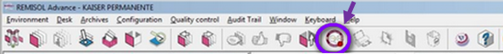
A.2 | Click Chart  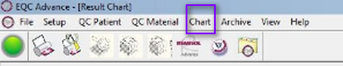
A.3 | Select Result Chart
A.4 | Choose from the drop-down menu for Protocol type, Chart type, Parameter and the Date range you wished to review. Click OK after fine tuning your selections.  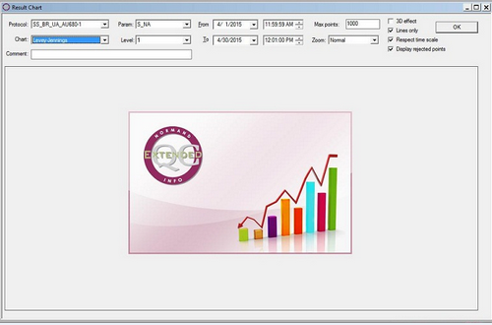
A.5 | This is a sample of Result Chart:  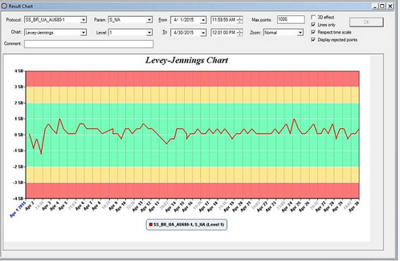

QUALITY CONTROL (QC) POLICY, Continued

A.6 | To see all details on a particular QC run, double click the QC point you wished to review.  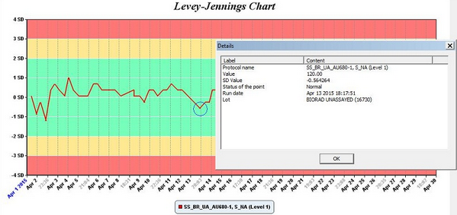

- EQC: How to Review Previous QC Lot number:
B.1 | Click EQC icon.
B.2 | Click Chart
B.3 | Select Archived Result Chart.
B.4 | Once you’ve made your selections using the drop down menu for each categories, click OK located at the upper right corner of the box.  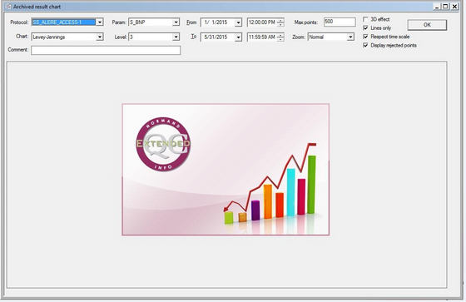

QUALITY CONTROL (QC) POLICY, Continued

B.5 | Below is a sample of Archived Result Chart based on the selections provided:  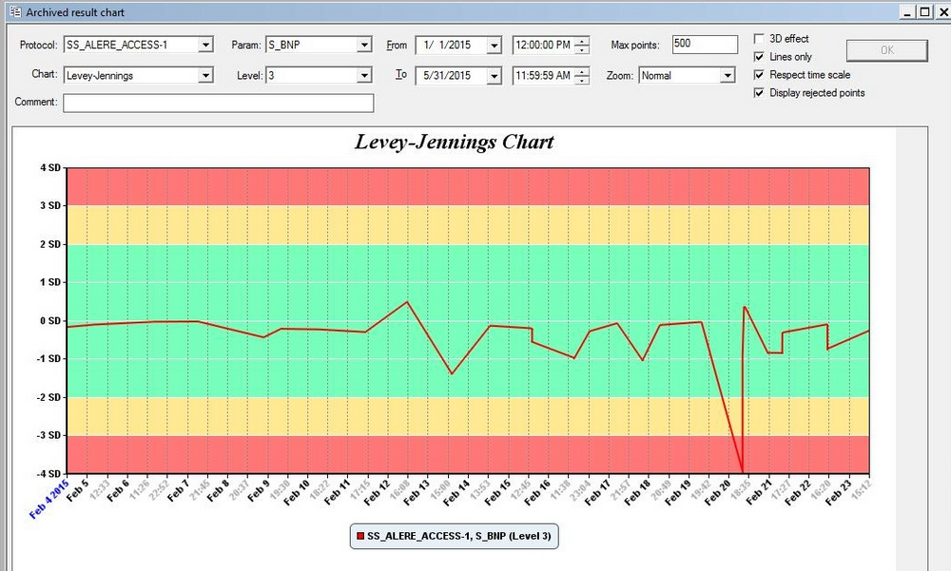
B.6 | To assess previous QC lot number, double click any QC point and a smaller box will pop up with QC details; see sample photo below:  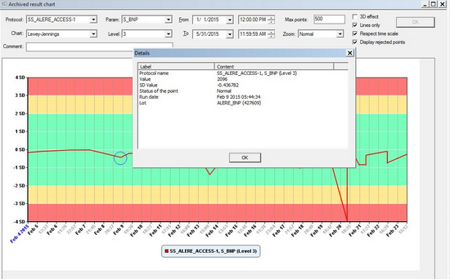

QUALITY CONTROL (QC) POLICY, Continued

Reviewed and approved by:

SIGNATURE | DATE
Julie Toti, CLS, MS
Manager, Clinical Laboratory – Los Angeles Medical Center
Joseph Thompson, M.D.
Director, Clinical Laboratory – Los Angeles Medical Center

Continued on next page
QUALITY CONTROL (QC) POLICY, Continued

HISTORY PAGE

Change type:  New, major, minor | Changes made to SOP - describe | Signature responsible person/date | Laboratory Director review/date | Laboratory Manager review/date | Date change implemented
New |  |  |  |  | 07/22/02
Major | - Listed QC schedule times.  - Deleted ref. on Bld Bank QC requirements – Regional SOP  - Updated instruments
Minor | Deleted 1515, ELA, and Glendale testing locations | MWA 6/25/2012
Major | Deleted 4700. Added MiniVidas (PCT) and MedTox. Specified possible corrective action for failed repeated QC result to troubleshoot with lab mgr if available. | MWA  12/19/2012
Minor | Updated the QC testing schedule for Pasadena. Revised external QC testing for Urine Strep Pneumo to new box kit.  Added PFA, AVL9180, and PocH-i | MWA 10/15/2013
Major | Deleted 4867 hospital lab, omitted 1505, updated Chem & Heme inst. CHCHHCHchChemHemHemeHeminstruments | JJ 7/10/14
Major | - Added Remisol Advance – EQC  - Added Six Sigma Criteria | AJC 6/23/15

