* + - There is no change to the Hemogram part of the CBC, only the Differential part – where **Absolute counts will now be reported instead of the % cell values. PROVIDER WILL ONLY ABLE TO SEE ABSOLUTE COUNT ONLY**
    - Only the Reference Ranges for the Absolute Lymph Auto and the Absolute Lymph Manual have changed.

**SCREEN SHOT OF RESULTS IN KP HEALTH CONNECT – ONLY ABSOLUTE DIFFERENTIAL COUNT IS REPORTED**

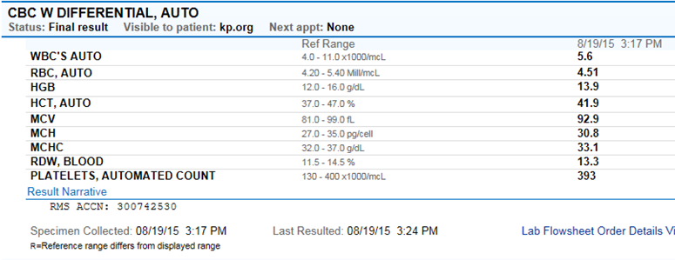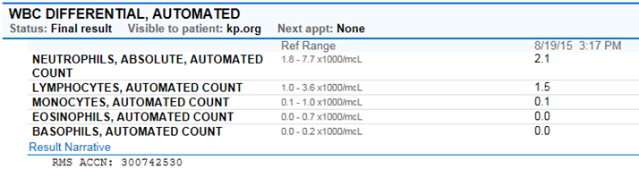

**DIFFERENTIAL COUNT IS STILL PERFORMED IN CELLAVISION AND REMISOL, NO CHANGES IN PROCEDURE JUST THE VALUES THAT ARE AVAILABLE FOR THE PROVIDER.**

**CERNER SCREEN SHOT: ALL DIFFERENTIAL COUNT PERCENTAGES WILL BE DNS(NOT REPORTED IN HEALTH CONNECT)**

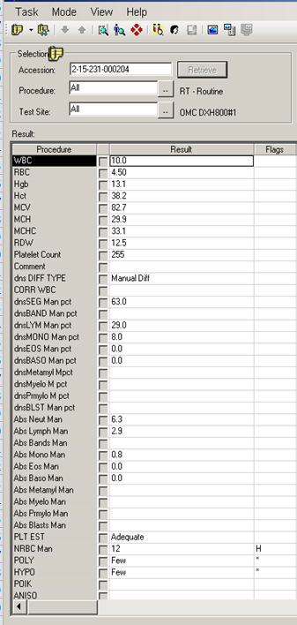

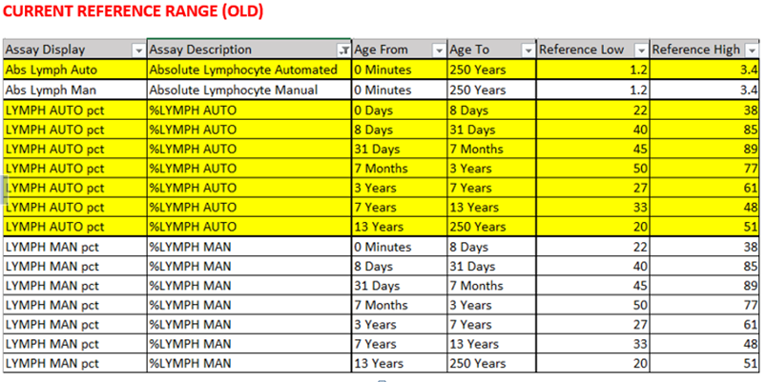

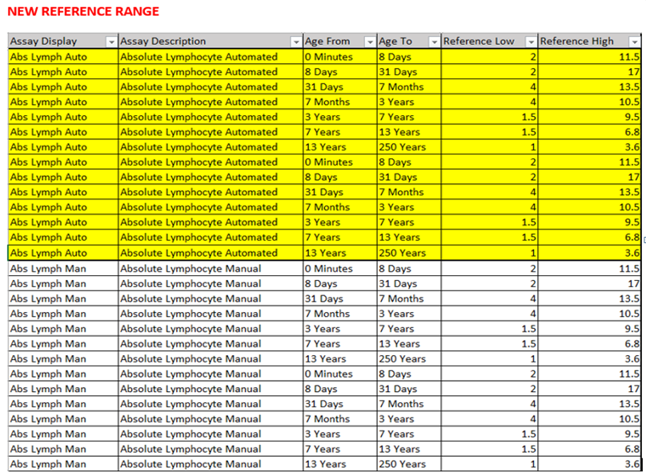

**RULES AFFECTED BY UPDATE ARE AS FOLLOWS:**

|  |  |  |  |
| --- | --- | --- | --- |
| DIFF | ANC>20 | SMEAR | NEUTROPHILIA, SCAN SLIDE |
| DIFF | PATIENT <12Y, MONO IS >3.0, WBC >10.0 no previous order within 14 days | SMEAR | MONOCYTOSIS, SCAN SLIDE |
| DIFF | EOSABS >0.5 | SMEAR | SCAN SMEAR |
| DIFF | BASOABS >0.5 | SMEAR | BASOPHILIA, SCAN SMEAR |