TBNK LYMPHOCYTE ENUMERATION USING 5-COLOR FLOW CYTOMETRY WITH NAVIOS FLOW CYTOMETER

Purpose | - This procedure describes the steps involved in enumeration of TBNK Lymphocyte panel using 5-color analysis.  - CD3, CD19, CD20, and CD56 with CD45 gating using Krome Orange will used to enumerate the different lymphocytes.  - Cytostat tetraCHROME™ CD45-FITC/CD4-RD1/CD8-ECD/CD3PC5 is used for the T-subset enumeration. CD8 antigen is present in peripheral blood lymphocytes and plays central role in regulating immune response through suppressor and cytotoxic action. The CD4 antigen on lymphocytes provides an inducer function for T-T, T-B, and T-macrophage interaction. CD3 is a lineage specific pan-T cell antigen that is normally present in the cell surface of mature T lymphocytes. CD45 pan-leukocyte antigen and is expressed brightly in lymphocytes.
Work Place Safety:

All laboratory employees are expected to maintain a safe working environment and an injury-free workplace. Laboratory employees are responsible for their own safety, the safety of others and adhering to all departmental and medical center safety policies and procedures.
- For standard precautions and safety practices in the laboratory; see LAMC-PPP-0130, specifically, but not limited to, equipment safety, proper body mechanics, sharps exposure and proper use of personal protective equipment (PPE).
- For Universal Body Substance precautions, see LAMC-PPP-0128, specifically, but not limited to, exposure to body fluids.
- For proper handwashing, see LAMC-PPP-0132, specifically, but not limited to, proper handwashing.
- For proper infection control, see LAMC-PPP-0127, specifically, but not limited to, proper use of gloves.
- For proper handling of regular and infectious waste, see LGM LAMC-PPP-0129, specifically, but not limited to proper disposal of regular and biohazardous waste.
- For cleaning bench, refer to LAMC-PPP-0130.

TBNK LYMPHOCYTE ENUMERATION USING 5-COLOR FLOW CYTOMETRY WITH NAVIOS FLOW CYTOMETER, continued
Policy | - CD3, CD19, CD20, and CD56 with CD45 gating using Krome Orange will used to enumerate the different lymphocytes.  - The monoclonal antibody used in this procedure is Cytostat tetraCHROME™ CD45-FITC/CD4-RD1/CD8-ECD/CD3PC5  - This method will be used with methodologies using Coulter-Q-Prep/ImmunoPreP reagent system.  - Grossly lipemic specimen can cause attenuation of SSC signal. Specimen will be washed with IsoFlow to obviate interfering effects of lipemia.  - Low T-cell total count with high percentage of lymphocytes may indicate presence of B-cell malignancy. Cases with this low T-cell will require additional work-up to rule-out B-Cell malignancy.  - All values of QC beads: Flow Check and Flow Set as well as ImmunoTrol cells should be within 3SD, otherwise, examine integrity of QC beads, ImmunoTrol cells, and repeat the test. If instrument problem is suspected, proceed with trouble-shooting, if not resolved, call for service.

Specimen Requirement

- Specimen anti-coagulated with EDTA in a 5ml lavender top tube is preferred. ACD and heparin is acceptable if EDTA is not available. Minimum of 1 ml required.
- Maintain and transport specimen at room temperature (18⁰C to 22⁰C) in a leak proof container. Avoid temperatures <10⁰C and >37⁰ C
- Take corrective action if the following occur:

- If the specimen is hot or cold to touch but not obviously hemolyzed or frozen, process it but note the temperature condition on the worksheet and report form. Abnormalities in the light-scatter patterns reveal a compromised specimen.

- If specimen is hemolyzed or frozen, reject specimen and request another.

- If clots are visible, reject the specimen and request another.

- If specimen is >48 hours old before processing, reject the specimen and request another.

- If the specimen is 30 hours but <48 hours, do viability testing. Refer to Cell Viability Testing by Flow Cytometry.

TBNK LYMPHOCYTE ENUMERATION USING 5-COLOR FLOW CYTOMETRY WITH NAVIOS FLOW CYTOMETER, continued

Reagent, Equipment and Materials

REAGENTS
- Cytostat tetraCHROME™ CD45-FITC/CD4-RD1/CD8-ECD/CD3PC5
Coulter Corporation, PN 6607013.
- ImmunoPrep™ Reagent System Whole Blood Lysing Reagents, Coulter Corporation, PN 7507950-E.
- Note: Use component of reagents kit only within the kit lot.
- CD3-FITC, Beckman Coulter, PN IM2181U.
- CD56-PE, Beckman Coulter, PN IM2073.
- CD19-ECD, Beckman Coulter, PN IM2708U.
- CD20-PC5, Beckman Coulter, PN IM2644U.
- CD45-Krome Orange Beckman Coulter, PN A96416
- IsoFlow™ Sheath Fluid, Beckman/Coulter Corporation, PN 8547008.
- Flow-Check™ Fluorospheres, Beckman/Coulter Corporation, PN 6605359
- Flow-Set Coulter® Fluourospheres, Beckman/Coulter Corporation, PN 6607007
- ImmunoTrol™ Control Cell Kit, Beckman/Coulter Corporation, PN 6607077
- Immno-Trol™ Low Cell/Immu-Trol Beckman/Coulter Corporation PN 6607098
- Immuno-Brite™ Standard Kit, Beckman/Coulter Corporation, PN 6603473
- Note: Use component of reagents kit only within the kit lot.

- CD45-FITC IOTEST ImmunoTech, PN IM0782.
- CD45-PE IOtest ImmunoTech, PN IM2078
- CD45-ECD IOtest ImmnoTech, PN IM2710
- CD45-ECD OItest ImmnoTech PN IM2653
- Cyto-Comp Cell Kit/CYTO-COMP Beckman Coulter 6607023
- Phosphate Buffered Saline at pH 7.4; Sigma 73813 QS to 1 Liter to obtain a concentration of 0.01M PBS.

EQUIPMENT
- Beckman/Coulter Cytomics Navios Flow Cytometer
- Coulter TQ-Prep
- Cerner Millenium PathNet GenLab Computer System

MATERIALS
- Plastic tubes (Polystyrene) 12 X75mm
- Test tube racks.

TBNK LYMPHOCYTE ENUMERATION USING 5-COLOR FLOW CYTOMETRY WITH NAVIOS FLOW CYTOMETER, continued

Daily/ Monthly/ Quality Control

Daily
- Check Alignment of the flow cytometer Navios by running using Flow Check beads. All data points must be with-in 3SD. If not examine integrity of the beads and repeat the test. If instrument is the problem, proceed with troubleshooting or call for service.
- Standardize PMT voltages of flow Cytometer Navios by running Flow Set beads. All data points must be within-in 3SD. If not examine integrity of the beads and repeat the test. If instrument is the problem, proceed with troubleshooting or call for service.
Tube Number | Type | Reagent
1 | Standardization | Flow Set Pro

- Run Verify Tube using Cytotrol Cells. All values should be within 3SD. Re-run all outliers (values outside 3SD) and if the value(s) still out, the reagents and the instrument will be evaluated to find out if there is a problem.
7 | Verify Tube: use (Cytotrol cells) | CD3-FITC, CD56-PE, CD19-ECD, CD20-PC5/CD45 Krome Orange.

Weekly
- Auto-Setup for TBNK Standardization:

Tube Number | Type | Reagent
1 | Standardization | Flow Set Pro
2 | FL1 Compensation | CD45-FITC
3 | FL2 Compensation | CD45-PE
4 | FL3 Compensation | CD45-ECD
5 | FL4 Compensation | CD45-PC5
6 | FL10 Compensation | CD45-Krome Orange
7 | Verify Tube: use (Cytotrol cells) | CD3-FITC, CD56-PE, CD19-ECD, CD20-PC5/CD45 Krome Orange.

Monthly

- Perform checks for fluorescence intensity and log amplifier linearity verification with ImmunoBrite.

TBNK LYMPHOCYTE ENUMERATION USING 5-COLOR FLOW CYTOMETRY WITH NAVIOS FLOW CYTOMETER, continued

Procedure

How to acknowledge receipt of specimen (Login Cerner Application):

Step | Action
1 | Click Specimen Log-in on the AppBar.
2 | 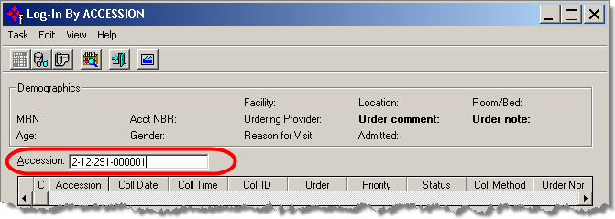  Scan the label barcode or Type the Accession number, Press, Enter.

Step | Action
3 | Select appropriate location. The login location is LA Cyto (BT Flow Cytometry) then click Login.

TBNK LYPHOCYTE ENUMERATION USING 5-COLOR FLOW CYTOMETRY WITH NAVIOS FLOW CYTOMETER, continued
How to print pending and overdue T-Cell Panel list (Print pending list everyday towards the end of shift.)

Step | Action
1 | Click Pending Inquiry on the Cerner AppBar. | Action
2 | - Type the Test Site beginning with location abbreviation: LA Cyto.  - Click ellipsis button, and press Enter.  - Select All Pending or in Lab only.

TBNK LYMPHOCYTE ENUMERATION USING 5-COLOR FLOW CYTOMETRY WITH NAVIOS FLOW CYTOMETER, continued

How to print pending list with Cerner using Pending Inquiry AppBar:

Step | Action
2 | This dialog screen shows where to input Test Site: LA Cyto and Procedure: T-cell.  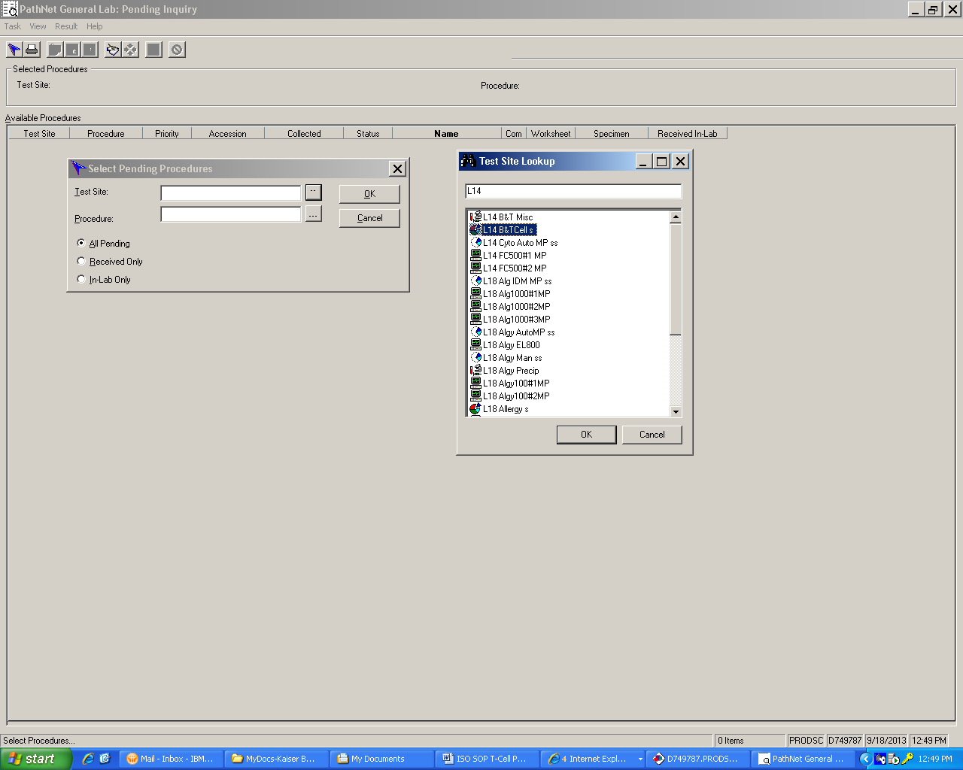  Click OK to display pending list.

TBNK LYMPHOCYTE ENUMERATION USING 5-COLOR FLOW CYTOMETRY WITH NAVIOS FLOW CYTOMETER, continued

3 | Cerner displays pending list. From Menu, click Task, Select Print, on the dialog screen, Print What?, select All.  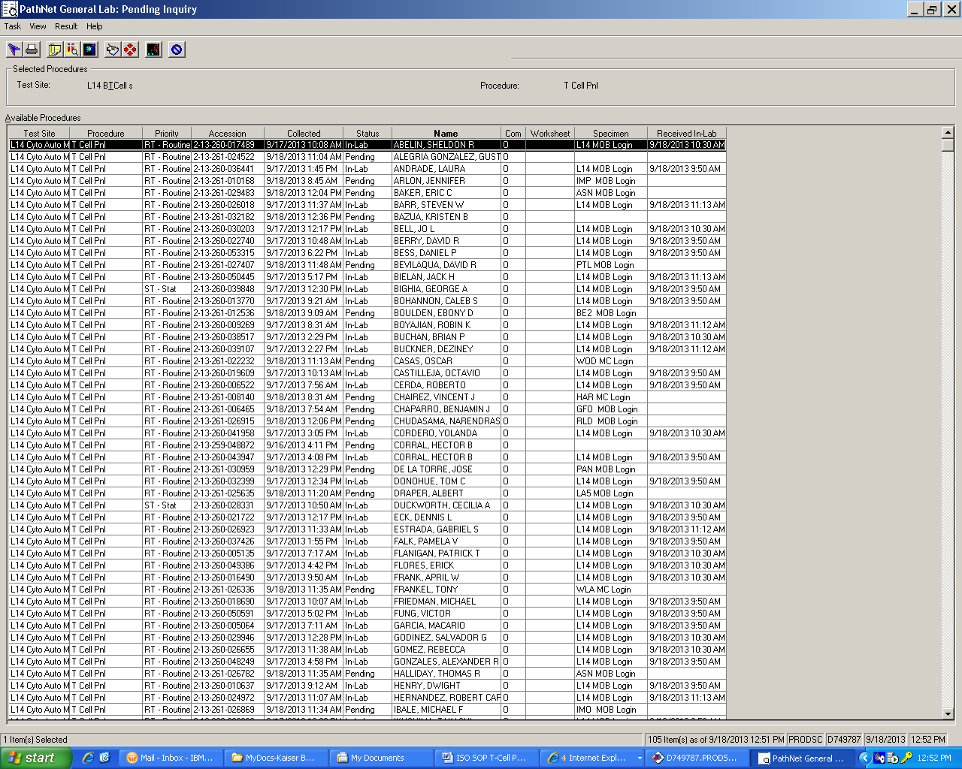  Note: To sort pending inquiry list, click column Header.

with pre-analytic

TBNK LYMPHOCYTE ENUMERATION USING 5-COLOR FLOW CYTOMETRY WITH NAVIOS FLOW CYTOMETER, continued
How to cancel the Order with pre-analytic problems in Pending Inquiry: clotted, hemolyzed, frozen, etc.

Step | Action
1 | Click Pending Inquiry on the Cerner AppBar.
2 | - Type the Test Site beginning with location abbreviation: LA Cyto.  - Click ellipsis button, and press Enter.  - Select All Pending or in Lab only.  - Click OK.  - Click the column header to sort column.  - Find and Highlight the order to be cancelled.  - Click Cancel icon on the toolbar  - Select a Cancel Reason.  - Click Cancel Order.

TBNK LYMPHOCYTE ENUMERATION USING 5-COLOR FLOW CYTOMETRY WITH NAVIOS FLOW CYTOMETER, continued

How to print additional bar-coded tube labels:

Step | Action
1 | Click Specimen Log-in on the AppBar.
2 | Scan of type the accession number.
3 | If typed, press Enter
4 | Click Label Reprint  button
5 | Affix the label to the tube
6 | Clik Task from the Menu, and select Exit.

Dilution for samples with WBC > 15,000

WBC COUNT | DILUTION  (Modified PBS)
15,000 to 30, 000 | 1:2
30,000 to 40,000 | 1:3
40,000 to 60,000 | 1:5

How to lyse RBC using TQ-Prep

Step | Action
1 | At the T-Q prep, touch screen to see the main MENU.
2 | Check reagent levels replenish if needed.
3 | On the TQ-Prep pad, press prime.
4 | Open lid, and place the carousel containing up the 30 specimens and make sure all tube are bar-coded.
5 | Prime TQ-Prep before running sample by putting an empty tube in slot #1 of the carousel containing the sample to be lysed.
7 | Press the upper left icon and choose Prep-Plus.
8 | Press PLAY to start the lysing process.

TBNK LYMPHOCYTE ENUMERATION USING 5-COLOR FLOW CYTOMETRY WITH NAVIOS FLOW CYTOMETER, continued
Preparation of cocktail of 5-color TBNK Lymphocyte Panel: Cocktail is stable for 1 month.

Preparation of 5 color TBNK Cocktail
ANTIBODY | SINGLE TEST (ul) | 40 test (ul)
CD3-FITC | 20 | 800
CD56-PE | 20 | 800
CD19-ECD | 10 | 400
CD20-PC5 | 10 | 400
Krome Orange | 10 | 400
TOTAL SINGLE | 70 | 2800
 |  | PIPET 70ul/test

How to stain TBNK lymphocyte Panel:

Step | Action
1 | Label tube patient tube with this format: Year-TBNK-Case # XX-TBNK-XXX and with Mab CD3/CD56/C19/CD20/KrO.
2 | Add 70ul of TBNK Lymphocyte cocktailed Monoclonal Antibody reagent.
3 | Add 100ul of the sample, and mix contents of the tube using a vortex mixer.
4 | Incubate the tube for 20 minutes in the dark.
5 | Lyse the tube using T-Prep.
6 | Acquire data using Navios Flow Cytometer.

Note: To Stain for T-cell panel refer to T-cell Panel Determination using 4-color Analysis with Navios. LBTM 220.24.

TBNK LYMPHOCYTE ENUMERATION USING 5-COLOR FLOW CYTOMETRY WITH NAVIOS FLOW CYTOMETER, continued

How to acquire and analyze samples for TBNK lymphocyte panel using 5-color analysis.

Step | Action
1 | At the Navios Cytometer’s Resource Explorer, Click BT Lab Folder.
2 | Click Panels Tab, click 5C TBNK-RITUXIMAB.PNL.
3 | Drag 5C TBNK-RITUXIMAB.PNL into the Acquisition Manager field.
4 | Enter Carousel number.
5 | Load Carousel, and press the PLAY icon or F9.

How to re-analyze, regate, and print a report of a re-gated sample using Navios software.

Step | Action
1 | Click Tools menu and select List Mode Playback , choose Insert Panel icon (third icon from left) and choose 5C Rituximab panel.
2 | Click LMD icon folder and select file to be printed.
3 | Click Stop if highlighted icon. When this app is opened, use Stop to exit
4 | To place a check mark, Click Save icon
5 | Press Play icon to print report.

TBNK LYMPHOCYTE ENUMERATION USING 5-COLOR FLOW CYTOMETRY WITH NAVIOS FLOW CYTOMETER, continued
How to enter and release results for upload of final results to the Health Connect (One at a time by scanning or typing an accession using Accession Results Entry (ARE) manual mode .
Step | Action
1 | Click Accession Results Entry (ARE) button on the AppBar.
2. | Click Mode on the menu bar.
3 | Select Manual.
4 | Scan or type accession, if the accession is typed, press Enter.
5 | Evaluate TBNK Lymphocyte Panel histogram and T-cell histogram print-out looking for the following problems:  - If SSC signal is attenuated (due to lipemia) wash cells and repeat staining process, re-acquire and re-analyze sample.  - If there is a predominance of debris (RBC’s are incompletely lysed) in the lymphocyte region, repeat staining process, re-acquire and re-analyze sample.  - If the TBNK Lymphocyte Panel histogram and T-cell histogram shows erroneous color compensation, see Section on How to re-analyze file.
6 | 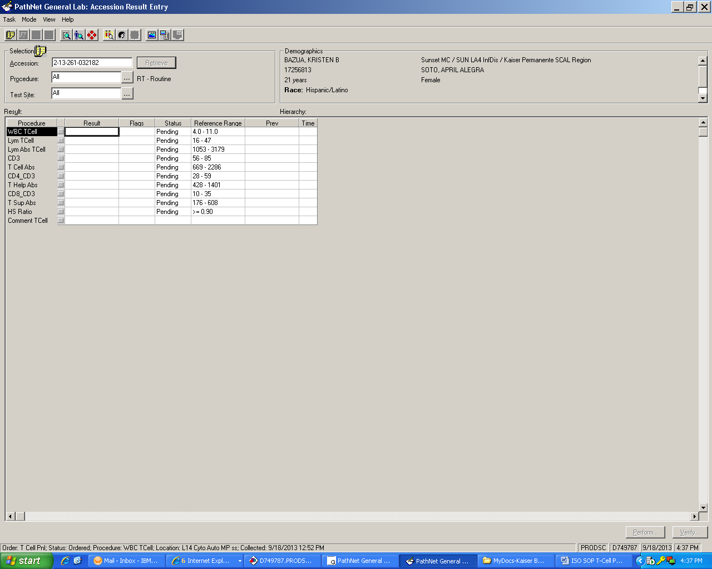  Above screen shows the Accession Result Entry display. Normally, all of the procedures are populated with result.

TBNK LYMPHOCYTE ENUMERATION USING 5-COLOR FLOW CYTOMETRY WITH NAVIOS FLOW CYTOMETER, continued

7 | If WBC or % Lymphocyte did not merge, Lymph Abs TCell procedures are not populated. Obtain WBC with Auto diff printout and enter the WBC and % Lymphocyte in the corresponding field.
8 | Once the WBC and % Lymphocytes field are populated, Cerner automatically computes absolute count for all parameters such T- Cell, T Help Abs, T Sup Abs, etc at the procedure fields. If all results are correct and to release result to Health connect, Click Perform, review results, and if all results are correctly entered, click Verify.

How to re-analyze a file in list mode for T-cell Panel component.

Step | Action
1 | At instrument’s Resource Explorer page, click on the Protocol Icon, double click on the Common Folder, double-click on tetracxp.
2 | Click on protocol that matches with the file to be analyzed:  Example: For 45/4/8/3 click on LSA-45-4-8-3.pro, drag it into a work space.
3 | Click on list mode icon and and click BT Lab folder and choose file to analyze.
4 | Once the file to be analyzed is selected or highlighted, drag it on to any of the histogram.
5 | Check for histogram markers and quadrant markers and gates, adjust if necessary.
6 | Click on the Flow Page, press print icon on the tool bar, click, OK.

How to re-analyze file for TBNK panel in the list mode for TBNK Panel procedure field.

Step | Action
1 | At instrument’s Resource Explorer page, click on the LMD Icon.
2 | Look for the LMD file that needs to be reanalyzed.
3 | Drag LMD file to the Workspace, and adjust gate and quadrant markers if necessary. Print re-analyzed page.

TBNK LYMPHOCYTE ENUMERATION USING 5-COLOR FLOW CYTOMETRY WITH NAVIOS FLOW CYTOMETER, continued
How to calculate % lymphocyte and %CD3 from Tetra software print-out when an abnormal WBC population is present.

Step | Action
1 | At instrument’s Resource Explorer page, click on the Protocol Icon, double click on the Common Folder, double-click on tetracxp.
2 | Click on protocol that matches with the file to be analyzed:  Example: For 45/4/8/3 click on LSA-45-4-8-3.pro, drag it into a work space.
3 | Click on list mode icon and click BT Lab folder and choose file to analyze.
4 | Once the file to be analyzed is selected or highlighted, drag it onto the workspace.
5 | Check for histogram markers and quadrant markers and gates, adjust GADJ region (CD45FITC vs. SS to gate the normal lymphocytes (brightest staining CD45).
6 | Click on the CD45FITC vs. SS histogram. Using the mouse, place cursor on the lower left side of the quadrant until you see Summation sign.( Σ). Right click to reveal the quadrant statistics.
7. | Click on the flow page, and right click CD45FITC vs. SS histogram on the flow page. Click delete.

TBNK LYMPHOCYTE ENUMERATION USING 5-COLOR FLOW CYTOMETRY WITH NAVIOS FLOW CYTOMETER, continued
8 | Drag CD45FITC vs. SS (mouse cursor at center) from the workspace and to the flow page. Right click to ungroup. Arrange Quadrant statistics markers. The % lymphocyte is % gated on the GADJ region.
9 | Click on the CD3 histogram. Using the mouse, place cursor on the lower left side of the quadrant until you see Summation sign.( Σ). Right click to reveal the quadrant statistics.
10 | Click on the flow page, and right click CD3 histogram on the flow page. Click delete.
 | Drag CD3, (mouse cursor at center) from the workspace and to the flow page. Right click to ungroup. Arrange Quadrant statistics markers. The % CD3 is the % gated on the ADJLIN 1 region.
11 | To calculate absolute count:  Absolute count CD3 = WBC x % lymphocytes x %CD3.  Absolute count CD3+CD4+ = WBC x % lymphocytes x CD3+/CD4+.  Absolute count CD3+/CD8+ = WBC x % lymphocytes x CD3+/CD8+.  Absolute count CD3-/CD56+ = WBC x % lymphocytes CD3-/CD56+ Absolute count CD19 = WBC x % lymphocytes x CD19.  Absolute count CD20 = WBC x % lymphocytes x CD20.
12 | Enter WBC, % lymphocytes, and calculated absolute counts results in the LMS computer.  Note: Do not put a comment referring to BT case in CoPath Plus.

TBNK LYMPHOCYTE ENUMERATION USING 5-COLOR FLOW CYTOMETRY WITH NAVIOS FLOW CYTOMETER, continued

How to correct erroneous results that have been released into Cerner.

Corrections to verified results in Cerner PathNet Millennium are made in Correction mode of
Accession Result Entry.

Step | Action
1 | Click ARE AppBar from the Cerner toolbar.
2 | 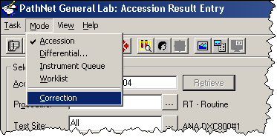  Click Mode on the Menu bar and select correction.
3 | 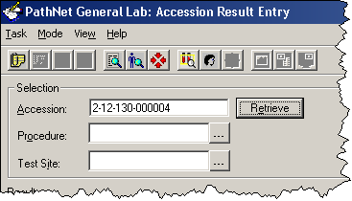  Scan or type accession and click Retrieve.

TBNK LYMPHOCYTE ENUMERATION USING 5-COLOR FLOW CYTOMETRY WITH NAVIOS FLOW CYTOMETER, continued

Step | Action
4 | In the appropriate Results field, type the corrections.
5 | Press Enter after each correction.
6 | Click Comments button on the tool bar.  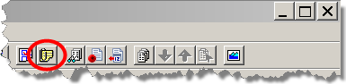
7 | Click Edit
8 | Type corr.
9 | Press F9
10 | Type the name of the physician notified or called.
11 | Press F3 to move to the next field.
12 | Type caller’s NUID
13 | Press F3 to move to the next field.
14 | Press F5 to enter current date and time.
15 | Click OK
16 | Click Close.
17 | Click Correct.

How to report TBNK Lymphocyte Panel and T-cell panel results during prolonged Cerner Millenium computer downtime.

Step | Action
1 | After acquisition of results of the 4-color analysis from the Navios cytometer, transcribe the results on Form # 110 (TBNK Panel).
2 | Fax the completed Form #110 form to Right Fax 866-576-9852. Use Right Fax cover page when faxing, indicate medical record number.  Note: Faxed document can be accessed on the Health Connect patient chart on the Media tab.

TBNK LYMPHOCYTE ENUMERATION USING 5-COLOR FLOW CYTOMETRY WITH NAVIOS FLOW CYTOMETER, continued

Interpretation
- Attenuation of SSC signal is seen when the specimen is grossly lipemic. In this case, the % Total CD3 maybe falsely depressed. True CD4+ and true CD8+ cell may be not be enumerated properly. Cells must be washed with RPMI 50/50 mix and centrifuge the cells using Clay Adams Serofuge II for 1 minute. Washed cells are re-stained and acquire and analyzed.
- If there is predominance of debris (RBCs are incompletely lysed) in the lymphocyte region, repeat staining process, re-acquire and re-analyze sample.
- If the white cell count is high, the white cell population includes blasts or other confounding cells, or abnormal dot plot patterns are noted, the results need to be reviewed by the Laboratory Director or designee before the report is released.
- Optimally, at least 95% of the population of the lymphocytes should be within the lymphocyte gate. Minimally, at least 90% of the lymphocytes should be within the gate. If below 90%, regate and re-analyze until acceptable.
- Optimally, at least 90% of the lymphocyte purity should be observed within the lymphocyte gate. Minimally, at least 85% purity should be observed with the gate. If below 85%, re-gate, and re-analyze until acceptable.

- Optimally, the sum of %CD4+CD3 and &CD8+/CD3 cells should equal the Total %CD3 cells within ±5%. Minimally, this variability should be ≤ 15%. If more than 15% Check previous test and compare. If the same variability (both and above 15%), accept the data, If no previous, repeat analysis to verify the data.

- Optimally, the sum of the %CD3, %CD19 and %CD56 should be equal the purity of lymphocytes in the gate ±5%. Minimally, this variability should be ≤15%. If more than 15%, check previous test and compare. If the same variability (both above 15%), accept the data. If no previous, repeat analysis to verify the data. If the data are corrected for lymphocyte purity, the sum should equal 95% to 105% or a minimum of 85% to 115%)
- The variability of %CD4+CD3+ compared to the previous test should be ≤10 unless the previous test was done six months prior to the current test. If more than 10, repeat analysis to verify the data.
- If the helper/suppressor ratio reverses from <0.08 to >1.0 in comparison from the previous test, repeat analysis is necessary to verify data.

TBNK LYMPHOCYTE ENUMERATION USING 5-COLOR FLOW CYTOMETRY WITH NAVIOS FLOW CYTOMETER, continued

Reporting and Documentation

- After reviewing specimen (All specimen problems are resolved) results are entered into Cerner and uploaded to KP Health Connect . Report can now be viewed by clinicians for monitoring CD19, CD20 and NK (CD3-CD56+) levels.

- Reference Range: (For General Population)

Cells | Percent  % | Absolute Count (cells/cu.mm.)
Lymphocytes | 16-47 | 1053-3179
Total T-Cell (CD3) | 56-85 | 669-2286
T-Helper (CD4+/CD3+) | 28-59 | 428-1401
T-Suppressor (CD8+CD3+) | 10-35 | 176-608
CD19 | 1-37 | 14-816
CD20 | 4.63-21.0 | 66-529
CD56 (NK) | 2-26 | 13-441

Controlled Document

- TBNK Panel Report Form: LBTM F110 (This form is to be used for reporting TBNK-cell panel reports when there is prolonged Cerner computer downtime only).
- LAMC-PPP-0123: Safety Practices.
- LAMC-PPP-0128 – Universal Body Substance Precautions (UBSP).
- LAMC-PPP-0132: Handwashing Policy.
- LAMC-PPP-0127: Infection Control
- LAMC-PPP-0129: Handling Regular and Infections Waste.
- LAMC-PPP-0130: Cleaning Work Areas.
- Form 292: Flow Set Pro-TBNK
- Form 293: Verify TBNK Panel – Cytocomp Cells

TBNK LYMPHOCYTE ENUMERATION USING 5-COLOR FLOW CYTOMETRY WITH NAVIOS FLOW CYTOMETER, continued

Uncontrolled Document
- Coulter Product Insert. The Coulter Procedure for Direct Immunofluorescence Cell Surface Staining. Coulter Immunology, Hialeah, FL, 1987.
- Coulter Immunoprep. Epics Leukocyte Preparation System. Coulter Electronics Inc., Hialeah, FL, December 1987.
- CDC MMWR, Guidelines for Performance of CD4+ T-Cell Determinations in Persons with HIV Infection, Vol. 41 No. RR-8, Atlanta, GA May 8, 1992.
- CDC Procedure Manual, Flow Cytometric Immunophenotyping, Quality Assurance and Quality Control Procedures for CD4+ T-Lymphocyte Determination. Atlanta, GA, April 1993.
- Navios Flow Cytometer: Training Modules. PN A84791AA (November 2009) Beckman Coulter Inc. Miami Education Center.

TBNK LYMPHOCYTE ENUMERATION USING 5-COLOR FLOW CYTOMETRY WITH NAVIOS FLOW CYTOMETER, continued

Self Assessment: | - True or False: If a specimen is hemolyzed or frozen, reject specimen and request another.  - True or False: Specimen anticoagulated with ACD and heparin is acceptable if EDTA is not available.  - Wash specimen if:  - Lipemic  - Hemolyzed  - Frozen  - TRUE OR FALSE: Predominance of incompletely lysed RBC in the lymphocyte region, repeat staining process re-acquire and re-analyzed sample.  - TRUE OR FALSE: Run Verify Tube using Cytotrol Cells. All values should be within 3SD. Re-run all outliers (values outside 3SD) and if the value(s) still out, the reagents and the instrument will be evaluated to find out if there is a problem.

Author: Giovanni B. Garcia, MBA, MT (ASCP), CLS

