BODY FLUID ANALYSIS
Policy | Body fluid counts and analysis must be completed asap and all CSF counts must be done within 1 hour of being received in the laboratory

Workplace safety
  All laboratory employees are expected to maintain a safe working environment and an injury-free workplace. Laboratory employees are responsible for their own safety, the safety of others and adhering to all departmental and medical center safety policies and procedures.
  - For standard precautions and safety practices in the laboratory; see LGM 8000, specifically, but not limited to, equipment safety, proper body mechanics, sharps exposure and proper use of personal protective equipment (PPE).
  - For Universal Body Substance precautions, see LGM 8005, specifically, but not limited to, exposure to body fluids.
  - For proper hand washing, see LGM 8010, specifically, but not limited to, proper hand washing.
  - For proper infection control, see LGM 8004, specifically, but not limited to, proper use of gloves.
  - For proper handling of regular and infectious waste, see LGM 8006, specifically, but not limited to proper disposal of regular and biohazardous waste.
  - For proper cleaning of work area, see LGM 8007 - Cleaning Work Areas.
  - For proper handling of chemicals and reagents, see the Chemical Hygiene Plan.
  For proper storage and disposal of chemical hazardous waste, see LGM 8012.

Specimen type | The following types of specimens are considered to be body fluids:  - CSF  - Pleural fluid  - Peritoneal fluid  - Gastric fluid  - Synovial fluid  - Pericardial fluid  - Abdominal fluid  - Ascites fluid  - Thoracentesis fluid

Continued on next page
BODY FLUID ANALYSIS, Continued

Specimen collection | Fluid specimens for cell counts are collected in EDTA or sterile container.  Note: CSF specimens are collected in sterile containers only  Note: Observe specimen for fibrin clots and pellicle formation. If a small fibrin clots are detected, perform test as usual and include a comment in report stating that results may not be accurate due to fibrin clot formation.  If specimen is completely clotted do not perform the cell count. Notify unit or provide that the specimen is clotted.  Note: Always use sterile technique when handling body fluid specimens.

Continued on next page
BODY FLUID ANALYSIS, Continued
Completing cell count | Follow the steps below to complete the cell count for RBC’s and WBC’s on body fluids.

Step | Action
1 | Mix specimen well. Use either disposable counting chamber or reusable one.  (Note: if using re-usable counting chamber cover slip the hemacytometer).  Load both chambers of the hemacytometer, with undiluted body fluid specimen.  Note: On high counts a dilution may be necessary. Place hemacytometer in  A covered Petri dish with a damp paper and two small applicator sticks. Let  equilibrate for five minutes before counting
2 | Verify that QC is done before performing patient testing. If not perform QC in same manner as patient testing and document the results in the QC log. Refer to Fluid Quality Control Procedure (LAMC-PPP-0304) for detailed information about QC procedure.
3 | Cell count will be performed in duplicate between two CLSs using 40x magnification. Each CLS will load specimen and count 1 chamber. RBC’s and WBC’S will be counted in the same number of squares. Typically 9 large squares are counted on each side of the chamber. For very high counts, less squares may be counted, however, equal number of corresponding squares must be counted on both sides of the chamber. Follow the No cell counting border policy.
4 | Each CLS will calculate his/her own result based of their own chamber using the following:  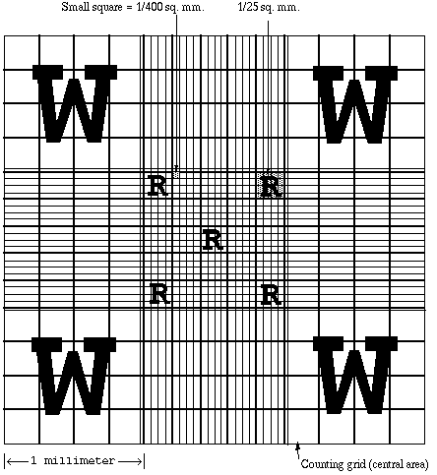  Large Square (W) = 1 mm²  Small Square (R) = 0.04 mm² for one small square  = 0.2 mm² for all 5 small squares  Formula:  Total cells/ μl = Total Average Count x 10 cells/μl  # of square mm counted
5 | The calculated counts between the two CLSs will be averaged as the final result but must agree within 25% difference or the count must be repeated.  % Difference is the difference between the 2 counts divided by the Average of 2 counts then multiplied by 100.
6 | After the count is completed dispose, disposable hemacytometer.

Continued on next page

BODY FLUID ANALYSIS, Continued
Performing cell count that needs dilution |  | In performing cell count using a hemacytometer, cells when checked on a microscope should be on a monolayer spread to have an accurate count. High counts that tend to make cells on top of each other should be diluted. Follow steps in performing cell count with dilution.
 | Step | Action
 | 1 | Diluent to be used for Cell count body fluid is collected from the instrument/DXH800. On the DXH 800 instrument choose Single-Tube presentation and Choose ‘Dispense Diluent’
 | 2 | Confirm procedure and insert an empty test tube on the left side loader as a container for your diluent to be used. Instrument will dispense diluent from instrument to the test tube. Repeat procedure for more diluent depending on the amount needed. Follow the instruction by instrument to stop Dispense diluent procedure
 | 3 | Still on Single-tube presentation, enter Specimen ID as ‘diluent’ and press enter. Run the dispensed diluent from instrument as a CBC to check background of the diluent dispensed. Results should all be zero to make sure diluent can be used for cell count dilution. Print out diluent dispensed background check and date/initial. File the diluent background check print out with Attachment A (Body Fluid Patient Log).
 | 4 | After passing the diluent background check, use the dispensed diluent to perform dilution analysis for Body Fluid Cell count. Use the lowest dilution factor possible to create a monolayer of cells on hemacytometer when checked on a microscope.
 | 5 | Cell count will be performed in duplicate between two CLSs using 40x magnification. Each CLS will load diluted specimen and count 1 chamber. RBC’s and WBC’S will be counted in the same number of squares. Typically 9 large squares are counted on each side of the chamber. For very high counts, less squares may be counted, however, equal number of corresponding squares must be counted on both sides of the chamber. Follow the No cell counting border policy.

Continued on next page

BODY FLUID ANALYSIS, Continued

6 | Each CLS will calculate his/her own result based of their own chamber using the following:  Large Square (W) = 1 mm²  Small Square (R) = 0.04 mm² for one small square  = 0.2 mm² for all 5 small squares  Formula:  Total cells/ μl = Total Average Count x 10 cells/μl x dilution factor  # of square mm counted
7 | The calculated counts between the two CLSs will be averaged as the final result but must agree within 25% difference or the count must be repeated.  % Difference is the difference between the 2 counts divided by the Average of 2 counts then multiplied by 100.
8 | After the count is completed, dispose disposable hemacytometer.

Verification of Cell count | Before resulting cell counts performed with unstained brightfield microscopy, verify results in correlation with the number and proportion of cells with the stained cytospin prepared slide used for differential count. Check box confirming that correlation was performed in the Body Fluid Patient Log form (Attachment A). For slide preparation see section preparing slide.

Continued on next page

BODY FLUID ANALYSIS, Continued

Preparing slide | Prepare a cytospin smear for differential count following Cytospin smear preparation using Thermo Scientific Cytospin 4 with cytocentrifuge rotor, procedure LAMC-PPP-0310. Dilute fluids with high cell counts with saline. Add a drop of albumin into the chamber. Once smear is ready let the smear air dry, fix and stain with Wright stain.

Performing differential | Follow the steps below to complete the differential count on body fluids.

Step | Action
1 | Count 100 WBCs , perform a 5 part differential
2 | If less than 100 WBCs are present for differential count, calculate count to percent of the total number of WBCs differentiated. Note the total number of cells differentiated in the comment field.
2 | Look for and note any abnormal cells
3 | If abnormal cells are present note the presence of abnormal cells on the comments section of the report. If there is an abundance of particular type of cell, make a comment in the comments section.
4 | Slides will be saved for one week.

Resulting count | Follow the steps below to complete the reporting of body fluid counts.
  Step | Action
  1 | Use the Body Fluid Results Log to show raw counts and calculations. See Attachment A(Body Fluid Results Log)
  2 | Results to be entered are:  - Source  - Color: Colorless, Yellow, Pink, Red, Xanthochromic  - Appearance: Bloody, Cloudy, Clear, Clotted, Hazy, Slightly Hazy  - RBC count -Calculation  - WBC count -Calculation  - Differential  Indicate in the result comments the presence of cell clumps
  3 | Final Results are entered in the LIS using manual entry

Continued on next page

BODY FLUID ANALYSIS, Continued

Suspected Malignant Cells | Follow the steps below for suspected malignant cells, document process to Attachment R1: Pathologist Review for Suspicious cells Log
  Step | Action
  1 | CLS will result the differential count but will not comment on the suspicious morphology.
  2 | Print new accession id sticker for specimen with suspicious cells for review using print accession feature in Cerner App Bar.
  3 | CLS will fill up the Pathologist Review for Suspicious cells Log  By entering current date, specimen id using accession id sticker, and specimen type.
  4 | CLS will:  - Enter notes about the slide (suspicious cells seen)  - Enter the X and Y coordinates of the cell(s) to be reviewed using the white circle marks found in the microscope stage.  - Enter diagram of how the slide was clipped on the stage.  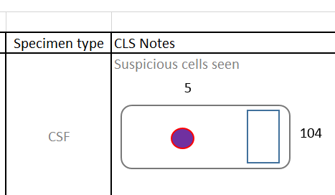
  5 | CLS will then send the slide with the Pathologist Review for Suspicious cells Log Binder to the Medical Director for review. In the absence of the Medical Director, send the slide to be reviewed to the Pathology Supervisor to forward slide to a Frozen- section pathologist from Pathology department.
  6 | If pathologist decides cells are suspicious or malignant, CLS will issue a corrected report with the comment provided by the pathologist in Cerner result entry under result comment.
  7 | If pathologist decides cells are not suspicious or malignant, no corrected report is needed.
  8 | Document the Pathology review comment in the Pathologist Review for Suspicious cells Log, the Pathologists name who performed review, and initial of CLS performing documentation.

Continued on next page

BODY FLUID ANALYSIS, Continued
Controlled documents | See list below

#
LGM8000 | Standard precautions and safety practices in the laboratory
LGM8005 | Universal Body Substance precautions
LGM8010 | Proper hand-washing
LGM8006 | Infection control
LGM8007 | Cleaning Work Areas
LGM8012 | Proper storage and disposal of chemical hazardous waste
LIMM 214 | Resulting Patients in the laboratory Information System
LAMC-PPP-0310 | Cytospin smear preparation using Thermo Scientific Cytospin 4
LAMC-PPP-0304 | Fluid Quality Control Procedure
Attachment A | Body Fluid Log Form
Attachment R1 | Pathologist Review for Suspicious cells Log

Author | Alvin Castillo, CLS

