T-CELL SUBSET ENUMERATION USING 4-COLOR FLOW CYTOMETRY WITH NAVIOS FLOW CYTOMETER

Purpose | - This procedure describes the steps involved in enumeration and determination of T-cell subsets using 4-color analysis.  - The monoclonal antibody used in this procedure is Cytostat tetraCHROME™ CD45-FITC/CD4-RD1/CD8-ECD/CD3PC5. CD8 antigen is present in peripheral blood lymphocytes and plays central role in regulating immune response through suppressor and cytotoxic action. The CD4 antigen on lymphocytesprovides an inducer function for T-T, T-B, and T-macrophage interaction. CD3 is a lineage specific pan-T cell antigen that is normally present in the cell surface of mature T lymphocytes. CD45 pan-leukocyte antigen and is expressed brightly in lymphocytes.
Work Place Safety:

All laboratory employees are expected to maintain a safe working environment and an injury-free workplace. Laboratory employees are responsible for their own safety, the safety of others and adhering to all departmental and medical center safety policies and procedures.
- For standard precautions and safety practices in the laboratory; see LAMC-PPP-0123, specifically, but not limited to, equipment safety, proper body mechanics, sharps exposure and proper use of personal protective equipment (PPE).
- For Universal Body Substance precautions, see LAMC-PPP-0128, specifically, but not limited to, exposure to body fluids.
- For proper handwashing, see LAMC-PPP-0132, specifically, but not limited to, proper handwashing.
- For proper infection control, see LAMC-PPP-0124, specifically, but not limited to, proper use of gloves.
- For proper handling of regular and infectious waste, see LAMC-PPP-0129, specifically, but not limited to proper disposal of regular and biohazardous waste.

T-CELL SUBSET ENUMERATION USING 4-COLOR FLOW CYTOMETRY WITH NAVIOS FLOW CYTOMETER, continued
Policy | - The monoclonal antibody used in this procedure is Cytostat tetraCHROME™ CD45-FITC/CD4-RD1/CD8-ECD/CD3PC5  - This method will be used with methodologies using Coulter-Q-Prep/ImmunoPreP reagent system.  - Grossly lipemic specimen can cause attenuation of SSC signal. Specimen will be washed with IsoFlow to obviate interfering effects of lipemia.  - Low T-cell total count with high percentage of lymphocytes may indicate presence of B-cell malignancy. Cases with this low T-cell will require additional work-up to rule-out B-Cell malignancy.  - All values of QC beads: Flow Check and Flow Set as well as ImmunoTrol cells should be within 3SD, otherwise, examine integrity of QC beads, ImmunoTrol cells, and repeat the test. If instrument problem is suspected, proceed with trouble-shooting, if not resolved, call for service.  - For multiple component reagent kit, Flow Cytometry lab uses components of reagent kits within kit lot only.

Specimen Requirement

- Specimen anti-coagulated with EDTA in a 5ml lavender top tube is preferred. ACD and heparin is acceptable if EDTA is not available. Minimum of 1 ml required.
- Maintain and transport specimen at room temperature (18⁰C to 22⁰C) in a leak proof container. Avoid temperatures <10⁰C and >37⁰ C
- Take corrective action if the following occur:

- If the specimen is hot or cold to touch but not obviously hemolyzed or frozen, process it but note the temperature condition on the worksheet and report form. Abnormalities in the light-scatter patterns reveal a compromised specimen.

- If specimen is hemolyzed or frozen, reject specimen and request another.

- If clots are visible, reject the specimen and request another.

- If specimen is >48 hours old before processing, reject the specimen and request another.

- If the specimen is 30 hours but <48 hours, do viability testing. Refer to Cell Viability Testing by Flow Cytometry.

T-CELL SUBSET ENUMERATION USING 4-COLOR FLOW CYTOMETRY WITH NAVIOS FLOW CYTOMETER, continued

Reagent, Equipment and Materials

REAGENTS
- Cytostat tetraCHROME™ CD45-FITC/CD4-RD1/CD8-ECD/CD3PC5
Coulter Corporation, PN 6607013.
- CYTO-STAT®tetraCHROME™ CD45-FITC/CD56-RD1/CD19-ECD/CD3-PC5, Beckman/Coulter Corporation, PN6607073.
- ImmunoPrep™ Reagent System Whole Blood Lysing Reagents, Coulter Corporation, PN 7507950-E: IsoFlow™ Sheath Fluid, Beckman/Coulter Corporation, PN 8547008.
- Flow-Check™ Fluorospheres, Beckman/Coulter Corporation, PN 6605359
- Flow-Set Coulter® Fluourospheres, Beckman/Coulter Corporation, PN 6607007
- ImmunoTrol™ Control Cell Kit, Beckman/Coulter Corporation, PN 6607077
- Immno-Trol™ Low Cell/Immu-Trol Beckman/Coulter Corporation PN 6607098
- Immuno-Brite™ Standard Kit, Beckman/Coulter Corporation, PN 6603473.
- CD45-FITC IOTEST ImmunoTech, PN IM0782.
- CD45-PE IOtest ImmunoTech, PN IM2078
- CD45-ECD IOtest ImmnoTech, PN IM2710
- CD45-ECD OItest ImmnoTech PN IM2653
- Cyto-Comp Cell Kit/CYTO-COMP Beckman Coulter 6607023
- Phosphate Buffered Saline at pH 7.4; Sigma 73813 QS to 1 Liter to obtain a concentration of 0.01M PBS.

Note: Flow Cytometry lab uses components of reagent kits within kit lot only.

EQUIPMENT
- Beckman/Coulter Cytomics Navios Flow Cytometer
- Coulter TQ-Prep
- Coulter Prep-PLUS-2
- Kaiser Permanente Data System (KRMS) Computer System.
- Cerner Millenium PathNet GenLab Computer System

MATERIALS
- Plastic tubes (Polystyrene) 12 X75mm
- Test tube racks.

T-CELL SUBSET ENUMERATION USING 4-COLOR FLOW CYTOMETRY WITH NAVIOS FLOW CYTOMETER, continued

Daily/ Monthly/ Quality Control

Daily
- Check Alignment of the flow cytometer Navios by running using Flow Check beads. All data points must be with-in 3SD. If not examine integrity of the beads and repeat the test. If instrument is the problem, proceed with troubleshooting or call for service.
- Standardize PMT voltages of flow Cytometer Navios by running Flow Set beads. All data points must be within-in 3SD. If not examine integrity of the beads and repeat the test. If instrument is the problem, proceed with troubleshooting or call for service.
- Run ImmunoTrol™ and ImmunoTrol™ Low stained with CD45FITC/CD4-RD1/CD8-ECD/CD3PC5 and CD45-FITC/CD56-RD1/CD19-ECD/CD3-PC5.All values should be within 3SD. Re-run all outliers (values outside 3SD) and if the value(s) still out, the reagents and the instrument will be evaluated to find out if there is a problem.

Monthly

- Perform checks for fluorescence intensity and log amplifier linearity verification with ImmunoBrite.

Procedure

How to acknowledge receipt of specimen (Login Cerner Application):

Step | Action
1 | Click Specimen Log-in on the AppBar.
2 | 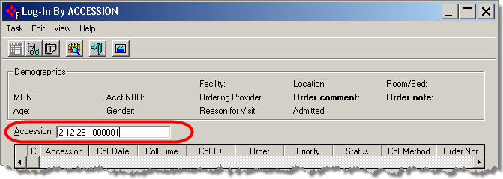  Scan the label barcode or Type the Accession number, Press, Enter.

T-CELL SUBSET ENUMERATION USING 4-COLOR FLOW CYTOMETRY WITH NAVIOS FLOW CYTOMETER, continued

Step | Action
3 | Select appropriate location. The login location is LA Cyto Auto MP ss then click Login.

How to print pending and overdue T-Cell Panel list (Print pending list everyday towards the end of shift.)

Step | Action
1 | Click Pending Inquiry on the Cerner AppBar. | Action
2 | - Type the Test Site beginning with location abbreviation: LA Cyto MP ss.  - Click ellipsis button, and press Enter.  - Select All Pending or in Lab only.

T-CELL SUBSET ENUMERATION USING 4-COLOR FLOW CYTOMETRY WITH NAVIOS FLOW CYTOMETER, continued

How to print pending list with Cerner using Pending Inquiry AppBar:

Step | Action
2 | This dialog screen shows where to input Test Site: LA Cyto Auto MP ss and Procedure: T-cell.  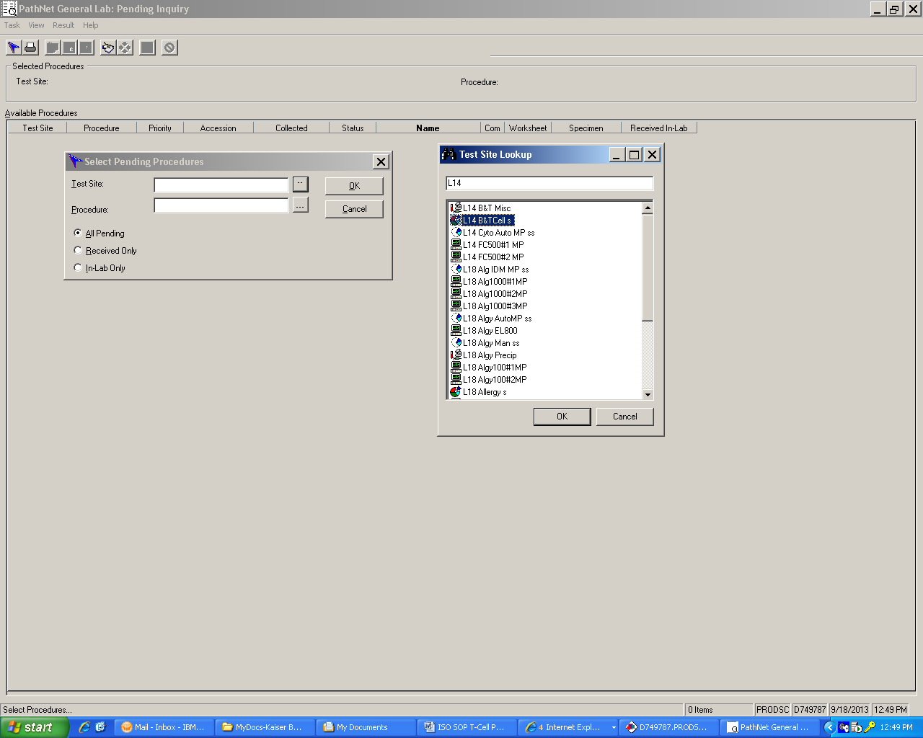  Click OK to display pending list.

T-CELL SUBSET ENUMERATION USING 4-COLOR FLOW CYTOMETRY WITH NAVIOS FLOW CYTOMETER, continued

3 | Cerner displays pending list. From Menu, click Task, Select Print, on the dialog screen, Print What?, select All.  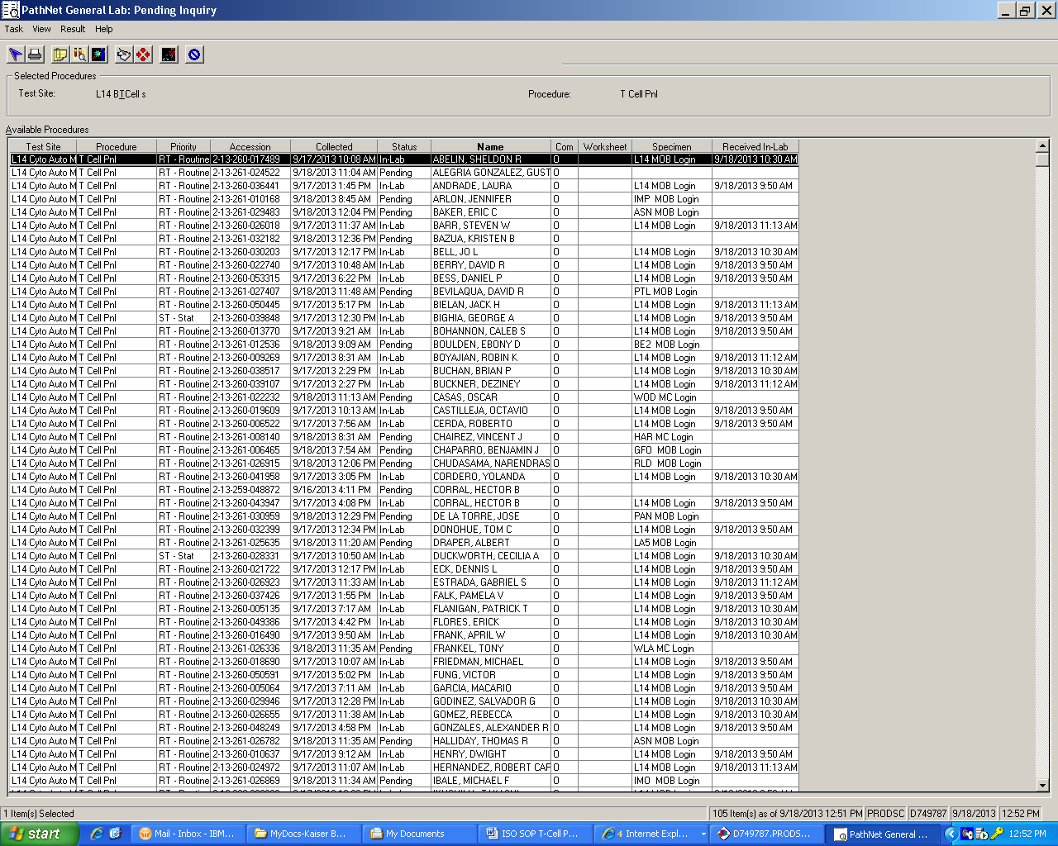  Note: To sort pending inquiry list, click column Header.

with pre-analytic

T-CELL SUBSET ENUMERATION USING 4-COLOR FLOW CYTOMETRY WITH NAVIOS FLOW CYTOMETER, continued

How to cancel the Order with pre-analytic problems in Pending Inquiry: clotted, hemolyzed, frozen, etc.

Step | Action
1 | Click Pending Inquiry on the Cerner AppBar.
2 | - Type the Test Site beginning with location abbreviation: L14.  - Click ellipsis button, and press Enter.  - Select All Pending or in Lab only.  - Click OK.  - Click the column header to sort column.  - Find and Highlight the order to be cancelled.  - Click Cancel icon on the toolbar  - Select a Cancel Reason.  - Click Cancel Order.

T-CELL SUBSET ENUMERATION USING 4-COLOR FLOW CYTOMETRY WITH NAVIOS FLOW CYTOMETER, continued

How to print additional bar-coded tube labels:

Step | Action
1 | Click Specimen Log-in on the AppBar.
2 | Scan of type the accession number.
3 | If typed, press Enter
4 | Click Label Reprint  button
5 | Affix the label to the tube
6 | Clik Task from the Menu, and select Exit.

Dilution for samples with WBC > 15,000

WBC COUNT | DILUTION  (Modified PBS)
15,000 to 30, 000 | 1:2
30,000 to 40,000 | 1:3
40,000 to 60,000 | 1:5

Buffy Coat procedure for sample with WBC< 1,000

Step | Action
1 | Centrifuge blood for 5 minutes at 500 g
2 | Draw off buffy coat with transfer pipette, collecting some red cells and some plasma to assure that all white cells are recovered.
3 | Completely re-suspend the cells by mixing several times with a transfer pipette.
4 | Determine all concentration using hemocytometer or hematology instrument.
5 | Adjust cell concentration to 1 x 10⁷/ ml with Modified PBS and add 100ul to diluted antibody and follow standard procedure.

T-CELL SUBSET ENUMERATION USING 4-COLOR FLOW CYTOMETRY WITH NAVIOS FLOW CYTOMETER, continued

How to load Coulter PrepPlus-2 for 4 color staining.

Step | Action
1 | Open the Coulter PrepPlus-2 windows and load first 12 specimens on the Coulter Prep plus test tube rack starting with first tube on the leftmost side o the rack. Load 13th sample starting from behind the right most space of the rack, and load of up to 24 tubes.
2 | Load reagent Cytostat tetraCHROME™ CD45-FITC/CD4-RD1/CD8-ECD/CD3PC5 Coulter Corporation, PN 660701 on space 9 of the reagent rack. Prep –Plus 2 is pre-programmed to dispense 10ul of Cytostat tetraCHROME™ CD45-FITC/CD4-RD1/CD8-ECD/CD3PC5, pre-programmed to dispense 100ul of specimen.
3. | Check level of IsoFlow™ and replace if level is <⅛ full. Also check level of the waste container, empty waste reservoir if necessary.
4 | Load carousel with labeled tubes that corresponds with specimen loaded in the Coulter PrepPlus-2 test tube rack.
5 | Close Coulter PrepPlus-2 windows.

How to program Coulter PrepPlus-2 using TQ-Prep for 4-color staining of
T-cell panel.

Step | Action
1 | At the TQ-Prep, touch screen to see the main menu.
2 | At the main menu, touch the upper left icon and choose TQ-Prep.
3 | Touch or press the center icon.
4 | Press arrow to select T-Cell panel.
5 | Press ERASE icon to delete previous worklist
6 | Press ++ icon or + icon and assign a number corresponding to the number of tubes to be stained. Check to see if carousel has same amount of tubes.
7 | Press the WRITE icon
8 | Press lower left corner icon 3X.
9 | At the reagent icon, check to see if the reagent is at slot 9
10 | Press the PLAY icon.
11 | After the Coulter Prep-Plus has completed the staining cycle, remove the carousel, vortex gently for about 2 seconds and incubate it for 10-12 minutes in the dark.

T-CELL SUBSET ENUMERATION USING 4-COLOR FLOW CYTOMETRY WITH NAVIOS FLOW CYTOMETER, continued

How to lyse RBC using TQ-Prep

Step | Action
1 | At the T-Q prep, touch screen to see the main MENU.
2 | Check reagent levels replenish if needed.
3 | On the TQ-Prep pad, press prime.
4 | Open lid, and place the carousel containing up the 30 specimens and make sure all tube are bar-coded.
5 | Prime TQ-Prep before running sample by putting an empty tube in slot #1 of the carousel containing the sample to be lysed.
7 | Press the upper left icon and choose Prep-Plus.
8 | Press PLAY to start the lysing process.

How to acquire and analyze samples for T-cell subset using 4- color analysis.

Step | Action
1 | At the Navios Acquisition Manager, click on Open Work Station icon on the tool bar.
2 | If there are 30 specimens in the carousel, click TETRA_30. Click, OPEN.  Note:  If <30 specimen, adjust number by scrolling the worklist until one finds that last item. Delete the worklist items until one match the number specimens to be run
3 | Put loaded carousel in the MCL.
4 | Press 9 to run the test.

T-CELL SUBSET ENUMERATION USING 4-COLOR FLOW CYTOMETRY WITH NAVIOS FLOW CYTOMETER, continued

How to enter and release results for upload of final results to the Health Connect (One at a time by scanning or typing an accession using Accession Results Entry (ARE) manual mode .
Step | Action
1 | Click Accession Results Entry (ARE) button on the AppBar.
2. | Click Mode on the menu bar.
3 | Select Manual.
4 | Scan or type accession, if the accession is typed, press Enter.
5 | Evaluate T-cell histogram print-out looking for the following problems:  - If SSC signal is attenuated (due to lipemia) wash cells and repeat staining process, re-acquire and re-analyze sample.  - If there is a predominance of debris (RBC’s are incompletely lysed) in the lymphocyte region, repeat staining process, re-acquire and re-analyze sample.  - If total T-cell is low, and WBC count is high, call pathologist for additional testing. See section for Interpretation.  - If the T-cell histogram shows erroneous color compensation, see Section on How to re-analyze file.
6 | 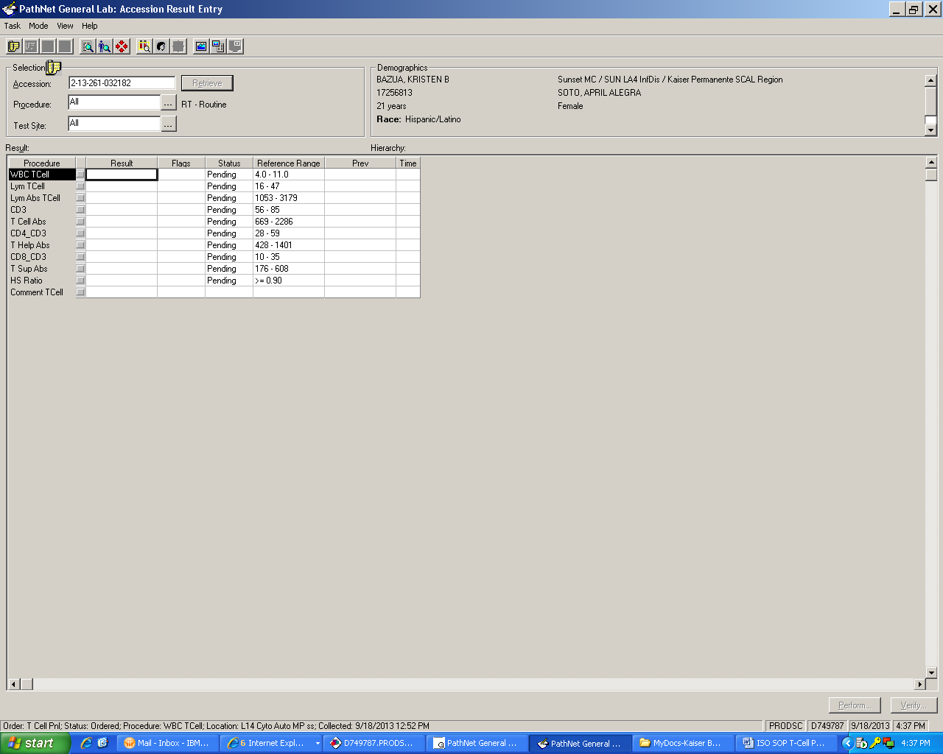  Above screen shows the Accession Result Entry display. Normally, all of the procedures are populated with result. To release results, Click, Verify.

T-CELL SUBSET ENUMERATION USING 4-COLOR FLOW CYTOMETRY WITH NAVIOS FLOW CYTOMETER, continued

7 | If WBC or % Lymphocyte did not merge, Lymph Abs TCell procedures are not populated. Obtain WBC with Auto diff printout and enter the WBC and % Lymphocyte in the corresponding field.
8 | Once the WBC and % Lymphocytes field are populated, Cerner automatically computes absolute count for T- Cell, T Help Abs, T Sup Abs procedure fields. If all results are correct and to release result to Health connect, Click Verify, otherwise click Perform to skip a result for later review.

How to re-analyze a file in list mode.

Step | Action
1 | At instrument’s Resource Explorer page, click on the Protocol Icon, double click on the Common Folder, double-click on tetracxp.
2 | Click on protocol that matches with the file to be analyzed:  Example: For 45/4/8/3 click on LSA-45-4-8-3.pro, drag it into a work space.
3 | Click on list mode icon and and click BT Lab folder and choose file to analyze.
4 | Once the file to be analyzed is selected or highlighted, drag it on to any of the histogram.
5 | Check for histogram markers and quadrant markers and gates, adjust if necessary.
6 | Click on the Flow Page, press print icon on the tool bar, click, OK.

T-CELL SUBSET ENUMERATION USING 4-COLOR FLOW CYTOMETRY WITH NAVIOS FLOW CYTOMETER, continued

How to calculate % lymphocyte and %CD3 from Tetra software print-out when an abnormal WBC population is present.

Step | Action
1 | At instrument’s Resource Explorer page, click on the Protocol Icon, double click on the Common Folder, double-click on tetracxp.
2 | Click on protocol that matches with the file to be analyzed:  Example: For 45/4/8/3 click on LSA-45-4-8-3.pro, drag it into a work space.
3 | Click on list mode icon and click BT Lab folder and choose file to analyze.
4 | Once the file to be analyzed is selected or highlighted, drag it onto the workspace.
5 | Check for histogram markers and quadrant markers and gates, adjust GADJ region (CD45FITC vs. SS to gate the normal lymphocytes (brightest staining CD45).
6 | Click on the CD45FITC vs. SS histogram. Using the mouse, place cursor on the lower left side of the quadrant until you see Summation sign.( Σ). Right click to reveal the quadrant statistics.
7. | Click on the flow page, and right click CD45FITC vs. SS histogram on the flow page. Click delete.

T-CELL SUBSET ENUMERATION USING 4-COLOR FLOW CYTOMETRY WITH NAVIOS FLOW CYTOMETER, continued
8 | Drag CD45FITC vs. SS (mouse cursor at center) from the workspace and to the flow page. Right click to ungroup. Arrange Quadrant statistics markers. The % lymphocyte is % gated on the GADJ region.
9 | Click on the CD3 histogram. Using the mouse, place cursor on the lower left side of the quadrant until you see Summation sign.( Σ). Right click to reveal the quadrant statistics.
10 | Click on the flow page, and right click CD3 histogram on the flow page. Click delete.
 | Drag CD3, (mouse cursor at center) from the workspace and to the flow page. Right click to ungroup. Arrange Quadrant statistics markers. The % CD3 is the % gated on the ADJLIN 1 region.
11 | To calculate absolute count:  Absolute count CD3 = WBC x % lymphocytes x %CD3.  Absolute count CD3+CD4+ = WBC x % lymphocytes x CD3+/CD4+.  Absolute count CD3+/CD8+ = WBC x % lymphocytes x CD3+/CD8+.
12 | Enter WBC, % lymphocytes, and calculated absolute counts results in the LMS computer.  Note: Do not put a comment referring to BT case in CoPath Plus.

How to correct erroneous results that have been released into Cerner.

Corrections to verified results in Cerner PathNet Millennium are made in Correction mode of
Accession Result Entry.

Step | Action
1 | Click ARE AppBar from the Cerner toolbar.
2 | 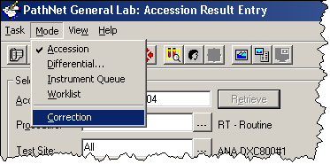  Click Mode on the Menu bar and select correction.
3 | 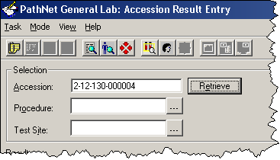  Scan or type accession and click Retrieve.

T-CELL SUBSET ENUMERATION USING 4-COLOR FLOW CYTOMETRY WITH NAVIOS FLOW CYTOMETER, continued

Step | Action
4 | In the appropriate Results field, type the corrections.
5 | Press Enter after each correction.
6 | Click Comments button on the tool bar.  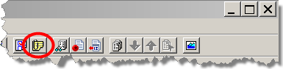
7 | Click Edit
8 | Type corr.
9 | Press F9
10 | Type the name of the physician notified or called.
11 | Press F3 to move to the next field.
12 | Type caller’s NUID
13 | Press F3 to move to the next field.
14 | Press F5 to enter current date and time.
15 | Click OK
16 | Click Close.
17 | Click Correct.

How to report T-cell panel results during prolonged Cerner Millenium computer downtime.

Step | Action
1 | After acquisition of results of the 4-color analysis from the Navios cytometer, transcribe the results on Form F048.
2 | Fax the completed F048 forms to Right Fax 866-576-9852. Use Right Fax cover page when faxing, indicate medical record number.  Note: Faxed document can be accessed on the Health Connect patient chart on the Media tab.

T-CELL SUBSET ENUMERATION USING 4-COLOR FLOW CYTOMETRY WITH NAVIOS FLOW CYTOMETER, continued

Interpretation
- Attenuation of SSC signal is seen when the specimen is grossly lipemic. In this case, the % Total CD3 maybe falsely depressed. True CD4+ and true CD8+ cell may be not be enumerated properly. Cells must be washed with RPMI 50/50 mix and centrifuge the cells using Clay Adams Serofuge II for 1 minute. Washed cells are re-stained and acquire and analyzed.
- If there is predominance of debris (RBCs are incompletely lysed) in the lymphocyte region, repeat staining process, re-acquire and re-analyze sample.
- If the white cell count is high, the white cell population includes blasts or other confounding cells, or abnormal dot plot patterns are noted, the results need to be reviewed by the Laboratory Director or designee before the report is released.

Additional steps needed for abnormal T-cell histogram patterns:

Step | Action
1 | Notify Hematopathologist to review case.
2 | Prepare two smears and stain with Modified Giemsa stain. See LBTM # 230.7.
3 | Send stained smears to the hematopathologist for further work-up.
4 | If hematopathologists requires further work-up, accession specimen to CoPath computer as a BT case.

- Optimally, at least 95% of the population of the lymphocytes should be within the lymphocyte gate. Minimally, at least 90% of the lymphocytes should be within the gate. If below 90%, regate and re-analyze until acceptable.
- Optimally, at least 90% of the lymphocyte purity should be observed within the lymphocyte gate. Minimally, at least 85% purity should be observed with the gate. If below 85%, re-gate, and re-analyze until acceptable.

T-CELL SUBSET ENUMERATION USING 4-COLOR FLOW CYTOMETRY WITH NAVIOS FLOW CYTOMETER, continued

- Optimally, the sum of %CD4+CD3 and &CD8+/CD3 cells should equal the Total %CD3 cells within ±5%. Minimally, this variability should be ≤ 15%. If more than 15% Check previous test and compare. If the same variability (both and above 15%), accept the data, If no previous, repeat analysis to verify the data.

- Optimally, the sum of the %CD3, %CD19 and %CD56 should be equal the purity of lymphocytes in the gate ±5%. Minimally, this variability should be ≤15%. If more than 15%, check previous test and compare. If the same variability (both above 15%), accept the data. If no previous, repeat analysis to verify the data. If the data are corrected for lymphocyte purity, the sum should equal 95% to 105% or a minimum of 85% to 115%)
- The variability of %CD4+CD3+ compared to the previous test should be ≤10 unless the previous test was done six months prior to the current test. If more than 10, repeat analysis to verify the data.
- If the helper/suppressor ratio reverses from <0.08 to >1.0 in comparison from the previous test, repeat analysis is necessary to verify data.

Reporting and Documentation

- After reviewing specimen (All specimen problems are resolved) results are entered into Cerner and uploaded to KP Health Connect . Report can now be viewed by clinicians for monitoring CD4 levels.

- Reference Range: (For General Population)

Cells | Percent  % | Absolute Count (cells/cu.mm.)
Lymphocytes | 16-47 | 1053-3179
Total T-Cell (CD3) | 56-85 | 669-2286
T-Helper (CD4+/CD3+) | 28-59 | 428-1401
T-Suppressor (CD8+CD3+) | 10-35 | 176-608

T-CELL SUBSET ENUMERATION USING 4-COLOR FLOW CYTOMETRY WITH NAVIOS FLOW CYTOMETER, continued
- Reference Range: (T-cell – Age specific Intervals)

AGE | LYMPH% | ABS LYMPHS | CD3+ | ABS CD3+ | CD3+/CD4+ | CD3+/CD4+ ABS | CD3+/CD8+ | CD3+/CD8+ ABS
>12 YEARS | 16-47 | 1053-3179 | 56-85 | 669-2286 | 28-59 | 428-1401 | 10-35 | 176-608
6M | 62-72 | 5395-7211 | 55-82 | 3505-5009 | 50-57 | 2780-3908 | 8-31 | 351-2479
12M | 60-69 | 5284-6714 | 55-82 | 3409-4575 | 49-55 | 2630-3499 | 8-31 | 351-2479
18M | 56-63 | 4943-5943 | 55-82 | 3156-3899 | 46-51 | 2307-2864 | 8-31 | 351-2479
24M | 52-59 | 4431-5508 | 55-82 | 2766-3508 | 42-48 | 1919-2472 | 8-31 | 351-2479
30M | 45-57 | 3855-5248 | 55-82 | 2324-3295 | 38-46 | 1538-2213 | 8-31 | 351-2479
36M | 38-53 | 3315-5058 | 55-82 | 1923-3141 | 33-44 | 1216-2009 | 8-31 | 351-2479
12Y | 22-69 | 1622-5370 | 55-82 | 1072-3890 | 27-57 | 428-1401 | 14-34 | 331-1445

Controlled Document

- T-Cell Panel Report Form: LAMC-FORM-0069 (This form is to be used for reporting T-cell panel reports when there is prolonged Cerner computer downtime only).
- LAMC-PPP-0123: Safety Practices.
- LAMC-PPP-0128: Universal Body Substance Precautions (UBSP).
- LAMC-PPP-0132: Handwashing Policy.
- LAMC-PPP-0127: Infection Control
- LAMC-PPP-0129: Handling Regular and Infections Waste.
- LAMC-PPP-0130: Cleaning Work Areas.

Uncontrolled Document
- Coulter Product Insert. The Coulter Procedure for Direct Immunofluorescence Cell Surface Staining. Coulter Immunology, Hialeah, FL, 1987.
- Coulter Immunoprep. Epics Leukocyte Preparation System. Coulter Electronics Inc., Hialeah, FL, December 1987.

T-CELL SUBSET ENUMERATION USING 4-COLOR FLOW CYTOMETRY WITH NAVIOS FLOW CYTOMETER, continued

- CDC MMWR, Guidelines for Performance of CD4+ T-Cell Determinations in Persons with HIV Infection, Vol. 41 No. RR-8, Atlanta, GA May 8, 1992.
- CDC Procedure Manual, Flow Cytometric Immunophenotyping, Quality Assurance and Quality Control Procedures for CD4+ T-Lymphocyte Determination. Atlanta, GA, April 1993.
- Cytomics FC 500 Training Modules, (September 2004) Beckman/ Coulter, Miami Education Center, Miami, Florida.

Self Assessment: | - True or False: If a specimen is hemolyzed or frozen, reject specimen and request another.  - True or False: Specimen anticoagulated with ACD and heparin is acceptable if EDTA is not available.  - Wash specimen if:  - Lipemic  - Hemolyzed  - Frozen  - Which of the following is true:  - Predominance of incompletely lysed RBC in the lymphocyte region, repeat staining process re-acquire and re-analyzed sample.  - It total T-cells and WBC is high, call pathologist for additional testing.  - A and b is correct  - None of the above.

Author: Giovanni B. Garcia, MBA, MT (ASCP), CLS

