The **CheckPoint** is a wireless temperature and environmental parameters monitoring system used to monitor appliances and locations that must be maintained within specific operating conditions. The System measures parameters such as temperature and humidity, which stores the data electronically in a central SQL database.

CheckPoint Icon

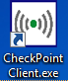

**LOGGING IN**

1. Double click the Checkpoint app icon from designated desktop.

2. Log in window will appear, user id will be your NUID#. New users, ask a manager to register you in the system

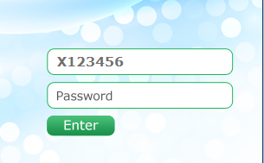

**F5**

3. To refresh Home window status **press**  on the keyboard.

Continued on the next page

**ADDRESSING ALERTS**

Once logged in, there are three tabs on the HOME WINDOW.

***Current Alerts*** (RED), ***Corrective Action in Progress*** (YELLOW), and ***All Equipment Status***.

1. **Current Alerts**

This tab will show all current issues that must be addressed.

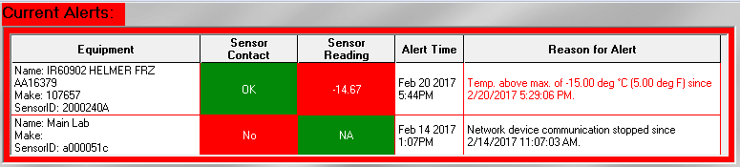

1. Right click on item and choose ***Graph It*** to investigate the alert . This would provide a visual that could be used to evaluate the status of the equipment over time.

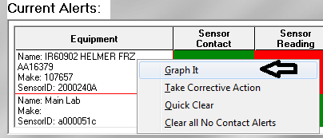

1. On ***1st or 2nd occurrence and if equipment is working properly upon investigation***, right click on alert and choose ***False Alert or Quick Clear(varies in software version****)*.

**Old software version screenshot New software version screenshot**

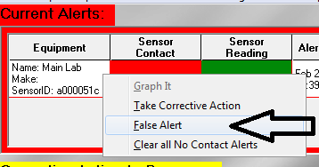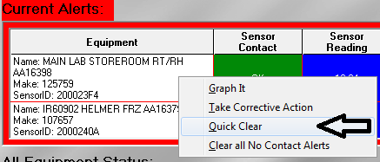

**ADDRESSING ALERTS, continued**

**Current Alerts**, continued

1. Record the current reading (Temp/Humidity) on the *Comment* window as seen below.
2. Click .

Save

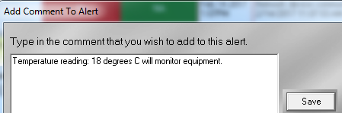

1. On ***3rd occurrence or if equipment is not working properly***, right click on item to resolve issue and choose *Take Corrective Action* instead.

**Old software version screenshot New software version screenshot**

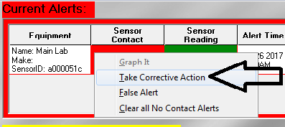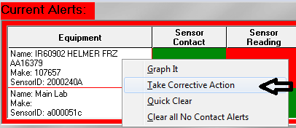

* 1. 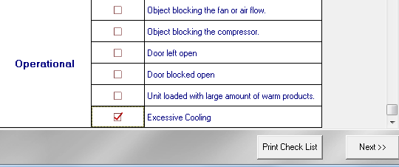A diagnose problem window will appear, select applicable diagnosis from the selection and click

Next >>

Continued on next page

**ADDRESSING ALERTS, continued**

**Current Alerts**, continued

Next >>

* 1. Confirm Action and click  **,** a *Corrective Action* Window will appear for documentation.

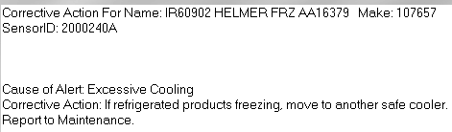

* 1. Call Engineering and submit an Easynet request to service instrument or check the condition.

Notify Manager about the issue. Document the corrective action performed on the *Corrective Action* window as shown below.

Choose “***No”***if equipment has not been resolved yet. This would place the alert in the *Corrective Action in Progress* (yellow) tab.

Save

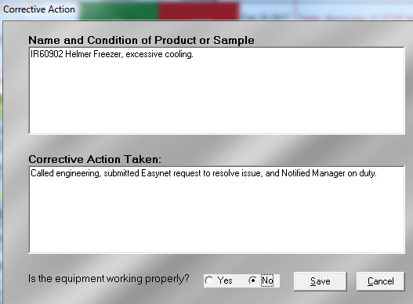Click .

Continued on next page

**ADDRESSING ALERTS, continued**

1. **Corrective Action in Progress**  –

This tab will show all issues that have been addressed and are currently in progress for resolution.

Once the issue has been properly resolved and the equipment is functioning properly, the alert can be removed from this tab.

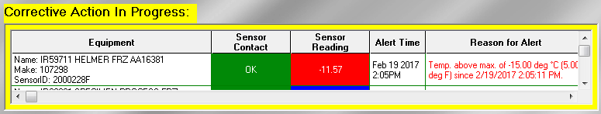

* 1. Right click on item to be cleared and choose ***Process Further*** to update the status of the equipment.

The *Corrective Action* window will appear. Document appropriately as shown below.

Choose *“****Yes”***  to confirm that the equipment is functional and working properly to remove item from Cor*rective Action in Progress* tab.

Save

Click .. .

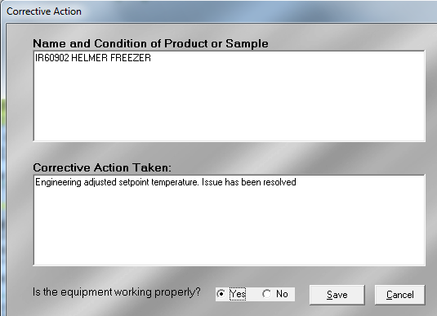

Continued on the next page

**ADDRESSING ALERTS,** continued

1. **All Equipment Status Tab** - this tab will include all equipment in the lab and the most current reading or status of each equipment including the acceptable ranges.

