|  |  |
| --- | --- |
| **Purpose** | The purpose is to give instructions in replacing Beckman Unicel DxH 800 Coulter Reagents. |

|  |  |
| --- | --- |
| **Policy** | Sufficient reagents must be on hand at all times. Reagents volume in the analyzer must be adequate for testing patient samples and must not exceed the expiration date. |

|  |  |
| --- | --- |
| Workplace Safety | All laboratory employees are expected to maintain a safe working environment and an injury-free workplace. Laboratory employees are responsible for their own safety, the safety of others and adhering to all departmental and medical center safety policies and procedures.   * For standard precautions and safety practices in the laboratory; see **Safety Practices**, specifically, but not limited to, equipment safety, proper body mechanics, sharps exposure and proper use of personal protective equipment (PPE). * For Universal Body Substance precautions, see **Universal Body Substance Precautions**, specifically, but not limited to, exposure to body fluids. * For proper hand-washing, see **Hand washing Policy**, specifically, not limited to, proper hand-washing. * For proper infection control, see **Infection Control**, specifically, but not limited to, proper use of gloves. * For proper handling of regular and infectious waste, see **Handling of Regular and Infectious Waste**, specifically, but not limited to, proper disposal of regular and biohazardous waste. * For proper cleaning of work area, see **Cleaning Work Areas**. * For proper handling of chemicals and reagents, see the Chemical Hygiene Plan.   For proper storage and disposal of chemical hazardous waste, see **Storage & Disposal of Chemical Hazardous Waste**. All laboratory employees are expected to maintain a safe working environment and an injury-free workplace. Laboratory employees are responsible for their own safety, the safety of others and adhering to all departmental and medical center safety policies and procedures. |

**PROCEDURE**

|  |  |
| --- | --- |
| **WHEN TO CHANGE REAGENTS** | The system monitors the supplies status and provides a visual indication of their states through the Supplies alert indicator icon. While there is a valid reagent usage remaining for all the supplies, the Supplies icon background is beige or neutral. A yellow background indicates a warning condition and a red background indicates an error condition. You can return the color to neutral by replacing the supplies that are low, depleted or expired.  NOTE: Except for the Diluent, Diluent must be replaced ONLY on red color background. There are two (2) containers of Diluent loaded in the instrument. Wait until the current diluent in use switches to the other diluent before proceeding with replacement. |

**REAGENT LIST**

* ***COULTER DxH Diluent PN 628017 (10 L)***

COULTER DxH Diluent is a cyanide-free, isotonic buffered saline solution. COULTER DxH Diluent dilutes the specimen, is used for rinsing module components between sample analyses, and provides a sheath stream to transport the sample through the flow cell.

* ***COULTER DxH Cell Lyse PN 628019 (5L)***

COULTER DxH Cell Lyse is a cyanide-free CBC lytic reagent that lyses red blood cells for the white blood cell and total nucleated cell counts, and works in conjunction with COULTER DxH Diluent to generate a stable hemoglobin measurement. COULTER DxH Cell Lyse is also used to lyse the red blood cells and discriminates nucleated red blood cells from white blood cells.

* ***COULTER DxH Cleaner PN 628023 (10 L)***

DxH Cleaner is a cyanide-free, aldehyde-free cleaning agent that degrades residual materials so that they may be flushed from the system with the diluent.

* ***COULTER DxH Diff Pack PN 628020***

The COULTER DxH Diff Pack consists of the Erythrolyse Lytic Reagent and Stabilyse Preservative Reagent. The Erythrolyse Lytic Reagent is a cyanide-free lytic reagent that dilutes the blood sample, and lyses red blood cells in preparation for white blood cell measurement in the flow cell. The StabiLyse Preservative Reagent neutralizes the Diff lytic reagent and preserves the white blood cells for measurement in the flow cell. Together, Erythrolyse and StabiLyse provide a dilution for the five-part differential.

* ***COULTER DxH Retic Pack PN 628021***

The DxH Retic Pack consists of a reticulocyte stain reagent and a reticulocyte-clearing reagent. The reticulocyte stain reagent is a cyanide-free reagent that uses a dye to stain reticulocytes. The reticulocyte-clearing reagent is a cyanide-free reagent that stabilizes the dye-reticulum complex to enhance discrimination of reticulocytes from mature red blood cells utilizing the VCSn technology.

For additional information, refer to the package inserts available at: <https://www.beckmancoulter.com/wsrportat/page/techdocs>

|  |  |
| --- | --- |
| **CHANGING REAGENTS** | Follow the steps below to replace reagents on the Beckman Coulter DxH 800. |

|  |  |
| --- | --- |
| **Step** | **Action** |
|  | Locate the old Reagent container. |
|  | Place the new reagent box near the old container. |
|  | Remove any cardboard cutouts from the new container. |
|  | Remove the cap and seal from the new reagent container. Be sure to completely remove the foil seal and lift the neck of the container. |
|  | Remove the plastic collar that secures the pickup tube assembly from the old reagent container. |
|  | Unscrew the pickup tube assembly of the old container and lift it straight up and out. |
|  | Inspect the pickup tube for damage, and replace if necessary. |
|  | Carefully insert the pickup tube assembly straight into the new container and tighten cap. |
|  | Insert the plastic collar that secures the pickup tubes. |
|  | Scan the new container’s information on the Setup DxH Supplies dialog box or manually enter information on the Setup Other Supply dialog box. |
|  | Opened reagent must be dated and with CLS/MLT initial. |
|  | Go to instrument SUPPLIES window and print reagent inventory by pressing (print screen) from the instrument keyboard.  PrintSc   * Review new **DxH Inventory supplies printout** and check if new reagent supplies loaded has a new lot compared to the previous **DxH Inventory supplies printout**. * Review if reagent is a new shipment, container will have a sticker **“New shipment QC prior to use”** which will be monitored by Hematology and Laboratory Unit Managers.   See **Attachment R1 and R2**   |  |  | | --- | --- | | If lot number of reagent loaded is the **same lot**… | If lot number of reagent loaded is a **new lot** or **new shipment**… | | 1. Note in the new **DxH Inventory supplies printout “Same lot number”** with initial & date. 2. File new printout in the **DxH Instrument Supplies binder**. | 1. **Perform Level 1 QC**   a. 6C QC for Diff pack, Cell Lyse, and diluents.  b. Retic-X QC for Retic Pack.   1. If QC passes, note in the new **DxH Instrument supplies printout “New lot number** or **New shipment for (reagent name), QC performed and acceptable”** with initial & date. 2. If QC fails, follow QC protocol on procedure LAMC-PPP-0277 for troubleshooting. 3. File new printout in the **DxH InstrumentSupplies binder**. | |
|  | Proceed with running patient specimens. |

|  |
| --- |
| **NOTE: DILUENT SUPPLIES REAGENT CHECK FOR NEW LOT NUMBER** |
| **Since DXH800 has a dual Diluent Supply system, reagent check happens when instrument switches from Diluent 1 to Diluent 2 or vice versa.**   * **Proceed to step 12 of table above (section Change Reagent) if switch of supplies happens.** * **Lot number to be checked will be the newly activated Diluent supply and not necessarily the new Diluent loaded** |

|  |  |  |  |
| --- | --- | --- | --- |
| **Uncontrolled Document** | The following uncontrolled documents support this procedure.   |  | | --- | | **Document Name** | | Instructions for Use UniCel® DxH 800 Coulter® Cellular Analysis System | |

|  |  |  |  |  |  |  |  |  |  |  |  |  |  |  |  |  |  |  |  |  |  |
| --- | --- | --- | --- | --- | --- | --- | --- | --- | --- | --- | --- | --- | --- | --- | --- | --- | --- | --- | --- | --- | --- |
| Controlled Documents | The following controlled documents support this procedure.   |  |  | | --- | --- | | **Document Number** | **Document Name** | | LAMC-PPP-0123 | Safety Practices | | LAMC-PPP-0127 | Infection Control | | LAMC-PPP-0128 | Universal Body Substance Precaution | | LAMC-PPP-0129 | Handling of Regular and Infectious Waste | | LAMC-PPP-0130 | Cleaning Work Areas | | LAMC-PPP-0132 | Hand-washing Policy | | LAMC-PPP-0134 | Storage and Disposal of Chemical Hazardous Waste | | LAMC-PPP-0277 | Beckman Coulter Unicel DxH 800 Quality Control | |  | Attachment R1 and R2 | |

|  |  |
| --- | --- |
| Author(s) | Alvin Castillo |

**Attachment R1**

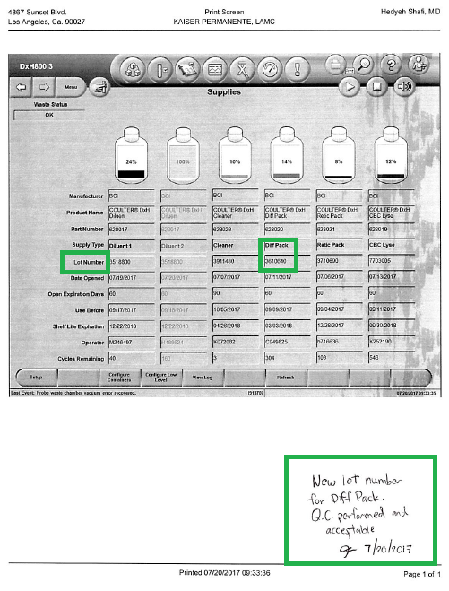

**Attachment R2**

