|  |  |
| --- | --- |
| Purpose | The Veritor™System for Rapid Detection of Respiratory Syncytial Virus (RSV), a moderately complex test under CLIA, is a rapid chromatographic immunoassay used for the direct and qualitative detection of RSV viral nucleoprotein antigens from nasopharyngeal swabs of symptomatic patients. |

|  |  |
| --- | --- |
| Scope | Clinical Laboratory Scientist and Medical Laboratory Technicians  CLIA – Moderately complex |

|  |  |
| --- | --- |
| Policy | This rapid detection of RSV is intended for *in vitro* diagnostic use only. |

|  |  |
| --- | --- |
| Specimen sources | Nasopharyngeal (NP) swabs in Universal Transport Medium or Universal Viral  Transport Medium (UTM/UVT) are acceptable specimens for this test. |

|  |  |
| --- | --- |
| Specimen collection | * Collect sample as soon as possible after onset of symptom * Acceptable specimens for testing with the BD Veritor™ System for Rapid Detection of RSV is nasopharyngeal (NP) swab specimens in appropriate transport media. * Specimens obtained early in the course of illness will contain the highest viral titers. |

|  |  |
| --- | --- |
| Specimen transport and storage | * Freshly collected specimens should be processed as soon as possible or within 1 hour. * If necessary, specimens may be stored at 2–8 °C for up to 72 hours and then tested at room temperature. After testing, samples should be saved for 3 days at 2-8°C in case the provider will request further testing. * Do not centrifuge specimens prior to use, as the removal of cellular material may adversely affect test sensitivity. |

|  |  |
| --- | --- |
| Specimen rejection | * Specimen collected using cotton tips, wood shafts and calcium alginate swabs * Specimens received with discrepant patient information (i.e., name, medical record number, date of birth) * Unlabeled specimens * Specimens other than NP swab in transport media. * Improperly collected or transported specimens. * Samples not in transport media (UTM/UVT) |

|  |  |  |  |
| --- | --- | --- | --- |
| Kit Reagents | **Description** | **Vendor** | **Storage** |
| BD Veritor™ System RSV - Laboratory kit (moderately complex) 30 test | Becton Dickinson Cat. Nos 256042 | Room Temp. |

|  |  |
| --- | --- |
| Materials and Supplies not Provided | * Timer & Tube Rack * UTM- Universal transport media/UVT- Universal viral transport * BD Veritor™ System RSV control Swab Set, 10 pairs swabs (Catalog No.256061) |

|  |  |
| --- | --- |
| Materials and Supplies Provided | **The following components are included in the BD Veritor System for Rapid Detection of RSV kit:**   * BD Veritor System RSV Devices: 30 devices with reactive strips * RV Reagent C: 30 tubes with 100 μL reagent * 300 µL Transfer pipette: 30 each * RSV Positive Control Swab, 1 each of RSV Positive Control Swab, RSV antigen (noninfectious cell lysate) with < 0.1% sodium azide (preservative) * RSV Negative Control Swab, 1 each of RSV Negative Control Swab, (detergent-treated non-infected cells) with < 0.1% sodium azide (preservative) |

|  |  |  |  |
| --- | --- | --- | --- |
| Safety and Precautions | * H302 Harmful if swallowed. H402 Harmful to aquatic life. H412 Harmful to aquatic life with long lasting effects. P273 Avoid release to the environment. P301+P312 IF SWALLOWED: Call a POISON CENTER or doctor /physician if you feel unwell. P501 Dispose of contents/container in accordance with local/regional/national/international regulations. * For in vitro Diagnostic Use. * Test results are not meant to be visually determined. All test results must be determined using the BD Veritor System Instrument. * The RSV Positive Control Swab and the positive control line on the BD Veritor System for Rapid Detection of RSV device has been prepared from RSVinfected tissue cell culture cells which have been inactivated by detergent treatment and sonication then subsequently tested by bioassay procedures. * Pathogenic microorganisms, including hepatitis viruses, Human Immunodeficiency Virus and novel influenza viruses, may be present in clinical specimens. “Standard Precautions”10-13 and institutional guidelines should be followed in handling, storing and disposing of all specimens and all items contaminated with blood and other body fluids. * Dispose of used BD Veritor System test devices as biohazardous waste in accordance with federal, state and local requirements. For more details see section Appropriate Waste Disposal. * Do not use kit components beyond the expiration date. * Do not reuse the BD Veritor System test device. * Do not use the kit if the Control RSV Positive Swab and Control RSV Negative swab do not yield appropriate results. * Wear protective clothing such as laboratory coats, disposable gloves and eye protection when specimens are assayed. * To avoid erroneous results, specimens must be processed as indicated in the assay procedure section. * Proper specimen collection, storage and transport are critical to the performance of the test. * Specific training or guidance is recommended if operators are not experienced with specimen collection and handling procedures. | | |
| Specimen Collection Procedure | Follow the steps below to properly collect the required nasal or nasopharyngeal swab specimens.  DOs and DON’Ts of Sample Collection:   * Do collect sample as soon as possible after onset of symptoms * Do test sample immediately – within ONE hour of collection * BD recommends flocked swabs. * Do not use cotton tips and wood shafts * Do not use calcium alginate swab | | |
| Specimen collection | | |
| **Step** | **Action** | |
| 1 | Use the flexible flocked nylon tip swab, which is included in the BD  Veritor System kit, to collect the nasal or nasopharyngeal specimen | |
| 2 | **Nasopharyngeal:** Insert the swab into one nostril of the patient, reaching the surface of the posterior nasopharynx. | |
| 3 |  | **Nasopharyngeal:**  Rotate the swab over the surface of the posterior nasopharynx. |
| 4 | Withdraw the swab from the nasal cavity and place it into a transport  media. The sample is now ready for processing/testing using the BD Veritor™ System Kit. | |

|  |  |
| --- | --- |
| Before you begin | * Patient specimens, reagents and devices must be at room temperature (15-30º C) before beginning the assay. * Check expiration date on each component and outer box before using. Do NOT use any test kit components that are expired/past the expiration date * Make sure that the BD Veritor™ System Reader is powered-on and ready prior to use. * Perform a function test using the verification cartridge on the Analyzer. |

|  |  |
| --- | --- |
| QualityControl | **Each BD Veritor™ System RSV device contains both positive and negative internal/procedural controls:**   * The internal positive control validates the immunological integrity of the device, proper reagent function, and assures correct test procedure. * The membrane area surrounding test lines functions as a background check on the assay device. * These positive and negative internal/procedural controls are evaluated by the BD Veritor System Reader after insertion of the BD Veritor System test device. * The BD Veritor System Reader will prompt the operator, should a quality issue occur. Failure of the internal/procedural controls will generate an invalid test result. * When the reader displays “RESULT INVALID” or “CONTROL INVALID” it means that the internal/procedural controls failed. The test or control must be repeated. * If the result of repeat testing is still invalid (internal/procedural controls failed), do not release the patient results. Notify the Manager or contact Becton Dickinson technical support at (800) 638-8663.     External Positive and Negative Controls:   * Swab controls (RSV positive and RSV negative) are supplied with each kit. Controls must be run daily or follow IQCP. * BD recommends that positive and negative controls be run once for:  1. Each new kit lot 2. Each new operator 3. Each new shipment of test kits 4. As required by internal quality control policies and procedures and in accordance with local, state and federal regulations or accreditation agencies requirements.  * If the results of the kit controls are INVALID, DO NOT test patient specimens/release patient results. Notify the Manager or contact Becton Dickinson technical support at (800) 638-8663. |

|  |  |  |
| --- | --- | --- |
| Testing Control Swab Procedure | Follow the steps below to perform the Testing Control Swab procedure | |
| Testing control swab | |
| **Step** | **Action** |
| 1 | **Prepare for Control Swab Testing:**  For each RSV positive control and negative control swab:   * Remove one **RV Reagent C** tube/tip and one BD Veritor System RSV device from its foil pouch immediately before testing. * Label each **RV Reagent C** tubes and BD Veritor System RSV device with each control to be tested. * Place the labeled **RV Reagent C** tube(s) in the designated area of   the tube rack. |
| 2 | **Prepare the Control Swabs:**   * Remove and discard the cap from the **RV Reagent C** tube corresponding to the control to be tested. * Using the transfer pipette, transfer 300uL of distilled or deionized water to the **RV Reagent C** tube, transfer pipettes are discarded in the biohazard sharps waste container * Insert the Control Swab all the way into the appropriately labeled **RV Reagent C** tube and vigorously plunge the swab up and down in the fluid for a minimum of 15 seconds. * Remove the Control swab while squeezing the sides of the tube to extract the liquid from the swab. * Properly discard the swab in the biohazard waste bag. |
| 3 | Proceed to Step 3 of the **Testing Patient Specimens Procedure** block. |

|  |  |  |
| --- | --- | --- |
| Testing Patient Specimens Procedure | Follow the steps below for testing patient’s nasopharyngeal swab specimens.   * Perform a functional test using the verification cartridge on the Analyzer * It is an ***option but not required*** to perform testing patient specimen ***steps 1 to 4*** under a Biological hood or safety protective shield. It is important though that ***steps 5 to 7 be performed outside of a biological hood***, as the hood’s airflow can affect a false negative result. | |
| Testing Patient Specimens | |
| **Step** | **Action** |
| 1 | **Prepare for patient testing:**   * For each patient specimen, remove one **RV Reagent C** tube/tip and one BD Veritor™ System RSV device from its foil pouch immediately before testing. * Label the **RV Reagent C** tube and device with each patient’s name. * Place the labeled **RV Reagent C** tube(s) in the designated area of the tube rack. |
| 2 | Prepare the patients’ nasopharyngeal swab specimens:   * Vortex or thoroughly mix NP swabs in transport media. Do not centrifuge. * Remove and discard the cap from the **RV Reagent C** tube corresponding to the sample to be tested. * Using the transfer pipette, transfer 300 μL of the specimen into the **RV Reagent C** tube. Transfer pipettes are discarded in the biohazard sharps waste container |

**Testing Patient**

**Specimens**

**Procedure,**

continued

|  |  |
| --- | --- |
| 3 | * + Press the attached tip firmly onto the **RV Reagent C** tube containing the processed specimen or control (threading/twisting not required).   + Vortex or mix thoroughly by swirling or flicking the bottom of the Tube |
| 4 | **Run the Test:**   * + Invert the **RV Reagent C** tube and hold the tube vertically (approximately one inch above the **BD Veritor System RSV** **device** sample well).   + Holding the **RV Reagent C** tube at the ridged area, squeeze gently allowing **three (3) drops** of the processed sample to be dispensed into the sample well of the appropriately **labeled BD Veritor** **System RSV device.**   ***Note:*** ***Squeezing the tube close to the tip may cause leakage.*** |
| 5 | **Incubate and Turn on the BD Veritor System Reader:**   * After adding the sample, allow the test to run for **10 minutes.** |

**Testing Patient**

**Specimens**

**Procedure,**

continued

|  |  |
| --- | --- |
| 6 | **Analyze the Results:**   * When the test is ready, insert the BD Veritor System RSV device into the BD Veritor Plus Sytem Reader. * Follow the Reader on-screen prompts to complete the procedure and obtain the test result. |
| 7 | **Interpretation of External Controls and Patient Specimen results:**  ***Notes:***   * ***The BD Veritor™ Plus System Reader must be used for all interpretation of results.*** * ***Testing personnel should not attempt to interpret assay results directly from the test strip contained within the BD Veritor™ Plus System RSV assay device.***  |  |  |  | | --- | --- | --- | | **Reader Display** | **Interpretation** | **Report in Cerner as:** | | RSV: + | Positive Test for RSV (RSV antigen present) | Positive | | RSV: - | Negative Test for RSV (no RSV antigen detected | Negative | | INTERNAL  CONTROL  INVALID | • Test invalid  • Repeat the test.  If Control result is still invalid, **Do not** report patient results.  Notify the Manager or  contact Becton Dickinson  technical support at **(800)**  **638-8663** | Cancel test order  using the Cerner  cancel message:  “**Technical Error;**  **Test Not Performed**”  [Under Notes: add  reason: Control  Invalid] |   **ALWAYS MESSAGE: Please see below for interpretive criteria:**  “Positive” Positive for the presence of RSV antigen.  “Negative” Presumptive negative for RSV antigen. If clinically indicated, an alternate method of testing may be warranted.  Performance characteristics have not been established for use with patients ≥ 20 years of age and for immunocompromised patients. |
| Testing Patient Specimens Procedure, continued |  | |
| **Step** | **Action** |
| 8 | Document the test results on the Manual Patient Logs and Cerner |

• **RSV [Positive, Negative] (required)**

• **dns Analyzer ID [ Veritor #1, Veritor #2] (required)**

• **dns Lot number (optional)**

• **dns Expiration date (optional)**

|  |  |  |  |  |  |  |  |
| --- | --- | --- | --- | --- | --- | --- | --- |
| Appropriate Waste Disposal | |  |  | | --- | --- | | Item | Waste Container | | * Transfer pipette | Biohazards sharps waste container | | * RV Reagent C tube * BD Veritor System RSV device * RSV QC Swabs * UTM/UVT patient specimen | Biohazard waste bag | |

|  |  |
| --- | --- |
| Reference Range | **Negative Test for RSV** |
| Limitations of the Procedure | * Failure to follow the Test Procedure may adversely affect test performance and/or invalidate the test result. * The contents of this kit are to be used for the qualitative detection of RSV antigens from NP wash, aspirate and swab in transport media specimens. * The BD Veritor System for Rapid Detection of RSV is capable of detecting both viable and non-viable RSV particles. The BD Veritor System for Rapid Detection of RSV performance depends on antigen load and may not correlate with other diagnostic methods performed on the same specimen. * Results from the BD Veritor System for Rapid Detection of RSV test should be correlated with the clinical history, epidemiological data and other data available to the clinician evaluating the patient. * A false-negative test result may occur if the level of viral antigen in a sample is below the detection limit of the test or if the sample was collected or transported improperly; therefore, a negative test result does not eliminate the possibility of RSV infection, and should be confirmed by viral cell culture or an FDA-cleared RSV molecular assay. * Positive test results do not rule out co-infections with other pathogens. * Negative test results are not intended to rule in other non-RSV viral or bacterial infections. * Positive and negative predictive values are highly dependent on prevalence rates. Positive test results are more likely to represent false positive results during periods of little/no RSV activity when disease prevalence is low. False negative test results are more likely during peak RSV activity when prevalence of disease is high. * This device has been evaluated for use with human specimen material only. * Monoclonal antibodies may fail to detect, or detect with less sensitivity, RSV viruses that have undergone minor amino acid changes in the target epitope region. * The performance of this test has not been evaluated for use in patients without signs and symptoms of respiratory infection. * The validity of the BD Veritor System for Rapid Detection of RSV test has not been proven for identification/confirmation of tissue culture isolates and should not be used in this capacity. * Therapeutic anti-RSV monoclonal antibodies may interfere with the BD Veritor System for Rapid Detection of RSV. * Performance characteristics have not been established for use with patients older than 20 years of age and for immunocompromised patients |

**EXPECTED VALUES**

The rate of positivity observed in RSV testing will vary depending on the method of specimen collection, handling/transport system employed, detection method utilized, time of year, age of the patient, geographic location and most importantly, local disease prevalence. In the 2011/2012 clinical trial, the overall prevalence of RSV as determined by viral cell culture for the nasopharyngeal swabs (NPS) in transport media was 24.5% (range of 5.6% to 31.8%). The overall prevalence of RSV as determined by viral cell culture for the nasopharyngeal washes and aspirates (NPWA) was 37.7% (range of 10.5% to 49.6%).

PERFORMANCE CHARACTERISTICS

**Explanation of Terms**

P: Positive

N: Negative

C.I.: Confidence Interval

**Clinical Performance**:

Performance characteristics for the BD Veritor System for Rapid Detection of RSV test were established in multi-center clinical studies conducted at five U.S. trial sites during the 2011–2012 respiratory season. A total of 1174 prospectively collected specimens received in the laboratory with an order for respiratory virus testing were enrolled in the study, of which, 26 were noncompliant with the study protocol and one was noncompliant on the viral cell culture reference testing level. Removal of these specimens yields a total of 1147 specimens. One additional specimen had a final undetermined viral cell culture reference result which could not be verified. Removal of this specimen results in a total of 1146 specimens. A total of 1146 were evaluated using the BD Veritor System for Rapid Detection of RSV test and viral cell culture. The prospective specimens consisted of 440 NPWA and 706 NPS in transport media from symptomatic patients. 44.3% of the samples were from females and 55.7% from males. 80% of patients were 2 years and under.

The performance of the BD Veritor System for Rapid Detection of RSV test was compared to an

FDA cleared D3 *Duet*™DFA on R-Mix cell culture and is presented in the following tables.

Table 1. Summary of the performance of the BD Veritor System for Rapid Detection of RSV Test compared to viral cell culture by specimen type, all sites.

|  |  |  |  |  |
| --- | --- | --- | --- | --- |
|  |  | **Viral Cell Cultu** | | **re** |
| **Specimen Type** | **BD Veritor RSV** | **P** | **N** | **Total** |
| NPS | **P** | 153 | 9* | 162 |
| **N** | 20 | 524 | 544 |
| **Total** | 173 | 533 | 706 |
|  | Reference Method: Viral Cell Culture  Sensitivity: 88.4% (95% CI: 82.8–92.4%)  Specificity: 98.3% (95% CI: 96.8–99.1%) | | |  |

**\***Of the 9 BD Veritor RSV Positive, Viral Cell Culture negative specimens, 6 were positive by FDA cleared Prodesse ProFlu+ molecular assay.

**Of the 15 BD Veritor RSV Positive, Viral Cell Culture negative specimens, 8 were positive by FDA cleared Prodesse ProFlu+ molecular assay.

**Reproducibility**

The reproducibility of the BD Veritor System for Rapid Detection of RSV test was evaluated at three clinical laboratory sites. The reproducibility panel was composed of 12 simulated RSV samples. These included moderate positive samples, low positive samples (near the assay limit of detection), high negative samples (i.e., containing very low concentrations of virus) and negative samples. The panel was tested by two operators at each site for five consecutive days. The results are summarized below.

|  |  |  |  |  |
| --- | --- | --- | --- | --- |
| **Reproducibility Results – Percent of RSV Positives** | | |  |  |
| **Sample** | **Site 1** | **Site 2** | **Site 3** | **Total** |
| High negative  RSV | 0% (0/30)  (95% CI: 0–11.3%) | 3.3% (1/30)  (95% CI: 0.6–16.7%) | 3.3% (1/30)  (95% CI: 0.6–16.7%) | 2.2% (2/90)  (95% CI: 0.6–7.7%) |
| Low positive  RSV | 93.3% (28/30)  (95% CI: 78.7–98.2%) | 76.7% (23/30)  (95% CI: 59.1–88.2%) | 93.3% (28/30)  (95% CI: 78.7–98.2%) | 87.8% (79/90)  (95% CI: 79.4–93%) |
| Moderate positive  RSV | 100% (30/30)  (95% CI: 88.6–100%) | 100% (30/30)  (95% CI: 88.6–100%) | 100% (30/30)  (95% CI: 88.6–100%) | 100% (90/90)  (95% CI: 95.9–100%) |
| Negative | 0% (0/30)  (95% CI: 0–11.3%) | 0% (0/30)  (95% CI: 0–11.3%) | 0% (0/30)  (95% CI: 0–11.3%) | 0% (0/90)  (95% CI: 0–4.1%) |

Analytical Studies

**Analytical Sensitivity (Limit of Detection)**

The limit of detection (LOD) for the BD Veritor System for Rapid Detection of RSV test was established for the following RSV strains The LOD for each strain represents the lowest concentration producing a positivity rate of ≥95% based on testing 60 to 80 replicates.

|  |  |  |  |
| --- | --- | --- | --- |
| **Viral Strain** | **Calculated LOD**  **(TCID50/mL)** | **No. Positive / Total** | **% Positive** |
| VR-26 (Long Subgroup A) | 1.43 x 105 | 57/60 | 95.0 |
| VR-955 (9320 subgroup B) | 3.98 x 104 | 57/60 | 95.0 |
| VR-1540 (A-2) | 1.94 x 103 | 59/60 | 98.3 |
| VR-1580 (Washington subgroup B) | 1.08 x 104 | 58/60 | 96.7 |
| VR-1400 (Wild Type subgroup B) | 2.96 x 103 | 76/80 | 95.0 |

TCID50/mL= 50% Tissue Culture Infectious Dose

Analytical Specificity (Cross Reactivity)

The BD Veritor System for Rapid Detection of RSV test was evaluated with bacteria and yeast at a target concentration of approximately 106 CFU/mL (CFU – Colony Forming Units) with the exception of *Fusobacterium nucleatum* which was tested at 1.5 X 106.The viruses were evaluated at concentrations of 103 TCID50/mL or greater. Of the microorganisms tested, none showed cross-reactivity in the RSV test.

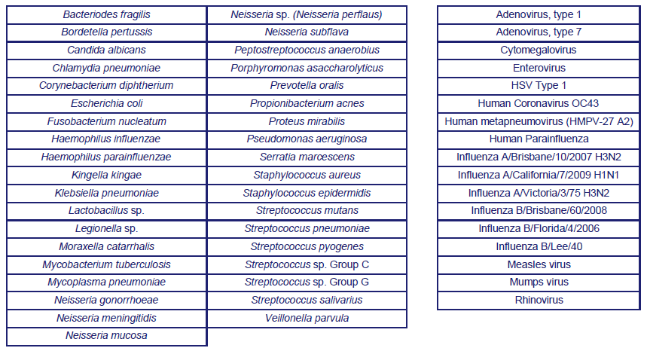

Interfering Substances

Various substances were evaluated with the BD Veritor System for Rapid Detection of RSV test.

These substances included whole blood (2%) and various medications. No interference was noted with this assay for any of the substances at the concentrations tested.

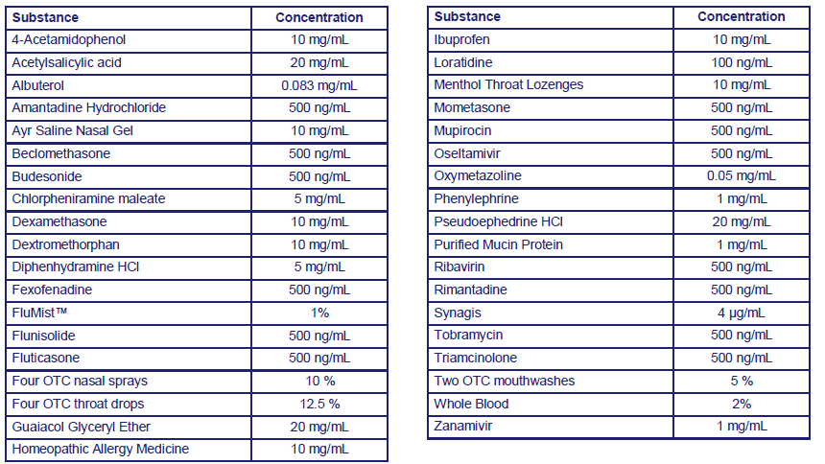

|  |  |
| --- | --- |
| Controlled Documents | The following controlled documents support this procedure.   * RSV Patient log (RSV – 020) * RSV Quality Control Log (RSV – 021) * RSV New Reagent Shipment Log (RSV – 022) * RSV Reagent kit Parallel test log (RSV – 023) |

|  |  |
| --- | --- |
| Non-Controlled **Documents** | The following non-controlled documents support this procedure.   * BD Veritor™ Plus System Reader Instruction Manual * BD Veritor™ System for Rapid Detection for RSV package Insert (2016-05) |
|  |  |

|  |  |
| --- | --- |
| Author(s) | Joven Cumpio, Ruby Hines and Arnold Gacusan |

|  |  |
| --- | --- |
| Updated by | Alvin Castillo |