Purpose | The purpose of this procedure is to provide complete instructions for processing urinalysis test on a urine aliquot using a BD vacutainer UA preservative tube.

Policy | Urinalysis samples with enough volume can be transferred to a BD vacutatiner UA preservative tube for testing. Urine samples that were transferred within 2 hours from time of collection on a BD vacutatiner UA preservative tube would be stable for 48 hours from time of collection.

Workplace Safety | All laboratory employees are expected to maintain a safe working environment and an injury-free workplace. Laboratory employees are responsible for their own safety, the safety of others and adhering to all departmental and medical center safety policies and procedures.  - For standard precautions and safety practices in the laboratory; see Safety Practices, specifically, but not limited to, equipment safety, proper body mechanics, sharps exposure and proper use of personal protective equipment (PPE).  - For Universal Body Substance precautions, see Universal Body Substance Precautions, specifically, but not limited to, exposure to body fluids.  - For proper hand-washing, see Hand washing Policy, specifically, not limited to, proper hand-washing.  - For proper infection control, see Infection Control, specifically, but not limited to, proper use of gloves.  - For proper handling of regular and infectious waste, see Handling of Regular and Infectious Waste, specifically, but not limited to, proper disposal of regular and biohazardous waste.  - For proper cleaning of work area, see Cleaning Work Areas.  - For proper handling of chemicals and reagents, see the Chemical Hygiene Plan.  For proper storage and disposal of chemical hazardous waste, see Storage & Disposal of Chemical Hazardous Waste. All laboratory employees are expected to maintain a safe working environment and an injury-free workplace. Laboratory employees are responsible for their own safety, the safety of others and adhering to all departmental and medical center safety policies and procedures.

Materials and equipment | BD Vacutainer UA preservative tube REF: 364992  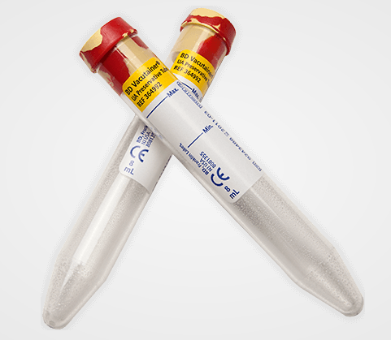

Procedure | Steps Action  Upon receiving the BD vacutainer UA preservative tube with patient urine sample, check that the order attached to the tube is the UA or UA micro tests only. Specimen in aliquot BD vacutainer UA preservative tube cannot be used for other urine test orders.  Check the tube for correct urine volume by using the guide marks on the sticker tube of Min. (7ml) and Max. (8ml). It is required that the urine volume is between these marks, anything beyond or below these marks would have to be rejected as “Improperly submitted, Test not performed”.  After confirming that specimen is acceptable for analysis, remove cap and perform urinalysis.  Note: Tube is compatible to Iricell racks and can be used as a direct test tube for analysis on the instrument.  After analysis, store urine samples tested on a BD vacutainer UA preservative tube for 48 hours.

Controlled Documents | The following controlled documents support this procedure.  Document Number Document Name  LAMC-PPP-0123 Safety Practices  LAMC-PPP-0127 Infection Control  LAMC-PPP-0128 Universal Body Substance Precaution  LAMC-PPP-0129 Handling of Regular and Infectious Waste  LAMC-PPP-0130 Cleaning Work Areas  LAMC-PPP-0132 Hand-washing Policy  LAMC-PPP-0134 Storage and Disposal of Chemical Hazardous Waste  LAMC-PPP-0766 Use of BD Vacutainer Urine Tubes for Urine Analysis - MOB Labs
Author(s) | Alvin Castillo

