Purpose |  | This procedure provides instructions for performing annual competency assessment of CLS and MLTs using the online CAP (College of American Pathologist) Competency Assessment Program  _________________________________________________________________
Scope | This procedure is intended for Clinical Laboratory Scientist (CLS), Medical Laboratory Technicians (MLT) and Area Laboratory Managers  Refer to ‘Competency Assessment’ LAMC-PPP-0750 for the frequency and scope of assessment.

Requirements
PC with Internet Access
Internet browser using Internet Explorer 11 or Google Chrome

__________________________________________________________________

Procedure | For Clinical Laboratory Scientist (CLS), Medical Laboratory Technicians (MLT)
 |  | Step | Action
 |  | 1 | Go to www.cap.org
 |  | 2 | Log on to the CAP website  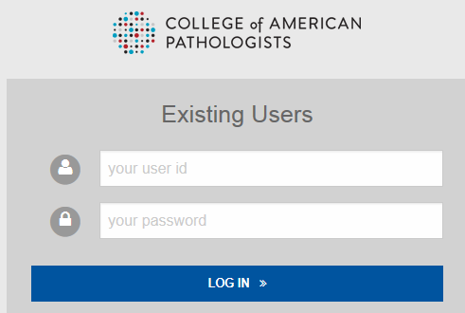
 |  | 3 | Under the “e-Lab Solutions Suite”, select and click on “Competency Assessment Program”  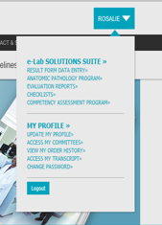
 |  | 4 | Under “Student Access”, click on “Access Course”. This will link to your assignments.  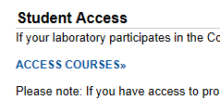
 |  | 5 | Click on the “Checklist’ button to access the competency checklist.  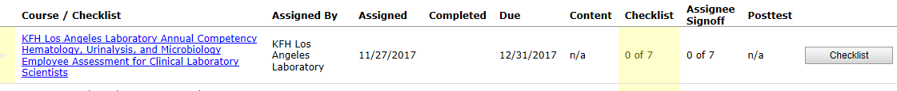
 |  | 6 | Under the column, ‘Assignee Sign Off’, click on the appropriate subtask/competency element that you have completed for each “Task”.  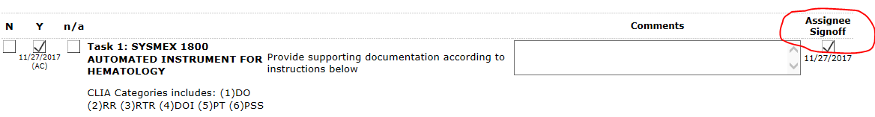
 |  | 7 | Documentation must be submitted to your manager for each sign off.
 |  | 8 | All sign off boxes must be checked to be deemed fully competent in the discipline.

For Competency Assessors/Area Lab Managers

Step | Action
1 | Go to www.cap.org
2 | Log on to the CAP website
3 | Under the “e-Lab Solutions Suite”, select and click on “Competency Assessment Program”
3 | Under “Education Administrator Actions”, click on “Manage Users’  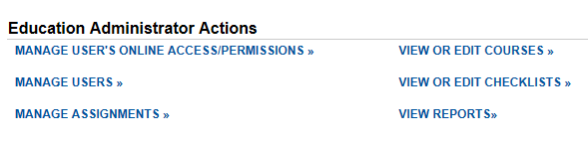
4 | Click on “View Users”  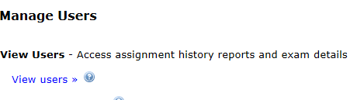
5 | Select the CLS/MLT to be assessed by clicking on their “Course Assignments”  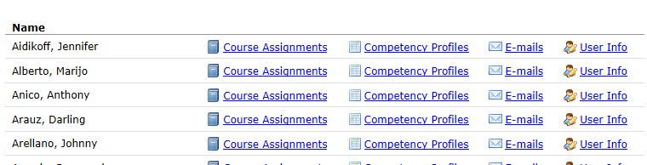
6 | The course/s or checklist/s assigned will display.  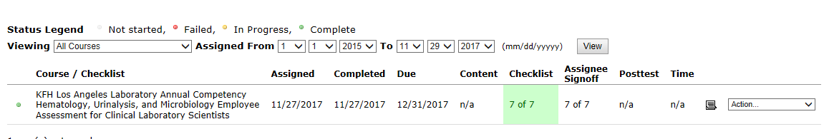
7 | Select the appropriate course/s or checklist/s by clicking on the “Action” dropdown.  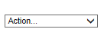
8 | Choose “View/Edit Checklist” from the dropdown.  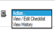
9 | The assessor will perform:  - Direct Observation (DO)  - Direct Observation of Instruments (DOI)
10 | The assessor will enter the completion date of the observations on the “Comment” section of subtask/element for “DO” and “DOI” (see example below).  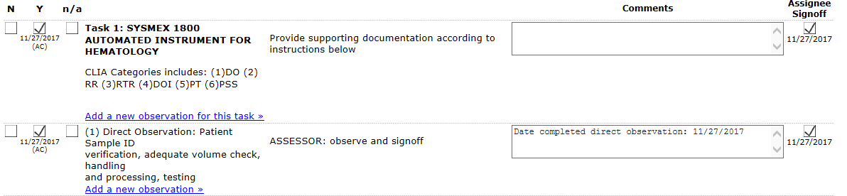
11 | If the requirements are satisfactory for these subtasks/elements, the assessor must click on Y button. If incomplete or unsatisfactory, the assessor must click on the N button and if not applicable, the assessor must click on N/A button.  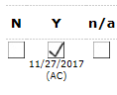
12 | Click on 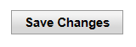
13 | Area Lab Manager will review the documentation for the following subtasks/elements:  - Recording and Reporting (RR)  - Review of Intermediate Test Results (RTR)  - Assessment of blind samples/proficiency testing samples (PT)  - Evaluation of problem solving skills (PSS)
14 | The Area Lab Manager will enter the completion date of the observations on the “Comment” section of subtask/element for “RR”, “RTR”, “PT” and “PSS”. (see example below).  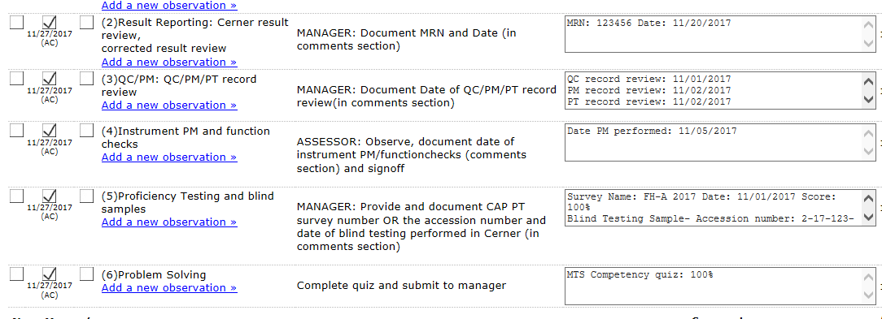
16 | If the requirements are satisfactory for these subtasks/elements, the Area Lab Manager must click on Y button. If incomplete or unsatisfactory, the Area Lab Manager must click on the N button and if not applicable, the assessor must click on N/A button.
17 | Once the competency assessment is complete, the Area Lab Manager will click on Y under the “Competency Assessment Summary” Task to indicate that the CLS/MLT is fully competent in the discipline. If the competency assessment is unsatisfactory, a corrective action plan must be entered in the “Comment” section.  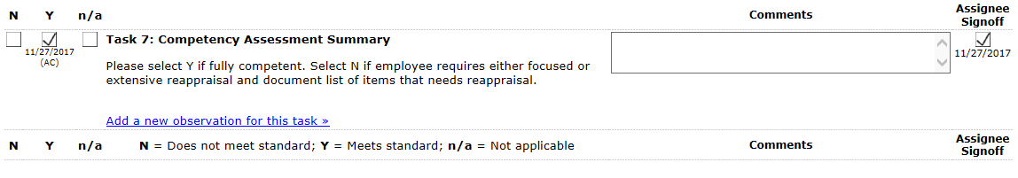
18 | Click on
19 | All remedial action for failed competency must be entered in the “Comment” section under the “Competency Assessment Summary” Task.

Controlled Documents | The following controlled documents support this procedure.
 |  | Document No. | Name of Documents
 |  | LAMC-PPP-0750 | Competency Assessment

Author(s) | Alvin Castillo, CLS  Rosalie I. Fajardo, MS CLS(ASCP)

