Rapid FLU A/B and RSV - SPECIMEN STABILITY REMINDER

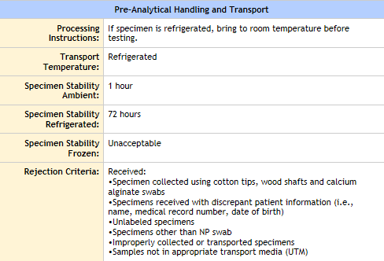

* Specimen received more than 1 hour from time of collection and was not refrigerated will have to be rejected.
* If specimen was received refrigerated, bring the sample at room temperature before testing.