Step | Action
Note | Clinical Laboratory Scientists
1 | CLS will receive STAT sample with KRMS -SO printout from the Lab Assistant.  Assign a unique downtime pink label per sample type per analyzer.  Note: Downtime pink labels are printed in pairs:  - Place 1 label for the blood tube (CBC, Coagulation or Chemistry)  - The remaining label is for the KRMS - SO printout.  Example:  CBC + COAG + CHEMISTRY  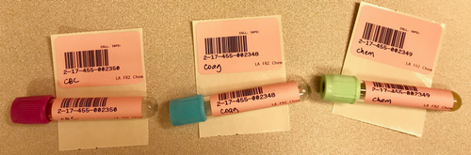  Note:  - Samples from Urgent Care must be accompanied with a copy of KPHC-SOT printout.  - Samples from Clinic Collect must have a KPHC Lab Order printout.
2 | For ESR, Flu, RSV, Wet Mount, and/or Urinalysis:  - Initiate an FPL - Temporary Laboratory Request and Report Form.  - Assign a unique downtime pink label per sample type.  - Affix one downtime pink label on the form and the remaining adhere on the sample container.  See sample screen shot below:  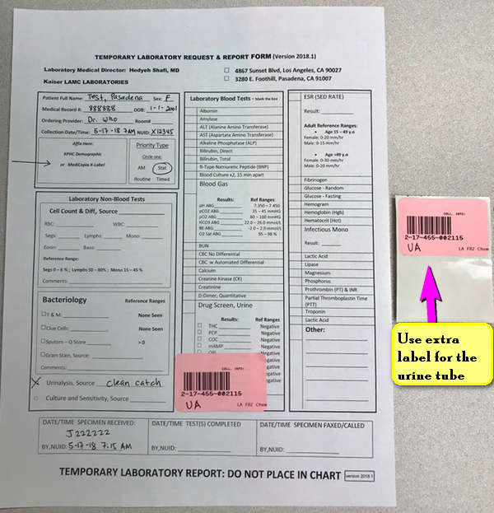
3 | Distribute specimen(s) for testing area.

Step | Action
Note | Clinical Laboratory Scientists – Analytical (Automated Instruments)
4 | Enable printing of results on all analyzers.
5 | Program testing on the analyzer using the information listed below:  - Full Name (Last Name, First Name)  - Medical Record Number  - Downtime pink label – accession number  - Test(s) ordered by the Ordering Provider based on the KRMS-SO printout.
6 | Load specimen(s) for testing.

Step | Action
Note | Clinical Laboratory Scientists – Reporting Results  (Automated Instruments)
7 | Obtain the printouts from the analyzers, review the results and write your NUID with Date & Time.  Document critical result call on the instrument printout following established protocol.
8 | Fax the instrument printout results to the Ordering Provider.
9 | After successful faxing, staple together the KRMS - SO printout and the instrument result printout. Organize the printouts alphabetically for recovery.

Step | Action
Note | Clinical Laboratory Scientists – Reporting Results for ESR, Flu, RSV, Wet Mount, and/or Urinalysis
10 | Transcribe results on the FPL - Temporary Lab Report Form.
11 | Fax results to the Ordering Provider.
12 | Staple the KRMS - SO printout together with the FPL - Temporary Lab Report Form.  Organize the printouts alphabetically for recovery.

Step | Action
Note | Clinical Laboratory Scientists – Recovery
13 | Log on to Cerner
14 | Go to Department Order Entry (DOE)
15 | For single test ordering  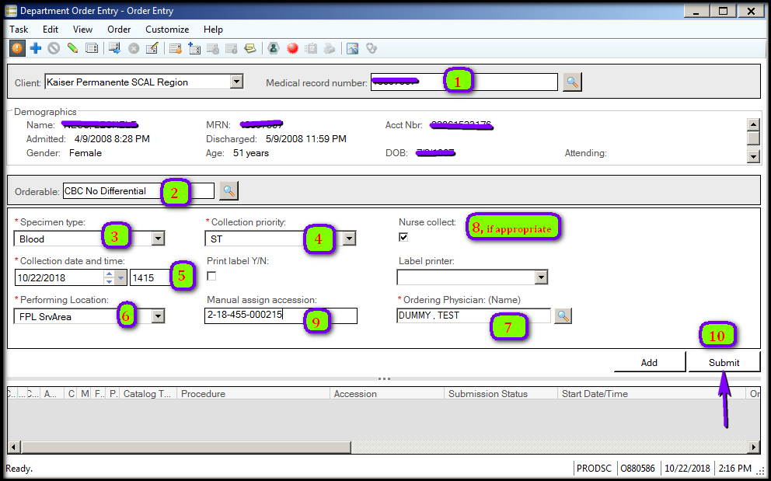  - Enter MRN & press Enter. Select the most current admission date. Review the patient information on the screen if correct. If a pop-up box displays on screen, The Selected Encounter is in a Discharged Status, click OK button.  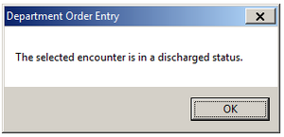  Verify that the Client box is defaulted to Kaiser Permanente SCAL Region.  - Order Test (i.e: CBC)  - Select from the drop down the Specimen Type, (i.e: Blood)  - Select “STAT” from the drop down of the Collection Priority.  - Enter the correct Collection date & time.  - Select “FPL SrvArea” from the drop down of the Performing Location.  - Enter the name of Ordering Provider. Press Enter.  - Mark the box Nurse Collect, if appropriate.  - Scan the Downtime pink label in the box, Manual Assign Accession.  - Click Submit button.
16 | For Multiple Chemistry orders (i.e: Electroytes, Glu , BUN & Creat). 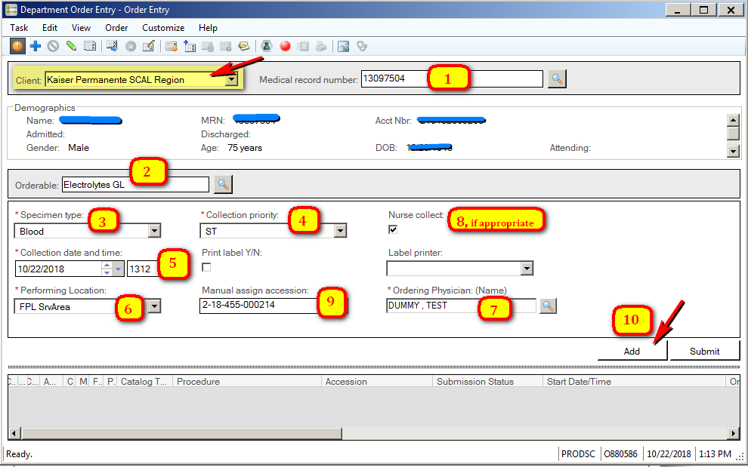  - Enter MRN & press Enter. Review the patient information on the screen if correct. Select the most current admission date. If a pop-up box displays on screen, The Selected Encounter is in a Discharged Status, click OK button.  Verify that the Client box is defaulted to Kaiser Permanente SCAL Region.  - Order Test (i.e: Electrolytes). Press Enter.  - Select from the drop down the Specimen Type, (i.e: Blood)  - Select “STAT” from the drop down of the Collection Priority.  - Enter the correct Collection date & time.  - Select “FPL SrvArea” from the drop down of the Performing Location.  - Enter the name of Ordering Provider. Press Enter and select accordingly.  - Mark the box Nurse Collect, if appropriate.  - Scan the Downtime pink label in the box, Manual Assign Accession. Downtime pink labels will have this pattern, X – XX- 455-XXXXXX.  - Click Add button.  - To order the next chemistry test (i.e: Glu), follow step b.  Most of the patient information will display on the screen; however, you must scan the same Downtime pink label for proper netting (i.e.2-18-455-000214) and click Add.  Keep repeating step 2) up until all tests performed under the same accession number are ordered.  - Click Submit button.
17 | Perform Specimen Log-In
18 | - Resend results to LIS from the analyzers (AU,Sysmex,Urinalysis,Stago, Access2 or/and iSED)  - For manual tests, proceed with Accession Result Entry (ARE)  Note: All results that are manual entry, click Performed button followed by Verified button.
19 | Reconcile all orders by reviewing Cerner pending lists.
20 | Retain all downtime documents on site for 3 months (LAMC-PPP-0015)
The End

