 | INITIAL RESPONSE / COMMUNICATION
 | NOTE: For MOB STAFF and MANAGERS
STEP | ACTION
1 | MOB Staff    Call the Main Lab and speak to any available Manager or Lead CLS if a manager is not on site to report the system issue.  3  3  2  3  7  8  4  9  6  1  Tie Line: 8 - 363 – 4961  Main Lab Manager or Lead CLS will escalate communication.  The manager will follow Downtime Communication Plan.
2 |   If downtime is ongoing by the end of your shift…  Notify your MOB Manager if you are available to stay to provide downtime support before clocking out to take care of our members.
3 | Keep all routine specimens collected at the MOBs until instructed by a manager.  Send only specimens that have been prepared for shipment prior to downtime.  Ensure seamless operations by ensuring break and meal coverage has been coordinated and taken as assigned.  - Prepare for printing HC demographics labels  - Prepare manual logs and file systems  - Prepare for sorters, supplies, stamps.  - Determine storage, supplies, totes.

   | PHLEBOTOMY
STEP | ACTION
1 | 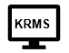    Log on to KRMS and PRINT the SO Screen (Scheduled Orders). Highlight STAT orders  PRINT
2 |   Stamp the SO printout with the MOB Phleb Collection stamp.  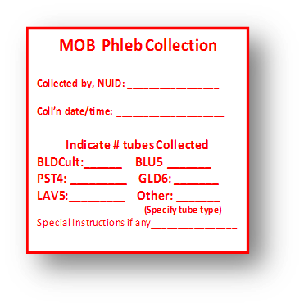  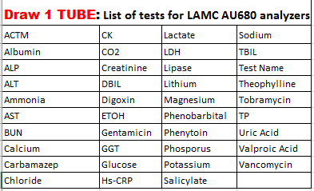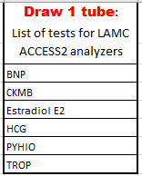
3 | Print HealthConnect demographic labels.  One label for each specimen container plus one additional for the Downtime Transfer Specimen log.  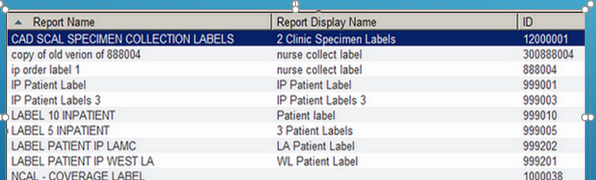  Example:  Label for Processing + Label for each Container = Total # Labels  + 2  3  4

   | PHLEBOTOMY
STEP | ACTION
1 | Collect the specimens from the patient based on the SO printout (KRMS).    Do NOT share or split samples during a downtime.  Draw ALL tubes to avoid misdirected or misplaced specimens  Refer to LabNet for collection information.
2 | Affix a KPHC demographic label on each of the primary specimen containers.
3 | Place all specimens from one patient in one biohazard bag. If there are STAT orders copy SO printout and place specimen in STAT bag.    One patient per bag
4 | Place the SO printout (KRMS) in the side pocket of the biohazard bag.      SO  printout
5 | Take specimen bag(s) to Processing area.

 | PROCESSING
STEP | ACTION
1 | Process all STATS and send to Main Lab by pneumatic tube system.  Make every effort to keep routine specimens from the same patient together.  Evaluate each set of specimens and separate the ones that require centrifugation, special handling, or are time and temperature sensitive.    Centrifugation:  Set aside the remaining specimens from the batch that have a tube for centrifugation.  Return centrifuged specimens to the specimen bag once it is complete.  Aliquot:  - Aliquot those specimens which require a separated sample.  - Indicate an aliquot is poured off by documenting on the SO printout.  - Store aliquot in the required temperature while awaiting packing and preparing for transport  Note:  Copy the SO printout and place with the aliquot if a separate storage temperature requirement is indicated.    Time / Temperature Sensitive:  Determine testing location and send appropriately. Place time/temperature sensitive specimen in a yellow special handling bag after centrifugation has been completed.  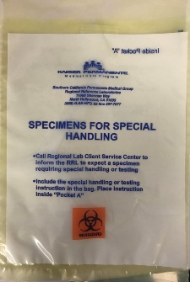    Biohazard specimen bag with other patient specimens, if any  Time / Temperature Sensitive Specimen or Special Handling  Yellow SPECIAL HANDLING BAG  Note:  If the specimen requires separate temperature or handling apart from any specimens that have been collected, indicate this on the SO printout.  Pack for transport / shipment separately in the yellow Special Handling bag and retain a copy on file. Refer to LabNet for collection information.

   | PACKING / TRANSPORT
STEP
1 | Start a MOB Downtime Transfer Log to send with specimens and affix additional HC downtime label on form.  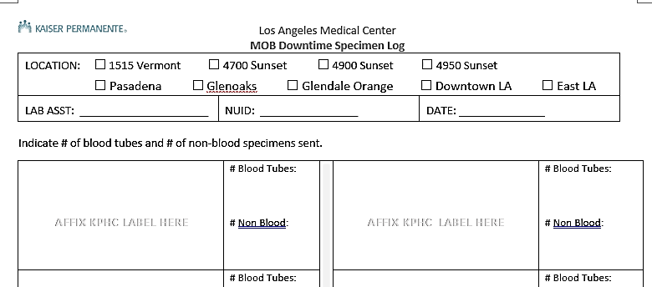  AFFIX LABEL HERE  SAMPLE
2 |   Evaluate each set of specimens to be sent and indicate the number of blood vs. non-blood specimen containers, labelling, stability requirements in preparing for transport.
3 | Document any specimens separated prior (i.e. STAT/Time sensitive) on the SO printout that will be sent to the Main Lab.
4 |   Print a copy of a SmartShip printout for each tote and indicate the total patient count per tote. 
5 |   Staple together the original copy of the MOB Downtime Transfer Log and the Smart Ship printout to go with the tote.    MOB Downtime  Log  Smart Ship
6 | Retain all downtime documents on site for 3 months (LAMC-PPP-0015)  
7 |   Stage the tote for outbound pickup by the courier.

 | RECOVERY
STEP | ACTION
1 |     Match the electronic order with the SO printout.  SO  or  Manual  Cerner  RMS  HealthConnect  v
2 | Log on to the Cerner and RMS systems.
3 | Accession the orders in RMS and complete the orders with one of the following:  If orders are…. Then use…  Laboratory and patient collect SO function  Clinic Collect OE function
4 | Print and validate that all the labels have been printed from Cerner and/or KRMS.  CERNER    KRMS
5 | Affix appropriate label on each specimen container.
6 | Perform Specimen Log-in in Cerner with pertinent collection information according to established protocol and reviewing the “Details”.    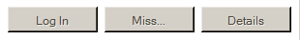
7 | Prepare specimens for transfer and send out according to procedure.

