Purpose | This procedure provides instructions for performing maintenance on bioMerieux Vidas 3.

Scope | This procedure is intended for Clinical Laboratory Scientist (CLS) and Medical Laboratory Technicians (MLT) who are trained and competent in operating bioMerieux Vidas 3.

Equipment | - bioMerieux Vidas 3

Material and supplies | - Dacron® Swabs  - Deproteinizing Detergent Solution (Alconox or Liquinox)  - 10% Bleach Solution  - Decontamination Wipes  - Powderless gloves

Safety | All laboratory employees are expected to maintain a safe working environment  and an injury-free workplace. Laboratory employees are responsible for their own safety, and the safety of others and adhering to all departmental and medical center safety policies and procedures.  - For standard precautions and safety practices in the laboratory; see LAMC-PPP-0123, specifically, but not limited to, equipment safety, proper body  mechanics, sharps exposure and proper use of personal protective  equipment (PPE).  - For Universal Body Substance precautions, see LAMC-PPP-0128, specifically, but not limited to, exposure to body fluids.  - For proper handwashing, see LAMC-PPP-0132, specifically, not limited to, proper handwashing.  - For proper infection control, see LAMC-PPP-0127, specifically, but not limited to, proper use of gloves.  - For proper handling of regular and infectious waste, see LAMC-PPP-0129, specifically, but not limited to, proper disposal of regular and biohazardous waste.  - For proper cleaning of work area, see LAMC-PPP-0130 – Cleaning Work Areas.  - For proper handling of chemicals and reagents, see the Chemical Hygiene Plan.  - For proper storage and disposal of chemical hazardous waste, see LAMC-PPP-0134.

Procedure | Monthly Maintenance  - Cleaning the SPR Blocks
 |  |  | Note: The SPR block cleaning procedure can be initiated from the SPR block cleaning area. It provides step-by-step instructions for cleaning all section SPR blocks.
 |  | 1 | Select [System] from the Navigation Toolbar.
 |  | 2 | Select Maintenance.
 |  | 3 | Select SPR block cleaning from the Maintenance Configuration Option List.
 |  | 4 | Select [Start] in the Action Bar. The SPR blocks are moved to the home position.
 |  |  | 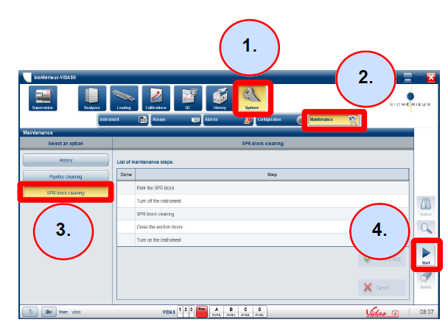
 |  | 5 | Turn OFF the instrument by pressing the power switch on the right side of the instrument. Wait until the instrument has completely turned off.
 |  | 6 | Select Validate step to confirm.  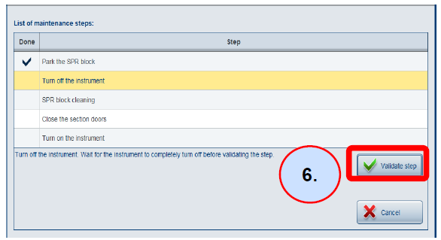
 |  | 7 | Open the section flap doors.  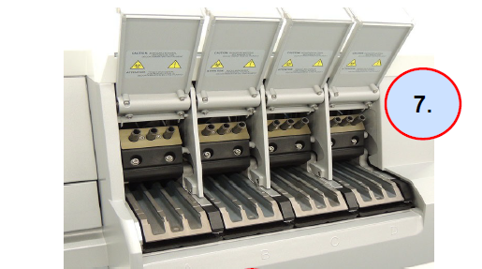
 |  | 8 | Flip the SPR block towards you and hold it in this position to easily access all surfaces of the block.
 |  | 9 | Clean all surfaces of the SPR block with a decontamination wipe.
 |  | 10 | When cleaning the rear surfaces of the SPR block, press each SPR liner to clean the bottom of the SPR liner.  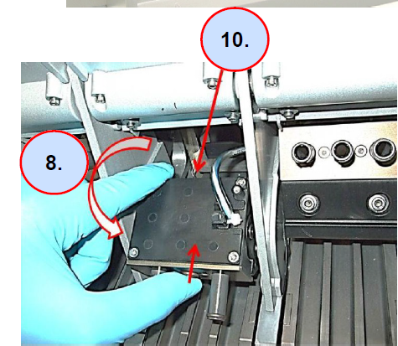
 |  | 11 | Using a Dacron® swab moistened with a detergent solution, carefully clean the interior of each SPR liner.  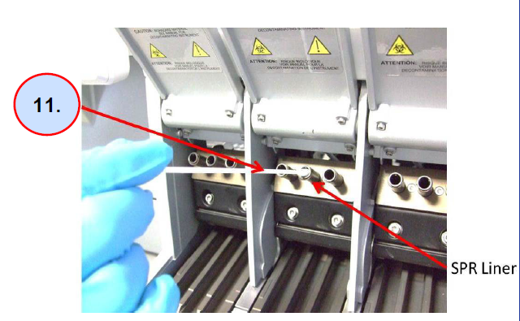
 |  | 12 | Using a Dacron® swab, clean the interior of each SPR liner with a 10% bleach solution. (0.5-0.6% active chlorine prepared with Demineralized Water)
 |  | 13 | Allow the bleach solution to react for 10 minutes.  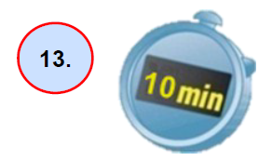
 |  | 14 | Using a Dacron® swab, clean the interior of each SPR liner with demineralized water.
 |  | 15 | On the VIDAS® 3 touchscreen, validate the completion of the SPR block cleaning.
 |  | 16 | Close the section flap doors.
 |  | 17 | Select Validate step to confirm.  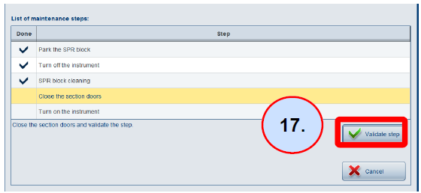
 |  | 18 | Turn ON the instrument and wait for the initialization process to complete (Global LED will blink red because specimen and disposable racks are always in error status after initialization.)
 |  | 19 | Remove and reinsert the racks to resolve the error status.
 |  | 20 | After initialization of the instrument, select Validate step.  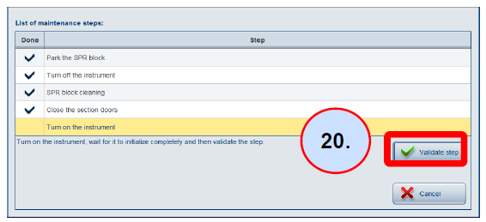
 |  | 21 | When the SPR block cleaning procedure is finished, select Completed to confirm.  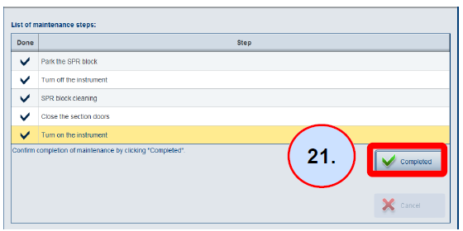
 |  | 22 | Document performance of maintenance on the maintenance log.

Controlled Documents | The following non-controlled documents support this procedure.
 |  | Document No. | Name of Documents
 |  | LAMC-PPP-0123 | Safety Practices
 |  | LAMC-PPP-0127 | Infection Control
 |  | LAMC-PPP-0128 | Universal Body Substance Precautions
 |  | LAMC-PPP-0129 | Handling of Regular and Infectious Waste
 |  | LAMC-PPP-0130 | Cleaning Work Areas
 |  | LAMC-PPP-0132 | Hand washing Policy
 |  | LAMC-PPP-0134 | Storage and disposal of Chemical Hazardous Waste

Non-Controlled Documents | The following controlled documents support this procedure.

Document No. | Name of Documents
 | bioMerieux Vidas 3 Operator’s Manual
 | Vidas 3 Basic Guide

Author(s) | Rosalie I. Fajardo, MS CLS(ASCP)

