AQUIOS CL FLOW CYTOMETER – OPERATION

Purpose:

- This procedure describes the steps involved in the sample processing of Aquios CL Flow Cytometer.

Principle:

Aquios CL Flow Cytometer is a closed system capable of combining automated sample preparation and lymphocyte subset analysis in a compact system. The instrument uses a 488nm solid state diode LASER as a light source for light scatter and fluorescence measurement. The instrument measures forward scatter (FS) and electronic volume (EV) for sizing, side scatter for granularity measurement, and four fluorescence parameters.

The sample is aspirated from an open tube or closed tube by cap-piercing probe. The specimen is dispensed into one or more wells of Deep Well Plate, fluorochrome conjugated antibodies are added and bind to molecules on the white cells that express specific antigens. After incubation, lysing reagents are added to lyse the red cells, and the prepared sample is aspirated from the plate using tubes that connects to the flow cell and events are analyzed for optical and electronic volume through hydrodynamic focusing.

The LASER light source (488nm) excites fluorescent dyes bound to cell passing through the beam, and as the dye emission is directed to the optical filters. The wavelengths of emitted dye are collected into the photomultiplier tubes which converts fluorescence intensities into proportional voltages.

The forward scatter (FS) detectors collects signals that bounces off the cells at angle less than 10 degrees for relative size measurements. The side scatter (SSC) detector collects light the bounces off the cell at an angle of 90 degrees for cell granularity. The syringe mechanism measures absolute counts by regulating the flow cell aspiration volume and sample metered delivery for accurate cell counting.

AQUIOS CL FLOW CYTOMETER – OPERATION AND SAMPLE PROCESSING, continued

Policy:

- Aquios Flow cytometer shall be used for flow cytometry data acquisition and analysis of peripheral blood for lymphocyte subset phenotyping.
- Wear suitable personal protective equipment when working with Aquios flow cytometer.
- QC procedure must be performed before loading and analyzing patient samples.

Work Place Safety:

All laboratory employees are expected to maintain a safe working environment and an injury-free workplace. Laboratory employees are responsible for their own safety, the safety of others and adhering to all departmental and medical center safety policies and procedures.
- For standard precautions and safety practices in the laboratory; see LAMC-PPP-0123, specifically, but not limited to, equipment safety, proper body mechanics, sharps exposure and proper use of personal protective equipment (PPE).
- For Universal Body Substance precautions, see LAMC-PPP-0128, specifically, but not limited to, exposure to body fluids.
- For proper handwashing, see LAMC-PPP-0132, specifically, but not limited to, proper handwashing.
- For proper infection control, see LAMC-PPP-0127, specifically, but not limited to, proper use of gloves.
- For proper handling of regular and infectious waste, see LAMC-PPP-0129, specifically, but not limited to proper disposal of regular and biohazardous waste.
- For proper cleaning of work area, see LAMC-PPP-0130 - Cleaning Work Areas.

Specimen Requirement

- Minimum volume of specimen collected in EDTA tube (13mm x 75) is 750 ul and Sarstedt 13mm x 90mm is 750ul. Specimen collected in other anticoagulants are not acceptable.
- Collect and transport specimen at room temperature between 18 degrees C to 26 degrees C or (64⁰ F to 78.8⁰ F). Specimen must be in the Laboratory within 48 hours after draw.
- Do not refrigerate specimen (refrigeration may cause aberrant results).
- Clotted, hemolyzed, and frozen specimen is not acceptable.
- Aliquoted and diluted specimens are not acceptable.

AQUIOS CL FLOW CYTOMETER – OPERATION AND SAMPLE PROCESSING, continued

Reagent, Materials, and Equipment:

Reagents:
- Aquios Lysing Reagent Kit, Beckman Coulter, PN B23535
- Aquios IsoFlow Sheath Fluid, Beckman Coulter, PN B25697
- Aquios Cleaning Agent, PN B25698
- Aquios Tetra-1 Panel, Beckman Coulter, PN B23533
- Aquios Immuno-Trol Cells, Beckman Coulter, PN B23535
- Aquios Immuno-Trol Low Cells, Beckman Coulter, PN B25700

Materials:
- Polyproplylene tubes 12X75mm.

Equipment:

- Aquios CL - flow cytometer

Procedure: | How create a test request:

Step | Action
1 | Select, 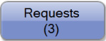 from the Main Screen
2 | Select . The Add Request Screen is shown below.  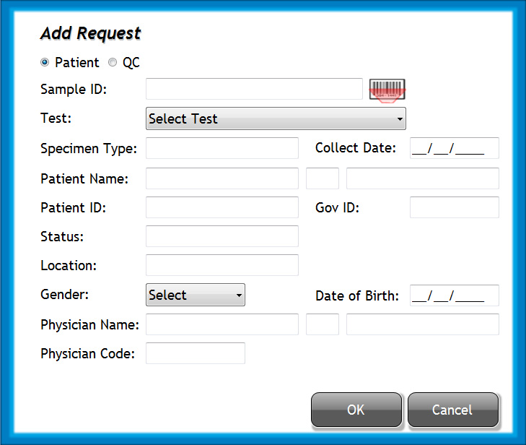

AQUIOS CL FLOW CYTOMETER – OPERATION AND SAMPLE PROCESSING, continued
3 | Ensure that Patient radio button is selected.
4 | Enter sample ID:  a. Select 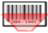next to the Sample ID field. The barcode reader next to the Single-tube Loader activates.  b. Scan the barcode on the specimen tube. If barcode reader deactivates, select again.  Manual Method:  a. Select and fill in the Sample ID field.
5 | Use the Test drop-down menu to select the desired test.
6 | Select 
7 | Enable LIS (Host). Test request can be received from LIS.
8 | Verify that all specimen tubes have pierceable cap, and bar code with unique label.
9 | Insert each specimen tube in to appropriate cassette:  - Firmly hold the cassette y the side and proceed to insert tube one tube at a time.  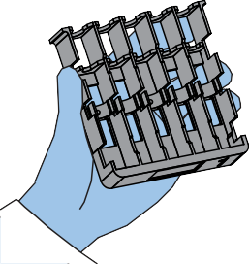

AQUIOS CL FLOW CYTOMETER – OPERATION AND SAMPLE PROCESSING, continued
Step | Action
10 | b. Hold the tube from the cap and insert the bottom part of the tube inside the lower part of the specimen cassette.  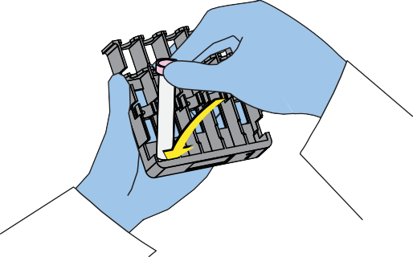  A symbol on the right side of the cassette indicates the correct orientation of the specimen tube in the cassette.  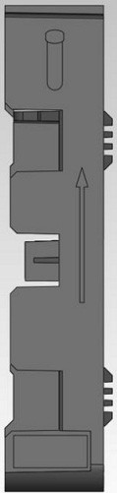  - Before securing the top part of the tube, align the barcode label so that it faces upward as the tube is fully secured into the cassette.  - Softly push the top part of the tube to lock into the cassette.  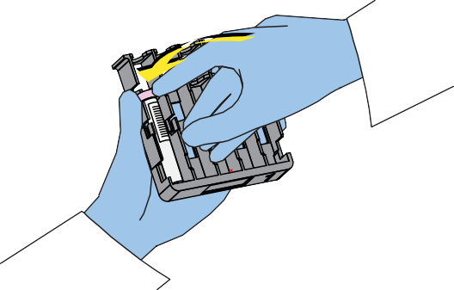 |  | Action

AQUIOS CL FLOW CYTOMETER – OPERATION AND SAMPLE PROCESSING, continued
Step | Action
10 | 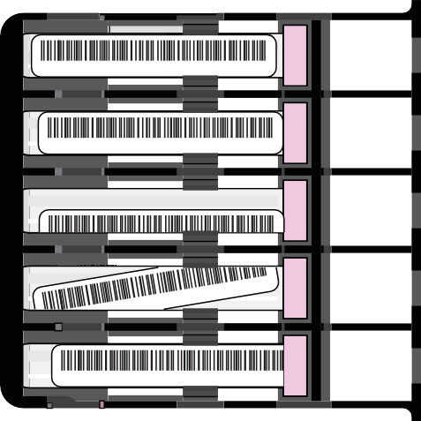  Verify that the barcode is properly positioned at the center of the tube.          Repeat until the all 5 tubes are loaded in the cassette.
11 | Load each cassette in the autoloader.  - Hold the cassette from the cap-pierce side and insert it horizontally at the top portion of the autoloader.  - Load up to eight casettes at a time in any desired order.
12 | Review all data plots and results.
13 | Transmit data to the Cerner.
14 | Remove any processed cassette from the autoloader.
15 | Remove the individual specimen tube from the cassette and store specimen in a test tube rack and discard after 7 days.

AQUIOS CL FLOW CYTOMETER – OPERATION AND SAMPLE PROCESSING, continued

How to review data generated by Aquios CL Cytometer
Step | Action
1 | 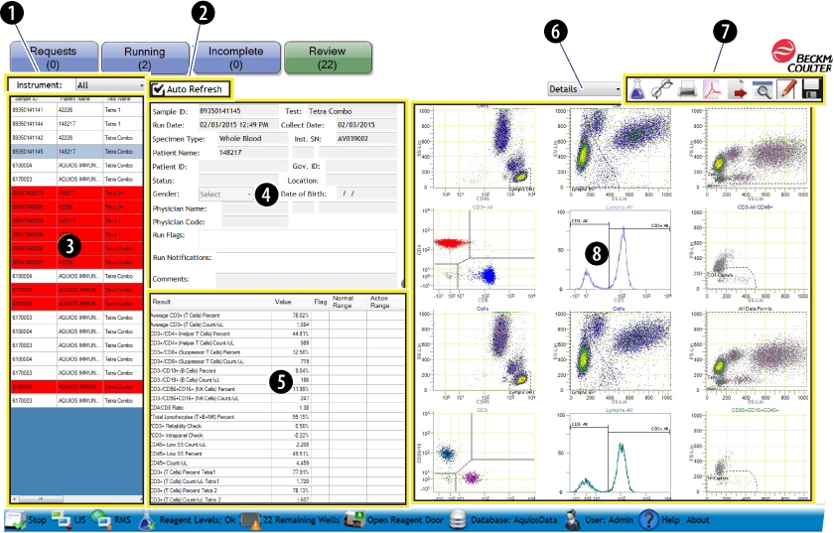  - Instrument Designation  - Auto Refresh  - Completed Run List  - Sample Identifiers and Run Information Area  - Result Table Area  - Graphic Options Selection (drop-down box)  - Action Toolbar  - Selected Graphic Display  The Figure above shows review screen for Aquios lymphocytes enumeration.  When a sample is selected for review, the default report selected appears for that sample. Select the Results, Histograms, or Dot Plots option from the drop-down box

AQUIOS CL FLOW CYTOMETER – OPERATION AND SAMPLE PROCESSING, continued
Step | Action
2 | Examine cell gate population:  Acceptable: Not Acceptable: (gate does not include all events)  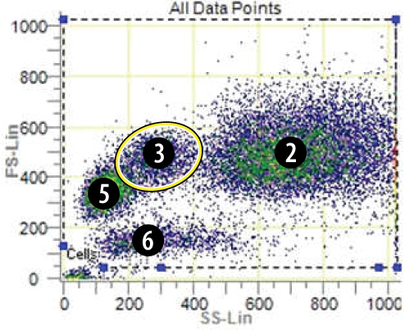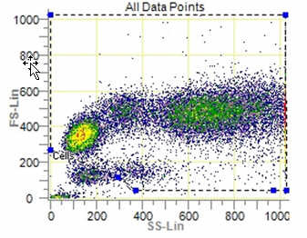
3 | Examine position of the CD45 gate:  Acceptable Not acceptable (gate includes portion of the monocytoid population)  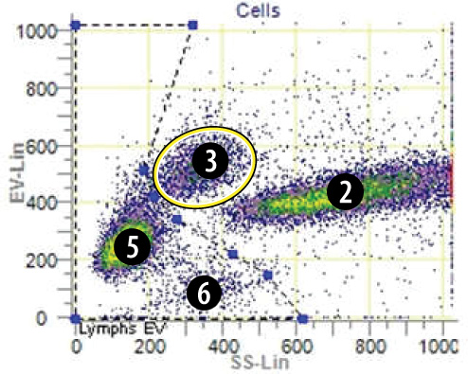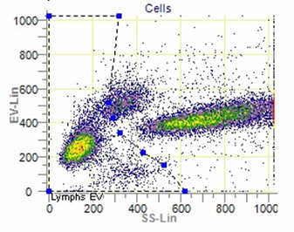
3 | Examine positions of the gated Lymphoid population:  Acceptable: Not Acceptable: (gate too wide) adjust gate on lymphoid population.  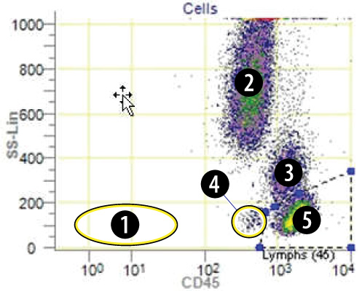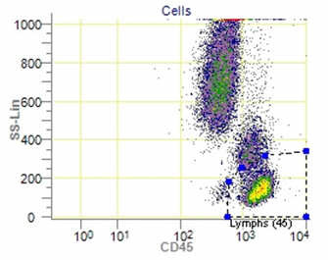

AQUIOS CL FLOW CYTOMETER – OPERATION AND SAMPLE PROCESSING, continued
Step | Action
4 | Examine position of the quadrant markers: CD4 and CD8:  Acceptable: Not Acceptable: quadrant markers is cutting CD4 and C8 events  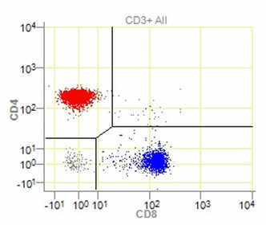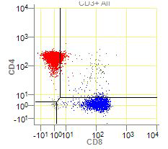
5 | Examine CD3 capture region (exclude lymphocytes with low FS and low SS expression)  Acceptable: Unacceptable: region is too wide encompassing CD3+ events.  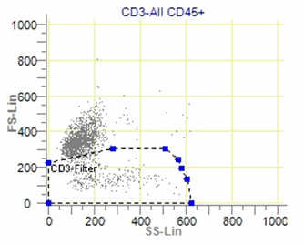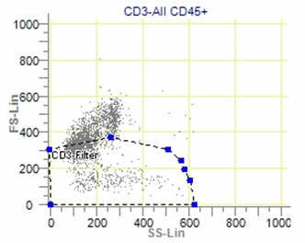
6 | Examine CD3 histogram:  Acceptable Not Acceptable: histogram marker cuts CD3+ population  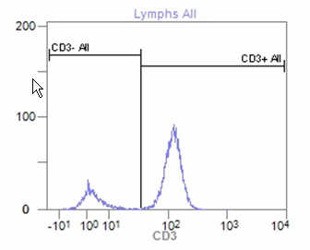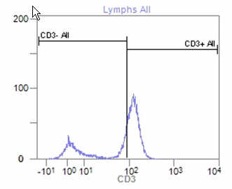

AQUIOS CL FLOW CYTOMETER – OPERATION AND SAMPLE PROCESSING, continued
Step | Action
7 | Examine CD45+ (All Data points)  Acceptable: Not Acceptable: majority of CD45 events are excluded.  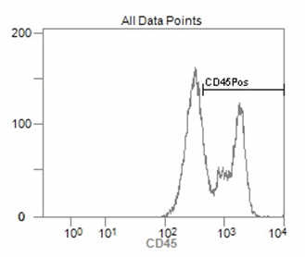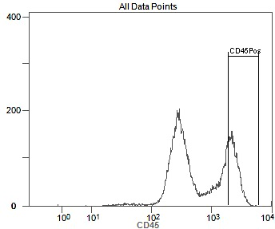
8 | Once all the gates and histograms are adjusted, select  to refresh the regions statistics.
9 | If one needs to modify gates and regions again, select  and then  to reject changes and repeat steps above.
10 | Select  to save changes to the file.
12 | After performing Daily QC on Immunotrol (LAMC-FORM-0155) and Immnunotrol Low (LAMC-FORM-0156) and all results are within limits, release results in Cerner.

Interpretation:

Flag | Definition | Recommended User Action
Insufficient Lysing | Too many red cells measured in the sample | Check lysing reagent, if not sufficient, change lyse reagent set
Underlysed | Red blood cells did not lyse due to nucleated red cells, protein concentration, or hemoglobinopathies. | Review lymphocyte gate.  If problem persist across different samples, call BCI representative.

AQUIOS CL FLOW CYTOMETER – OPERATION AND SAMPLE PROCESSING, continued

Underlysed specimen: check presence of underlysed RBC, see figure below:
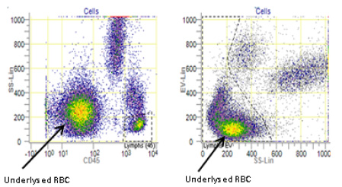

Underlysed Immunotrol Cells:

AQUIOS CL FLOW CYTOMETER – OPERATION AND SAMPLE PROCESSING, continued

Controlled Document:

- LAMC-FORM-0155 Aquios Immunotrol Daily Quality Control
- LAMC-FORM-0156 Aquios Immunotrol Low Daily Quality Control
- LAMC-PPP-0123- Safety Practices.
- LAMC-PPP-0128– Universal Body Substance Precautions (UBSP).
- LAMC-PPP-0132– Handwashing Policy.
- LAMC-PPP-0127– Infection Control.
- LAMC-PPP-0130– Cleaning Work Areas.
- LAMC-PPP-0129– Handling of Regular and Infectious Waste.

Uncontrolled Document:

Document | Description
PN B21896AB | Instruction For Use: Aquios Cytometer. Beckman Coulter Ireland Inc, April 2015. Lismeehan O’Callaghan’s Mills Co. Clare, Ireland

Self Assessment

- True or False: There is a symbol on the right side of the cassette indicates the correct orientation of the specimen tube in the cassette.
- True or False: Presence of huge population of cells on the left side of the WBC population may indicate underlysed red blood cells.
- True or False: Figure below shows an acceptable CD3 histogram:

Author:

Giovanni B. Garcia, MT(ASCP), CLS, MBA

