DAILY START-UP PROCEDURE FOR AQUIOS FLOW CYTOMETER

Purpose

- This procedure describes the steps involved in the daily start-up of Aquios flow cytometer.

Principle

The AQUIOS CL Flow Cytometer system is a cytometer capable of automated for hands-off processing of whole-blood samples from sample pipetting for reporting flow cytometric analysis of lymphocyte subsets. The Aquios CL Cytometer efficiently performs T-cell subset enumeration for diagnostic immune monitoring applications that use a no-wash sample preparation process.
The Aquios instrument uses hydrodynamic focusing to bring cells to the laser beams one cell at a time along the same path through a flow cell. Cross cylindrical lenses focus the laser beam as it reaches the sample. The focused laser beam illuminates one cell at a time. The first lens controls the width of the laser beam, and the other lens, height, and focused elliptical beam is directed on the sensing area of the flow cell.
As the cells moves through the sensing area of the flow cell, the elliptical beam illuminates the particles and the surface of cells stained with fluorescent dyes scatter the laser light and fluorescent dyes gives off emission after excitation by the laser beam.
The amount of laser light scattered at narrow angles to the axis of the laser beam is the forward scatter which is proportional to the size of the cell. The scattered light at 90 degrees (side scatter) corresponds to the granularity of the cell. In addition to the surface markers of cells emit fluorescent light (FL) at different angles the axis of the laser beam.
The cytometer has several sensors that generate voltage signal as each cell passes through the laser beam, and voltage pulse signal is directly related to the intensity of the light from each sensor. The Aquios cytometer’s electronic components amplify, condition, integrate, and analyze voltage pulse for software analysis of generated signal.

Policy

- Aquios Flow cytometer shall be used for flow cytometry data acquisition and analysis of peripheral blood for lymphocyte subset phenotyping.
- Wear suitable personal protective equipment when working with Aquios flow cytometer.

DAILY START-UP PROCEDURE FOR AQUIOS FLOW CYTOMETER, continued
Work Place Safety:

All laboratory employees are expected to maintain a safe working environment and an injury-free workplace. Laboratory employees are responsible for their own safety, the safety of others and adhering to all departmental and medical center safety policies and procedures.
- For standard precautions and safety practices in the laboratory; see LAMC-PPP-0123, specifically, but not limited to, equipment safety, proper body mechanics, sharps exposure and proper use of personal protective equipment (PPE).
- For Universal Body Substance precautions, see LAMC-PPP-0128, specifically, but not limited to, exposure to body fluids.
- For proper handwashing, see LAMC-PPP-0132, specifically, but not limited to, proper handwashing.
- For proper infection control, see LAMC-PPP-0127, specifically, but not limited to, proper use of gloves.
- For proper handling of regular and infectious waste, see LAMC-PPP-0129, specifically, but not limited to proper disposal of regular and biohazardous waste.
- For proper cleaning of work area, see LAMC-PPP-0130 - Cleaning Work Areas.

Specimen Requirement

- Not applicable for this procedure.

Reagent, Materials and Equipment

Reagents:
- Aquios Lysing Reagent Kit, Beckman Coulter, PN B23535
- Aquios IsoFlow Sheath Fluid, Beckman Coulter, PN B25697
- Aquios Cleaning Agent, PN B25698

Materials:
- Polyproplylene tubes 12X75mm.

Equipment:

- Aquios CL - flow cytometer

DAILY START-UP PROCEDURE FOR AQUIOS FLOW CYTOMETER, continued

Procedure | (Daily Start-Up)

Step | Action
1 | Turn on the Aquios Cytometer. The power switch is located on the left rear of the cytometer.  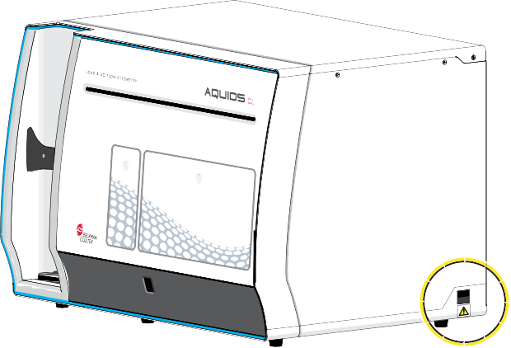

DAILY START-UP PROCEDURE FOR AQUIOS FLOW CYTOMETER, continued

2 | Power on the Supply cart. The switch is located on the right side of the cytometer’s cart.

DAILY START-UP PROCEDURE FOR AQUIOS FLOW CYTOMETER, continued

Step | Action
3 | Turn on the workstation:  The first screen you see is the Windows login screen. Login as either AqAdmin or AqUser.
4 | Double-click the AQUIOS icon from the desktop, the Login screen appears.  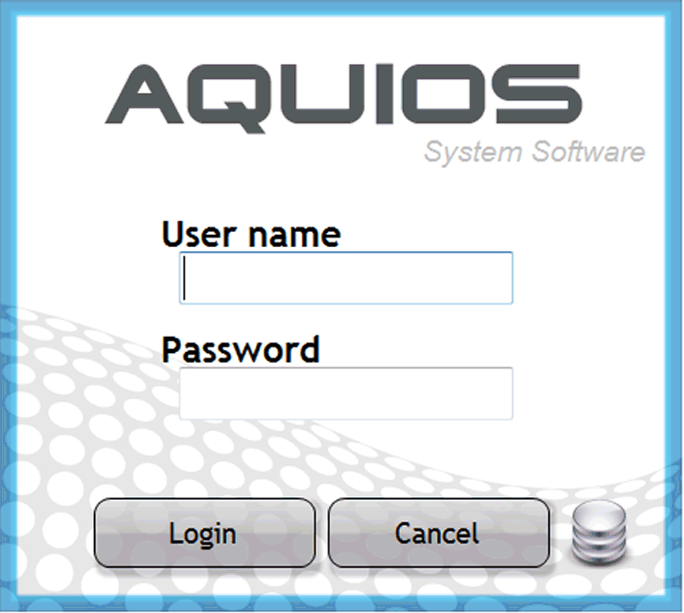  Enter Username and Password and select . The Main Screen appears.

DAILY START-UP PROCEDURE FOR AQUIOS FLOW CYTOMETER, continued

Step | Action
4 | Open the reagent door by pressing at the top, middle part of the door in one single, solid motion.  Important:  To remove the probability of instrument damage. Immediately prior to placing a new antibody vial in the carousel to put on board the system, replace the solid, non-pierceable, monoclonal antibody shipping caps with the pierceable caps provided in the  reagent packaging.

DAILY START-UP PROCEDURE FOR AQUIOS FLOW CYTOMETER, continued

Step | Action
5 | Load the AQUIOS monoclonal antibody reagents that are appropriate for the application being used into the carousel and onboard the cytometer. Then add 2 mL of AQUIOS Sodium Hypochlorite Solution to a clean 12 x 75 mm tube and place in the  designated position of the plate holder.  Important:  The Bleach Cycle, if needed, can be run during the day which is why the AQUIOS Sodium Hypochlorite reagent needs to be present while the system is running.

DAILY START-UP PROCEDURE FOR AQUIOS FLOW CYTOMETER, continued

Step | Action
6 | Before loading the Aquios Lysing Agent, remove the caps and insert the application specific reagents with labels facing outward.

DAILY START-UP PROCEDURE FOR AQUIOS FLOW CYTOMETER, continued

Step | Action
7 | Load the 96-deep-well plate. Ensure well A1 of the plate is next to the A1 on the plate holder and the bar code label is facing the front.  A1  Important:  To remove probability of probe damage the well plate must be positioned in the plate platform. Ensure that plate is in the locked position on edges of the plate platform.

DAILY START-UP PROCEDURE FOR AQUIOS FLOW CYTOMETER, continued
Step | Action
8 | Close the Aquios instrument reagent door, and to engage the latch, press the top center firmly.  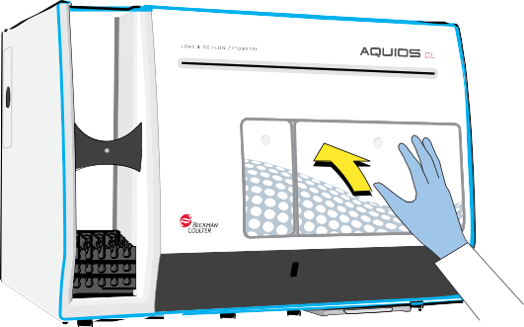
9 | Select  from the Status bar and the following Warning appears.  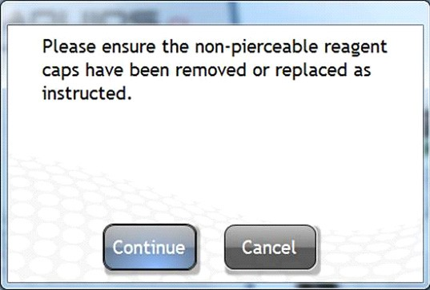  Note: If it has been <24 hours since the instrument was started, selecting initiates a quick Startup rather than a full Startup. This quick Startup primes and prepares the system for operation. This only occurs if the system was previously on, and the software had been exited, but the system was not shut down.  Note: When Start is selected, if any cassettes are in the Autoloader, they are ejected and will not be run.

DAILY START-UP PROCEDURE FOR AQUIOS FLOW CYTOMETER, continued
Step | Action
10 | Select “Continue” and the START cycle runs. When it is complete, the reagents and plate are scanned and the Reagents Levels dialog is displayed.
11 | Verify the levels of the onboard reagents and, if needed, load new reagents.

Interpretation

Not Applicable for this procedure.

Controlled Document

- Fill-out Maintenance Log and QC Log Form.
- LAMC-PPP-0123- Safety Practices.
- LAMC-PPP-0128– Universal Body Substance Precautions (UBSP).
- LAMC-PPP-0132– Handwashing Policy.
- LAMC-PPP-0127– Infection Control.
- LAMC-PPP-0130– Cleaning Work Areas.
- LAMC-PPP-0129– Handling of Regular and Infectious Waste.

DAILY START-UP PROCEDURE FOR AQUIOS FLOW CYTOMETER, continued

Uncontrolled Document

Document | Description
PN B21896AB | Instruction For Use: Aquios Cytometer. Beckman Coulter Ireland Inc, April 2015. Lismeehan O’Callaghan’s Mills Co. Clare, Ireland

Self Assessment
- True or False: Before loading the Aquios Lysing Agent, remove the caps with labels facing outward.

Author:

Giovanni B. Garcia, MT(ASCP), CLS, MBA

