AQUIOS FLOW CYTOMETER – PREVENTIVE MAINTENANCE

Purpose

- This procedure describes the steps involved in the Preventive Maintenance of Aquios flow cytometer.

Principle

Preventive maintenance of Aquios CL Flow Cytometer is performed to ensure that the instrument performs as specified. The maintenance menu consists of easy user interface using instrument Drop-down method to access cleaning of flow cell from blockages, perform cleaning cycle with Aquios Sodium Hypochlorite Solution and Gravimetrics to verify the syringe pipetting accuracy. Aquios Maintenance menu can record user, color compensation, laser settings, voltages, system crash, maintenance, routine task reagents and potential error.

Policy

- Wear suitable personal protective equipment when working with Aquios flow cytometer.
- Risk of personal injury if instrument cover is removed or a door is left open due to
possible exposure to high voltages, laser radiation, and/or moving parts. Never
operate the instrument without a cover or with a door opened.
- Perform Extended Shutdown if instrument is not used for more than seven days.
- Risk of personal injury from radiation exposure. Never remove the shield
surrounding a laser. Never remove covers.

AQUIOS FLOW CYTOMETER – PREVENTIVE MAINTENANCE, continued

Work Place Safety:

All laboratory employees are expected to maintain a safe working environment and an injury-free workplace. Laboratory employees are responsible for their own safety, the safety of others and adhering to all departmental and medical center safety policies and procedures.
- For standard precautions and safety practices in the laboratory; see LAMC-PPP-0123, specifically, but not limited to, equipment safety, proper body mechanics, sharps exposure and proper use of personal protective equipment (PPE).
- For Universal Body Substance precautions, see LAMC-PPP-0128, specifically, but not limited to, exposure to body fluids.
- For proper handwashing, see LAMC-PPP-0132, specifically, but not limited to, proper handwashing.
- For proper infection control, see LAMC-PPP-0127, specifically, but not limited to, proper use of gloves.
- For proper handling of regular and infectious waste, see LAMC-PPP-0129, specifically, but not limited to proper disposal of regular and biohazardous waste.
- For proper cleaning of work area, see LAMC-PPP-0130 - Cleaning Work Areas.

Specimen Requirement

- Not applicable for this procedure.

Reagent, Materials and Equipment

Reagents:
- Aquios Lysing Reagent Kit, Beckman Coulter, PN B23535
- Aquios IsoFlow Sheath Fluid, Beckman Coulter, PN B25697
- Aquios Cleaning Agent, PN B25698

Materials:
- Polyproplylene tubes 12X75mm.
- 40 tube holder
- Empty Gravimetrics bottle
- 16 each, 12 x 55mm polypropylene test tubes
- Analytical laboratory scale
- Deionized water
Equipment:
- Aquios CL - flow cytometer

AQUIOS FLOW CYTOMETER – PREVENTIVE MAINTENANCE, continued

Maintenance Screen: The Maintenance screen contains and  to trigger cleaning cycles and to trigger the Gravimetrics check and Diagnostics (service only) functions. The Maintenance log displays the routine maintenance performed by the user and the system events, warnings and error messages.

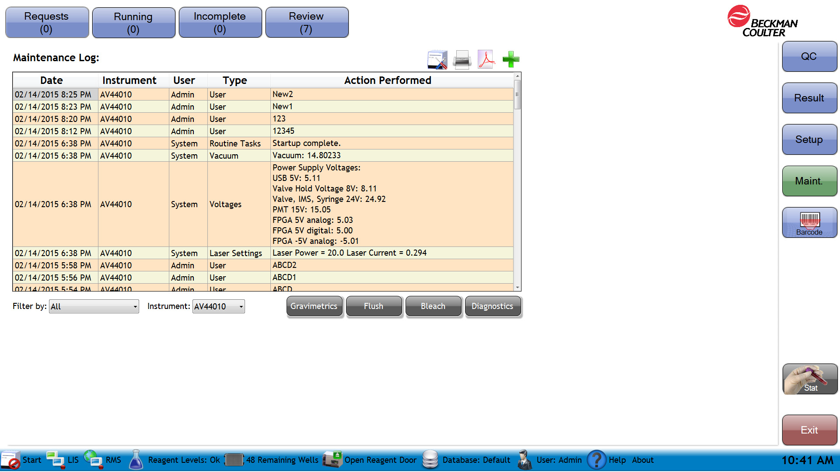

Figure 1: Aquios Maintenance Screen

AQUIOS FLOW CYTOMETER – PREVENTIVE MAINTENANCE, continued

How to Enter Maintenance User Log Entry

Step | Action
1 | Select 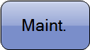 as shown in Figure 1
2 | Select  the maintenance Add icon, and the maintenance Add Entry window appears.  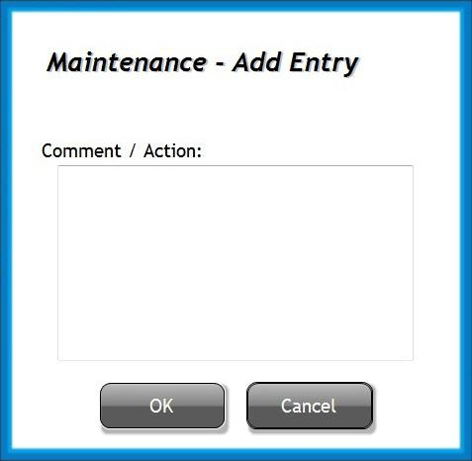  Enter comment/action
3 | Select .  NOTE System actions, warnings, and errors are automatically entered in the Maintenance Log by the software.

AQUIOS FLOW CYTOMETER – PREVENTIVE MAINTENANCE, continued
How to Run Flush Cycle:

Flush Cycle is used to empty fluid from the flow cell, then refills the same locations, running sheath fluid and cleaning agent at a high rate through the flow cell. It is useful for clearing blockages from the flow cell. Wait until the system completes analysis of all running samples in progress before selecting Flush.

Step | Action
1 | Allow all samples currently being analyzed to complete before performing a flush cycle.  NOTE If samples are currently being analyzed, a system message appears, stating Unable to perform Flush. The system is processing samples.
2 | Select . The message Are you sure you want to Flush the instrument? is displayed.  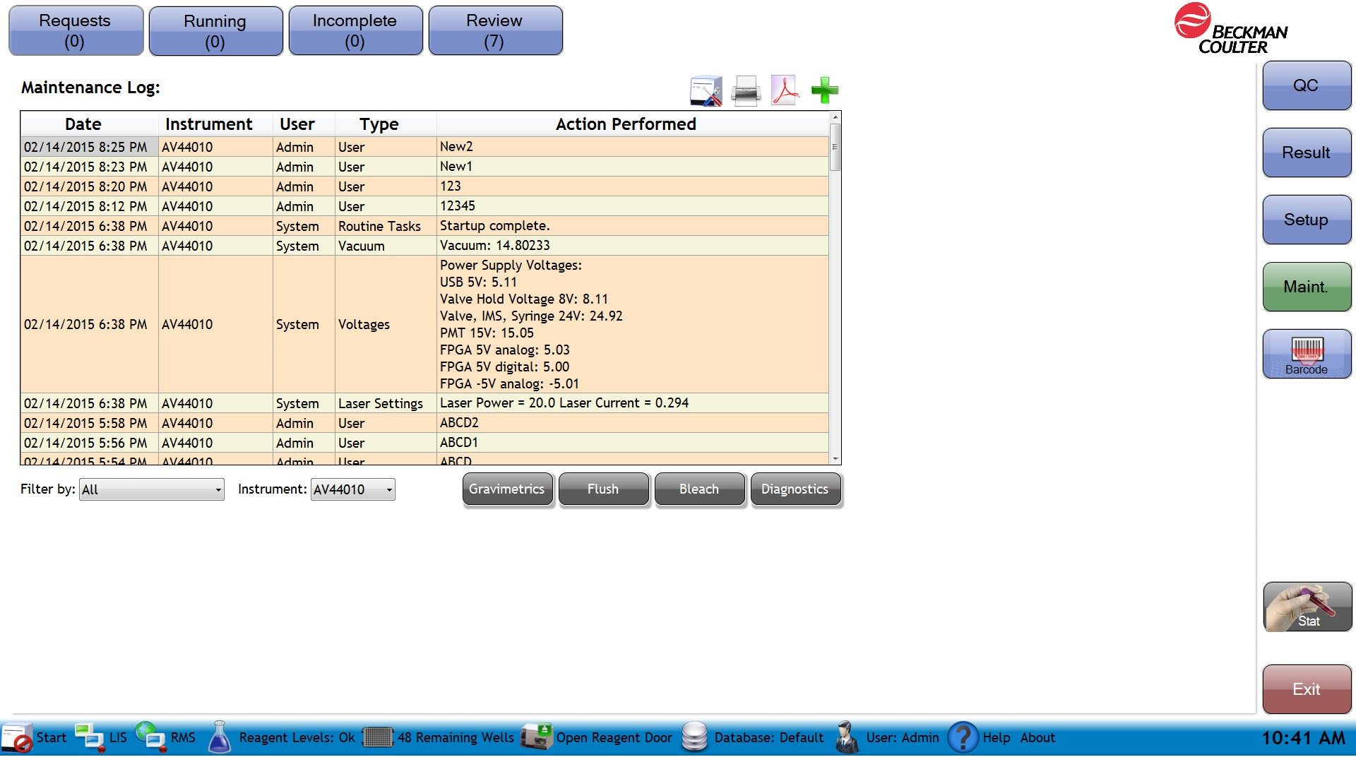
3 | Select. The message The system is Flushing please wait is displayed.
4 | The message Flush complete is displayed. Select . The Flush cycle is logged in the Maintenance Log.

AQUIOS FLOW CYTOMETER – PREVENTIVE MAINTENANCE, continued
How to run the Bleach Cycle:


Use to perform a cleaning cycle with AQUIOS Sodium Hypochlorite Solution. Do this only after the system completes analysis of all running samples in progress. Table below provides information on when a bleach cycle is required.

IMPORTANT Prior to starting a Bleach Cycle, ensure that a tube of AQUIOS Sodium Hypochlorite in the holder.

Step | Action
1 | Allow all samples currently being analyzed to finish before performing a bleach cycle.  NOTE If samples are currently being analyzed, a system message appears, stating You cannot perform a Bleach while the system is processing samples.
2 | Select icon.
3 | Select . Are you sure you want to Bleach the instrument? appears.
4 | Select  . The system is bleaching please wait appears. Bleaching complete then appears. The Bleach cycle is logged in the Maintenance log.
5 | Select .

AQUIOS FLOW CYTOMETER – PREVENTIVE MAINTENANCE, continued
How to perform Gravimetrics: Perform Gravimetric every six months to verify syringe pipetting accuracy.
NOTE: Ensure that the Sample Prep Probe indicator light is green before performing this test.
Step | Action
1 | Select on the right side of the main screen.
2 | Select from the Maintenance Screen, a message will appear The software will need to be restarted once the Gravimetrics screen is available. Are you sure you want to continue Gravimetrics? Select Yes or No.  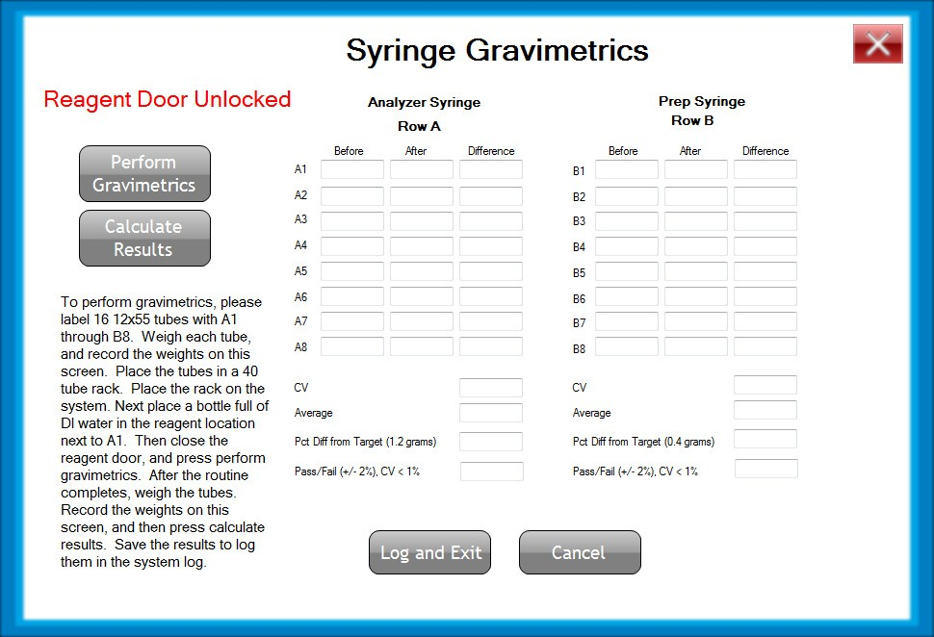
3 | Obtain and label 16 12x55 tubes with A1-A8, B1-B8 with a permanent marker, for placement in the 40-tube holder.
4 | Measure the weight of the empty A-1 tube.

AQUIOS FLOW CYTOMETER – PREVENTIVE MAINTENANCE, continued
Step | Action
5 | Record the weight of the empty A-1 tube on the Syringe Gravimetrics screen under the Before column next to the respective tube number.
6 | Repeat steps 4-5 for each labeled tube until you have completed all the A tubes and the B tubes required for the procedure.
7 | Open the reagent door. If there is a 96 well plate in place, remove the plate and insert the 40-tube holder plate. Remove and cap any reagents that may be on the system.
8 | Fill an empty Gravimetrics bottle with DI water and place the bottle in the reagent location next to A1 as indicated on the plate.  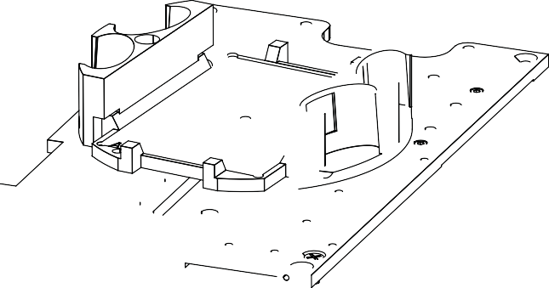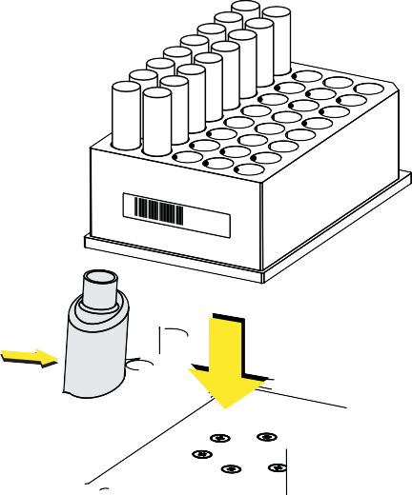

AQUIOS FLOW CYTOMETER – PREVENTIVE MAINTENANCE, continued
Step | Action
9 | Place the previously weighed tubes in a 40-tube holder on the plate loader inside the instrument and close the reagent door, ensuring to press the top center firmly so that the latch engages.  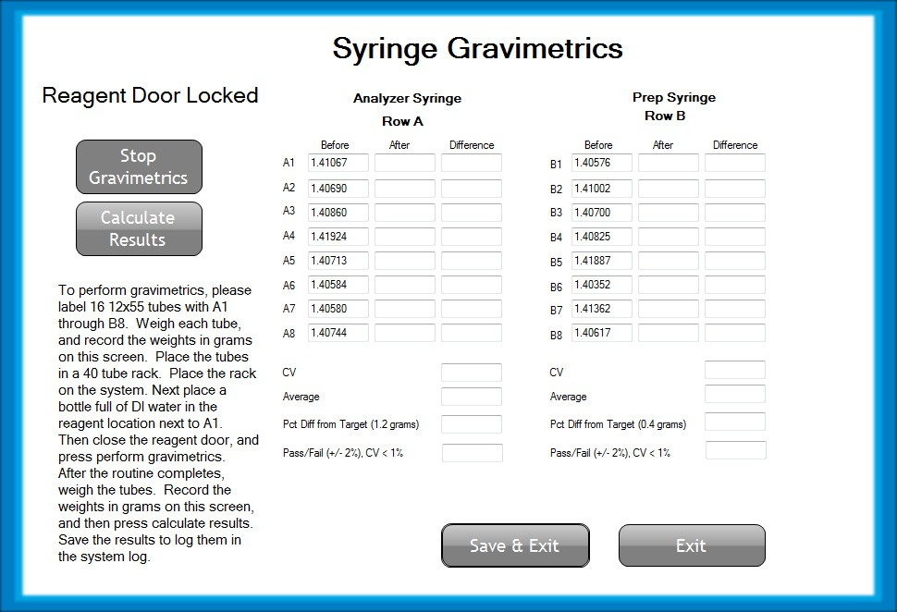
10 | Select 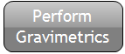 .  The system performs the gravimetric cycle, aspirating and dispensing the DI water to the relevant tubes.
11 | When the cycle is complete, the system notifies with the following message: Gravimetrics complete. Please weigh for after values. Record the values and calculate results. Select .  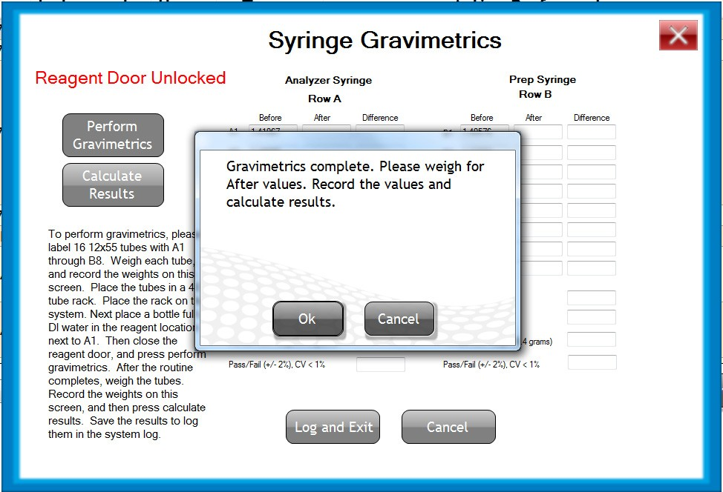

AQUIOS FLOW CYTOMETER – PREVENTIVE MAINTENANCE, continued
Step | Action
12 | Open the reagent door by pressing the top middle part of the door in one single, solid motion. and remove the 40-tube rack and the Gravimetrics bottle with DI water from the system.
13 | Closer the reagent door.
14 | Remove the tube labeled A-1 and weigh the tube.
15 | Record the weight of tube A-1 now containing DI water on the Syringe Gravimetrics screen in the After column next to the respective tube number.  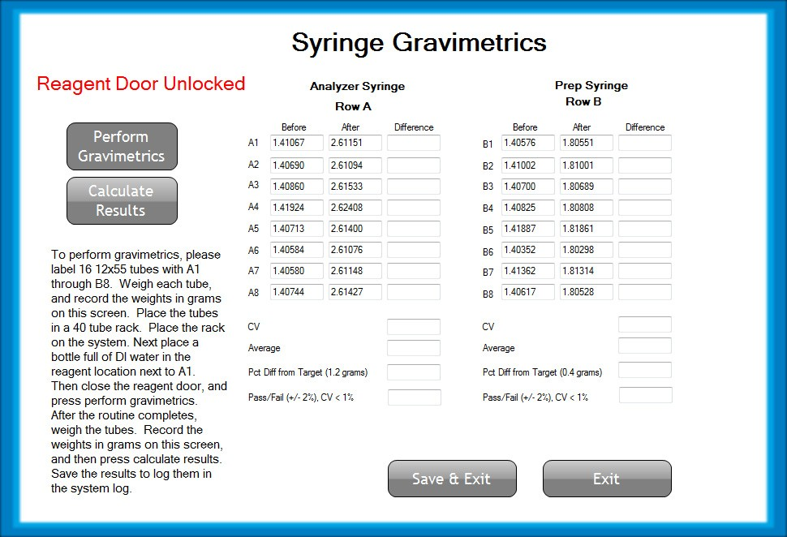
16 | Repeat steps 14 and 15 for each labeled tube until you have completed all the A tubes and the B tubes in the 40 tube rack.
17 | Select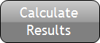 , and the system calculates the results and reports either pass or fail.

AQUIOS FLOW CYTOMETER – PREVENTIVE MAINTENANCE, continued
Step | Action
18 | If the results fail, repeat the Gravimetrics test. If the problem persists, contact your Beckman  Coulter Representative. If the results have passed the criteria, select  to save the results to the system maintenance log.
19 | The system will then exit the software.
20 | Select the AQUIOS icon from the desktop to relaunch the software and Login.
21 | Select to have the system perform a quick startup.
22 | Select to review the maintenance log for the system. The results for the gravimetrics appears in the maintenance log as shown below.  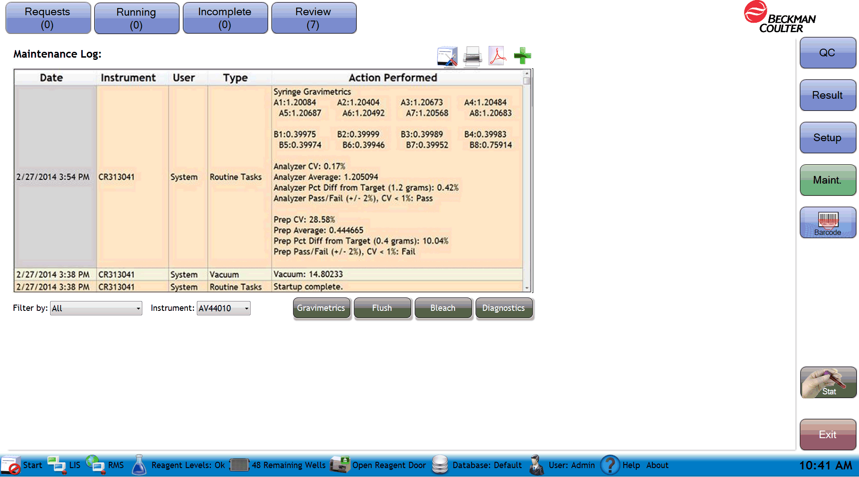

AQUIOS FLOW CYTOMETER – PREVENTIVE MAINTENANCE, continued

Controlled Document

- LAMC-PPP-0157 – Aquios Daily PM and QC
- LAMC-PPP- 0109 – Outlier Action Log
- LAMC-PPP-0123- Safety Practices.
- LAMC-PPP-0128– Universal Body Substance Precautions (UBSP).
- LAMC-PPP-0132– Handwashing Policy.
- LAMC-PPP-0127– Infection Control.
- LAMC-PPP-0130– Cleaning Work Areas.
- LAMC-PPP-0129– Handling of Regular and Infectious Waste.

Uncontrolled Document

Document | Description
PN B21896AB | Instruction For Use: Aquios Cytometer. Beckman Coulter Ireland Inc, April 2015. Lismeehan O’Callaghan’s Mills Co. Clare, Ireland

Self Assessment

Author:

Giovanni B. Garcia, MT(ASCP), CLS, MBA

