Purpose | The purpose is to provide complete instructions for India ink preparation. India detects presence of Cryptococcus neoformans (encapsulated yeast). The capsules surrounding the yeast are clearly visible in the India ink preparations.

Workplace Safety | All laboratory employees are expected to maintain a safe working environment and an injury-free workplace. Laboratory employees are responsible for their own safety, the safety of others and adhering to all departmental and medical center safety policies and procedures.  - For standard precautions and safety practices in the laboratory; see Safety Practices, specifically, but not limited to, equipment safety, proper body mechanics, sharps exposure and proper use of personal protective equipment (PPE).  - For Universal Body Substance precautions, see Universal Body Substance Precautions, specifically, but not limited to, exposure to body fluids.  - For proper hand-washing, see Hand washing Policy, specifically, not limited to, proper hand-washing.  - For proper infection control, see Infection Control, specifically, but not limited to, proper use of gloves.  - For proper handling of regular and infectious waste, see Handling of Regular and Infectious Waste, specifically, but not limited to, proper disposal of regular and biohazardous waste.  - For proper cleaning of work area, see Cleaning Work Areas.  - For proper handling of chemicals and reagents, see the Chemical Hygiene Plan.  - For proper storage and disposal of chemical hazardous waste, see Storage & Disposal of Chemical Hazardous Waste.  All laboratory employees are expected to maintain a safe working environment and an injury-free workplace. Laboratory employees are responsible for their own safety, the safety of others and adhering to all departmental and medical center safety policies and procedures.

Reagents and supplies | See below the list of reagents and supplies required.  Micrsocope slides  Coverslips  Cotton swabs  Pipettes  India ink Control kit (positive and negative quality control)  Higgins Waterproof India Ink (drawing ink), Pelikan Drawing Ink, No 17 (black) or comparable
Specimen Stability | 24 hours from time of collection – ambient temperature

Procedure | CSF, sputum, other excudates and tissue are suitable specimens for India ink preparations. Follow the directions outlined below to make an India ink preparation.

Step | Action
A | Verify that controls have been run on the day of testing. If not run controls prior to reporting patients.  Note: You can run additional control with each sample if desired to aid test interpretation if desired.
A | Mix a small amount of specimen with a small drop of India ink on a clean slide.
B | Cover with 22x40 mm glass coverslip
C | The preparation should be thin. If necessary apply gentle pressure to obtain a thin slide.
D | Scan under low power, using reduced light.
E | Switch to high power to examine for presence of encapsulated yeast cells. The mucoid capsules appear as a clear halo that surrounds the yeast cell or lies between the cell wall and the surrounding black mass of India Ink particles. Capsules may be broad or narrow. The yeast cells my be oval, round or elongated. Buds may be absent, single or rarely multiple. The buds may be detached from the mother cell, but enclosed in a common capsule.

Resulting and Interpretation | Step Action  1 Report results in Cerner using the Microbiology Result Entry app   2 Enter “FIN” in entry field for final reporting, a Final Report window will pop out.  3a For positive encapsulated yeast cell(s) seen, enter result codes on cells provided: EYS. These codes will create chart result as “ Encapsulated yeast seen.” 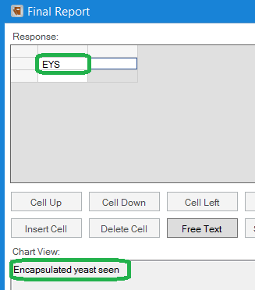

Resulting and Interpretation, continued | 3b For negative encapsulated yeast cell(s) seen, enter result codes on cells provided: NEYS. These codes will create chart result as “ No Encapsulated yeast seen” 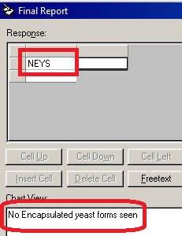  4 Click Verify to report desired results. Note: You can Press F2 to see Result Responses(Result Codes)during Final Reporting

Controlled Documents | Document Number Document Name  LAMC-PPP-0123 Safety Practices  LAMC-PPP-0127 Infection Control  LAMC-PPP-0128 Universal Body Substance Precaution  LAMC-PPP-0129 Handling of Regular and Infectious Waste  LAMC-PPP-0130 Cleaning Work Areas  LAMC-PPP-0132 Hand-washing Policy  LAMC-PPP-0134 Storage and Disposal of Chemical Hazardous Waste  See below the list of controlled documents
Author(s) | Alvin Castillo

