9/16/2020
URINE CULTURE (1:100) – that needs to be plated due to low volume urine(< 3mL)
- CERNER will now print 2 accession labels that will display 1:100 and 1:1000 as shown below.
- Each label will be used to identify the dilution on 2 required separate biplates.
BIPLATE #1 – 1ST LABEL | 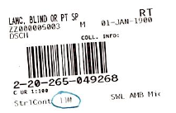 | - ml/ 10uL loop
BIPLATE #2 – 2ND LABEL | 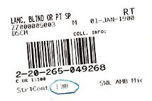 | 0.001 ml/ 1uL loop

