TC52 Job AID
Step 1  Open Application  - Double Tap Medicopia Icon | 
Step 2  Login with credentials  - Enter username  - Enter password  - Click “Login” | 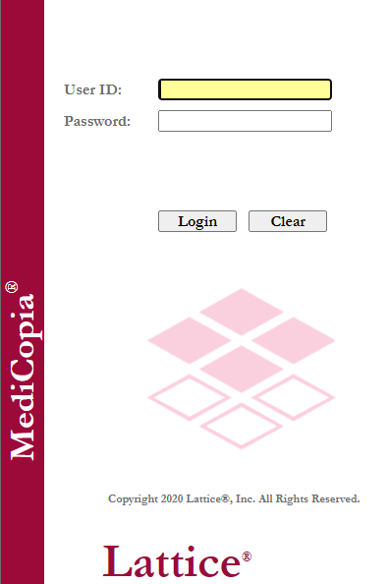
STep 3  Link Printer  - Scan printer barcode  - Click “OK” | 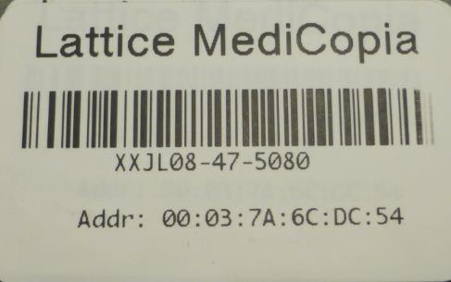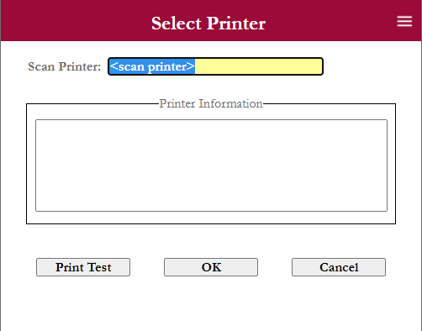
STep 4  Select facility  If user is active in more than 1 facility  - Tap on current facility  (handheld will default to last facility) | 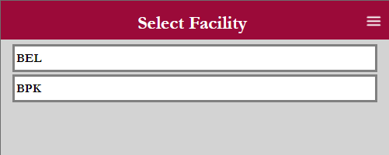
STep 5  Select unit(S)  - Tap on Individuals units (or)  - Tap on Hospital Abbreviation to select all units  - Click on “Get Orders” | 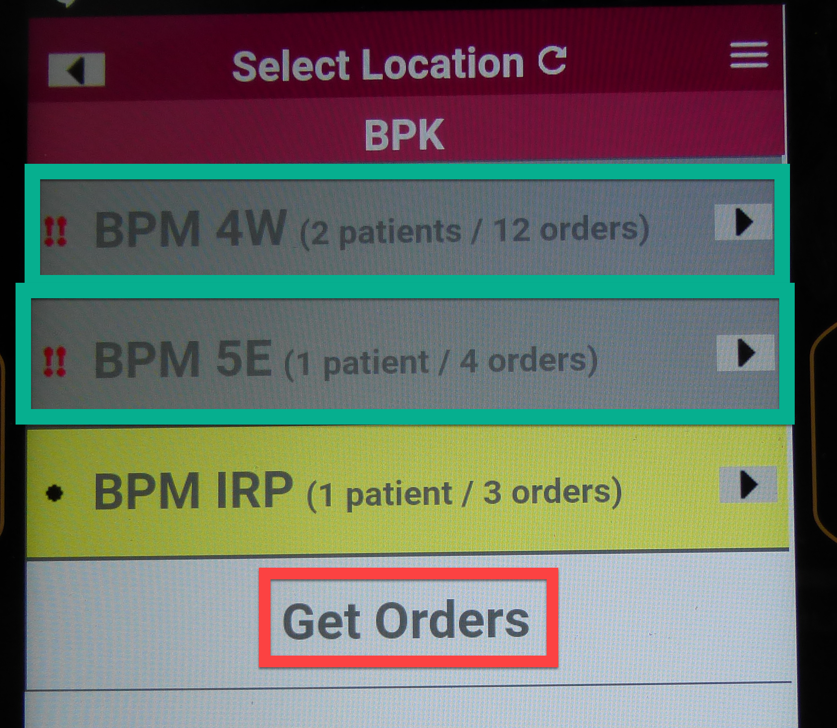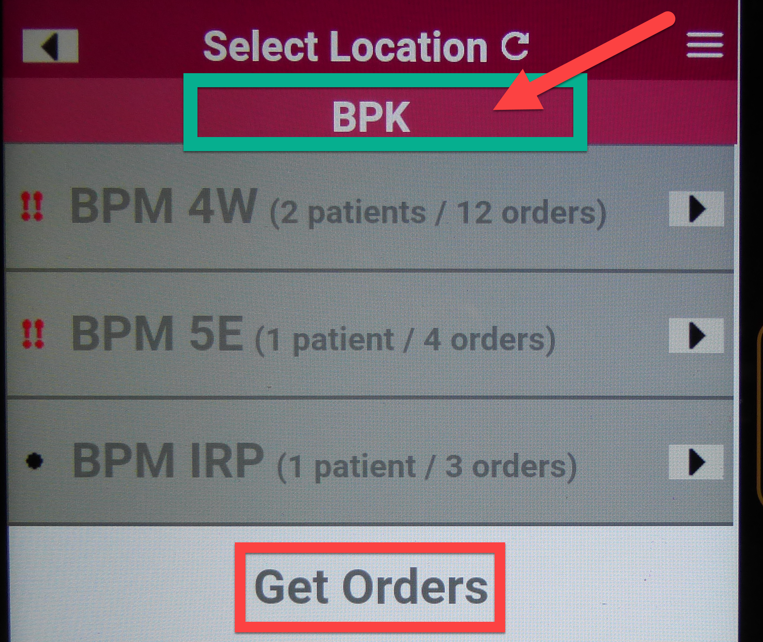
STep 6  SELECT PATIENT IN UNIT  - Click on patient to view list of orders  - Click on “Play” icon to validate patient | 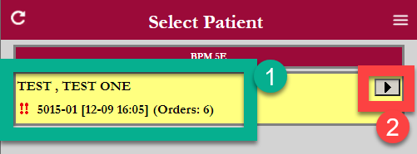  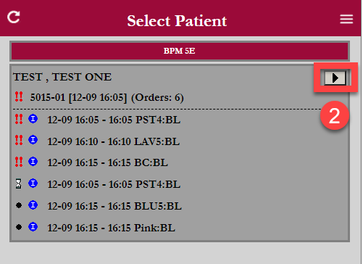
STep 7  Validate patient  - Scan Armband FIN  - Click “Patient Identify Confirmed” box | 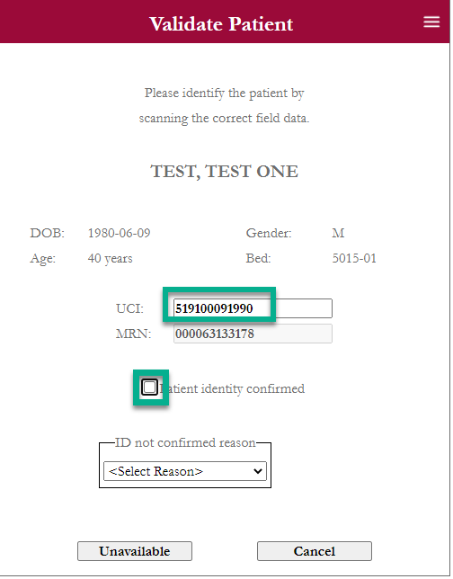
STep 8  Select orders which were collected  - Tap orders collected | 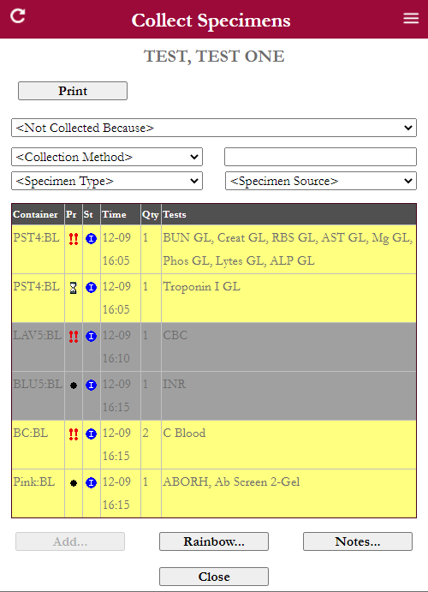
STep 9  select collection method and specimen source  - Select Method  - Select Source  Follow local protocol for documentation of specimen source. | 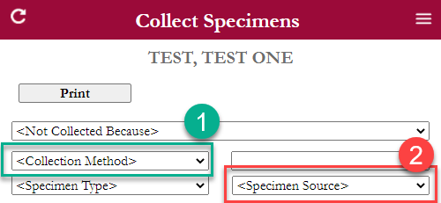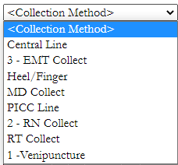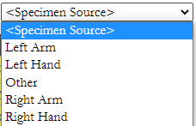
STep 10  Print labels  - Click Print  - Place label on specimen | 