TC52 patient(UNIT) or order View screen
STep 1  Select unit(S)  - Tap on Individuals units  - Tap on Hospital Abbreviation to select all units  - Click on “Get Orders” | 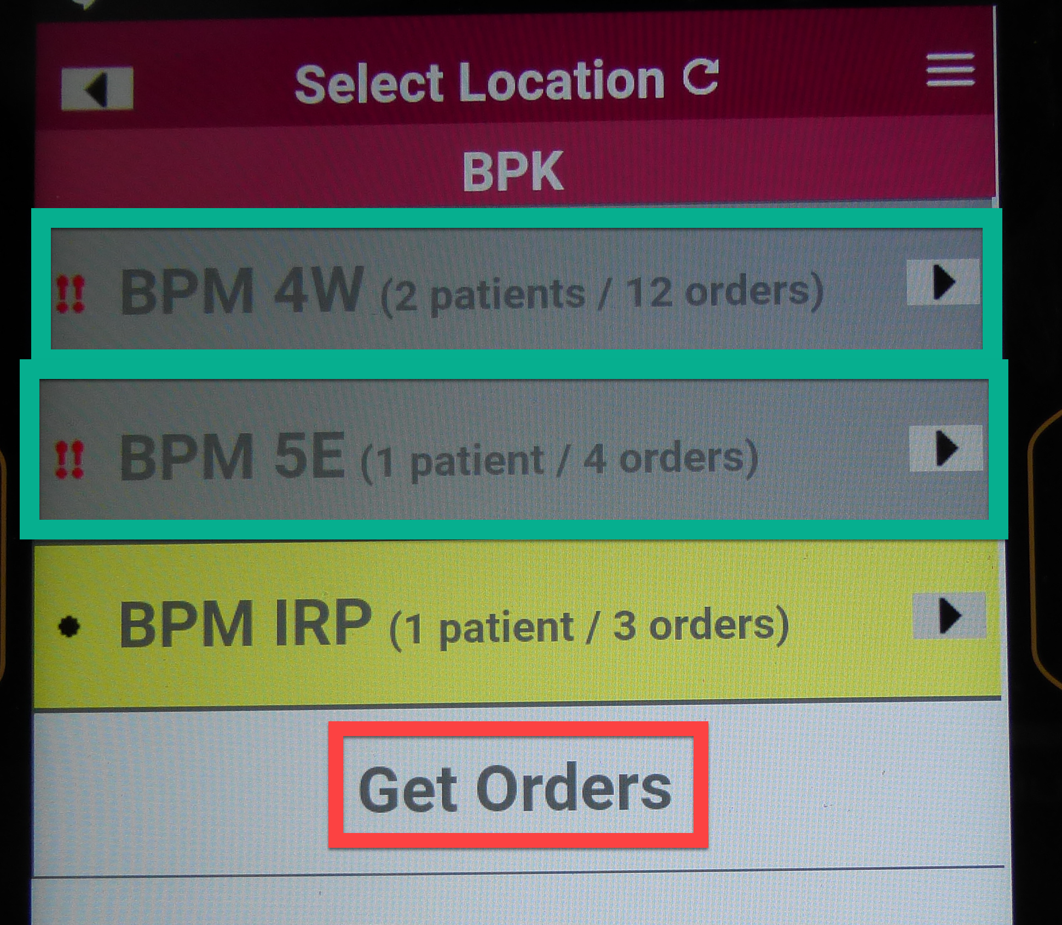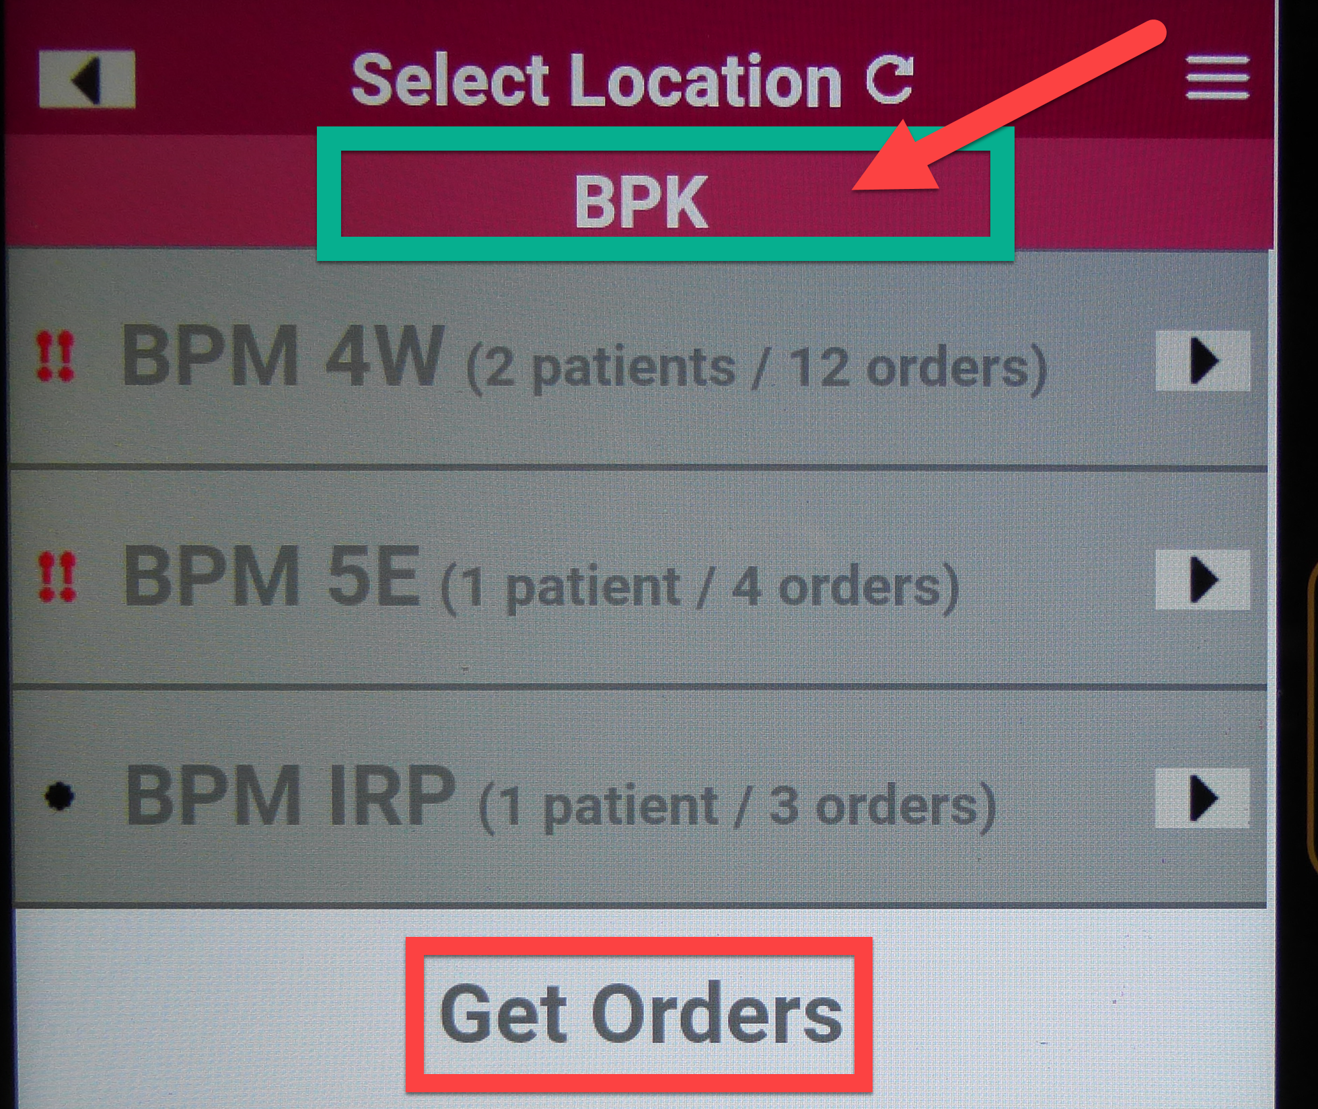
STep 2  Unit View by Patient  Orders will display by unit and in the order by room number(NOT BY ORDER TIME)  Steps to change to Order display  - To toggle to order view by time  - Tap on Hamburger Icon  - Tap on “View Orders” | 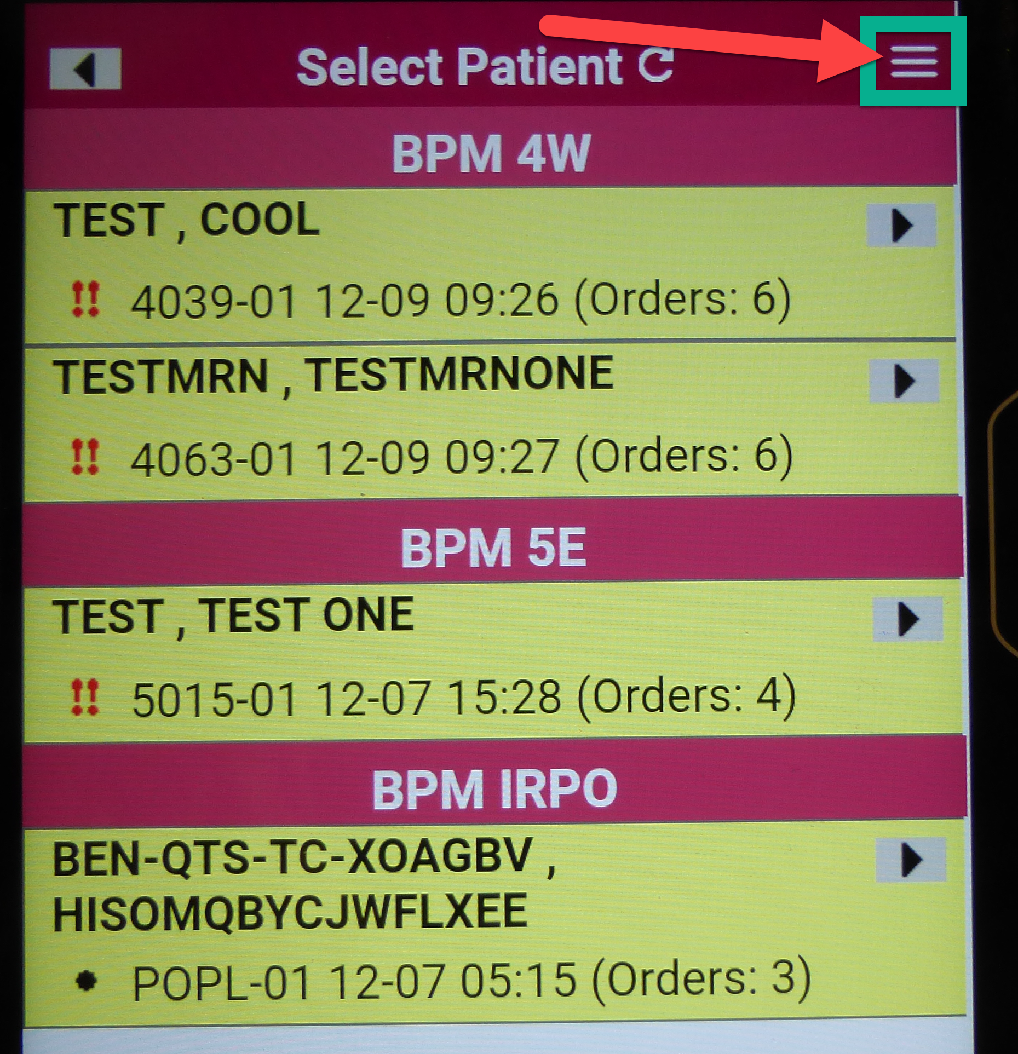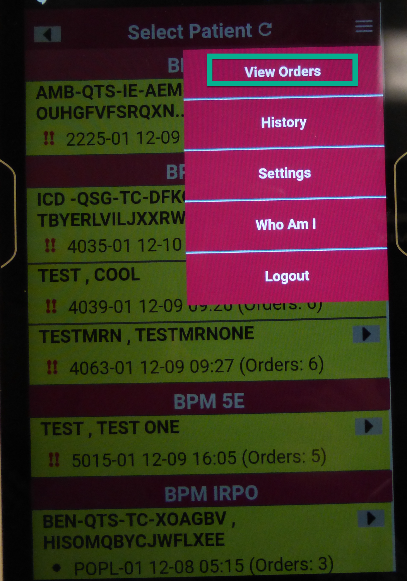
STep 3  STAT ORders by time  Orders will display by STAT order time  - Patient Name  - Priority  - Room Number  - Scheduled Collection Time | 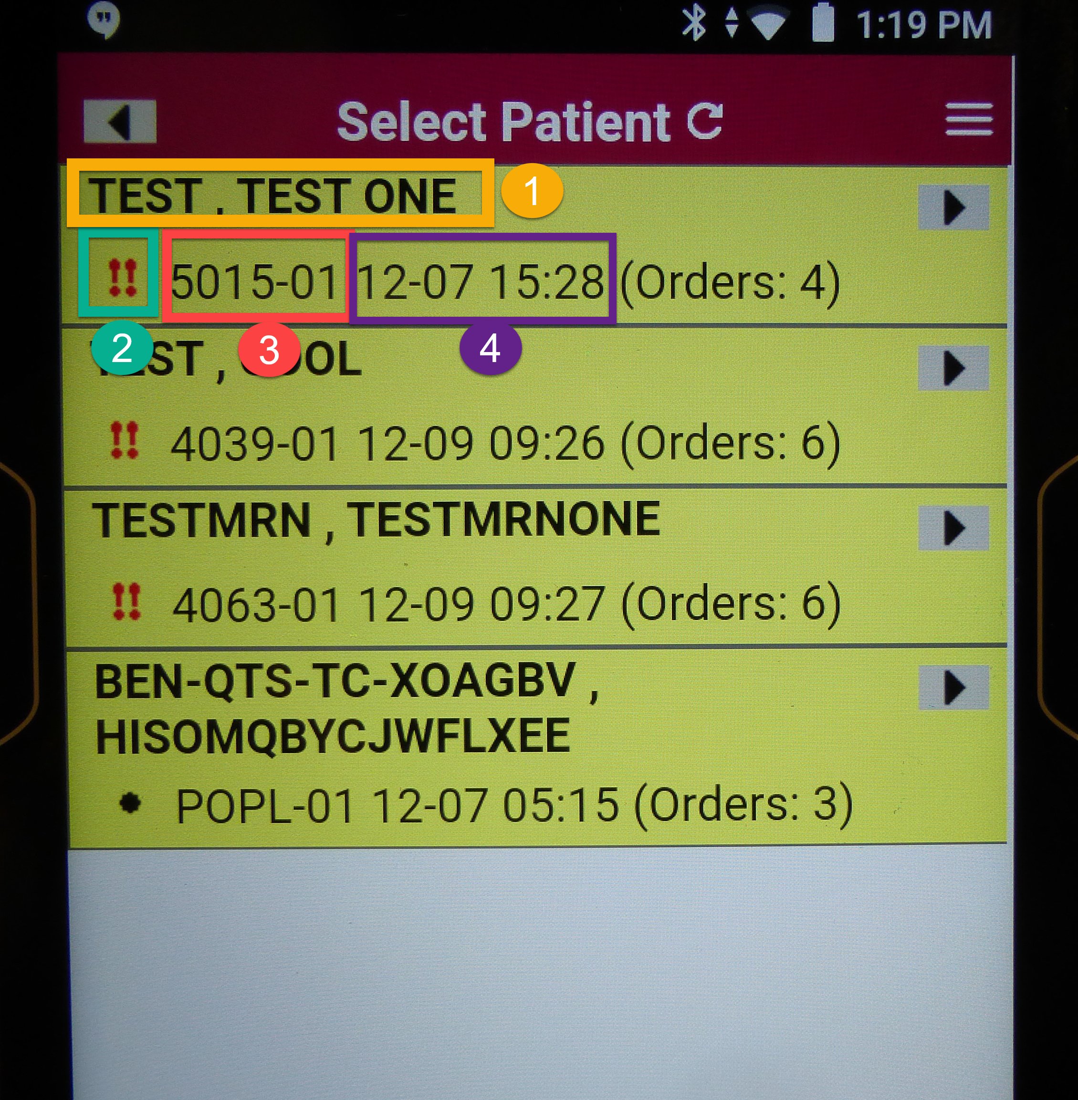
STep 4  Go back to UNIT view  - Tap on Hamburger  - Tap on “View Patients” | 