|  |  |
| --- | --- |
| **Procedure** | The following document outlines the cell localization procedure (Quality Control) for the Cellavision DM96 which also checks the Quality of staining procedures using Wright Stain. |

|  |  |  |
| --- | --- | --- |
| **Policy** | The Cell Location procedure should be performed as a daily quality control and after any changes to the staining procedure or staining solutions. All staining procedures/instrument used on a daily basis will have a freshly stained slide for Cell Location procedure performed in the Cellavision instrument. The test establishes how many percent of the nucleated cells (i.e., WBC and NRBC) are found on a slide by the unit. | |
| Workplace Safety | | All laboratory employees are expected to maintain a safe working environment and an injury-free workplace. Laboratory employees are responsible for their own safety, the safety of others and adhering to all departmental and medical center safety policies and procedures.   * For standard precautions and safety practices in the laboratory; see **Safety Practices**, specifically, but not limited to, equipment safety, proper body mechanics, sharps exposure and proper use of personal protective equipment (PPE). * For Universal Body Substance precautions, see **Universal Body Substance Precautions**, specifically, but not limited to, exposure to body fluids. * For proper hand-washing, see **Hand washing Policy**, specifically, not limited to, proper hand-washing. * For proper infection control, see **Infection Control**, specifically, but not limited to, proper use of gloves. * For proper handling of regular and infectious waste, see **Handling of Regular and Infectious Waste**, specifically, but not limited to, proper disposal of regular and biohazardous waste. * For proper cleaning of work area, see **Cleaning Work Areas**. * For proper handling of chemicals and reagents, see the Chemical Hygiene Plan.   For proper storage and disposal of chemical hazardous waste, see **Storage & Disposal of Chemical Hazardous Waste**. All laboratory employees are expected to maintain a safe working environment and an injury-free workplace. Laboratory employees are responsible for their own safety, the safety of others and adhering to all departmental and medical center safety policies and procedures. | |

|  |  |
| --- | --- |
| **Specimen requirements** | * To get a reliable result the blood used should have a WBC count above 7000 to reduce processing time. If the system cannot locate at least 100 nucleated cells, the result will be discarded * The percentage of non-nucleated cells (i.e. all other objects that are not identified as being a WBC or NRBC cell, e.g. smudge cells) must not exceed 50% of the total number of objects * Slide specimen must be freshly stained from the current stain being used for that day. |

|  |  |
| --- | --- |
| **Staining Instrument currently used** | These are the instruments currently being used that needs Cell Location procedure performed in Cellavision:   1. **Beckman Coulter DxH SMS (Stat and Core Area)** 2. **Siemens Hematek Stainer** |

|  |  |
| --- | --- |
| **Quality Control Procedure** | The program is automatically started with the Cellavision scans slides that are labeled with barcodes starting with the text "QC". All slides with this kind of label are automatically treated as cell localization test slides. When the slide has been processed it will only be available in the Cell Localization tool. |

|  |  |
| --- | --- |
| **Step** | **Action** |
| **1** | Make sure daily maintenance was performed in the Cellavision before performing Cell location |
| **2** | Select a slide that meets the requirements described above and put a Cellavision QC barcode label on it. |
| **3** | Put the slide in a magazine. Place it in the Cellavision to start processing the slide |
| **4** | When the processing is complete, select "Tools" from the main menu and then "Cell Location". |
| **5** | Select the new slide at the top of the slide list which is noted by the QC id, and date/time Cell Location was performed |
| **6** | Examine each image in the list of overview images to see if they contain any missed nucleated cells. Double click in the overview image to magnify the area of interest.   * A green box marks the nucleated cells * A blue box marks other found objects and false positives, i.e. artifacts. * Missed nucleated cells are those cells *not* marked with a box in the image (false n~atives). |
| **7** | Enter the number of missed cells, in the input field for each image. While checking the images, examine the quality of stain. See below for **Criteria for a Good Stain.** |
| **8** | When all images have been examined, the result will appear at the end. Result must be ***>95%* to pass.** |
| **9** | Log QC slide result in the Cellavision Quality Control log with corresponding instrument used in staining the slide, QC ID, date/time and initial of CLS who performed Cell location. See **Attachment C1 and C2**. |

**Quality Control Procedure,** continued…

|  |  |
| --- | --- |
| **10** | All corrective actions for failed Cell location must be documented under **Comments and Action log** found in Cellavision Quality Control Log |

|  |  |
| --- | --- |
| Criteria for a Good Stain | Well-stained film should be reddish-brown. Microscopically, erythrocytes should be salmon pink, leukocyte nuclei should be purple-blue (depending on maturation), and platelets should have purple-blue to lilac cytoplasm containing red-purple granules. Additional criteria include distinct orange granules in eosinophils (an excellent stain pH indicator), pinkish-tan cytoplasm in neutrophils, and gray, ground-glass cytoplasm with many tiny red-purple granules in monocytes. |

Attachment C1

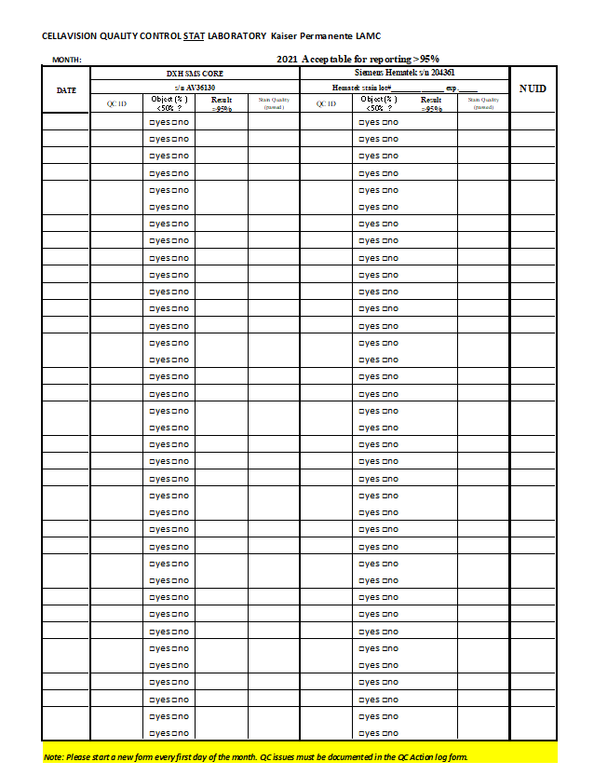

Attachment C2

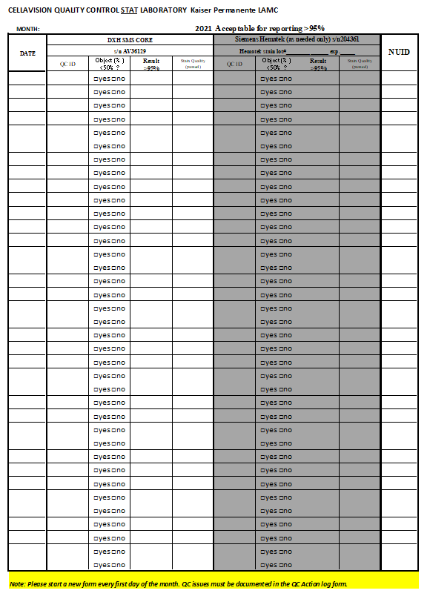

|  |  |
| --- | --- |
| **Non Controlled documents** | Cellavision DM96 Manual  Beckman DxH SMS Manual  Siemens Hematek Slide Stainer Manual |

|  |  |  |  |  |  |  |  |  |  |  |  |  |  |  |  |  |  |
| --- | --- | --- | --- | --- | --- | --- | --- | --- | --- | --- | --- | --- | --- | --- | --- | --- | --- |
| Controlled Documents | The following controlled documents support this procedure.   |  |  | | --- | --- | | **Document Number** | **Document Name** | | LAMC-PPP-0123 | Safety Practices | | LAMC-PPP-0127 | Infection Control | | LAMC-PPP-0128 | Universal Body Substance Precaution | | LAMC-PPP-0129 | Handling of Regular and Infectious Waste | | LAMC-PPP-0130 | Cleaning Work Areas | | LAMC-PPP-0132 | Hand-washing Policy | | LAMC-PPP-0134 | Storage and Disposal of Chemical Hazardous Waste | |
|  |  |
| Author(s) | Alvin Castillo |