OPERATION of pH Meter Mettler-Toledo SevenCompact S220

Purpose:

- The purpose of this procedure is to describe the operation of pH meter Fisher Sci 510 for determining and adjusting pH of a lysing agent Ammonium Chloride NH₄Cl.

Work Place Safety:

All laboratory employees are expected to maintain a safe working environment and an injury-free workplace. Laboratory employees are responsible for their own safety, the safety of others and adhering to all departmental and medical center safety policies and procedures.
- For standard precautions and safety practices in the laboratory; see LAMC-PPP-0123, specifically, but not limited to, equipment safety, proper body mechanics, sharps exposure and proper use of personal protective equipment (PPE).
- For Universal Body Substance precautions, see LAMC-PPP-0128, specifically, but not limited to, exposure to body fluids.
handwashing.
- For proper infection control, see LAMC-PPP-0127, specifically, but not limited to, proper use of gloves.
- For proper handling of regular and infectious waste, see LAMC-PPP-0129, specifically, but not limited to proper disposal of regular and biohazardous waste.
- For proper cleaning of work area, see LAMC-PPP-0130 - Cleaning Work Areas.

Policy:

- Wear personal protective equipment when working with pH meter Mettler-Toledo
- pH Meter will be taken out of service when it is out of order.
- pH Meter has a one year warranty. Manufacturer For service call Mettler-Toledo at 800-638-8537

OPERATION of pH Meter Mettler-Toledo SevenCompact S220, continued,

Principle:
- pH is the negative log of the activity of the hydrogen ion concentration in aqueous solution Aqueous solutions with a pH less than 7 are said to be acidic and solutions with a pH greater than 7 are basic, and pure water has a hydrogen ion concentration of 7.
- Primary pH standard values are determined by measuring the voltage difference between a hydrogen electrode and a standard electrode such as the silver chloride glass electrode. By definition pH is the negative logarithm of the dissolved hydrogen atom and it is commonly expressed as the measure of the hydronium ion concentration.
- SevenCompact S 220 pH meter is a microprocessor-based instrument for measuring pH and is equipped with liquid crystal display (LCD) to display pH reading.

Specimen Requirement:

- Aqueous solution.

Reagent, Materials and Equipment:

- Reagent:
- Ammonium Chloride 500g Sigma-Aldrich Catalog Number 213330-500g.
- Potassium bicarbonate 327205 Sigma-Aldrich Catalog Number 237205-500g
- Ethylenediaminetetraacetic acid tetrasodium salt.
- Orion Buffer
- pH 4.01 Buffer, Orion 910104, Thermofisher.
- pH 7.00 Buffer, Orion 910107, Thermofisher.
- pH 10.01 Buffer, Orion 910110, Thermofisher.
- pH Electrode Storage Solution, Orion 910001, Thermofisher
- Distilled Water
- Materials:
- Spatula
- Curwood Parafilm M 4in W x 125 L, Catalog #13-374-10 Fisher-Scientific.
- Parafilm Dispense/Cutter, Catalog # 06-666-52, Fisher Scientific.
- Erlenmeyer Flask -1000ul
- 25ml pyrex graduated beaker (3).

OPERATION of pH Meter Mettler-Toledo SevenCompact S220, continued,
- 100ml Pyrex graduated beaker.

- Equipment:
- pH Meter Mettler-Toledo SevenCompact S220

Procedure:

How to perform three-point calibration of pH Meter Mettler-Toledo SevenCompact S220
Step | Action
1 | Turn on the power: Press the on/off key located at the upper left side of the pH meter.
2 | Rinse the pH electrode with deionized water or rinse solution.  Note: Do not wipe the electrode as wiping may cause build-up of electrostatic charge and will create calibration and measurement instability.
3 | Select first pH buffer, pH 7.0, and pour about 10ml of the buffer into a 25ml glass beaker.
4 | Place the electrode into the pH 7.0 buffer and ensure that the electrode is completely immersed into the buffer; stir solution to create a homogenous solution.
5 | Press CAL (right lower side) key to enter pH Calibration mode. The CAL 1 appears on the display and the Endpoint Type icon is blinking.  Note: The icon appears as soon as the signal is stable, the measurement will stop automatically
6 | Rinse sensor with deionized water and place sensor in the next calibration buffer/standard.
7 | Press Cal.  Cal 2 appears on the display and Endpoint Type icon is blinking.  The icon appears as soon as the signal is stable, the measurement will stop automatically.

OPERATION of pH Meter Mettler-Toledo SevenCompact S220, continued,

8 | Remove the electrode from the pH 7.0 buffer, rinse the electrode using distilled water to avoid contamination.
9 | Place the electrode into the beaker containing pH 4.01. (The lower display of the meter automatically switches to the pH buffer solution selected.
10 | The stabilized pH measured value (pH 4.01buffer) appear. Rinse sensor with DI water.
11 | Repeat step with pH 10.01 buffer.
12 | The stabilized pH measured value (pH 10.01buffer) appears when the READY indicator displays on the left-hand corner.
13 | Press ENTER key to confirm the calibration. The upper display flashes the calibration value for few seconds before storing the calibration point in the meter.  At this point, the meter is now ready to measure pH of an aqueous solution. The meter automatically returns to the pH measurement mode after three-point calibration is performed.
14 | Press the down scroll button to next page of result. Press Save to accept calibration.
15 | Record calibration reading on LAMC-FORM-0145.

Note: If any error message appears during any of the calibration three-point, refer to section on “Troubleshooting pH meter calibration error.”

Windows of Accepted Values of USA calibration buffer:

Calibration Buffer | Limit in (pH)
USA Calibration buffer (pH 4.01) | 4.0 ±1.0
USA Calibration buffer (pH 7.01) | 7.0 ±1.5
USA Calibration buffer (pH 10.01) | 10.0 ±1.0

OPERATION of pH Meter Mettler-Toledo SevenCompact S220, continued,

How to measure the pH of a solution:
Step | Action
1 | Rinse the electrode with distilled water or tap water before use to remove any impurities adhering to the surface of the electrode body. If the pH electrode has not been in the electrode solution (dehydrated), soak the electrode for half an hour into the electrode storage solution.
2 | Press the ON key to switch the meter. Press and hold READ to change the display mode (uFocus).  Place and hold MODE to change the channel selection of both channels are active. Then press MODE ot change the measurement mode.
3 | Dip the electrode into the beaker or flask containing the sample, ensuring that the glass bulb of the electrode is completely immersed into the solution. Stir if necessary to create a homogenous sample.
4 | Press Read to start measurement.  Endpoint type icon is blinking, indicating a measurement is progress. The display show the measurement value of the sample.  Note: The READ mode shows that the readings are stable within a range of pH 7.4 ±0.1 pH.  - pH is not within range (pH 7.4 ±0.1), adjust pH as follows:  if pH < 7.3 adjust pH using 1N NaOH, if pH is >7.5, adjust pH using 1N HCl.  - Record pH readings using LAMC-FORM-0145.

OPERATION of pH Meter Mettler-Toledo SevenCompact S220, continued,
Troubleshooting pH meter:

Table below show a diagnosis guideline for possible problems encountered during calibration of pH meter.

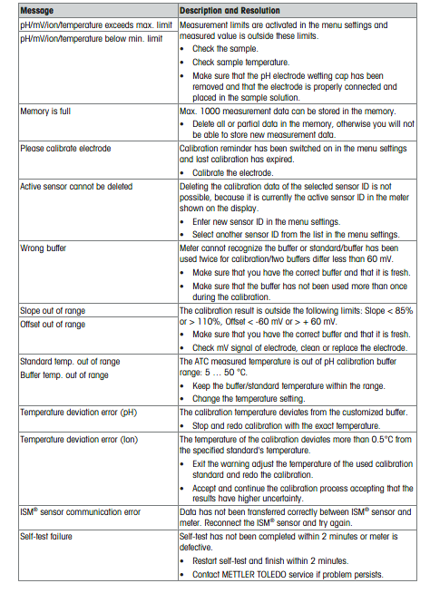

OPERATION of pH Meter Mettler-Toledo SevenCompact S220, continued,
Other Message (troubleshooting) with pH meter:
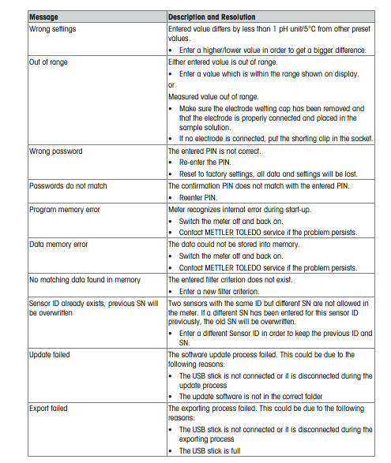

Interpretation
- Not applicable for this procedure

OPERATION of pH Meter Mettler-Toledo SevenCompact S220, continued,

Reporting and Documentation

- After performing required daily maintenance, Daily Maintenance Form is signed daily by CLS and reviewed monthly by Laboratory Supervisor. (Maintenance Form is provided by Regional Instrumentation Laboratory.

Controlled Document
- Daily Maintenance form provided by Kaiser Permanente SCMPG Laboratory Instrumentation Services.
- LAMC-PPP-0123 - Safety Practices.
- LAMC-PPP-0128 - Universal Body Substance Precautions (UBSP).
- LAMC-PPP-0132 - Handwashing Policy.

- LAMC-PPP-0127: Infection Control
- LAMC-PPP-0129: Handling Regular and Infections Waste.
- LAMC-PPP-0130: Cleaning Work Areas.
- LAMC-FORM-0145: Flow Cytometry pH meter Logbook.

Uncontrolled Document
Instruction Manual of pH Meter Mettler-Toledo S220. Retrieved June 25, 2021 from https://www.mt.com/us/en/home/library/operating-instructions/lab-analytical-instruments/S220_Op_Instr.html

Self-Assessment

- Calibration of pH Meter Mettler-Toledo S220 involves:
- One-point calibration
- Two-point calibration
- Three-point calibration

OPERATION of pH Meter Mettler-Toledo SevenCompact S220, continued,

- The type of buffer used for calibration in the Flow Cytometry lab is:
- USA
- NIST
- USA and NIST
- Does not matter if USA or NIST
- True or False:
During the three-point calibration process, the operator press ENTER to confirm the calibration.
- READY annunciator display means:
- Measured pH value has been stabilized.
- Measured pH value needs to be stabilized by pressing Enter Key.
- All of the above.

Author: Giovanni B. Garcia, MT (ASCP), CLS, MBA

